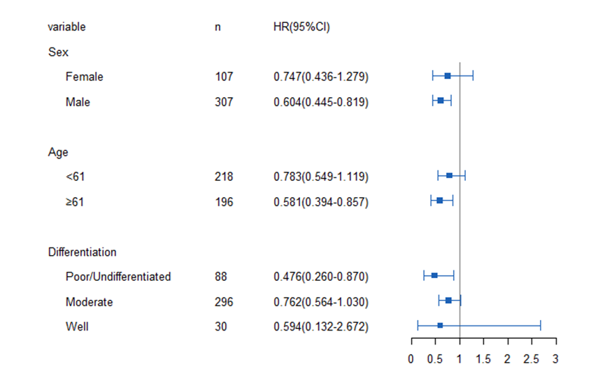
Supplement figure 1. Multivariate analysis results stratified by sex, age and differentiation.

