Figure S1
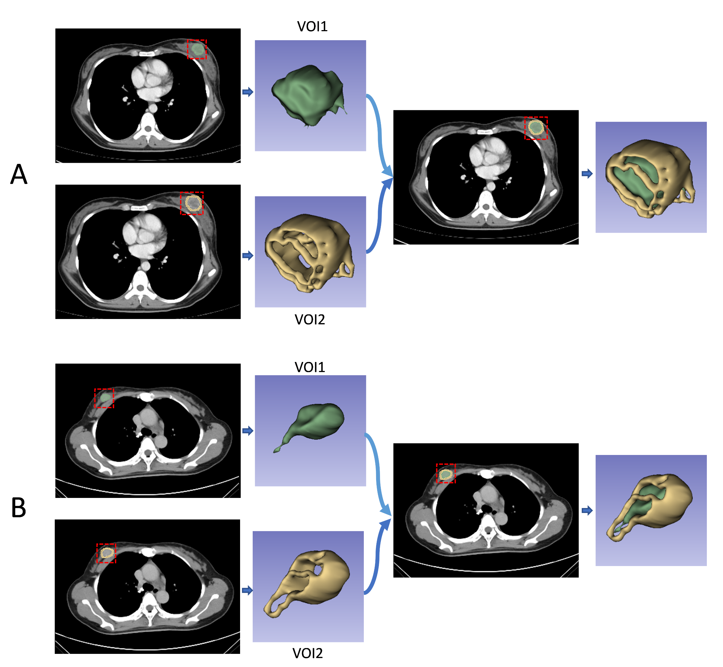
Figure S1. VOI segmentation. (A) The process of lesion delineation in a patient with breast cancer who achieved pCR in the evaluation of the efficacy of NAC. (B) The process of lesion delineation in a patient with breast cancer who achieved Non-pCR in the evaluation of the efficacy of NAC.

Figure S2
Figure S2. (A)Segmentation Process of WSI, (B)color normalization.

Figure S3
Figure S3. Image preprocessing in CellProBased on the “Unmix Colors” module to separate H&E-stained images and convert them into haematoxylin-stained and eosin-stained greyscale images, The H&E-stained images were also converted to greyscale images using the “ColorToGray” module.

Figure S4
Figure S4. (A)Pipeline 1. First, greyscale H&E, haematoxylin and eosin images were assessed by using the “MeasureImageQuality” module with three types of features, including blur features, intensity features and threshold features. Subsequently, ‘MeasureColocalization’ module measured the colocalization and correlation between intensities in haematoxylin images and eosin images on a pixel-by-pixel basis. Next, ‘MeasureGranularity’ module outputed spectra of size measurements of the textures in three types of images. Finally, ‘MeasureTexture’ module measured the degree and nature of textures within three types of images to quantify their roughness and smoothness. (B)Pipeline 2. Haematoxylin-stained images were segmented via ‘IdentifyPrimaryObjects’module and‘IdentifySecondaryObjects’ module ,Quantitative image features of object shape, size, texture, and pixel intensity distribution were further extracted via multiple modules, including measure models of ‘Object Intensity Distribution’, ‘Object Intensity’, ‘Texture’, and ‘Object Size Shape’.

Table S1 Baseline characteristics in the training and validation Sets.
Characteristics | Training set(n=155) | Validation set(n=56) | P
Age | 49.0(46.0,55.0) | 49.5(45.0,56.2) | 0.627
T stage (%) |  |  | 0.925
T1 | 7 (4.52) | 3 (5.36)
T2 | 111 (71.6) | 41 (73.2)
T3 | 18 (11.6) | 7 (12.5)
T4 | 19 (12.3) | 5 (8.93)
N stage (%) |  |  | 0.110
N0 | 41 (26.5) | 14 (25.0)
N1 | 94 (60.6) | 29 (51.8)
N2 | 17 (11.0) | 8 (14.3)
N3 | 3 (1.94) | 5 (8.93)
ER status (%) |  |  | 0.859
Negative | 76 (49.0) | 26 (46.4)
Positive | 79 (51.0) | 30 (53.6)
PR status (%) |  |  | 0.280
Negative | 60 (38.7) | 27 (48.2)
Positive | 95 (61.3) | 29 (51.8)
HER2 status (%) |  |  | 0.611
Negative | 91 (58.7) | 30 (53.6)
Positive | 64 (41.3) | 26 (46.4)
Ki-67 status (%) |  |  | 1.000
<30% | 37 (23.9) | 13 (23.2)
≥30% | 118 (76.1) | 43 (76.8)
Note:Data in parentheses are percentages; p values were derived from the univariate analysis between each of characteristic and pCR Status.

Table S2 The selected radiomics features.
Radiomics Features(n=30)
exponential_glszm_SizeZoneNonUniformityNormalized
exponential_glszm_SmallAreaLowGrayLevelEmphasis
lbp-3D-k_firstorder_Skewness
lbp-3D-k_glszm_SizeZoneNonUniformityNormalized
lbp-3D-m1_gldm_DependenceVariance
lbp-3D-m2_glcm_ClusterShade
lbp-3D-m2_glcm_InverseVariance
log-sigma-4-0-mm-3D_glszm_SmallAreaLowGrayLevelEmphasis
log-sigma-5-0-mm-3D_firstorder_Skewness
logarithm_gldm_SmallDependenceLowGrayLevelEmphasis
logarithm_glrlm_RunVariance
squareroot_glcm_Imc2
wavelet-HLH_glcm_Correlation
wavelet-HLH_glszm_SmallAreaEmphasis
wavelet-HLL_firstorder_Skewness
wavelet-LLH_firstorder_10Percentile
PR_exponential_glszm_ZonePercentage
PR_gradient_glcm_Correlation
PR_lbp-3D-k_glszm_SmallAreaHighGrayLevelEmphasis
PR_log-sigma-2-0-mm-3D_glcm_InverseVariance
PR_log-sigma-5-0-mm-3D_glcm_DifferenceEntropy
PR_wavelet-HLH_glcm_DifferenceEntropy
PR_wavelet-HLL_firstorder_InterquartileRange
PR_wavelet-HLL_firstorder_Skewness
PR_wavelet-HLL_glszm_ZoneVariance
PR_wavelet-LHL_firstorder_RootMeanSquared
PR_wavelet-LHL_glcm_ClusterShade
PR_wavelet-LLH_firstorder_Skewness
PR_wavelet-LLH_glszm_ZonePercentage
PR_wavelet-LLL_firstorder_10Percentile
Note: PR= peritumoral region.

Table S3 The selected pathomics features.
Pathomics Features(n=12)
ExecutionTime_09MeasureGranularity
Granularity_15_Hematoxylin
Granularity_5_OrigGray
Granularity_6_Eosin
Granularity_8_Eosin
Granularity_9_Eosin
H_Mean_IdentifySecondaryObjects_AreaShape_Zernike_8_2
H_Median_IdentifySecondaryObjects_AreaShape_Zernike_4_4
H_StDev_IdentifyPrimaryObjects_AreaShape_Zernike_9_9
H_StDev_IdentifySecondaryObjects_AreaShape_Zernike_6_4
H_StDev_IdentifySecondaryObjects_AreaShape_Zernike_7_3
H_StDev_IdentifySecondaryObjects_Texture_Correlation_Hematoxylin_3_03_256
Table S4 The selected deep learning pathomics features.
Deep Learining Pathomics Features(n=8)
DLP_0
DLP_2
DLP_3
DLP_5
DLP_51
DLP_61
DLP_62
DLP_80

