Additional file
Additional file 1: Flow diagram of Women aged 69+ (i.e., women born before 1948) invited for an additional HPV-based screening test in Central Denmark Region
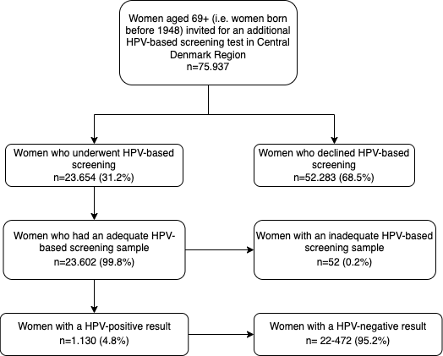
*Reference no. 16: The Danish Quality Database for cervical cancer screening (Dansk Kvalitetsdatabase for Livmoderhalskræftscreening – DKLS) “Resultater fra Engangstilbuddet: Livmoderhalskræftscreening blandt danske kvinder født før 1948” 1. delrapport. 2019

