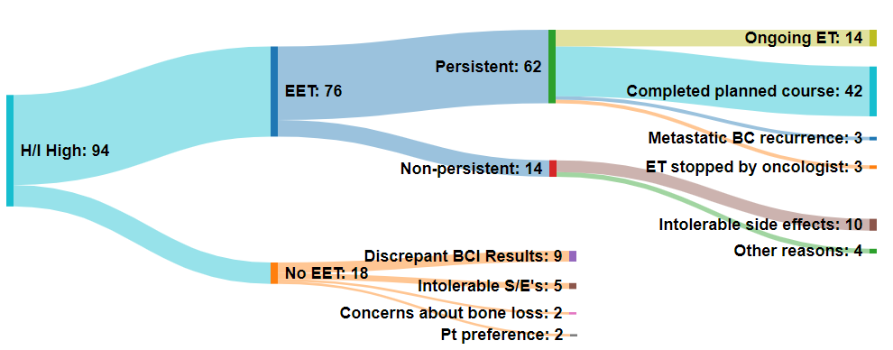
Supplementary Figure 1.

Sankey diagram illustrating the reasons for discontinuing ET in 94 patients with high likelihood of benefit from EET (H/I high). The width of the lines is proportional to the patient distribution from one clinical category to the next. Of the 94 H/I high patients, 76 (81%) elected for EET and 18 (19%) stopped ET at around 5 years. Among the 18 patients who stopped ET, the most common reason for stopping ET were equivocal BCI results. Of the 76 patients who continued EET, 62 (81.5%) remained persistent. Among the 14 patients with non-persistence, the most common (71%) reason for early discontinuation were intolerable side effects.

