Supplementary Information

Figure S1: Weight measurements in grams by NBW and LBW babies over 24 month follow up period.
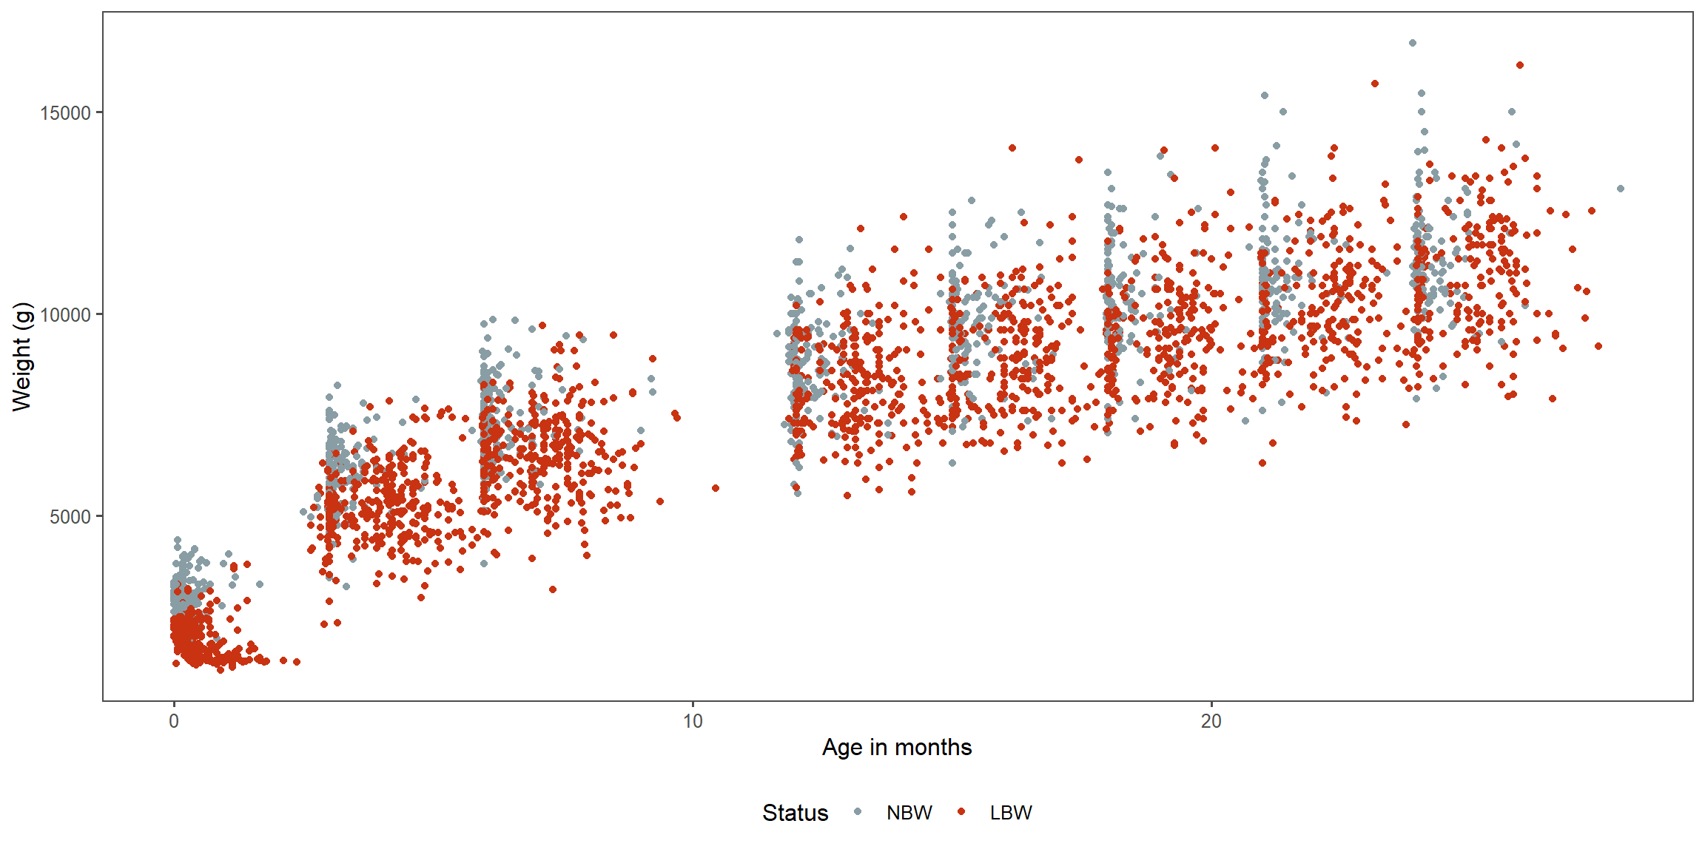
Figure S2: Weight gain (g per day per kg from previous visit) in the NBW and LBW babies over 24 month follow up period.
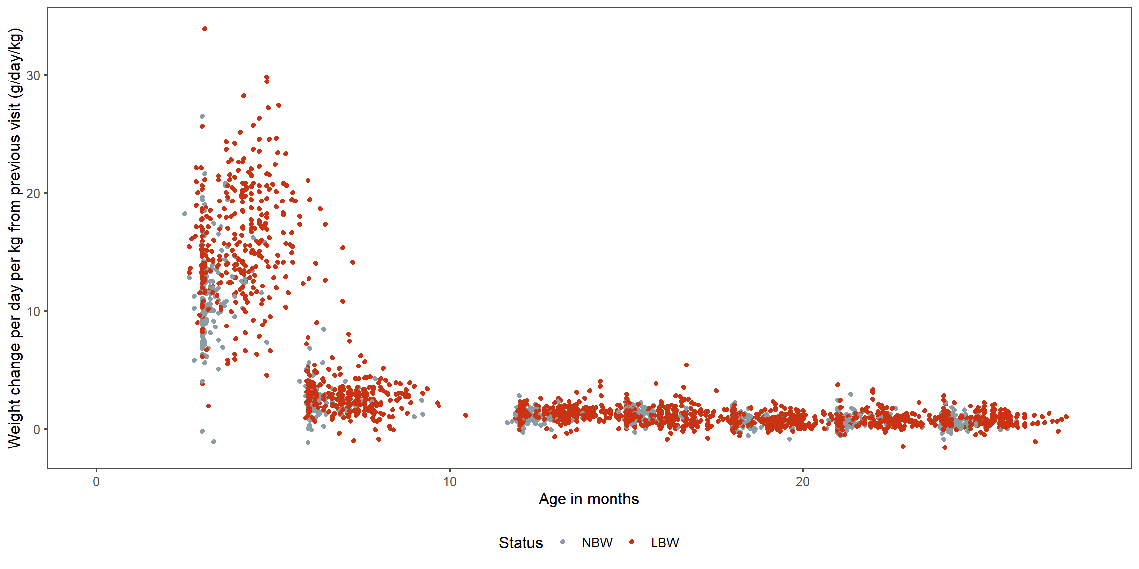

Table S 1 Weight change per day (in g) from the previous visit by group (NBW vs LBW).
 | Weight change per day from the previous visit (g)
 | NBW |  | LBW
visit | n | Mean (sd) | n | Mean (sd)
3 | 197 | 33.3 (8.2) | 376 | 30.2 (7.5)
6 | 179 | 14.7 (6.3) | 332 | 13.7 (6.1)
12 | 164 | 7 (3.4) | 312 | 8.6 (3.6)
15 | 151 | 10.2 (4.3) | 273 | 8.4 (5.8)
18 | 143 | 6.2 (4.9) | 251 | 6.2 (4.4)
21 | 135 | 6.8 (5.2) | 236 | 7.2 (5.4)
24 | 127 | 5.8 (5.5) | 218 | 7.8 (5.5)
visit | n | Median [range] | n | Median [range]
3 | 197 | 32.6 [-3.7-56.2] | 376 | 30.5 [3.9-49.9]
6 | 179 | 14.1 [-6.8-33.1] | 332 | 13.5 [-6.7-36.8]
12 | 164 | 6.5 [-1.8-14.9] | 312 | 8.5 [-4.6-24.7]
15 | 151 | 10.3 [-2.7-20] | 273 | 8 [-7.4-40.7]
18 | 143 | 5.9 [-7.7-21.6] | 251 | 6.1 [-5.4-20.5]
21 | 135 | 6.1 [-7.1-23.5] | 236 | 6.6 [-17.8-31.5]
24 | 127 | 5.3 [-11.1-24] | 218 | 7.5 [-14.6-29.7]

Table S2 Estimated weight from linear mixed models and 95% confidence intervals (in grams) at birth, 6, 12, 18 and 24 months for NBW and LBW infants adjusted by age and sex.
 |  | NBW |  | LBW
 | Age (months) | Estimated weight (g) | 95%CI | Estimated weight (g) | 95%CI
Females | 0 | 2679.3 | 2607.4- 2751.1 | 1507.0 | 1400.5-1613.6
 | 6 | 6946.4 | 6803.5- 7089.2 | 5893.2 | 5744.9-6041.5
 | 12 | 8772.2 | 8623.9- 8920.5 | 7929.5
 | 18 | 10016.7 |  | 9183.8
 | 24 | 11261.1 |  | 10438.0
Males | 0 | 2851.3 | 2754.9-2947.7 | 1679.07 | 1532.4-1825.8
 | 6 | 7118.4 | 6922.4-7314.5 | 6065.24 | 5861.1-6269.4
 | 12 | 8944.2 | 8712.3-9176.2 | 8101.58
 | 18 | 10188.7 |  | 9355.80
 | 24 | 11433.1 |  | 10610.02
NBW = normal birth weight, LBW = low birth weight

Figure S3: Height measurements in cm for NBW and LBW babies over 24 month follow up period.

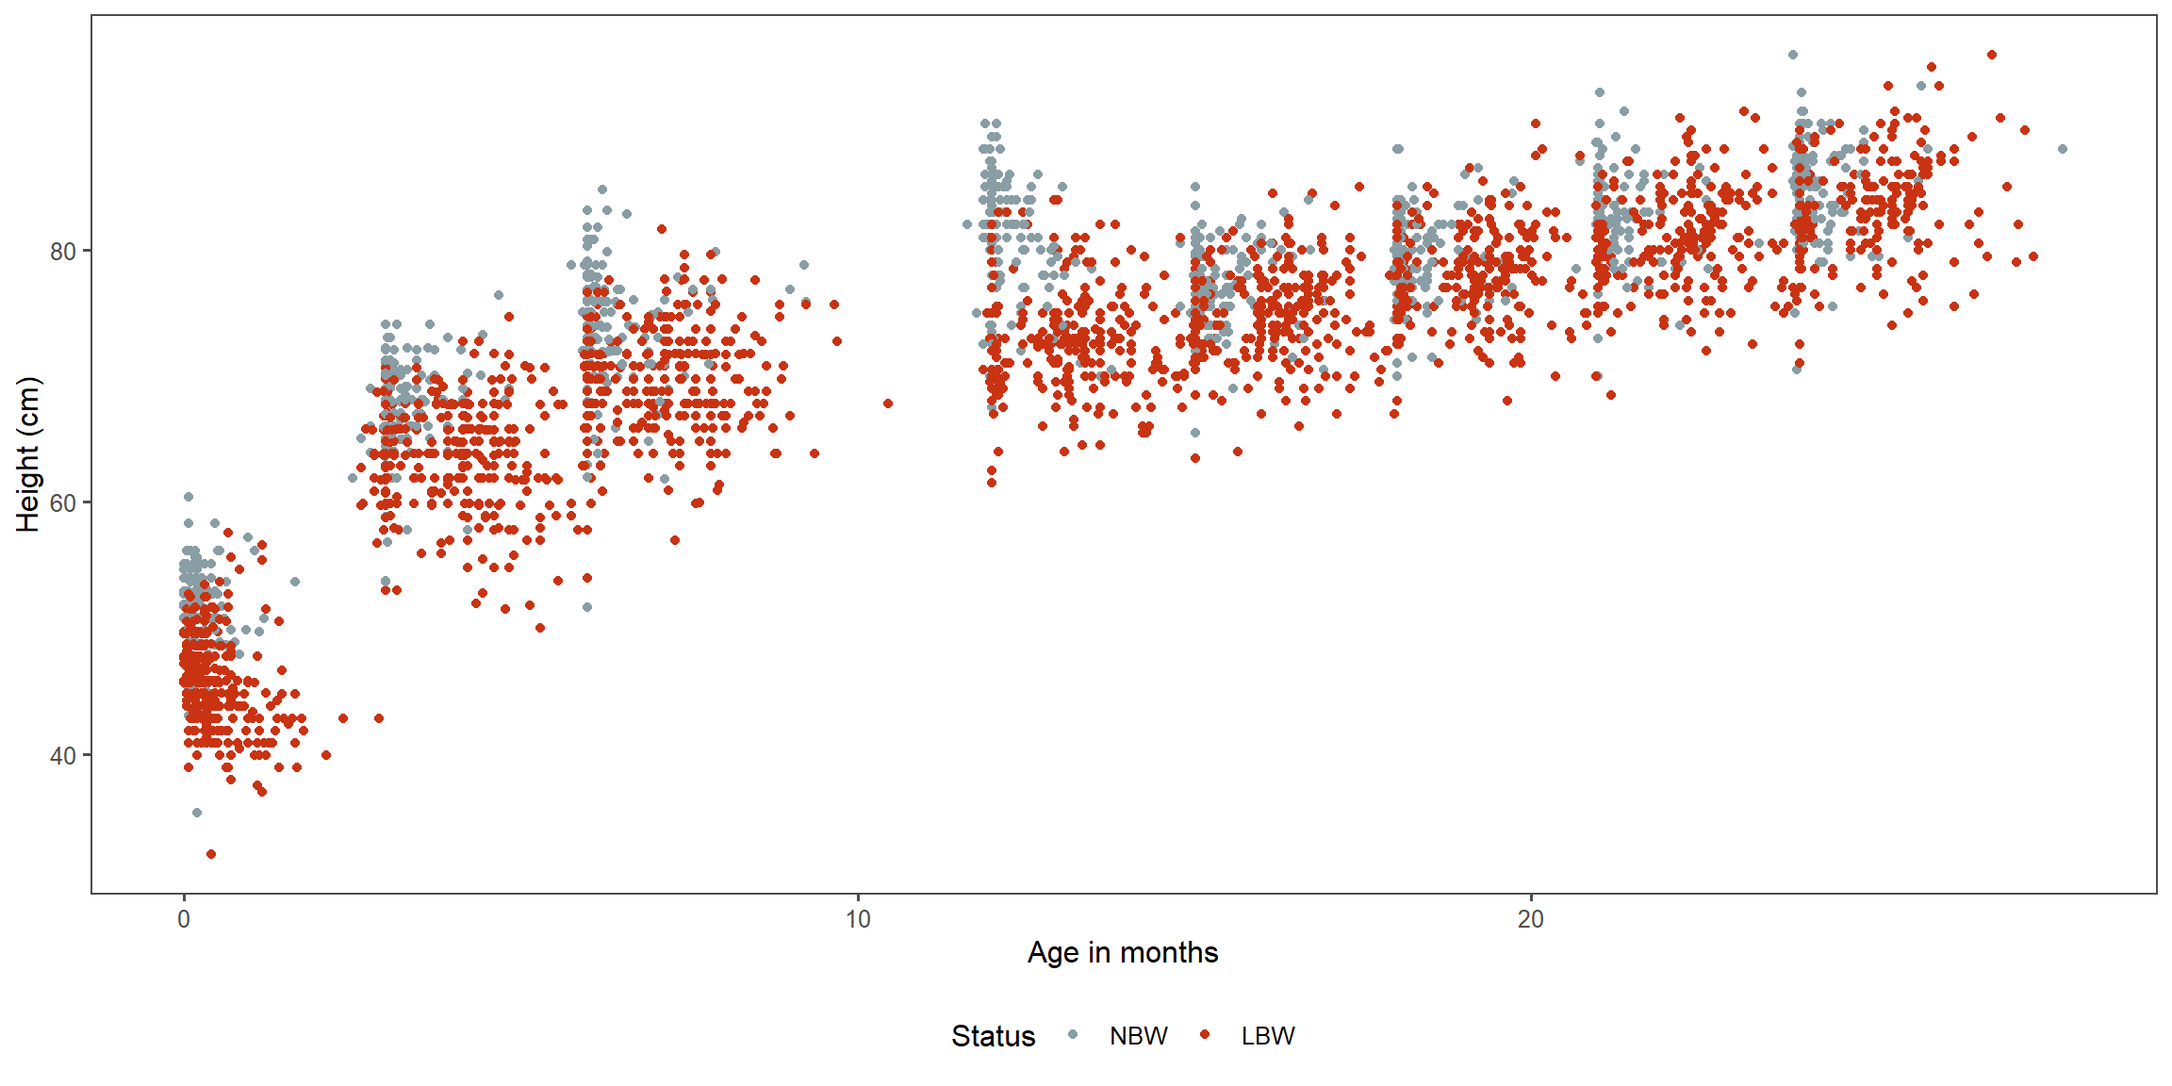

Table S3 Estimated length from linear mixed models and 95% confidence intervals (in grams) at birth, 6, 12, 18 and 24 months for NBW and LBW infants adjusted by sex.
 |  | NBW |  | LBW
 | Age (months) | Estimated length (cm) | 95%CI | Estimated length (cm) | 95%CI
Females | 0 | 49.5 | 49.0- 50.0 | 43.06 | 42.6- 43.5
 | 6 | 70.6 | 70.1- 71.1 | 65.81 | 65.4- 66.3
 | 12 | 78.0 | 77.5- 78.5 | 72.03
 | 18 | 80.2 |  | 76.70
 | 24 | 82.5 |  | 81.36
Males | 0 | 50.6 | 49.9- 51.2 | 44.17 | 43.6- 44.8
 | 6 | 71.7 | 71.0- 72.4 | 66.92 | 66.3- 67.6
 | 12 | 79.1 | 78.4- 79.8 | 73.14
 | 18 | 81.3 |  | 77.81
 | 24 | 83.6 |  | 82.47
NBW = normal birth weight, LBW = low birth weight
Table S4 Estimated Bayley Scales III raw scores from linear mixed models and 95% confidence intervals for gross motor skills, fine motor skills, cognitive skills, receptive communication skills and expressive communication skills in female infants.
Bayley scale |  | NBW |  | LBW
 | Age (months) | Estimated score | 95%CI | Estimated score | 95%CI
Gross Motor skills | 6 | 25.4 | 24.5-26.3 | 21.0 | 20.1-21.9
 | 12 | 40.4 | 39.6-41.1 | 37.2 | 36.3-38.0
 | 18 | 47.4 |  | 44.7
 | 24 | 54.4 |  | 52.2
Fine motor skills | 6 | 19.3 | 18.8-19.9 | 17.4 | 16.9-17.9
 | 12 | 28.9 | 24.5-29.3 | 28.8 | 28.3-29.2
 | 18 | 32.8 |  | 32.3
 | 24 | 36.8 |  | 35.8
Cognitive skills | 12 | 38.4 | 37.2-39.5 | 37.6 | 36.4-38.8
 | 18 | 49.6 | 48.5-50.7 | 47.6
 | 24 | 55.4 |  | 55.4
Receptive communication skills | 12 | 12.8 | 12.3-13.4 | 11.7 | 11.1-12.2
 | 18 | 18.2 | 17.7-18.6 | 17.4
 | 24 | 23.8 |  | 22.4
Expressive communication skills | 12 | 12.3 | 11.5-13.1 | 11.9 | 11.1-12.7
 | 18 | 18.2 | 17.5-18.9 | 16.2
 | 24 | 24.9 |  | 22.6

Table S5 Estimated Bayley Scales III raw scores from linear mixed models and 95% confidence intervals for gross motor skills, fine motor skills, cognitive skills, receptive communication skills and expressive communication skills in male infants.
Bayley scale |  | NBW |  | LBW
 | Age (months) | Estimated score | 95%CI | Estimated score | 95%CI
Gross Motor skills | 6 | 25.9 | 24.7-27.1 | 21.4 | 20.3-22.6
 | 12 | 40.8 | 39.7-41.9 | 37.6 | 36.4-38.8
 | 18 | 47.8 |  | 45.1
 | 24 | 54.9 |  | 52.6
Fine motor skills | 6 | 19.4 | 18.7-20.1 | 17.5 | 16.8-18.1
 | 12 | 29.0 | 28.4-29.5 | 28.8 | 28.1-29.5
 | 18 | 32.9 |  | 32.4
 | 24 | 36.9 |  | 35.9
Cognitive skills | 12 | 39.7 | 38.2-41.2 | 39.0 | 37.4-40.5
 | 18 | 50.9 | 49.4-52.4 | 48.6
 | 24 | 56.8 |  | 54.7
Receptive communication skills | 12 | 12.9 | 12.2-13.6 | 11.7 | 11.0-12.4
 | 18 | 18.2 | 17.6-18.9 | 17.5
 | 24 | 23.8 |  | 22.4
Expressive communication skills | 12 | 12.6 | 11.6-13.6 | 12.2 | 11.2-13.3
 | 18 | 18.6 | 17.6-19.6 | 16.5
 | 24 | 25.2 |  | 23.0

Table S6 Prediction models for outcome weight and length with predictor of age
TermMeaning | Value | Estimate.weight | Pval.weight | Estimate.length | Pval.length
Intercept | NA | 2777.4 | 0.000 | 50.1 | 0
Change LBW vs NBW | 1 if LBW | -1199.3 | 0.000 | -6.6 | 0
Monthly change m0-3 | x (x<3); 3 (x>3) | 1117.8 | 0.000 | 5.8 | 0
Monthly change after m3 until m12 | x-3 (x>3 and x=<12) or 12-3 (x>12) | 304.6 | 0.000 | 1.2 | 0
Monthly change after m12 | x-12 (x>12) | 207.3 | 0.000 | 0.4 | 0
if LBW: Monthly change m0-3 | 1 if LBW AND x (x<3); 3 (x>3) | 4.6 | 0.874 | 0.7 | 0
if LBW: Monthly change after m3 until m12 | 1 if LBW AND x-3 (x>3 and x=<12) or 12-3 (x>12) | 34.7 | 0.002 | -0.2 | 0
if LBW: Monthly change after m12 | 1 if LBW AND x-12 (x>12) | 1.7 | 0.815 | 0.4 | 0

Table S7: Prediction models for outcome weight and length with predictor of age and sex
TermMeaning | Value | Estimate.weight | Pval.weight | Estimate.length | Pval.length
Intercept | NA | 2679.2 | 0.000 | 49.5 | 0
Change LBW vs NBW | 1 if LBW | -1172.2 | 0.000 | -6.4 | 0
Monthly change m0-3 | x (x<3); 3 (x>3) | 1118.1 | 0.000 | 5.8 | 0
Monthly change after m3 until m12 | x-3 (x>3 and x=<12) or 12-3 (x>12) | 304.3 | 0.000 | 1.2 | 0
Monthly change after m12 | x-12 (x>12) | 207.4 | 0.000 | 0.4 | 0
Male vs Female | 1 if male | 172.0 | 0.000 | 1.1 | 0
if LBW: Monthly change m0-3 | 1 if LBW AND x (x<3); 3 (x>3) | 4.6 | 0.873 | 0.7 | 0
if LBW: Monthly change after m3 until m12 | 1 if LBW AND x-3 (x>3 and x=<12) or 12-3 (x>12) | 35.1 | 0.002 | -0.2 | 0
if LBW: Monthly change after m12 | 1 if LBW AND x-12 (x>12) | 1.6 | 0.819 | 0.4 | 0

Table S8: Prediction models for outcome weight and length with predictor of age, sex and prematurity
TermMeaning | Value | Estimate.weight | Pval.weight | Estimate.length | Pval.length
Intercept | NA | 2763.9 | 0.000 | 49.8 | 0
Change LBW vs NBW | 1 if LBW | -855.5 | 0.000 | -5.1 | 0
Monthly change m0-3 | x (x<3); 3 (x>3) | 1116.8 | 0.000 | 5.8 | 0
Monthly change after m3 until m12 | x-3 (x>3 and x=<12) or 12-3 (x>12) | 304.0 | 0.000 | 1.2 | 0
Monthly change after m12 | x-12 (x>12) | 207.5 | 0.000 | 0.4 | 0
Male vs Female | 1 if male | 118.1 | 0.004 | 1.0 | 0
Change preterm vs fullterm | 1 if preterm | -620.7 | 0.000 | -2.5 | 0
if LBW: Monthly change m0-3 | 1 if LBW AND x (x<3); 3 (x>3) | 5.6 | 0.846 | 0.7 | 0
if LBW: Monthly change after m3 until m12 | 1 if LBW AND x-3 (x>3 and x=<12) or 12-3 (x>12) | 35.4 | 0.002 | -0.2 | 0
if LBW: Monthly change after m12 | 1 if LBW AND x-12 (x>12) | 1.5 | 0.831 | 0.4 | 0

Table S9: Prediction models for cognitive, receptive communication and expressive communication skills with predictor of age
TermMeaning | Value | Estimate.CS | Pval.CS | Estimate.RC | Pval.RS | Estimate.EC | Pval.EC
Intercept | NA | 16.7 | 0.000 | 2.2 | 0.016 | 0.5 | 0.675
Change LBW vs NBW | 1 if LBW | 2.1 | 0.431 | -2.1 | 0.100 | 2.9 | 0.108
Monthly change m12-18 | x (x<18); 18 (x>18) | 1.9 | 0.000 | 0.9 | 0.000 | 1.0 | 0.000
Monthly change after m18 | x-18 (x>18) | 1.0 | 0.000 | 0.9 | 0.000 | 1.1 | 0.000
if LBW: Monthly change m12-18 | 1 if LBW AND x (x<18); 18 (x>18) | -0.3 | 0.132 | 0.1 | 0.370 | -0.3 | 0.017
if LBW: Monthly change after m18 | 1 if LBW AND x-18 (x>18) | 0.0 | 0.771 | -0.1 | 0.118 | 0.0 | 0.703

Table S10: Prediction models for cognitive, receptive communication and expressive communication skills with predictor of age and sex
TermMeaning | Value | Estimate.CS | Pval.CS | Estimate.RC | Pval.RS | Estimate.EC | Pval.EC
Intercept | NA | 15.9 | 0.000 | 2.1 | 0.020 | 0.3 | 0.792
Change LBW vs NBW | 1 if LBW | 2.4 | 0.369 | -2.0 | 0.103 | 2.9 | 0.100
Monthly change m12-18 | x (x<18); 18 (x>18) | 1.9 | 0.000 | 0.9 | 0.000 | 1.0 | 0.000
Monthly change after m18 | x-18 (x>18) | 1.0 | 0.000 | 0.9 | 0.000 | 1.1 | 0.000
Male vs Female | 1 if male | 1.3 | 0.037 | 0.1 | 0.806 | 0.3 | 0.423
if LBW: Monthly change m12-18 | 1 if LBW AND x (x<18); 18 (x>18) | -0.3 | 0.131 | 0.1 | 0.369 | -0.3 | 0.017
if LBW: Monthly change after m18 | 1 if LBW AND x-18 (x>18) | 0.0 | 0.770 | -0.1 | 0.118 | 0.0 | 0.703

Table S10: Prediction models for cognitive, receptive communication and expressive communication skills with predictor of age, sex and prematurity
TermMeaning | Value | Estimate.CS | Pval.CS | Estimate.RC | Pval.RS | Estimate.EC | Pval.EC
Intercept | NA | 16.0 | 0.000 | 2.2 | 0.015 | 0.5 | 0.710
Change LBW vs NBW | 1 if LBW | 3.0 | 0.268 | -1.5 | 0.239 | 3.7 | 0.040
Monthly change m12-18 | x (x<18); 18 (x>18) | 1.9 | 0.000 | 0.9 | 0.000 | 1.0 | 0.000
Monthly change after m18 | x-18 (x>18) | 1.0 | 0.000 | 0.9 | 0.000 | 1.1 | 0.000
Change male vs female | 1 if male | 1.3 | 0.043 | 0.0 | 0.911 | 0.3 | 0.495
Change preterm vs fullterm | 1 if preterm | -1.3 | 0.096 | -1.2 | 0.000 | -1.6 | 0.001
if LBW: Monthly change m12-18 | 1 if LBW AND x (x<18); 18 (x>18) | -0.3 | 0.143 | 0.1 | 0.323 | -0.3 | 0.021
if LBW: Monthly change after m18 | 1 if LBW AND x-18 (x>18) | 0.0 | 0.746 | -0.1 | 0.137 | 0.0 | 0.750

Table S11: Prediction models for gross and fine motor skills with predictor of age
TermMeaning | Value | Estimate.fm | Pval.fm | Estimate.gm | Pval.gm
Intercept | NA | 9.8 | 0.000 | 10.8 | 0.000
Change LBW vs NBW | 1 if LBW | -3.7 | 0.000 | -5.7 | 0.000
Monthly change m6-12 | x (x<12); 12 (x>12) | 1.6 | 0.000 | 2.5 | 0.000
Monthly change after m12 | x-12 (x>12) | 0.7 | 0.000 | 1.2 | 0.000
if LBW: Monthly change m6-12 | 1 if LBW AND x (x<12); 12 (x>12) | 0.3 | 0.000 | 0.2 | 0.041
if LBW: Monthly change after m12 | 1 if LBW AND x-12 (x>12) | -0.1 | 0.049 | 0.1 | 0.116

Table S12: Prediction models for gross and fine motor skills with predictor of age and sex
TermMeaning | Value | Estimate.fm | Pval.fm | Estimate.gm | Pval.gm
Intercept | NA | 9.8 | 0.000 | 10.5 | 0.000
Change LBW vs NBW | 1 if LBW | -3.7 | 0.000 | -5.7 | 0.000
Monthly change m6-12 | x (x<12); 12 (x>12) | 1.6 | 0.000 | 2.5 | 0.000
Monthly change after m12 | x-12 (x>12) | 0.7 | 0.000 | 1.2 | 0.000
Male vs Female | 1 if male | 0.1 | 0.785 | 0.4 | 0.397
if LBW: Monthly change m6-12 | 1 if LBW AND x (x<12); 12 (x>12) | 0.3 | 0.000 | 0.2 | 0.039
if LBW: Monthly change after m12 | 1 if LBW AND x-12 (x>12) | -0.1 | 0.049 | 0.1 | 0.116

Table S13: Prediction models for gross and fine motor skills with predictor of age, sex and prematurity
TermMeaning | Value | Estimate.fm | Pval.fm | Estimate.gm | Pval.gm
Intercept | NA | 13.1 | 0.000 | 14.1 | 0.000
Change LBW vs NBW | 1 if LBW | -1.9 | 0.001 | -3.7 | 0.000
Monthly change m12-18 | x (x<18); 18 (x>18) | 1.2 | 0.000 | 2.0 | 0.000
Monthly change after m18 | x-18 (x>18) | 0.4 | 0.000 | 0.5 | 0.000
Change male vs female | 1 if male | 0.0 | 0.953 | 0.3 | 0.620
Change preterm vs fullterm | 1 if preterm | -0.3 | 0.340 | -1.8 | 0.005
if LBW: Monthly change m12-18 | 1 if LBW AND x (x<18); 18 (x>18) | 0.1 | 0.010 | 0.1 | 0.067
if LBW: Monthly change after m18 | 1 if LBW AND x-18 (x>18) | -0.1 | 0.140 | 0.2 | 0.018

Table S14: Reference list of the R packages used in the data analysis
- Douglas Bates, Martin Maechler, Ben Bolker, Steve Walker (2015). Fitting Linear Mixed-Effects Models Using lme4. Journal of Statistical Software, 67(1), 1-48. doi:10.18637/jss.v067.i01.
- Lüdecke D (2021). _sjPlot: Data Visualization for Statistics in Social Science_. R package version 2.8.7, <URL: https://CRAN.R-project.org/package=sjPlot>.
- Lüdecke D (2018). "ggeffects: Tidy Data Frames of Marginal Effects from Regression Models." _Journal of Open Source Software_, *3*(26), 772. doi: 10.21105/joss.00772 (URL: https://doi.org/10.21105/joss.00772).
- Kuznetsova A, Brockhoff PB, Christensen RHB (2017). "lmerTest Package: Tests in Linear Mixed Effects Models." _Journal of Statistical Software_, *82*(13), 1-26. doi: 10.18637/jss.v082.i13 (URL: https://doi.org/10.18637/jss.v082.i13).
- Wickham et al., (2019). Welcome to the tidyverse. Journal of Open Source Software, 4(43), 1686, https://doi.org/10.21105/joss.01686
- Russell V. Lenth (2020). emmeans: Estimated Marginal Means, aka Least-Squares Means. R package version 1.5.3. https://CRAN.R-project.org/package=emmeans
- Michal Bojanowski (2017). lspline: Linear Splines with Convenient Parametrisations. R package version 1.0-0. https://CRAN.R-project.org/package=lspline
- Jeffrey B. Arnold (2021). ggthemes: Extra Themes, Scales and Geoms for 'ggplot2'. R package version 4.2.4. https://CRAN.R-project.org/package=ggthemes
- Karthik Ram and Hadley Wickham (2018). wesanderson: A Wes Anderson Palette Generator. R package version 0.3.6. https://CRAN.R-project.org/package=wesanderson
- Yihui Xie (2021). knitr: A General-Purpose Package for Dynamic Report Generation in R. R package version 1.31.
- Yihui Xie (2015) Dynamic Documents with R and knitr. 2nd edition. Chapman and Hall/CRC. ISBN 978-1498716963
- Yihui Xie (2014) knitr: A Comprehensive Tool for Reproducible Research in R. In Victoria Stodden, Friedrich Leisch and Roger D. Peng, editors, Implementing Reproducible Computational Research. Chapman and Hall/CRC. ISBN 978-1466561595

