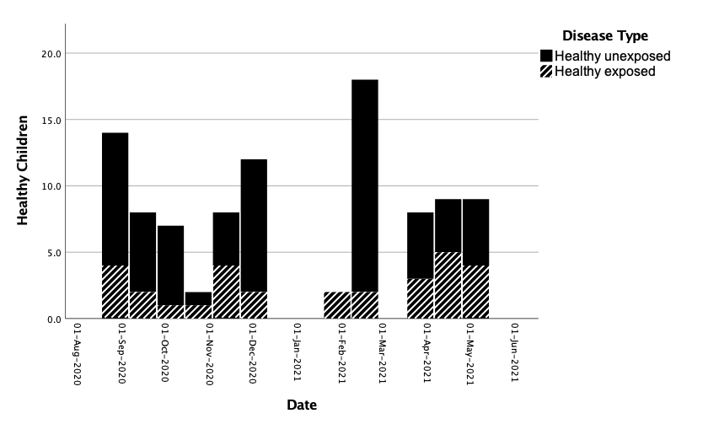
Supplementary Figure 1: Seroprevalence of SARS-CoV-2 in healthy children. 97 children presenting to RXH for elective surgeries that were otherwise well were recruited between August 2020 and May 2021. Twenty-nine of these healthy children had antibodies to SARS-CoV-2 (healthy exposed) with an estimated seroprevalence of 30% during this period.

