Additional file
Figure S1: Summary of study selection and exclusion

Potentially relevant papers identified and screened for retrieval
Original search (n=7,633)
Update search (n=2,547)
Total abstracts screened
Original search (n=3,451)
Update search (n=186)
Total full papers screened
Original search (n=153)
Update search (n=55)
Studies potentially relevant
Original search (n=23)
Update search (n=7)
Studies excluded at title sift
Original search (n=4,182)
Update search (n=2,361)
Studies excluded at abstract sift
Original search (n=3,298)
Update search (n=131)
Studies excluded at full paper sift
Original search (n=130)
Update search (n=48)
Studies excluded on the basis of inclusion/exclusion criteria (employed CBT)
Original search (n=17)
Update search (n=6)

Total included full papers
Original search (n=6)
Update search (n=1)
(RCTs, n=3; Non RCTs, n=4)
Figure S2. Risk of Bias summary using Cochrane Risk of Bias Tool
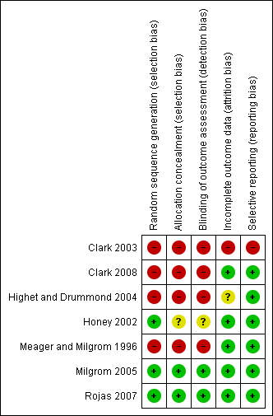

Figure S3. Risk of Bias graph using Cochrane Risk of Bias Tool.
