Additional file 5: Additional analyses
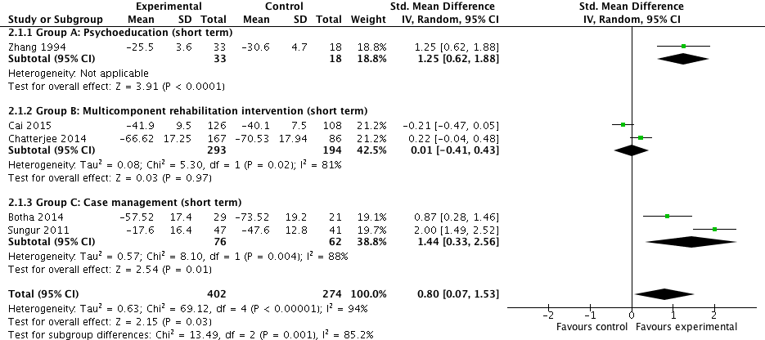
Figure a: Community-based psychosocial intervention versus usual care: impact on symptom severity (<18 months post intervention and high quality studies)

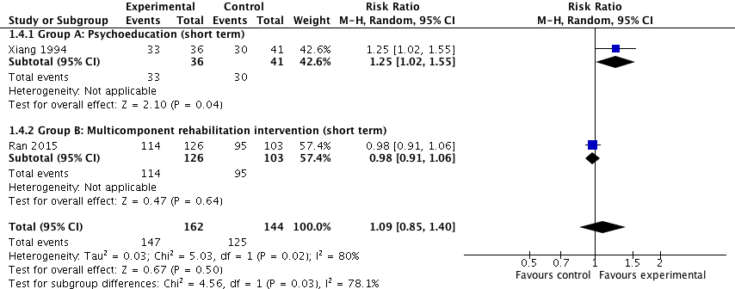
Figure b: Community-based psychosocial intervention versus usual care: impact on ability to work (<18 months post intervention)

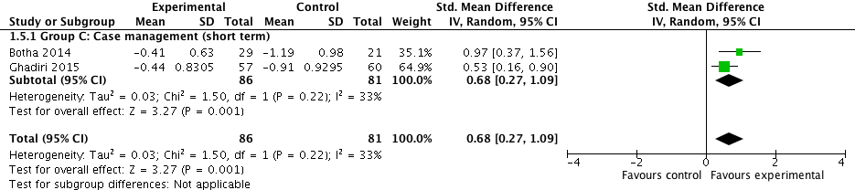
Figure c: Community-based psychosocial intervention versus usual care: impact on number of readmissions (<18 months post intervention)

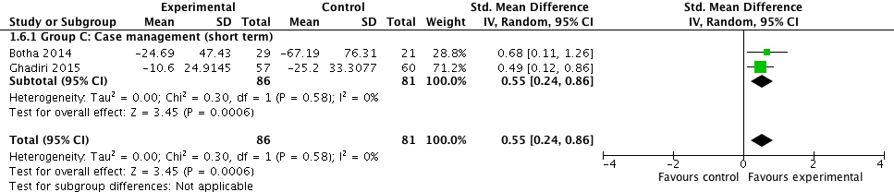
Figure d: Community-based psychosocial interventions versus usual care: impact on number of days in hospital (<18 months post intervention)

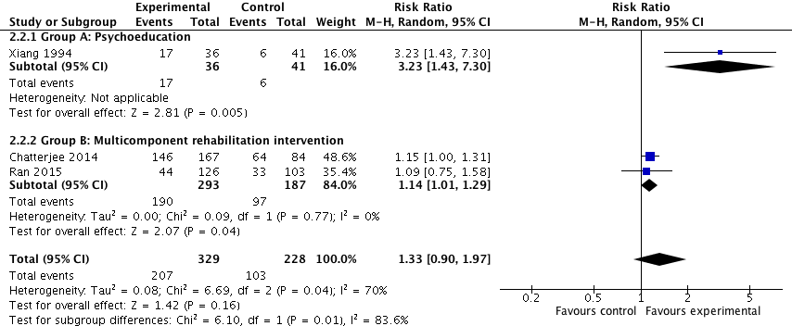
Figure e: Community-based psychosocial intervention versus usual care: impact on medication adherence (<18 months post intervention and high quality studies)

