Supplementary Figure 1 PRISMA flow diagram
10 systematic reviews / meta-analyses [Tam et al 2019]
Identified from Tam et al 2019

Supplementary Figure 2 Pooled prevalence of depressive symptoms computed from the reported prevalence from each included study
Exclusion:
Data no longer available (14)
Declined or Lost contact after first email (10)
Unable to provide the data due to loss of labelling or other reasons (14)

34 datasets from 37 studies
75 studies with responses from authors
197 studies with email addresses
249 primary studies
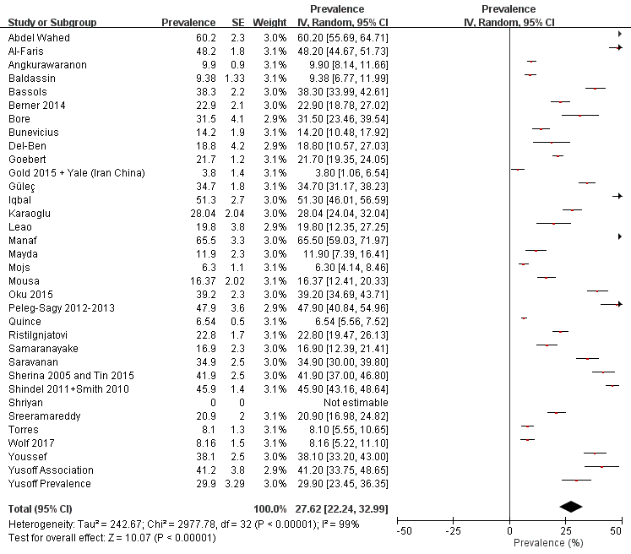

Supplementary Figure 3 Pooled prevalence of depressive symptoms for males and for females
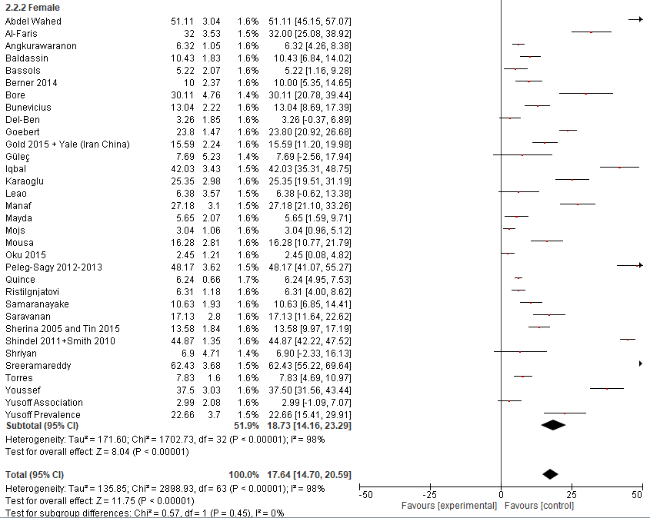
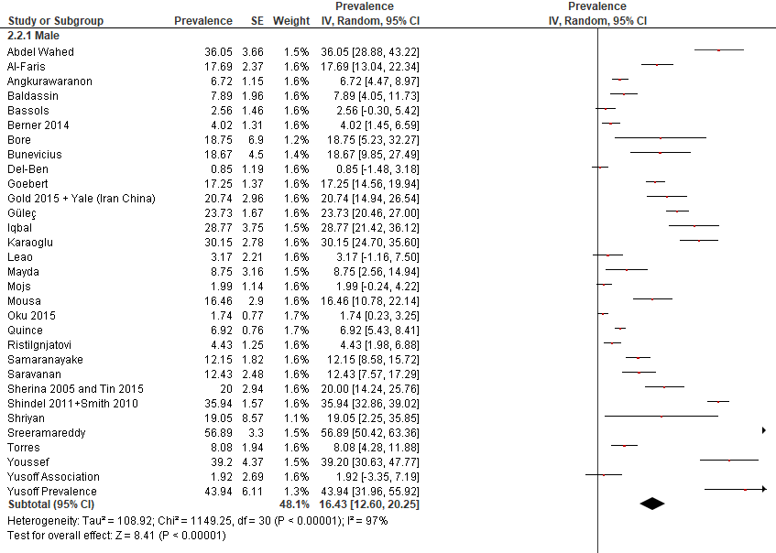

Supplementary Figure 4 Pooled prevalence of depressive symptoms according to the years of study
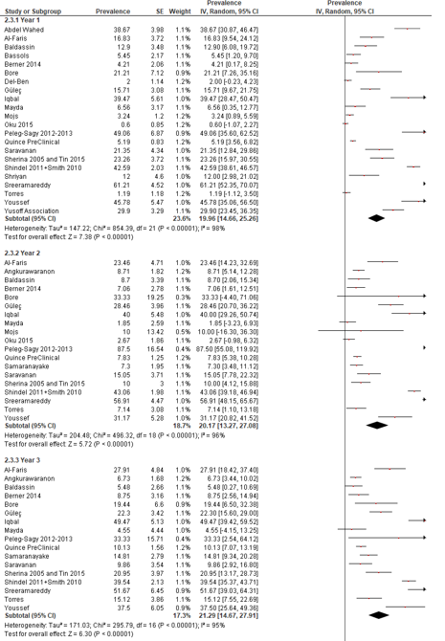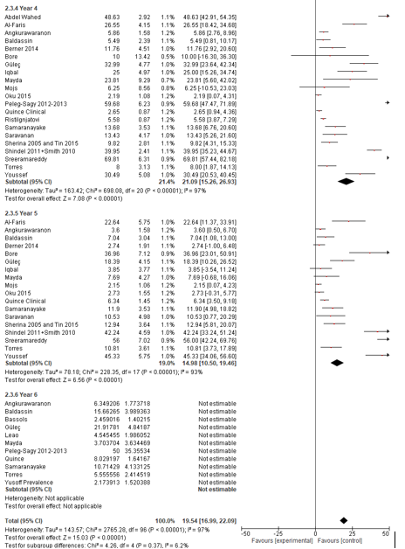
Supplementary Figure 5 Pooled prevalence of depressive symptoms according to regions
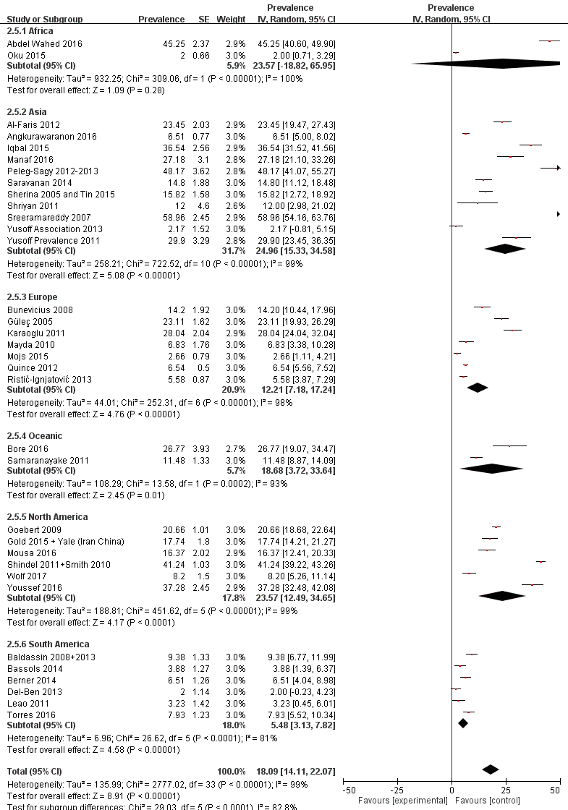

Supplementary Figure 6 Pooled prevalence of depressive symptoms according to assessment tools
