Supplementary materials
Dependence network 2
Figure S1. Expected influence stability of AAS dependence network 2
Figure S2. Edge weight bootstrap of AAS dependence network 3
Figure S3. Bootstrap difference node expected influence of AAS dependence network 4
Figure S4. Bootstrap difference edge weights of AAS dependence network 5
MDI network: AAS users 6
Figure S5. Expected influence stability of muscle dysmorphia network in AAS users 6
Figure S6. Edge weight stability of muscle dysmorphia network in AAS users 7
Figure S7. Bootstrap difference node expected influence of muscle dysmorphia network in AAS users 8
Figure S8. Bootstrap difference edge weight of muscle dysmorphia network in AAS users 9
MDI network: WLC 10
Figure S9. Expected influence stability of muscle dysmorphia network in WLC 10
Figure S10. Edge weight stability of muscle dysmorphia network in WLC 11
Figure S11. Bootstrap difference expected influence of muscle dysmorphia network in WLC 12
Figure S12. Bootstrap difference edge weights of muscle dysmorphia network in WLC 13
Table S1. Network Comparison Test results 14
Dependence + MDI network 15
Figure S13. Expected influence stability of dependence and muscle dysmorphia network 15
Figure S14. Edge weight stability of dependence and muscle dysmorphia network 16
Figure S15. Bridge strength stability of dependence and muscle dysmorphia network 17
Figure S16. Bootstrap difference expected influence of dependence and muscle dysmorphia network 18
Figure S17. Bootstrap difference edge weights of dependence and muscle dysmorphia network 19
Figure S18. Bootstrap difference bridge strength of dependence and muscle dysmorphia network 20

Dependence network

Figure S1. Expected influence stability of AAS dependence network
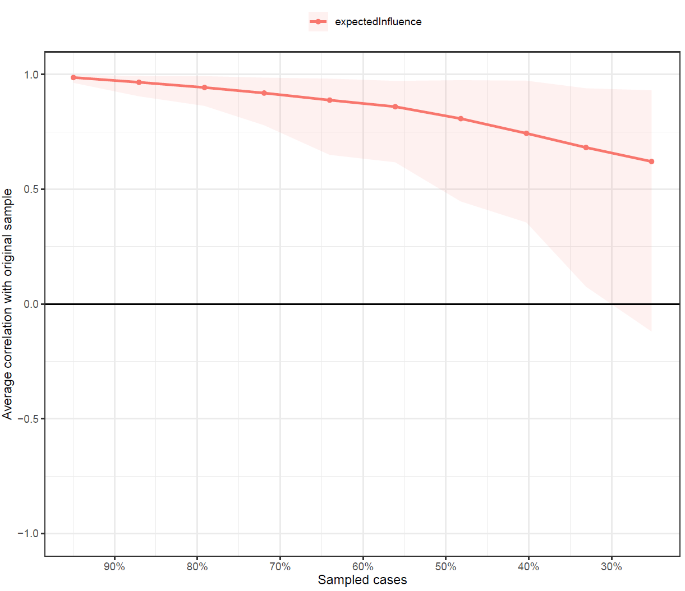

Figure S2. Edge weight bootstrap of AAS dependence network
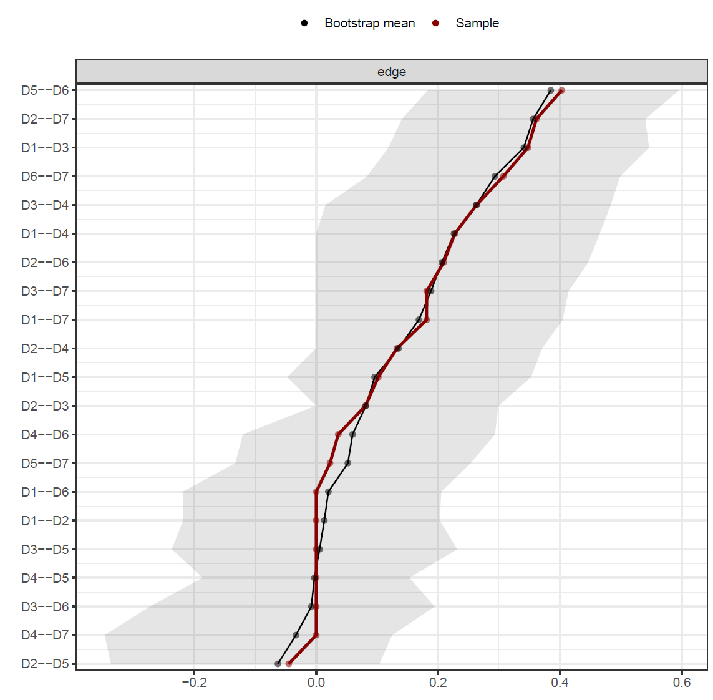
D1: Tolerance, D2: Withdrawal, D3: Use longer than planned, D4: Unable to stop, D5: Time spent, D6: Interferes with work/life, D7: Physical/mental problems

Figure S3. Bootstrap difference node expected influence of AAS dependence network
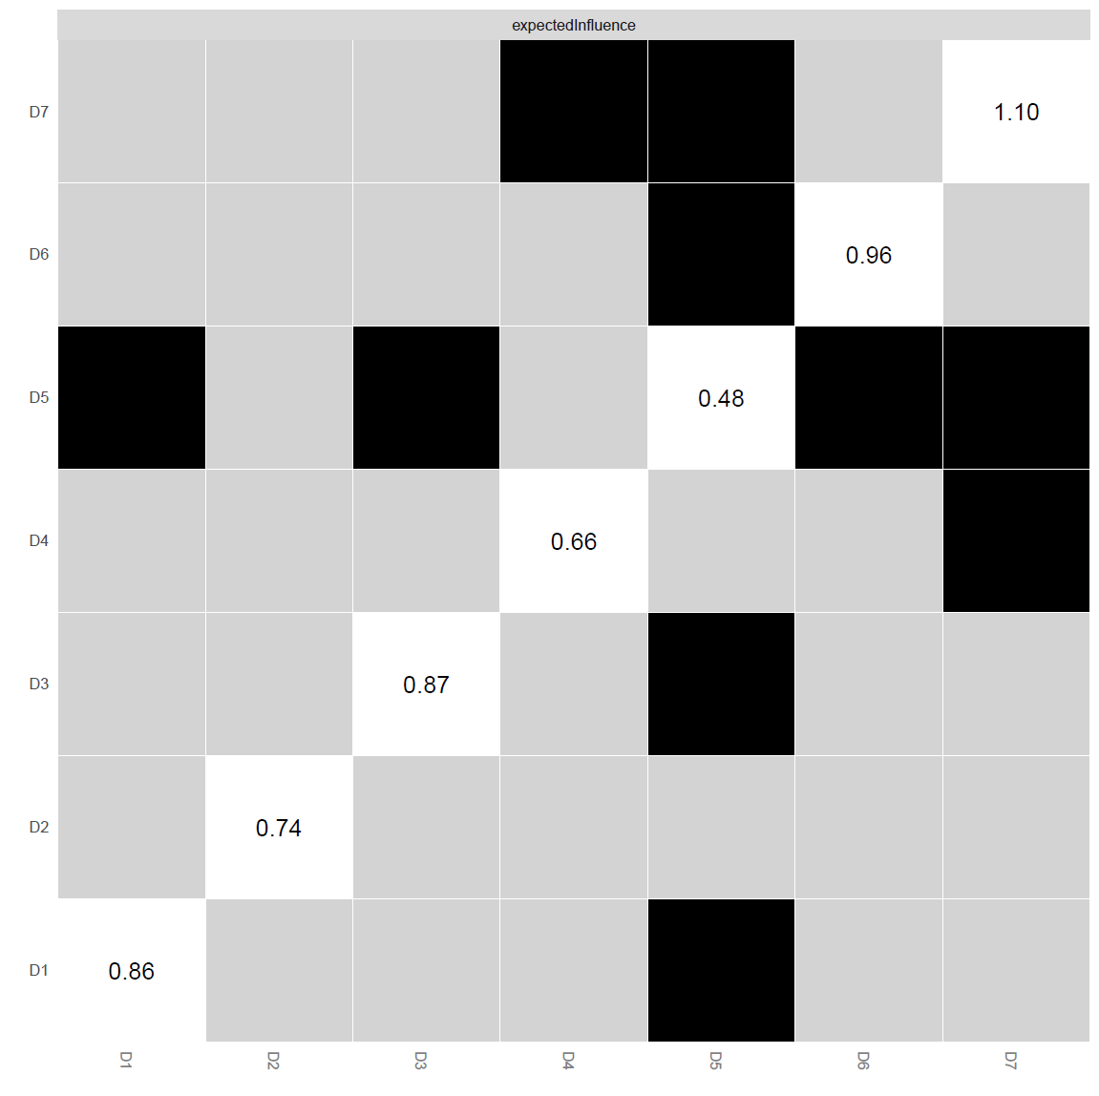
D1: Tolerance, D2: Withdrawal, D3: Use longer than planned, D4: Unable to stop, D5: Time spent, D6: Interferes with work/life, D7: Physical/mental problems

Figure S4. Bootstrap difference edge weights of AAS dependence network
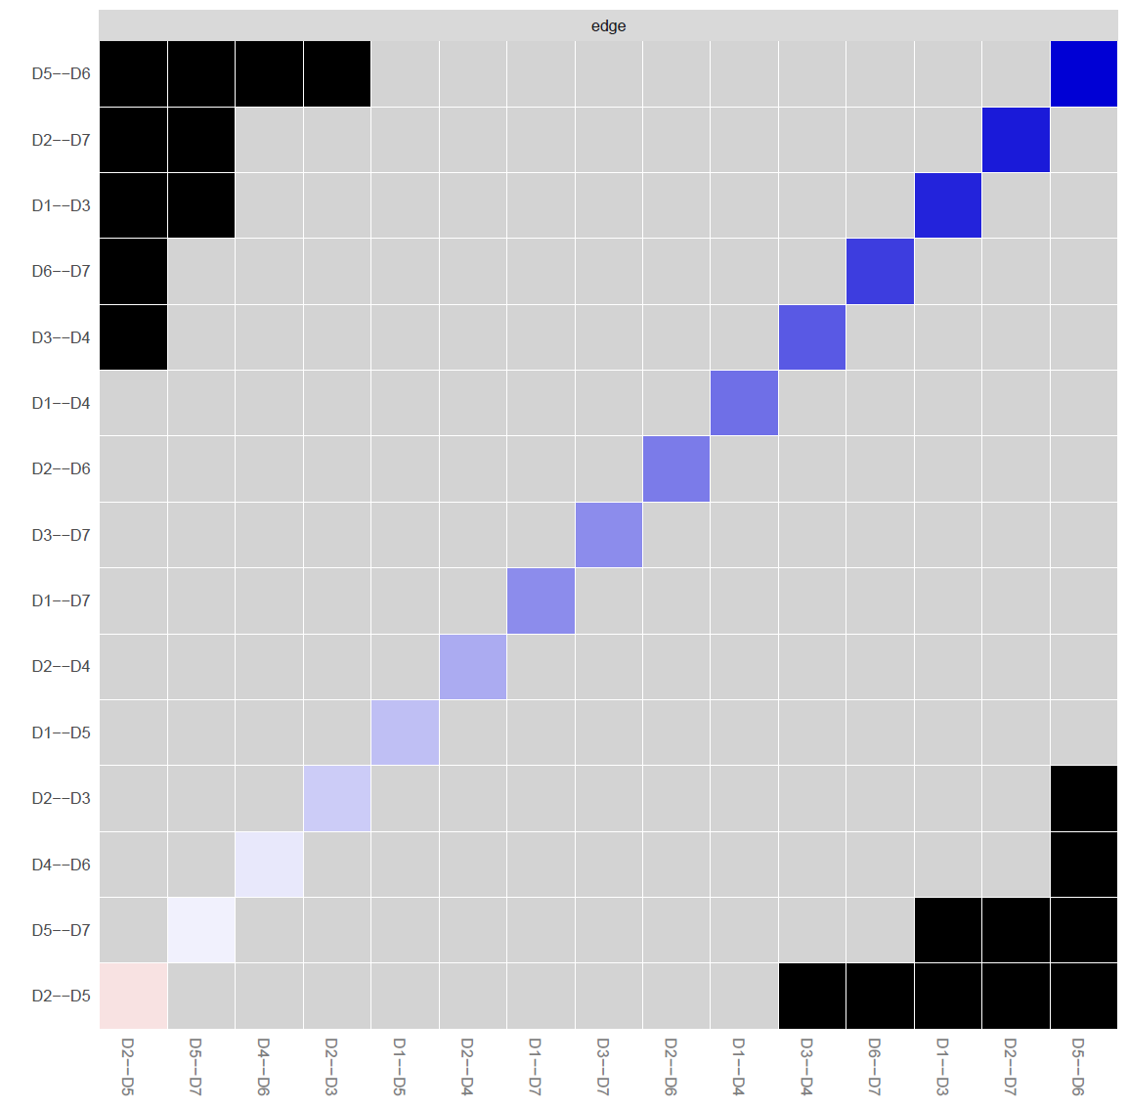
D1: Tolerance, D2: Withdrawal, D3: Use longer than planned, D4: Unable to stop, D5: Time spent, D6: Interferes with work/life, D7: Physical/mental problems

MDI network: AAS users

Figure S5. Expected influence stability of muscle dysmorphia network in AAS users
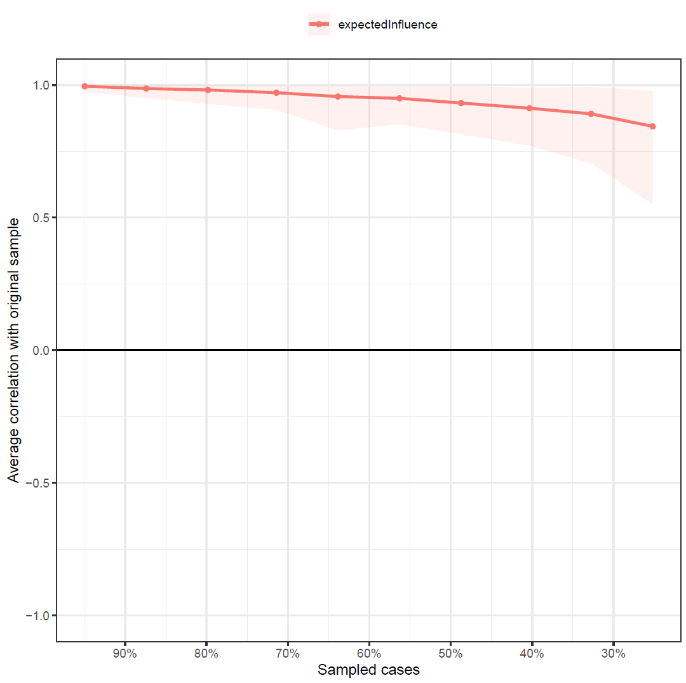

Figure S6. Edge weight stability of muscle dysmorphia network in AAS users
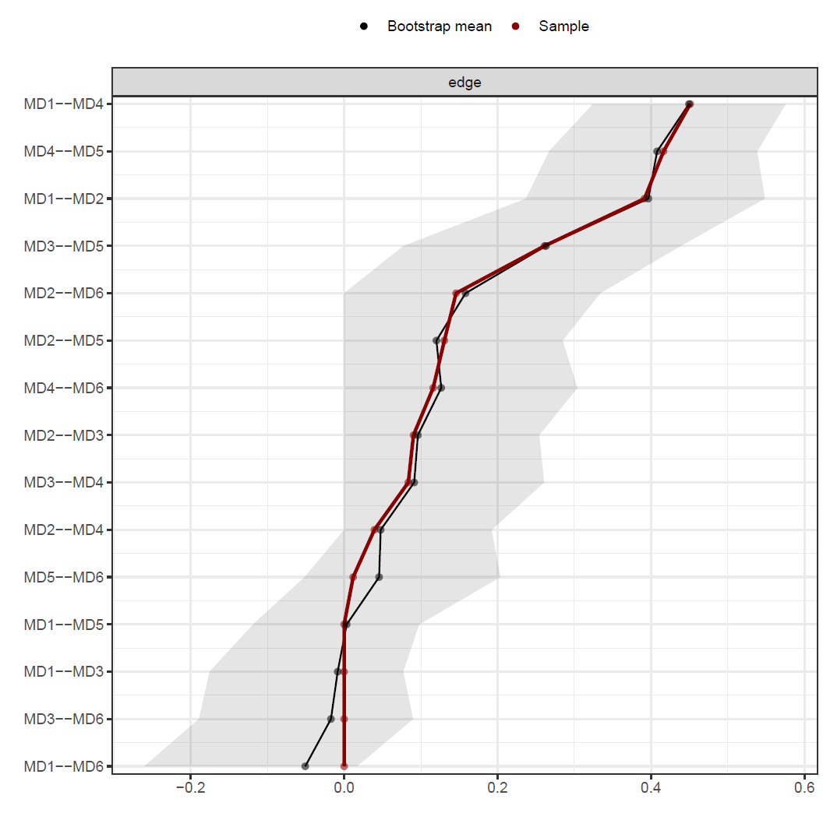
MD1: Diet, MD2: Supplement, MD3: Physique concealment, MD4: Exercise dependence, MD5: Size/symmetry concerns, MD6: Pharmacological concerns

Figure S7. Bootstrap difference node expected influence of muscle dysmorphia network in AAS users
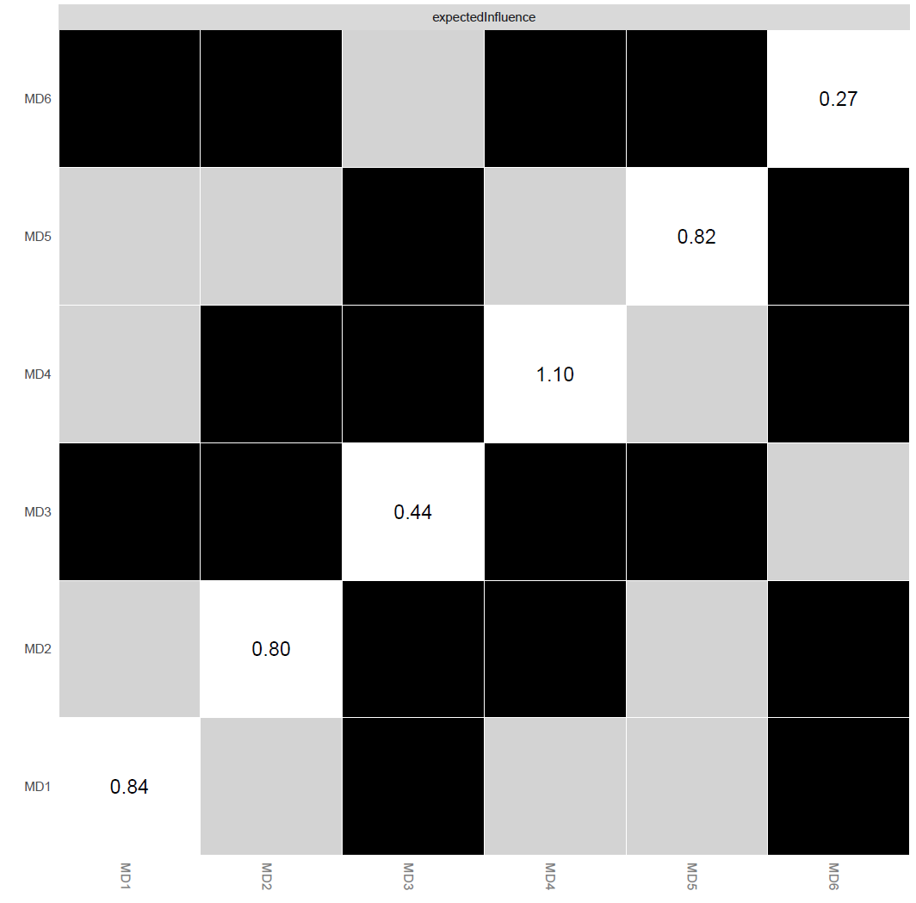
MD1: Diet, MD2: Supplement, MD3: Physique concealment, MD4: Exercise dependence, MD5: Size/symmetry concerns, MD6: Pharmacological concerns

Figure S8. Bootstrap difference edge weight of muscle dysmorphia network in AAS users
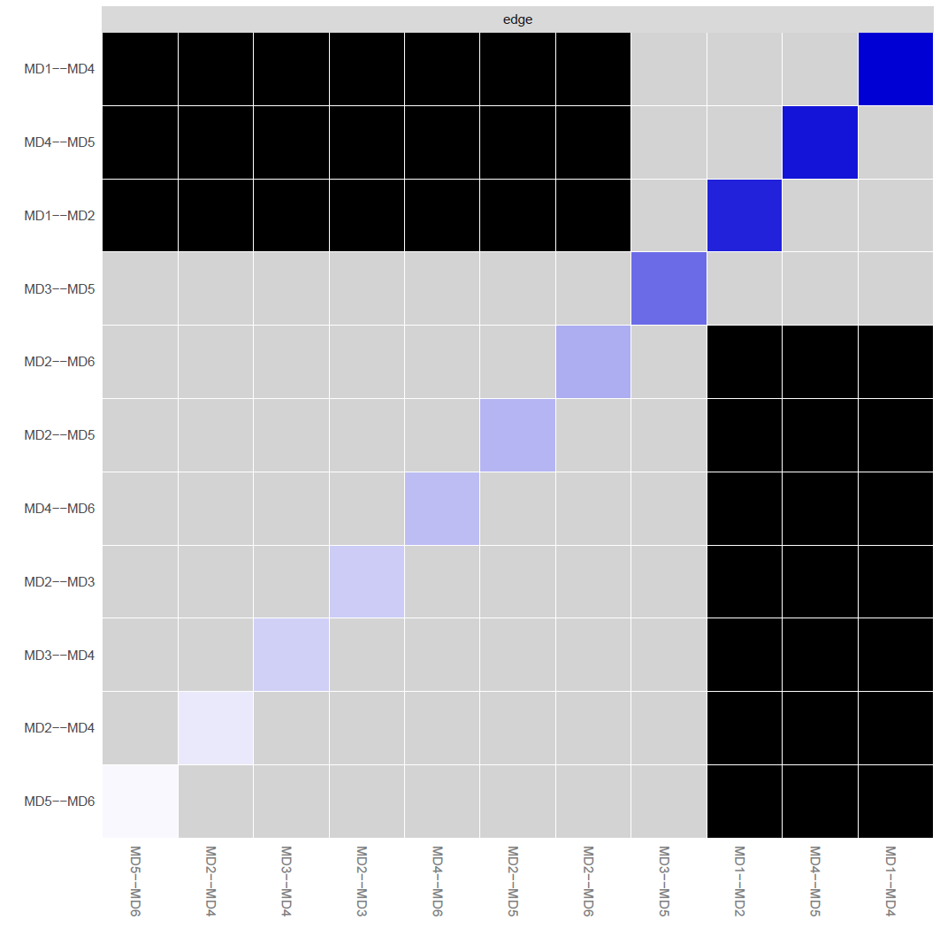
MD1: Diet, MD2: Supplement, MD3: Physique concealment, MD4: Exercise dependence, MD5: Size/symmetry concerns, MD6: Pharmacological concerns

MDI network: WLC

Figure S9. Expected influence stability of muscle dysmorphia network in WLC
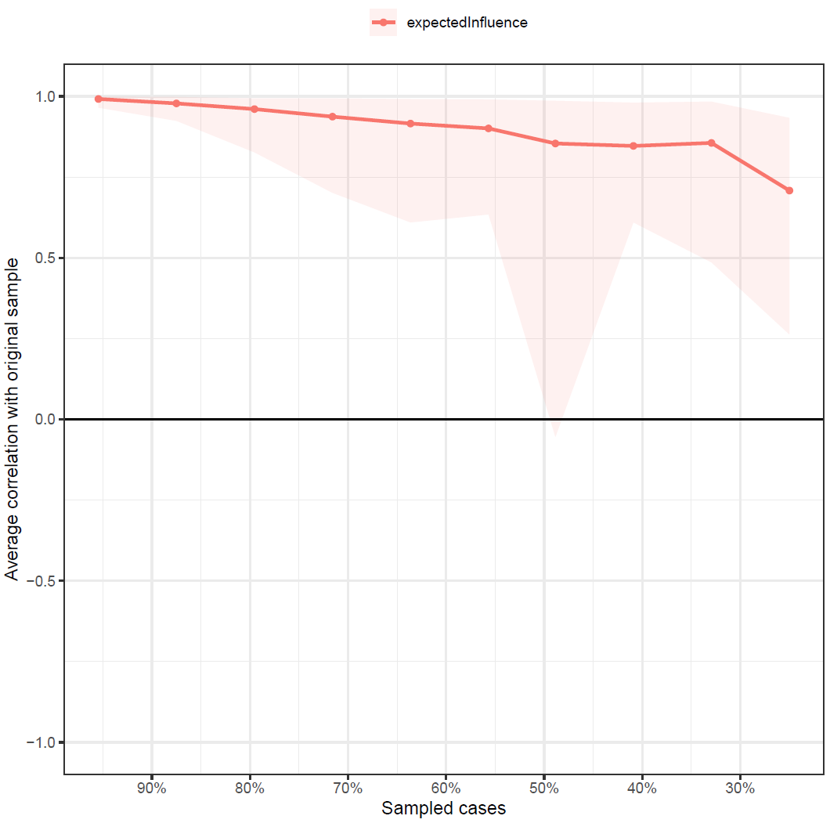

Figure S10. Edge weight stability of muscle dysmorphia network in WLC
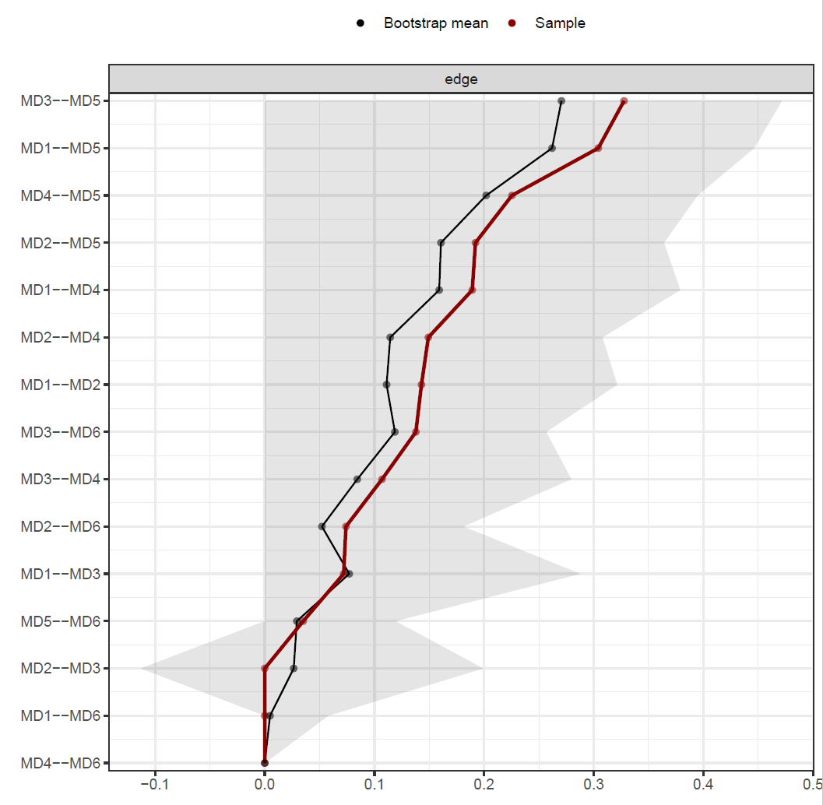
MD1: Diet, MD2: Supplement, MD3: Physique concealment, MD4: Exercise dependence, MD5: Size/symmetry concerns, MD6: Pharmacological concerns

Figure S11. Bootstrap difference expected influence of muscle dysmorphia network in WLC
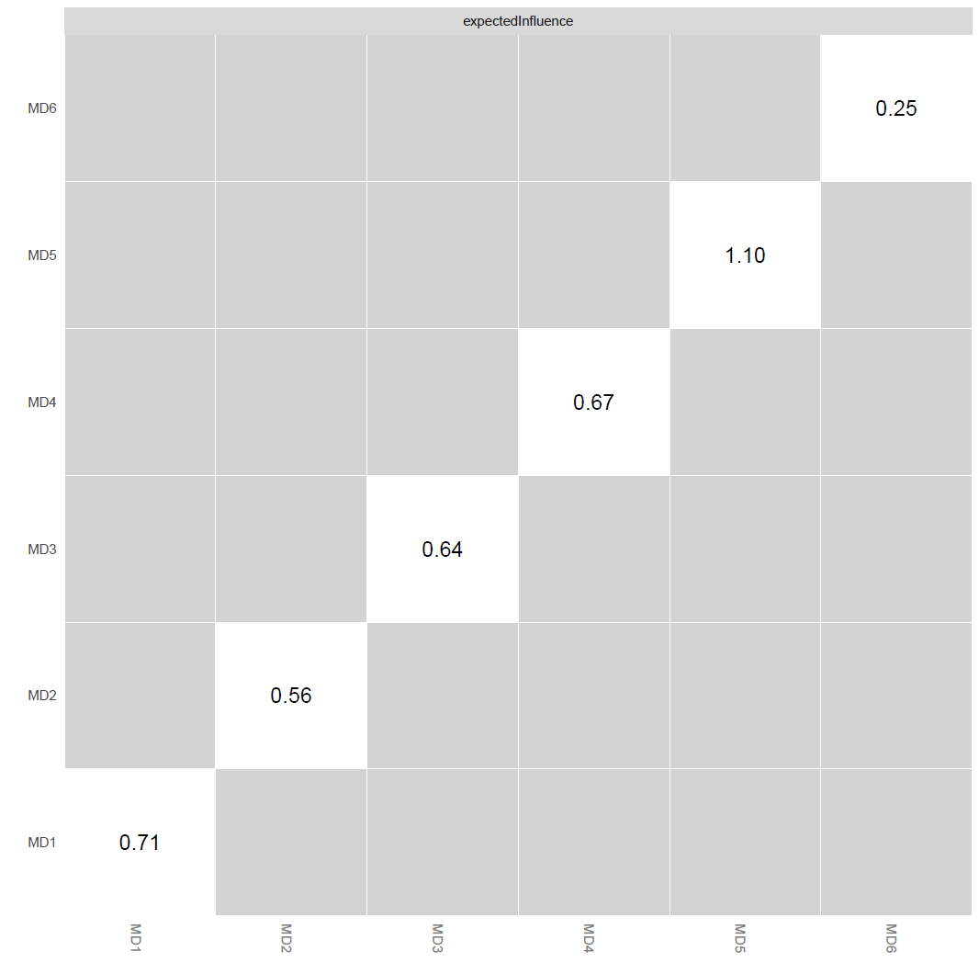
MD1: Diet, MD2: Supplement, MD3: Physique concealment, MD4: Exercise dependence, MD5: Size/symmetry concerns, MD6: Pharmacological concerns

Figure S12. Bootstrap difference edge weights of muscle dysmorphia network in WLC
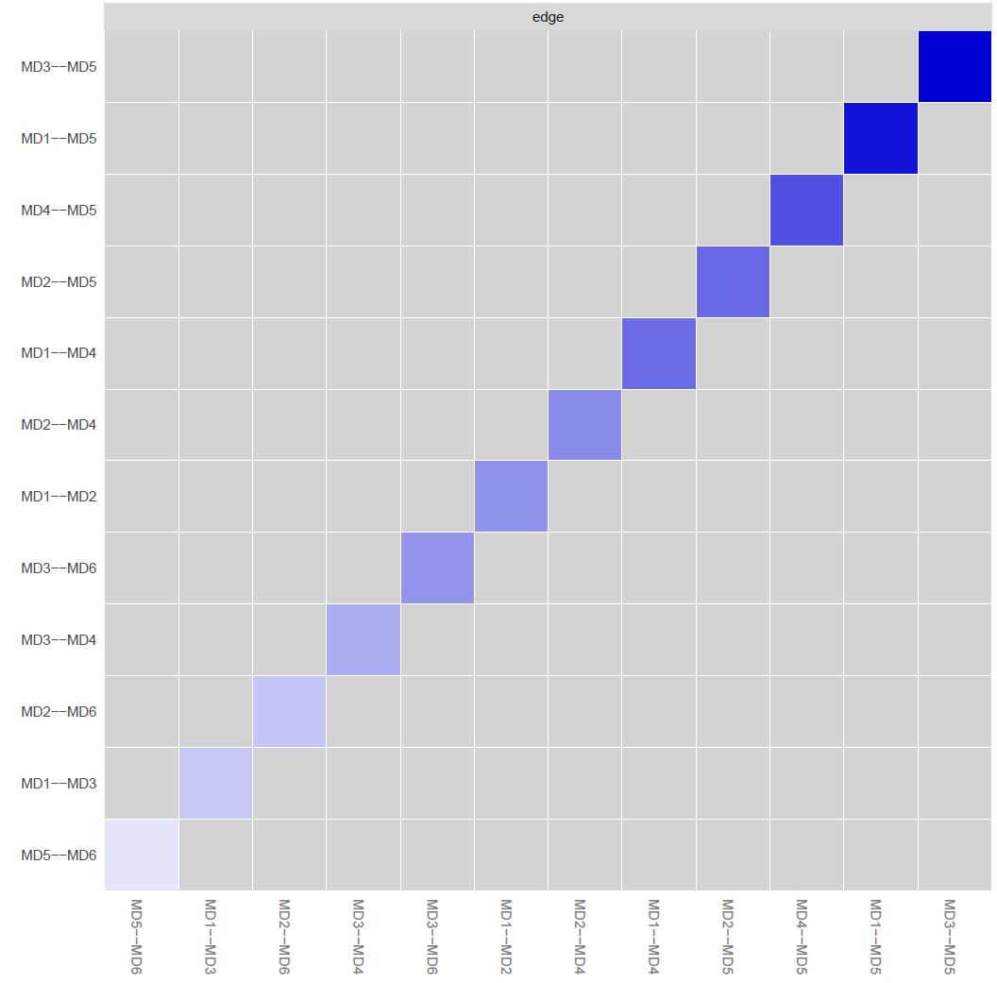
MD1: Diet, MD2: Supplement, MD3: Physique concealment, MD4: Exercise dependence, MD5: Size/symmetry concerns, MD6: Pharmacological concerns

Table S1. Network Comparison Test results
NETWORK INVARIANCE TEST
Test statistic M: 0.3041389
p= 0.157

GLOBAL STRENGTH INVARIANCE TEST
Global strength per group: 2.137931 1.956241
Test statistic S: 0.1816901
p= 0.203

EDGE INVARIANCE TEST

Var1 Var2 p
MD1 MD2 0.070
MD1 MD3 0.508
MD2 MD3 0.523
MD1 MD4 0.035
MD2 MD4 0.457
MD3 MD4 0.867
MD1 MD5 0.003
MD2 MD5 0.684
MD3 MD5 0.626
MD4 MD5 0.100
MD1 MD6 1.000
MD2 MD6 0.588
MD3 MD6 0.289
MD4 MD6 0.120
MD5 MD6 0.882

CENTRALITY INVARIANCE TEST

closeness betweenness strength expectedInfluence
MD1 0.1226 0.1444 0.3964 0.3920
MD2 0.3310 0.7926 0.1090 0.1086
MD3 0.1506 0.0612 0.2570 0.2490
MD4 0.0032 0.0018 0.0104 0.0092
MD5 0.6478 0.8458 0.2528 0.2534
MD6 0.6492 1.0000 0.8742 0.8712
MD1: Diet, MD2: Supplement, MD3: Physique concealment, MD4: Exercise dependence, MD5: Size/symmetry concerns, MD6: Pharmacological concerns

Dependence + MDI network

Figure S13. Expected influence stability of dependence and muscle dysmorphia network
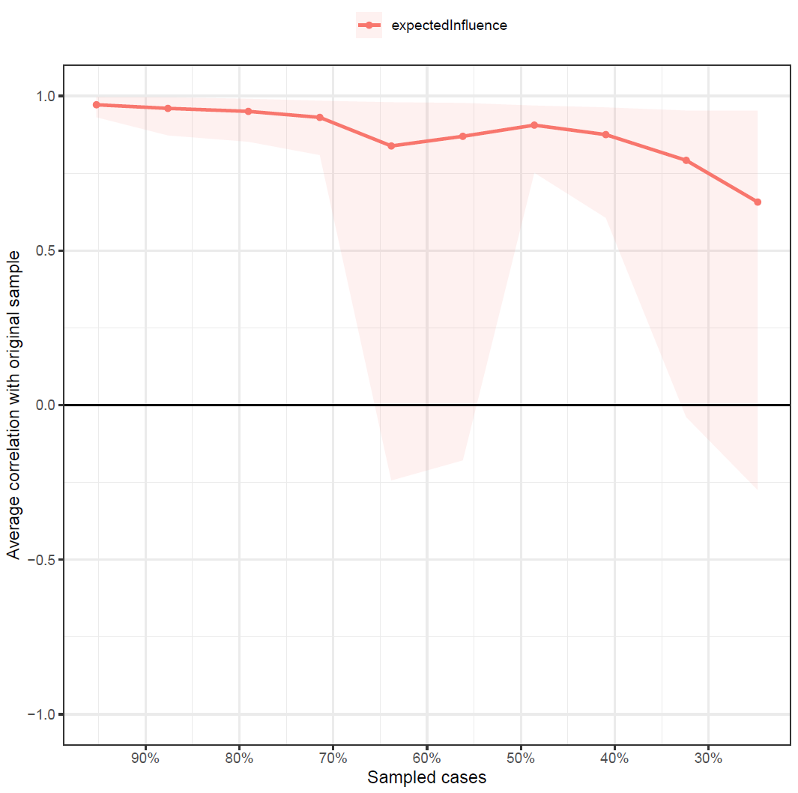

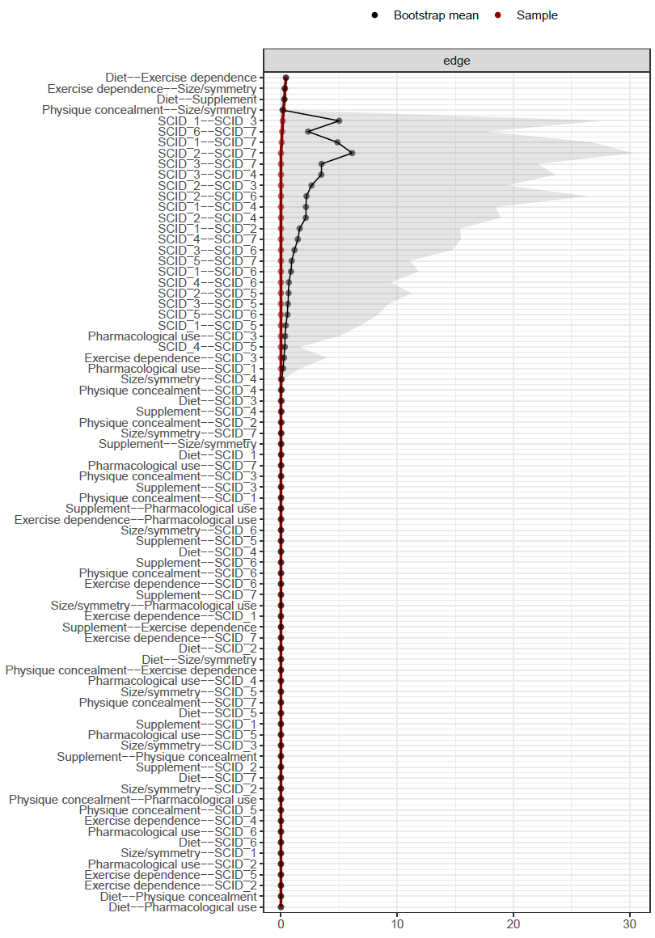
Figure S14. Edge weight stability of dependence and muscle dysmorphia network

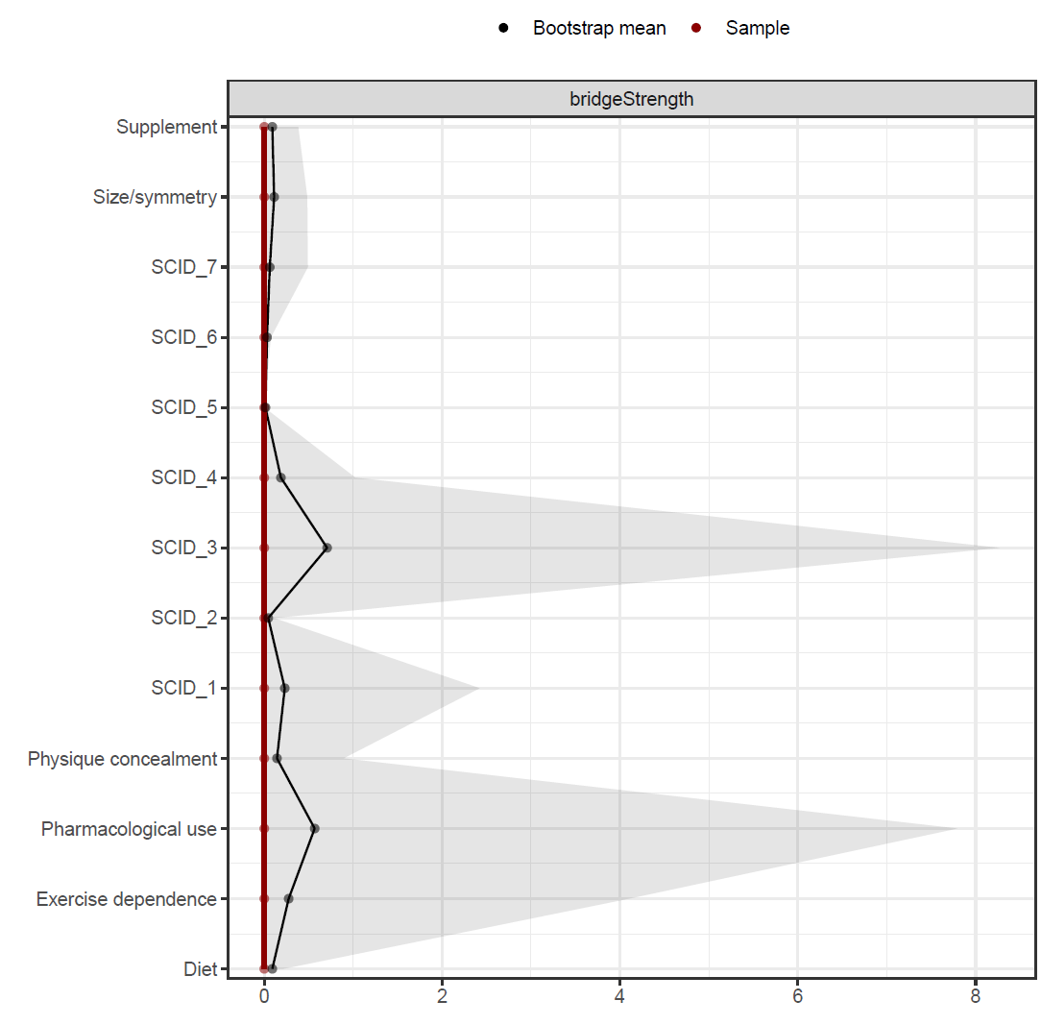
Figure S15. Bridge strength stability of dependence and muscle dysmorphia network

SCID1: Tolerance, SCID2: Withdrawal, SCID3: Use longer than planned, SCID4: Unable to stop, SCID5: Time spent, SCID6: Interferes with work/life, SCID7: Physical/mental problems

Figure S16. Bootstrap difference expected influence of dependence and muscle dysmorphia network
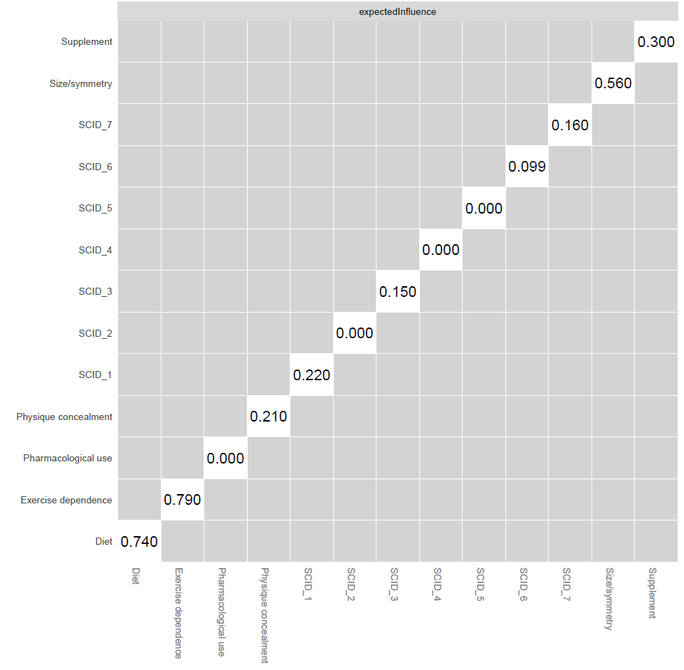
SCID1: Tolerance, SCID2: Withdrawal, SCID3: Use longer than planned, SCID4: Unable to stop, SCID5: Time spent, SCID6: Interferes with work/life, SCID7: Physical/mental problems

Figure S17. Bootstrap difference edge weights of dependence and muscle dysmorphia network

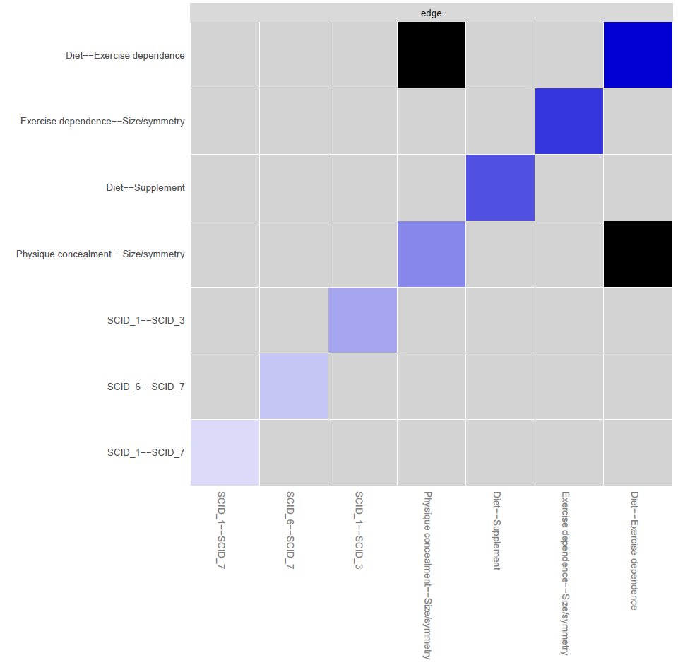 SCID1: Tolerance, SCID2: Withdrawal, SCID3: Use longer than planned, SCID4: Unable to stop, SCID5: Time spent, SCID6: Interferes with work/life, SCID7: Physical/mental problems

Figure S18. Bootstrap difference bridge strength of dependence and muscle dysmorphia network
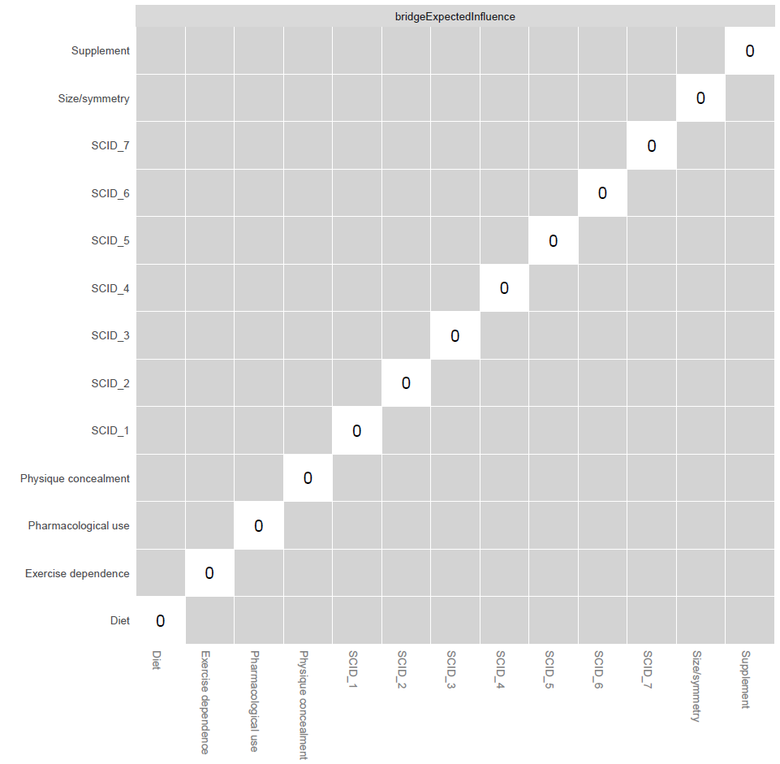
SCID1: Tolerance, SCID2: Withdrawal, SCID3: Use longer than planned, SCID4: Unable to stop, SCID5: Time spent, SCID6: Interferes with work/life, SCID7: Physical/mental problems

