Supplementary file 1

Impacts of the Covid-19 lockdown and relevant vulnerabilities on capability well-being, mental health and social support: An Austrian survey study

Judit Simon^{1,2}, Timea M. Helter¹, Ross G. White³, Catharina van der Boor³, Agata Łaszewska¹

¹ Department of Health Economics, Center for Public Health, Medical University of Vienna, Kinderspitalgasse 15, 1090 Vienna, Austria
² Department of Psychiatry, University of Oxford, Warneford Hospital, Oxford OX3 7JX, UK
³ Primary Care and Mental Health, Institute of Population Health, University of Liverpool, School of Psychology, Brownlow Hill, Liverpool, L69 3GB, UK

Corresponding Author
Judit Simon, Department of Health Economics, Center for Public Health, Medical University of Vienna, Kinderspitalgasse 15, 1090 Vienna, Austria; Phone: +43 1 40160 34841; E-Mail: judit.simon@meduniwien.ac.at

List of questionnaire sections:
- Demographic section
- COVID-19 questions
- OxCAP-MH
- Hospital Anxiety and Depression Scale
- Multidimensional Scale of Perceived Social Support
- WHO-5 Well-being measure

- Demographic section

While answering the questionnaire, please always think about the 4 weeks between mid-March and mid-April 2020 when the stay-home restrictions in Austria were at their peak.

- Gender

Male
Female
Diverse

- What is your age? (Years from 18 to 90 in numbers). If you prefer not to give this information then please leave it blank.

- Do you have a migration background?

No
EU countries prior to 2004 / EEA / Switzerland
EU accession countries from 2004
Former Yugoslavia (non-EU), Turkey
Other countries

- What is your highest educational achievement?

Primary school
Apprenticeship with vocational school
Technical or commercial school
“Matura”
Degree from a university, (technical) college
Any other higher degree following “Matura”

5. In which federal state was your main residence?

Burgenland
Carinthia
Lower Austria
Upper Austria
Salzburg
Styria
Tyrol
Vorarlberg
Vienna

6. What was the reason for your stay in Austria?

I am an Austrian citizen
I am an asylum seeker or a refugee
I work in Austria
I am here on vacation
I am studying here
Other reason (please specify)
I prefer not to provide this information

7. What was your marital status in mid-March 2020?

Single
Married or registered partnership, living together
Married or registered partnership, separated
Widowed
Divorced
I prefer not to provide this information

- Do you have any children?

Yes
No
I prefer not to provide this information

- If yes, how many?

- What was your employment status in mid-March 2020?

I was not employed (e.g. household)
Student
Employed
Self-employed
Civil servant
Unemployed
Retired
I prefer not to provide this information

- If you are currently employed, what type of employment do you do?

Business, consulting and management
Accountancy, banking and finance
Charity and voluntary work
Creative arts and design
Energy and utilities
Engineering and manufacturing
Environment and agriculture
Healthcare
Hospitality and events management
Information technology
Law
Law enforcement and security
Leisure, sport and tourism
Marketing, advertising and PR
Media and internet
Property and construction
Public services and administration
Recruitment and HR
Retail
Sales
Science and pharmaceuticals
Social care
University lecturer or Researcher
Teacher
Transport and logistics
I prefer not to provide this information

- Have you been fired due to COVID-19?

Yes
No
I prefer not to provide this information

- Have you been sent to short-term working (“Kurzarbeit”) due to COVID-19?

Yes
No
I prefer not to provide this information

- Did you receive treatment or support for a mental health problem during COVID-19 lockdown?

No
Yes
I prefer not to provide this information

- If yes, please state which mental health problem:

Acquired brain injury or neurological disorder (i.e. dementia, brain damage, delirium)
Mental and behavioural disorders due to psychoactive substance use (i.e. alcohol, or drugs)
Psychosis (including schizophrenia, schizotypal or delusional disorders)
Mood disorders (i.e. depression or bipolar affective disorder,)
Neurotic, stress-related and somatoform disorders (i.e. anxiety disorders, obsessive compulsive disorder)
Behavioural syndromes associated with physiological disturbances and physical factors (i.e. eating disorders, sleeping disorders)
Disorders of adult personality and behaviour (i.e. specific personality disorders, gender identity disorders)
Disorders of psychological development (i.e. Asperger's syndrome, specific reading disorders)
I prefer not to provide this information

- Did you receive treatment or support for a mental health problem prior to COVID-19?

No
Yes
I prefer not to provide this information

- If yes, please state which mental health problem:

Acquired brain injury or neurological disorder (i.e. dementia, brain damage, delirium)
Mental and behavioural disorders due to psychoactive substance use (i.e. alcohol, or drugs)
Psychosis (including schizophrenia, schizotypal or delusional disorders)
Mood disorders (i.e. depression or bipolar affective disorder,)
Neurotic, stress-related and somatoform disorders (i.e. anxiety disorders, obsessive compulsive disorder)
Behavioural syndromes associated with physiological disturbances and physical factors (i.e. eating disorders, sleeping disorders)
Disorders of adult personality and behaviour (i.e. specific personality disorders, gender identity disorders)
Disorders of psychological development (i.e. Asperger's syndrome, specific reading disorders)
I prefer not to provide this information

- Are you currently receiving treatment for (yes/no/prefer not to say):

Diabetes
Heart/cardiovascular disease
Stroke/cerebrovascular disease
Lung disease (e.g. Asthma, Cystic Fibrosis, COPD)
Liver disease (e.g. Hepatitis)
Cancer

- COVID-19 Questions

- I have tested positive for COVID-19

Yes
No

- I have experienced the symptoms of COVID-19 including persistent cough and high body temperature (above 37.8 degrees Celsius) since the outbreak in Austria began but was not tested.

Yes
No

- I have a close friend who has tested positive for COVID-19

Yes
No

- I have one or more immediate family members who have tested positive for COVID-19

Yes
No

- I have known someone who died as a consequence of COVID-19

Yes
No

- I work in a job that is categorised by the government as an essential/key role

Yes
No
I prefer not to provide this information

- OxCAP-MH [1]
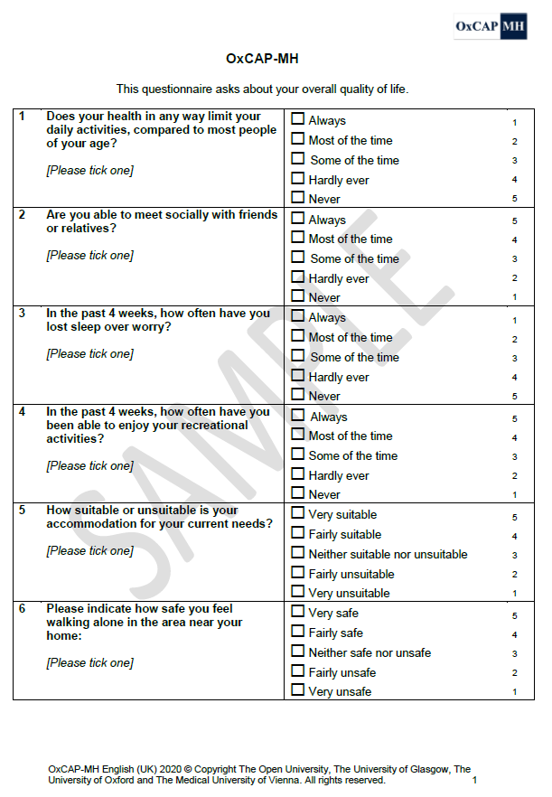

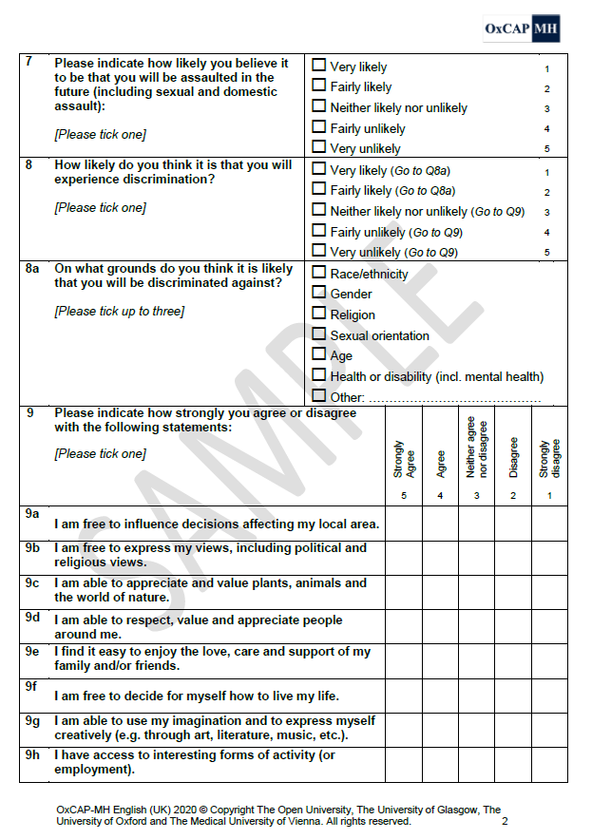

- Hospital Anxiety and Depression Scale (HADS) [2]*
*Author’s note: A request to the authors of the questionnaire to reproduction is in progress. To access the full version of the questionnaire, contact:
GL Assessment Ltd.
1st Floor Vantage London
Great West Road
London TW8 9AG
United Kingdom
Email: permissions@gl-assessment.co.uk
Website: www.gl-assessment.co.uk

- Multidimensional Scale of Perceived Social Support [3]

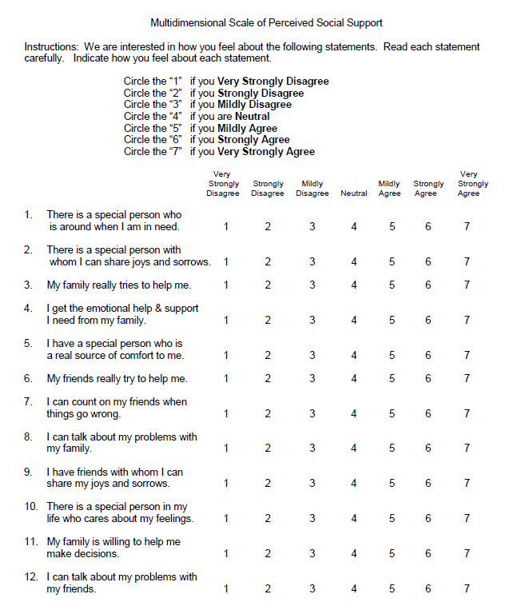

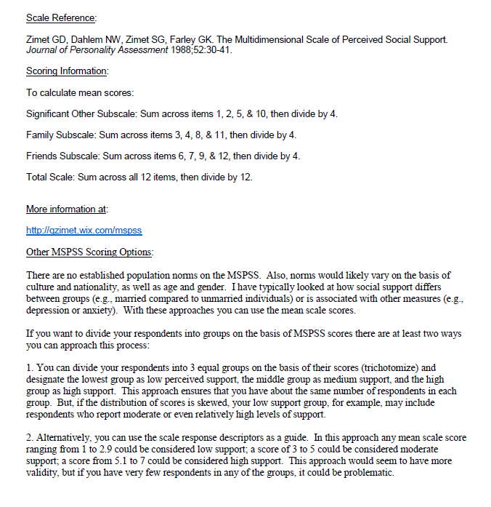

- WHO (Five) Well-Being Index [4]

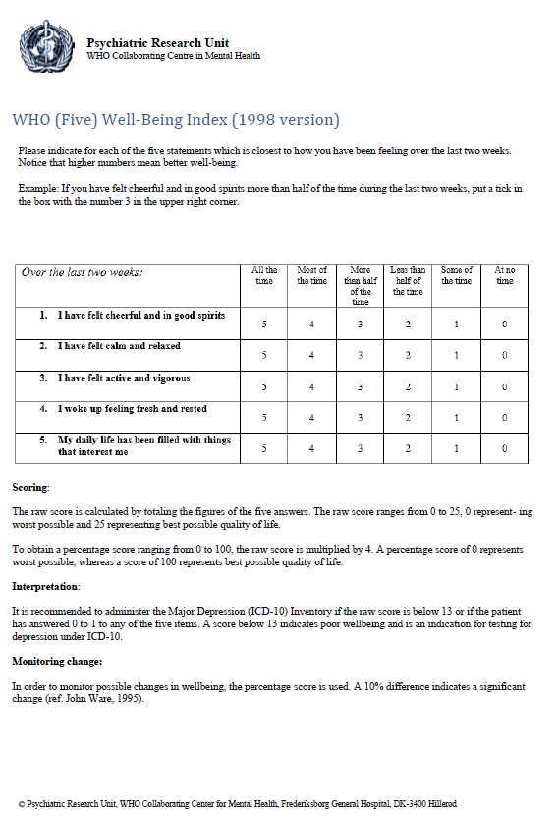

References
1 Simon J, Anand P, Gray A, Rugkåsa J, Yeeles K, Burns T. Operationalising the capability approach for outcome measurement in mental health research. Soc Sci Med. 2013;98:187-96
2 Snaith RP, Zigmond AS. The hospital anxiety and depression scale. Br Med J (Clin Res Ed). 1986;292(6516):344
3 WHO. Well-being Measures in Primary Health Care/The Depcare Project. Report on a WHO Meeting. WHO Regional Office for Europe. Copenhagen 1998
4 Zimet GD, Dahlem NW, Zimet SG, Farley GK. The Multidimensional Scale of Perceived Social Support. J Pers Assess. 1988;52(1):30-41

