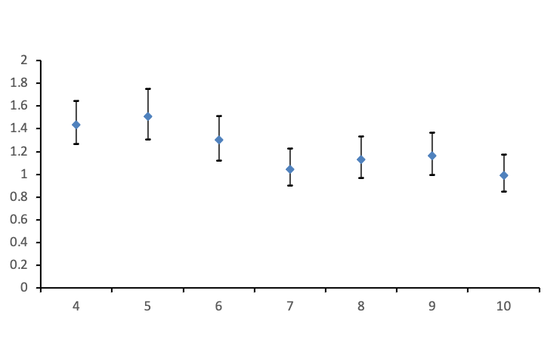
Supplement Figure 1. Relative risks of allergic rhinitis associated with daily mean temperature at 75th percentile relative to median temperature at lag02 day using different degrees of freedom per year.

