Supplementary Table 1. Poisson model results for monthly suicide rate in five urban California counties (1999–2019).
 | Baseline (Temperature Excluded) |  | Average Temperature |  | Maximum Temperature |  | Minimum Temperature
 | IRR | 95% CI | IRR | 95% CI | IRR | 95% CI | IRR | 95% CI
Temperature
Average | - |  | 1.0083 | 1.0029-1.0139 | - |  | -
Maximum | - |  | - |  | 1.0070 | 1.0024-1.0116 | -
Minimum | - |  | - |  | - |  | 1.0088 | 1.0026-1.0151
Month
January (ref.) | - |  | - |  | - |  | -
February | 0.8772 | 0.8345-0.9220 | 0.8753 | 0.8327-0.9201 | 0.8754 | 0.8328-0.9202 | 0.8754 | 0.8328-0.9202
March | 0.9607 | 0.9151-1.0085 | 0.9415 | 0.8953-0.9902 | 0.9418 | 0.8955-0.9904 | 0.9440 | 0.8978-0.9926
April | 0.9974 | 0.9506-1.0466 | 0.9624 | 0.9123-1.0152 | 0.9628 | 0.9128-1.0156 | 0.9668 | 0.9171-1.0193
May | 0.9925 | 0.9458-1.0415 | 0.9342 | 0.8777-0.9944 | 0.9389 | 0.8838-0.9975 | 0.9366 | 0.8793-0.9977
June | 0.9950 | 0.9481-1.0442 | 0.9053 | 0.8369-0.9792 | 0.9117 | 0.8457-0.9829 | 0.9096 | 0.8400-0.9849
July | 1.0162 | 0.9688-1.0660 | 0.9015 | 0.8223-0.9883 | 0.9123 | 0.8374-0.9939 | 0.9036 | 0.8212-0.9943
August | 1.0413 | 0.9930-1.0920 | 0.9247 | 0.8441-1.0130 | 0.9343 | 0.8575-1.0180 | 0.9285 | 0.8454-1.0198
September | 0.9579 | 0.9124-1.0057 | 0.8657 | 0.7973-0.9399 | 0.8723 | 0.8064-0.9436 | 0.8700 | 0.8003-0.9458
October | 0.9821 | 0.9355-1.0309 | 0.9207 | 0.8634-0.9819 | 0.9246 | 0.8684-0.9845 | 0.9245 | 0.8666-0.9861
November | 0.8975 | 0.8540-0.9431 | 0.8739 | 0.8292-0.9211 | 0.8747 | 0.8300-0.9217 | 0.8763 | 0.8316-0.9234
December | 0.8846 | 0.8418-0.9296 | 0.8889 | 0.8458-0.9342 | 0.8894 | 0.8463-0.9348 | 0.8877 | 0.8446-0.9328
Model Characteristics
AIC | 7605.69 |  | 7598.56 |  | 7598.69 |  | 7599.77
% Deviance Explained | 51.62% |  | 51.97% |  | 51.97% |  | 51.93%
AIC: Akaike information criterion; CI: Confidence interval; IRR: Incidence rate ratio.

Supplementary Table 2. Negative binomial model results for monthly suicide rate in five urban California counties (1999–2019) after imputation of suppressed counts.
 | Baseline (Temperature Excluded) |  | Average Temperature |  | Maximum Temperature |  | Minimum Temperature
 | IRR | 95% CI | IRR | 95% CI | IRR | 95% CI | IRR | 95% CI
Temperature
Average | - |  | 1.0084 | 1.0026-1.0142 | - |  | -
Maximum | - |  | - |  | 1.0072 | 1.0023-1.0121 | -
Minimum | - |  | - |  | - |  | 1.0086 | 1.0020-1.0153
Month
January (ref.) | - |  | - |  | - |  | -
February | 0.8666 | 0.8209-0.9149 | 0.8649 | 0.8194-0.9129 | 0.8651 | 0.8195-0.9131 | 0.8650 | 0.8194-0.9131
March | 0.9538 | 0.9045-1.0058 | 0.9345 | 0.8847-0.9870 | 0.9343 | 0.8846-0.9869 | 0.9373 | 0.8876-0.9899
April | 0.9949 | 0.9439-1.0486 | 0.9594 | 0.9053-1.0168 | 0.9593 | 0.9052-1.0165 | 0.9646 | 0.9107-1.0217
May | 0.9849 | 0.9343-1.0382 | 0.9260 | 0.8654-0.9908 | 0.9296 | 0.8705-0.9927 | 0.9297 | 0.8681-0.9957
June | 0.9841 | 0.9336-1.0374 | 0.8944 | 0.8219-0.9732 | 0.8992 | 0.8292-0.9750 | 0.9007 | 0.8268-0.9813
July | 1.0149 | 0.9631-1.0695 | 0.8994 | 0.8150-0.9925 | 0.9083 | 0.8285-0.9958 | 0.9041 | 0.8160-1.0017
August | 1.0418 | 0.9889-1.0975 | 0.9241 | 0.8381-1.0190 | 0.9319 | 0.8499-1.0217 | 0.9305 | 0.8414-1.0290
September | 0.9488 | 0.8997-1.0006 | 0.8566 | 0.7842-0.9357 | 0.8616 | 0.7919-0.9375 | 0.8629 | 0.7888-0.9439
October | 0.9651 | 0.9153-1.0176 | 0.9045 | 0.8440-0.9693 | 0.9073 | 0.8481-0.9707 | 0.9094 | 0.8482-0.9749
November | 0.8886 | 0.8420-0.9378 | 0.8654 | 0.8176-0.9159 | 0.8657 | 0.8180-0.9161 | 0.8682 | 0.8204-0.9188
December | 0.8837 | 0.8373-0.9327 | 0.8880 | 0.8414-0.9372 | 0.8887 | 0.8420-0.9379 | 0.8866 | 0.8401-0.9357
Model Characteristics
AIC | 7924.96 |  | 7919.00 |  | 7918.77 |  | 7920.44
% Deviance Explained | 46.43% |  | 46.80% |  | 46.81% |  | 46.73%
AIC: Akaike information criterion; CI: Confidence interval; IRR: Incidence rate ratio.

Supplementary Figure 1. Quartile-quartile plots for the negative binomial models of monthly suicide rate. The straight line shows the expected distribution of the residuals.
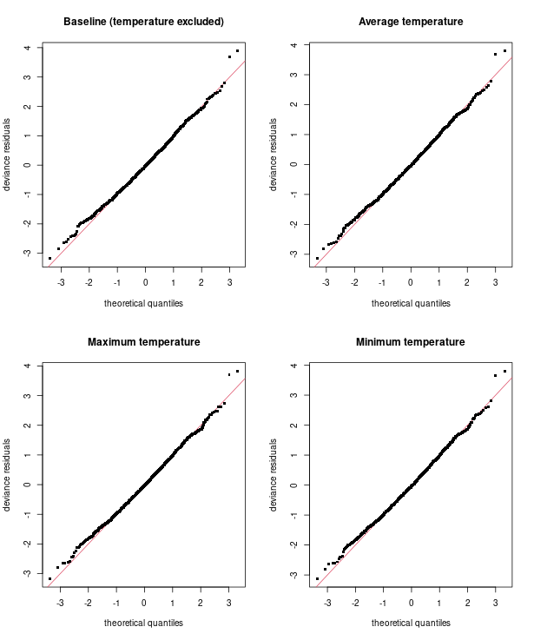

Supplementary Figure 2. Autocorrelation plots by county of the response residuals from the negative binomial model of the relationship between average monthly temperature and monthly deaths by suicide in five urban California counties (1999–2019). The blue dashed lines indicate lags at which the autocorrelation is statistically significantly different from 0.
