Public Health Messages on Arboviruses Transmitted by Aedes aegypti in Brazil

India L. Clancy^{1†}, Robert T. Jones^{2†}, Grace M. Power^{2,3}, James G. Logan^{2*}, Jorge Alberto Bernstein Iriart⁴, Eduardo Massad⁵, John Kinsman⁶.
¹Department of Public Health, Environments & Society, London School of Hygiene & Tropical Medicine, London, United Kingdom; ²Department of Disease Control, London School of Hygiene & Tropical Medicine, London, United Kingdom; ³ MRC Integrative Epidemiology Unit, Population Health Sciences, Bristol Medical School, University of Bristol, United Kingdom; ⁴Institute of Collective Health, Universidade Federal da Bahia, Salvador, Brazil.
⁵School of Applied Mathematics, Fundacao Getulio Vargas, Rua Praia de Botafogo 190, Rio de Janeiro, CEP 22250-900, RJ, Brazil; ⁶Department of Epidemiology and Global Health, Faculty of Medicine, Umeå University, Umeå, Sweden
*corresponding author
†Contributed equally to this work

Supplementary Material 1.

Full set of posters

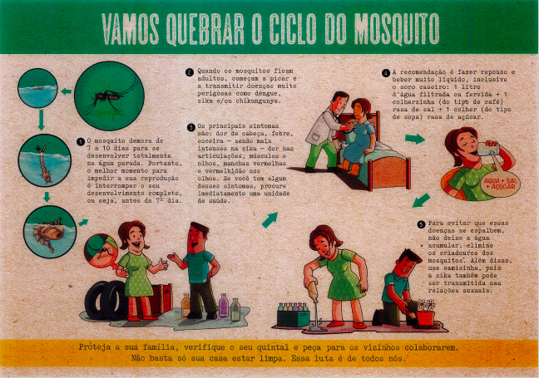
National Poster 1 (N1)

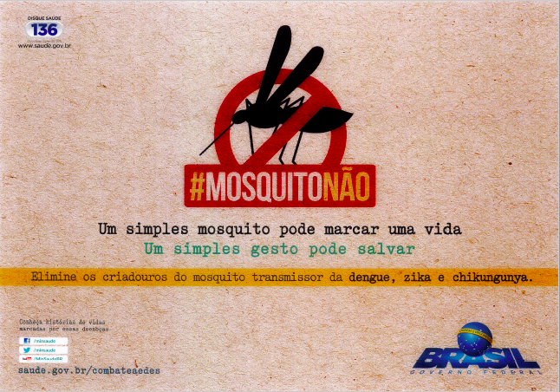
National Poster 2 (N2)
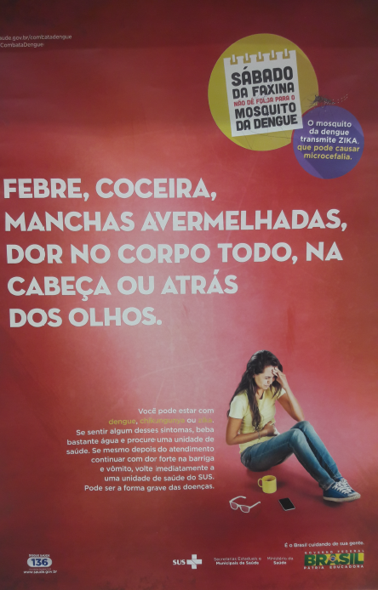
National Poster 3 (N3)

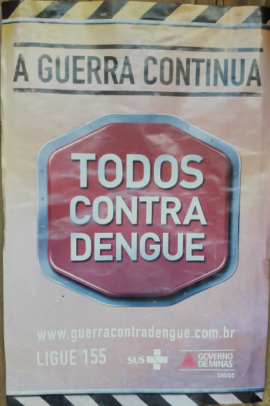
National Poster 4 (N4)
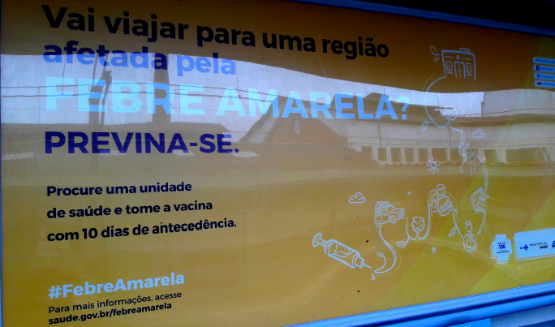
National Poster 5 (N5)

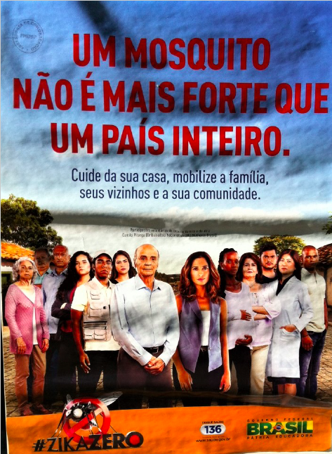
National Poster 6 (N6)

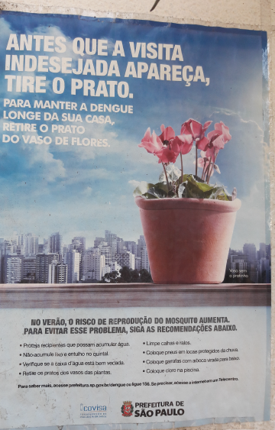
São Paulo Poster 1 (SP1)

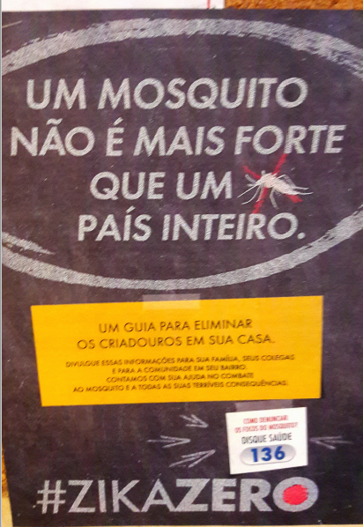
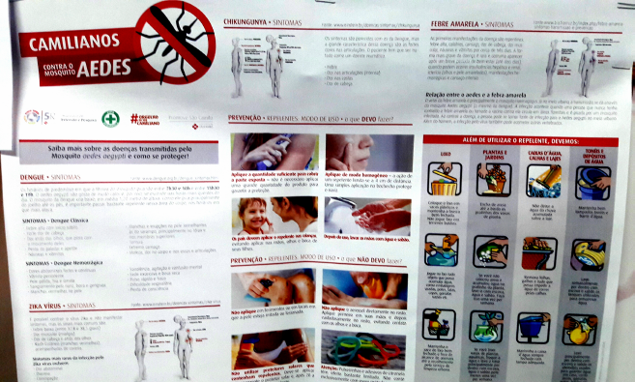
São Paulo Poster 2 – Pages 1 & 2 (SP2)
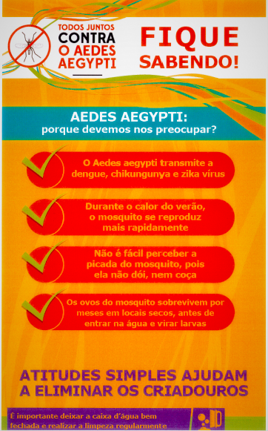
São Paulo Poster 3 (SP3)

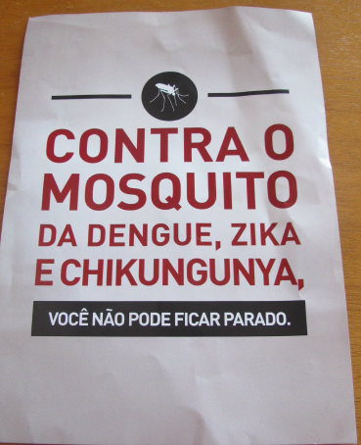
São Paulo Poster 4 (SP4)

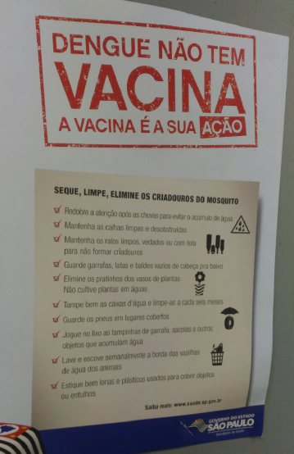
São Paulo Poster 5 (SP5)

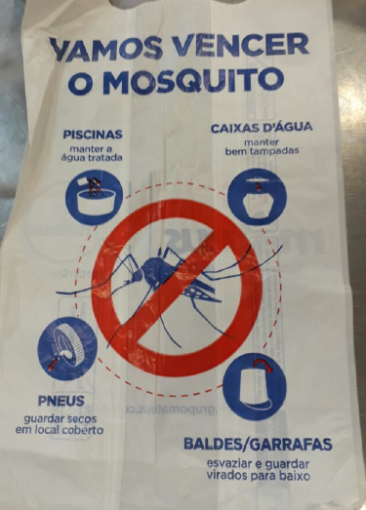
São Paulo Poster 6 (SP6)

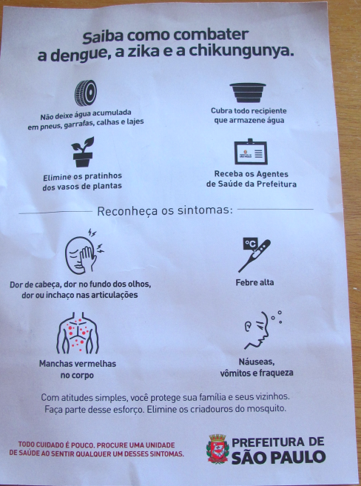
São Paulo Poster 7 (SP7)

Salvador Poster 1 (S1)

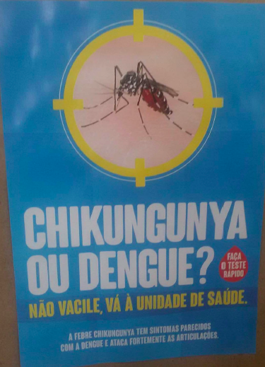

Salvador Poster 2 (S2)

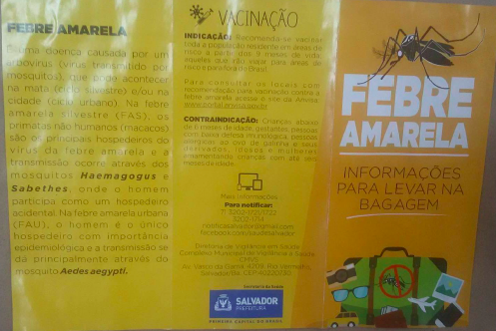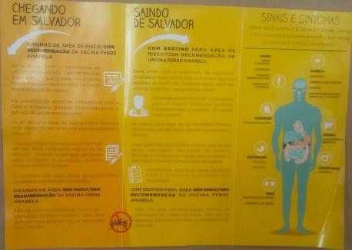Salvador Poster 3 – Pages 1 & 2(S3)

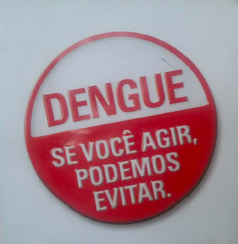
Salvador Poster 4 (S4)

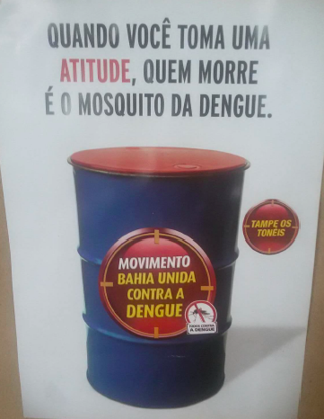
Salvador Poster 5 (S5)

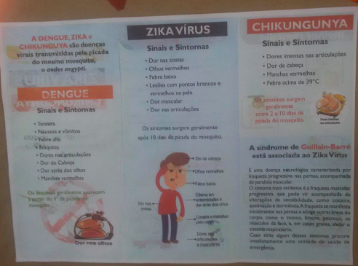
Salvador Poster 6 (S6)

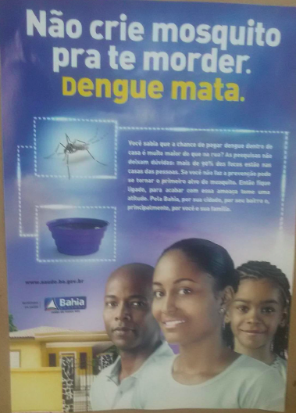
Salvador Poster 7 (S7)

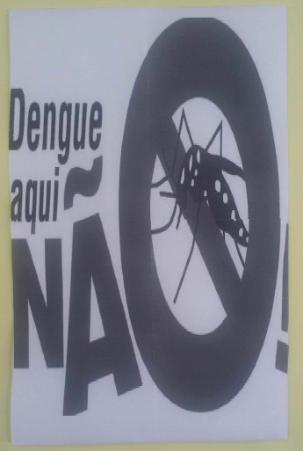
Salvador Poster 8 (S8)

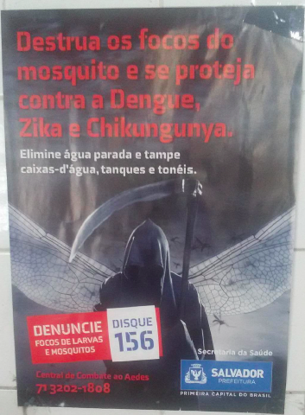
Salvador Poster 9 (S9)

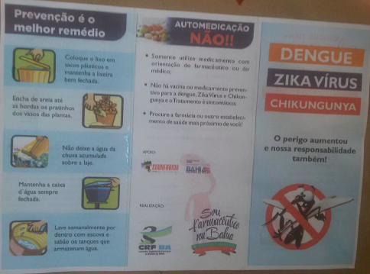
Salvador Poster 10 (S10)

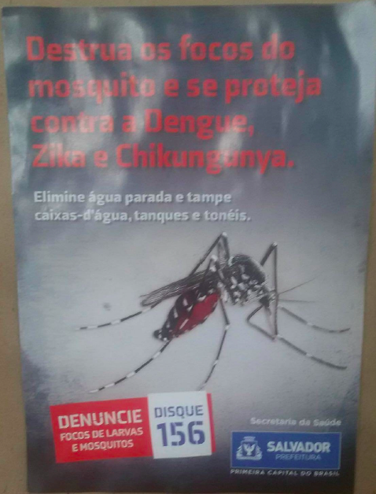
Salvador Poster 11 (S11)
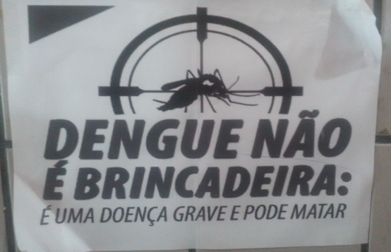
Salvador Poster 12 (S12)

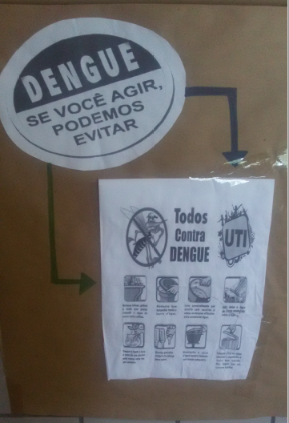
Salvador Poster 13 (S13)

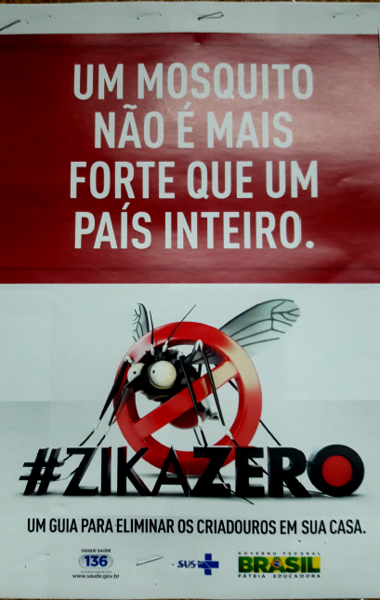

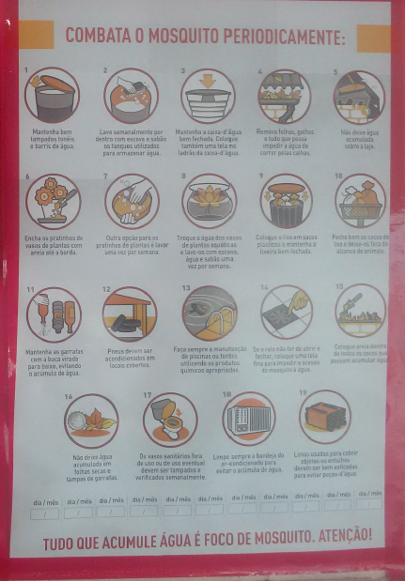
Salvador Poster 14 – Pages 1 & 2 (S14)

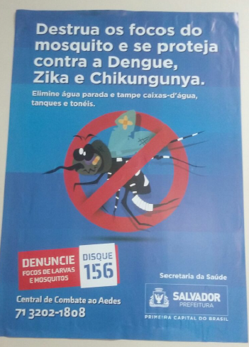
Salvador Poster 15(S15)

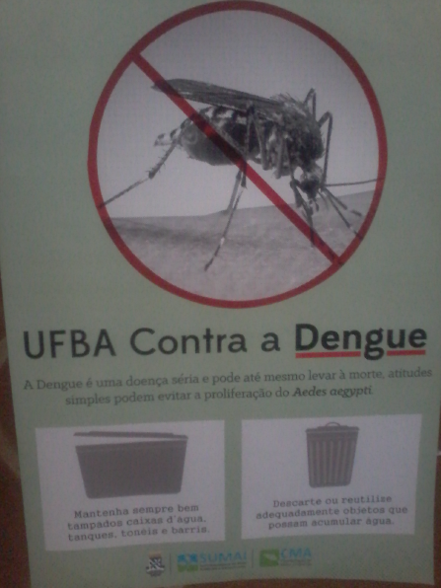
Salvador Poster 16 (S16)

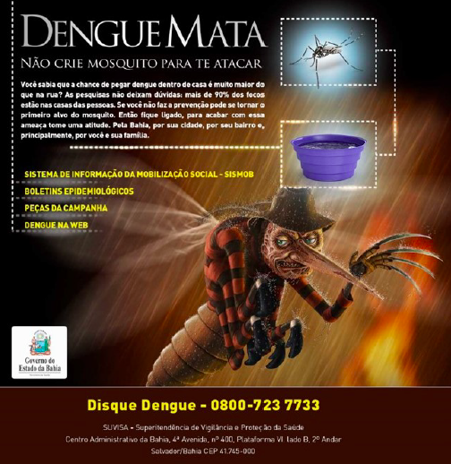
Salvador Poster 17 (S17)

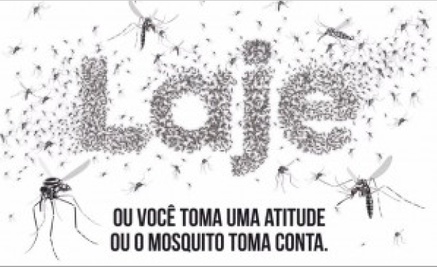
Salvador Poster 18 (S18)

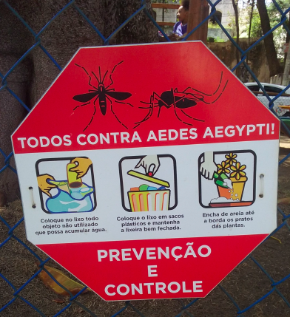
Salvador Poster 19 (S19)
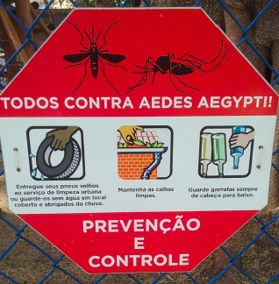
Salvador Poster 20 (S20)

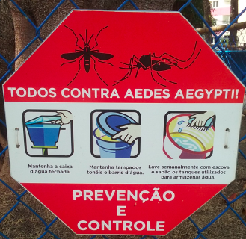
Salvador Poster 21 (S21)

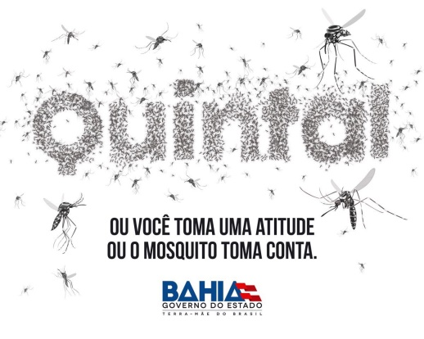
Salvador Poster 22 (S22)

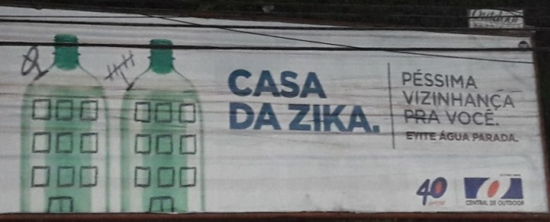
Salvador Poster 23 (S23)

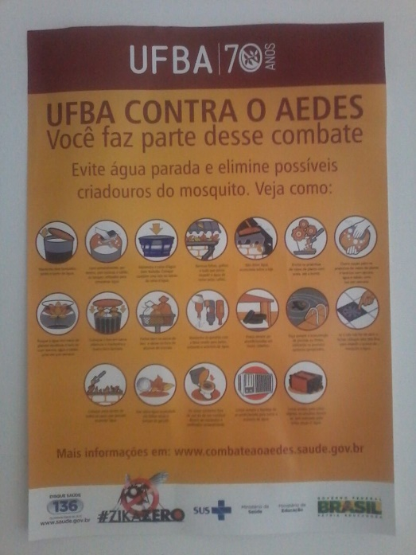
Salvador Poster 24 (S24)

