Addition file 5: Predicted adjusted margins for the significant interaction between wave and demographic variables for specific interventions

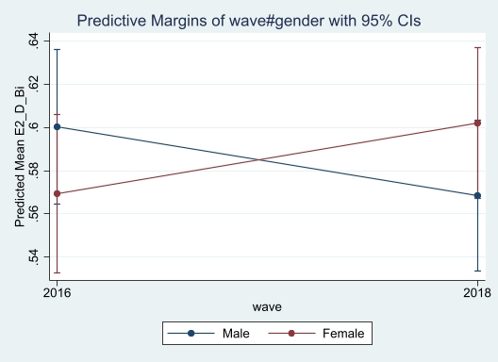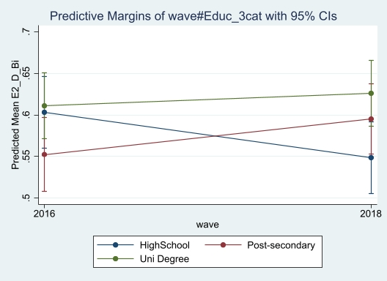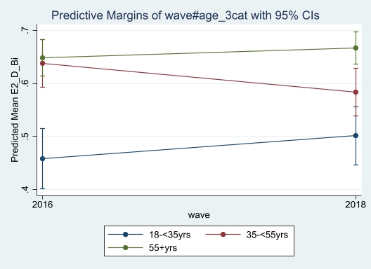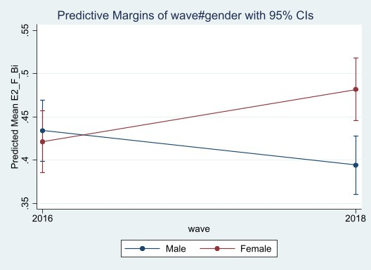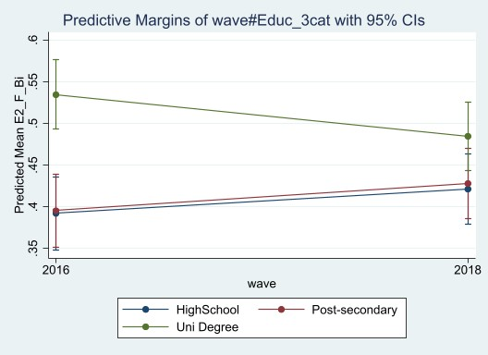

B

A

C

D

E

Panel A shows predicted adjusted margins for the interaction between wave and gender of proportion saying the government had not gone far enough on restricting advertising of unhealthy foods to children.

Panel B shows predicted adjusted margins for the interaction between wave and education of proportion saying the government had not gone far enough on restricting advertising of unhealthy foods to children.

Panel C shows predicted adjusted margins for the interaction between wave and age of proportion saying the government had not gone far enough on restricting advertising of unhealthy foods to children

Panel D shows predicted adjusted margins for the interaction between wave and gender of proportion saying the government had not gone far enough on taxing soft drink.

Panel E shows predicted adjusted margins for the interaction between wave and education of proportion saying the government had not gone far enough on taxing soft drink.