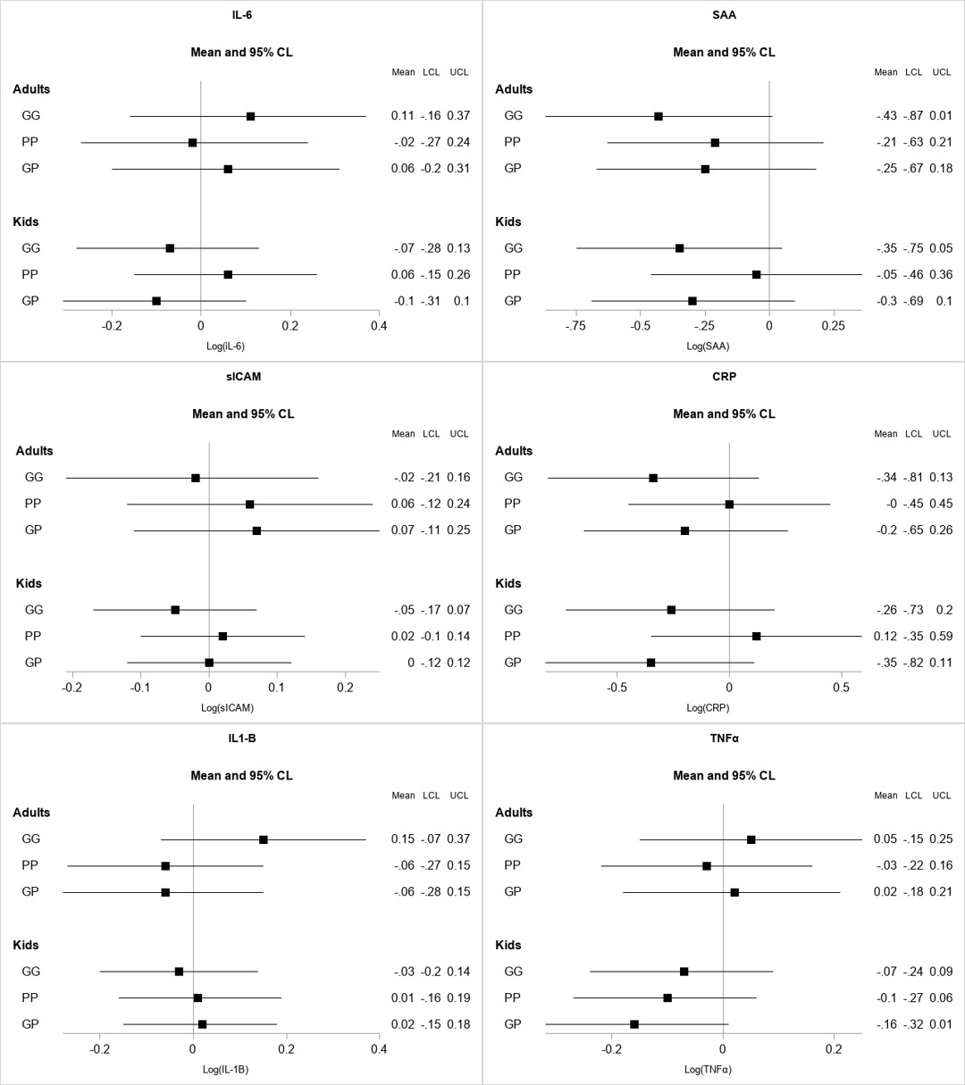
Supplemental Figure 1: Unadjusted coefficient estimates and 95% confidence intervals from linear mixed models examining the effect of the three stove interventions group on 8 biomarkers, relative to the control group. Each panel shows a separate biomarker, with results shown separately for adults (primary cooks, n=184) and children (n=211). Group GG = Gyapa/Gyapa, Group PP = Philips/Philips, Group GP = Gyapa/Philips (reference = Control). No additional covariates included.

