Online Supplement
Trends and external causes of traumatic brain injury and spinal cord injury mortality in southern China, 2014–2018: An ecological study
Xue-yan Zheng^{1*}, Qian Yi^{1,2*}, Xiao-jun Xu^{1*}, Rui-lin Meng, Shu-li Ma², Si-li Tang³, Hao-feng Xu¹, Ying-shan Xu¹，Yan-jun Xu^{1#}, Yi Yang^{2#}
1 Guangdong provincial center for disease control and prevention, Guangdong, China.
2 Department of Epidemiology and Biostatistics, School of Public Health, Guangdong Pharmaceutical University, Guangzhou, China.
3 School of Public Health, Southern Medical University, Guangdong, China

* These authors contributed equally to this work
# These authors are joint senior authors on this work.

# Correspondence author 1: Yan-jun Xu. Guangdong provincial center for disease control and prevention, Guangdong, China. Address: 160 Qunxian Road, Panyu district, Guangzhou, Guangdong, China. Fax: 020-31051492, Phone: 020-31051353, E-mail:759888406@qq.com.
Correspondence author 2: Yi Yang. Department of Epidemiology and Biostatistics, School of Public Health, Guangdong Pharmaceutical University, Guangzhou, China. E-mail: yangyigz@163.com

Methods
Completeness of death surveillance
The completeness of death surveillance data was estimated empirically according to the methods proposed by Adair and Lopez [1]. Briefly, the following equation was calculated to predict the completeness:
logit$($𝐶^{All}$)$=𝑅eg𝐶𝐷𝑅𝑠𝑞×(-0.0238$)$+𝑅eg𝐶𝐷𝑅×0.8419+%65×(-19.6118)+ln(5q0$)$×(-1.5135$)$+𝑌𝑒𝑎𝑟×(-0.0251$)$+44.3755+γ
where $C^{A\text{ll}}$ was the completeness of registration of all ages, $\log{i}t\left(C^{A\text{ll}}\right)$ denoted$\text{ ln}\left(\frac{C^{\text{All}}}{1\text{-}{\text{C}}^{\text{All}}}\right)$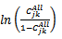, $R\text{eg}CDR$ was the registered crude death rate (CDR), $R\text{eg}CDR\text{sq}$ was the square of RegCDR, %65 was the fraction of the population aged 65 years or greater (%), $\text{ln}\left(5q0\right)$ was the natural logarithm of the under-5 mortality rate, Year was the calendar year, γ was the random effect, and the predicted completeness was converted by using the inverse logit: $\frac{e^{\text{logit}\left(C^{A\text{ll}}\right)}}{e^{\text{logit}\left(C^{A\text{ll}}\right)}+1}$. The results of the internal data verification and the completeness of death surveillance for each district in this study were listed in E-Table 1.

E-Table 1. The internal data verification and the completeness of death surveillance
District | 2014 |  |  |  |  | 2015 |  |  |  |  | 2016 |  |  |  |  | 2017 |  |  |  |  | 2018
 | CDR | %65 | 5q0 | C^{All} |  | CDR | %65 | 5q0 | C^{All} |  | CDR | %65 | 5q0 | C^{All} |  | CDR | %65 | 5q0 | C^{All} |  | CDR | %65 | 5q0 | C^{All}
Liwan | 8.7 | 15.7 | 6.2 | 98.1 |  | 8.1 | 19.1 | 3.4 | 98.0 |  | 8.4 | 17.1 | 4.0 | 98.5 |  | 8.4 | 17.4 | 3.8 | 98.5 |  | 8.5 | 17.8 | 2.2 | 99.3
Yuexiu | 6.8 | 14.8 | 3.9 | 98.1 |  | 6.4 | 17.7 | 4.2 | 95.4 |  | 7.0 | 15.8 | 4.5 | 97.3 |  | 6.8 | 16.3 | 4.0 | 97.1 |  | 7.2 | 16.7 | 3.3 | 98.1
Panyu | 4.8 | 8.7 | 5.4 | 97.1 |  | 4.2 | 10.4 | 5.4 | 94.3 |  | 4.4 | 9.2 | 6.0 | 95.2 |  | 4.3 | 9.3 | 2.1 | 98.8 |  | 4.3 | 9.3 | 4.0 | 96.8
Wujiang | 5.9 | 13.1 | 13.3 | 86.9 |  | 5.6 | 13.6 | 15.6 | 80.5 |  | 5.3 | 10.9 | 9.2 | 92.4 |  | 5.5 | 11.0 | 4.9 | 97.2 |  | 5.6 | 11.2 | 6.1 | 96.2
Wengyuan | 6.0 | 9.3 | 10.2 | 95.8 |  | 5.7 | 12.2 | 17.1 | 83.0 |  | 5.9 | 9.6 | 7.3 | 97.1 |  | 5.9 | 9.4 | 7.0 | 97.2 |  | 5.9 | 9.6 | 5.7 | 97.9
Nanxiong | 6.4 | 9.4 | 8.1 | 97.6 |  | 5.8 | 12.8 | 17.2 | 81.8 |  | 5.7 | 9.4 | 8.1 | 96.4 |  | 6.2 | 9.7 | 7.1 | 97.4 |  | 6.5 | 10.0 | 7.0 | 97.7
Nanshan | 1.1 | 2.9 | 3.3 | 94.1 |  | 0.9 | 3.4 | 5.1 | 86.5 |  | 0.8 | 3.1 | 2.3 | 95.4 |  | 0.9 | 3.5 | 2.0 | 96.0 |  | 1.0 | 3.5 | 1.7 | 97.0
Doumen | 5.7 | 9.7 | 10.9 | 94.3 |  | 4.9 | 11.1 | 7.7 | 92.8 |  | 5.1 | 9.4 | 6.5 | 96.1 |  | 5.0 | 9.6 | 4.7 | 97.3 |  | 4.9 | 9.8 | 3.9 | 97.7
Chancheng | 5.9 | 13.1 | 9.8 | 91.6 |  | 5.9 | 15.5 | 12.0 | 82.7 |  | 6.3 | 13.9 | 7.1 | 94.7 |  | 5.8 | 13.9 | 5.1 | 95.7 |  | 5.7 | 13.9 | 4.7 | 95.8
Shunde | 6.1 | 10.8 | 6.9 | 97.1 |  | 5.6 | 12.6 | 6.7 | 94.7 |  | 5.6 | 11.0 | 5.1 | 97.3 |  | 5.6 | 11.2 | 3.9 | 98.0 |  | 5.2 | 11.3 | 3.9 | 97.5
Taishan | 8.0 | 11.6 | 6.0 | 98.9 |  | 7.3 | 16.0 | 11.7 | 90.8 |  | 7.9 | 13.6 | 7.3 | 97.7 |  | 7.8 | 14.1 | 6.9 | 97.5 |  | 7.6 | 14.5 | 4.0 | 98.6
Heshan | 7.5 | 10.8 | 5.3 | 99.0 |  | 6.5 | 16.2 | 5.8 | 94.8 |  | 7.1 | 13.6 | 7.0 | 96.7 |  | 7.3 | 13.3 | 5.6 | 97.9 |  | 7.1 | 13.6 | 5.3 | 97.7
Wuchuan | 4.0 | 9.5 | 6.6 | 92.6 |  | 3.1 | 10.4 | 20.8 | 49.2 |  | 3.4 | 8.4 | 12.2 | 80.1 |  | 3.9 | 8.5 | 10.5 | 86.8 |  | 4.1 | 8.7 | 12.4 | 84.6
Gaozhou | 3.4 | 10.1 | 18.5 | 61.8 |  | 3.2 | 11.5 | 31.8 | 31.1 |  | 3.8 | 9.8 | 17.0 | 70.8 |  | 4.3 | 9.6 | 14.2 | 81.4 |  | 4.4 | 9.8 | 14.3 | 81.2
Duanzhou | 5.3 | 12.0 | 14.3 | 84.5 |  | 5.2 | 13.6 | 9.2 | 87.5 |  | 5.2 | 11.9 | 6.6 | 94.2 |  | 5.2 | 11.6 | 6.6 | 94.2 |  | 5.2 | 11.7 | 3.5 | 97.7
Sihui | 7.0 | 8.7 | 7.6 | 98.6 |  | 6.0 | 14.2 | 9.0 | 91.3 |  | 6.6 | 11.8 | 5.0 | 98.2 |  | 6.5 | 11.7 | 4.8 | 98.2 |  | 6.3 | 11.9 | 4.6 | 98.0
Huiyang | 5.4 | 8.1 | 7.9 | 96.9 |  | 5.3 | 8.0 | 10.4 | 94.9 |  | 5.7 | 6.1 | 6.3 | 98.6 |  | 6.6 | 6.4 | 7.1 | 98.9 |  | 5.5 | 6.5 | 6.5 | 98.2
Boluo | 5.5 | 9.1 | 14.2 | 91.5 |  | 4.7 | 11.5 | 11.6 | 84.7 |  | 5.0 | 9.5 | 8.8 | 93.5 |  | 5.1 | 9.3 | 5.9 | 96.7 |  | 5.3 | 9.4 | 7.2 | 95.8
Wuhua | 5.5 | 7.8 | 9.1 | 96.6 |  | 3.9 | 8.4 | 18.7 | 75.2 |  | 3.8 | 7.2 | 10.0 | 89.9 |  | 4.2 | 7.1 | 7.5 | 94.6 |  | 4.3 | 7.3 | 8.3 | 93.8
Shanwei | 5.7 | 6.2 | 5.7 | 98.8 |  | 6.5 | 5.9 | 27.9 | 92.4 |  | 6.5 | 4.7 | 15.6 | 97.4 |  | 4.9 | 5.1 | 5.6 | 98.4 |  | 3.9 | 5.3 | 5.6 | 96.9
Heping | 5.4 | 26.0 | 3.2 | 78.5 |  | 3.9 | 11.7 | 20.7 | 57.8 |  | 5.1 | 9.5 | 13.5 | 89.4 |  | 5.1 | 9.4 | 9.6 | 93.3 |  | 5.4 | 9.5 | 5.9 | 96.9
Yangdong | 5.0 | 10.7 | 4.0 | 97.6 |  | 4.6 | 12.6 | 13.0 | 77.6 |  | 5.3 | 10.7 | 11.1 | 90.5 |  | 5.1 | 11.0 | 6.2 | 95.2 |  | 5.1 | 11.3 | 6.9 | 93.8
Qingcheng | 5.8 | 9.7 | 10.2 | 95.0 |  | 4.8 | 12.3 | 9.9 | 86.5 |  | 5.3 | 9.9 | 7.2 | 95.6 |  | 5.2 | 10.0 | 3.3 | 98.5 |  | 5.6 | 10.2 | 5.6 | 97.1
Yingde | 5.6 | 11.0 | 12.0 | 91.0 |  | 4.8 | 12.4 | 25.3 | 60.7 |  | 5.2 | 9.3 | 12.1 | 91.5 |  | 5.3 | 9.3 | 5.4 | 97.5 |  | 5.4 | 9.4 | 5.6 | 97.4
Zhongshan | 5.9 | 9.8 | 7.0 | 97.3 |  | 5.6 | 12.4 | 9.3 | 91.9 |  | 5.8 | 10.4 | 6.0 | 97.2 |  | 5.6 | 10.5 | 5.0 | 97.5 |  | 5.4 | 10.6 | 3.8 | 98.0
Huilai | 2.7 | 8.9 | 2.9 | 95.2 |  | 2.6 | 6.0 | 12.7 | 78.3 |  | 2.9 | 5.3 | 14.9 | 79.5 |  | 2.7 | 5.5 | 7.5 | 89.8 |  | 3.1 | 5.7 | 8.3 | 90.3
Yuncheng | 4.7 | 10.9 | 7.2 | 93.0 |  | 5.2 | 12.7 | 14.0 | 81.9 |  | 5.5 | 10.2 | 6.9 | 96.1 |  | 5.5 | 10.1 | 6.4 | 96.6 |  | 5.7 | 10.3 | 8.0 | 95.4
Luoding | 4.6 | 8.4 | 7.7 | 94.9 |  | 4.8 | 8.6 | 13.2 | 89.5 |  | 5.3 | 6.2 | 12.2 | 95.3 |  | 5.1 | 6.4 | 10.6 | 95.4 |  | 4.6 | 6.6 | 7.1 | 96.3
Note: CDR, the registered crude death rate (%); %65, the fraction of the population aged 65 years or greater (%); 5q0, the under-5 mortality rate (per 10⁵ population); C^{All}, the completeness of registration of all ages (%).

Reference:
- Adair T, Lopez AD. Estimating the completeness of death registration: An empirical method. PLoS One. 2018; 13(5):e0197047.
Results
E-Table 2. Sample characteristics of the included Disease Surveillance Points of Guangdong province between 2014 and 2018
Demographic characteristic | 2014 |  |  | 2015 |  |  | 2016 |  |  | 2017 |  |  | 2018 |  |  | China census population in 2010
 | No. | % |  | No. | % |  | No. | % |  | No. | % |  | No. | % |  | No. | %
Sex
Male | 11,515,312 | 51.5 |  | 12,366,035 | 51.4 |  | 12,383,069 | 51.2 |  | 12,443,215 | 51.1 |  | 12,563,746 | 51.0 |  | 682,329,104 | 51.2
Female | 10,861,589 | 48.5 |  | 11,706,783 | 48.6 |  | 11,807,802 | 48.8 |  | 11,918,384 | 48.9 |  | 12,058,675 | 49.0 |  | 650,481,765 | 48.8
Age group
0~4years | 1,273,339 | 5.7 |  | 1,147,357 | 4.8 |  | 1,304,650 | 5.4 |  | 1,443,642 | 5.9 |  | 1,476,637 | 6.0 |  | 75,532,610 | 5.7
5~14years | 2,674,862 | 12.0 |  | 2,849,647 | 11.8 |  | 2,719,130 | 11.2 |  | 2,898,834 | 11.9 |  | 2,981,411 | 12.1 |  | 145,790,011 | 10.9
15~24years | 3,595,491 | 16.1 |  | 4,270,641 | 17.7 |  | 3,554,008 | 14.7 |  | 3,424,105 | 14.1 |  | 3,344,139 | 13.6 |  | 227,301,632 | 17.1
25~44years | 7,099,156 | 31.7 |  | 7,530,847 | 31.3 |  | 8,173,184 | 33.8 |  | 8,004,756 | 32.9 |  | 8,074,879 | 32.8 |  | 440,931,978 | 33.1
45~64years | 5,417,600 | 24.2 |  | 5,486,329 | 22.8 |  | 6,105,300 | 25.2 |  | 6,221,987 | 25.5 |  | 6,305,534 | 25.6 |  | 324,327,480 | 24.3
65~74years | 1,312,118 | 5.9 |  | 1,348,366 | 5.6 |  | 1,315,452 | 5.4 |  | 1,396,119 | 5.7 |  | 1,457,186 | 5.9 |  | 74,085,679 | 5.6
≥75years | 1,004,335 | 4.5 |  | 1,439,631 | 6.0 |  | 1,019,147 | 4.2 |  | 972,156 | 4.0 |  | 982,635 | 4.0 |  | 44,841,479 | 3.4
Location
Urban | 9,772,211 | 43.7 |  | 10,342,139 | 43.0 |  | 10,528,416 | 43.5 |  | 10,775,153 | 44.2 |  | 10,990,591 | 44.6 |  | 670,005,546 | 50.3
Rural | 12,604,690 | 56.3 |  | 13,730,679 | 57.0 |  | 13,662,455 | 56.5 |  | 13,586,446 | 55.8 |  | 13,631,830 | 55.4 |  | 662,805,323 | 49.7
Total | 22,376,901 | 100.0 |  | 24,072,818 | 100.0 |  | 24,190,871 | 100.0 |  | 24,361,599 | 100.0 |  | 24,622,421 | 100.0 |  | 1,242,612,226 | 100.0

E-Table 3. Associations between the traumatic brain injury mortality from motor vehicle crashes and the socio-demographic variables, estimated with multivariate negative binomial regression model (Guangdong, China, 2014-2018).
Socio-demographic variable | TBI mortality from motor vehicle crashes by road user category
 | Vehicle occupant |  |  |  | Motorcyclist |  |  |  | Pedal cyclist |  |  |  | Pedestrian |  |  |  | All others
 | MRR | 95%CI |  |  | MRR | 95%CI |  |  | MRR | 95%CI |  |  | MRR | 95%CI |  |  | MRR | 95%CI
 |  | Lower | Upper |  |  | Lower | Upper |  |  | Lower | Upper |  |  | Lower | Upper |  |  | Lower | Upper
Sex (reference= female)
Male | 2.3* | 1.3 | 3.8 |  | 4.6* | 3.2 | 6.7 |  | 2.7* | 1.3 | 5.4 |  | 2.0* | 1.6 | 2.5 |  | 2.6* | 1.7 | 3.9
Age (reference= 25~44 years)
0~4 | 0.4* | 0.2 | 1.1 |  | 0.2* | 0.1 | 0.4 |  | 0.1* | 0.0 | 0.5 |  | 0.9* | 0.6 | 1.4 |  | 0.5* | 0.2 | 1.0
5~14 | 0.1* | 0.0 | 0.2 |  | 0.2* | 0.1 | 0.3 |  | 0.3* | 0.1 | 1.0 |  | 0.4* | 0.3 | 0.6 |  | 0.3* | 0.1 | 0.6
15~24 | 0.6* | 0.3 | 1.6 |  | 1.0* | 0.5 | 2.0 |  | 0.6* | 0.2 | 1.9 |  | 0.9* | 0.6 | 1.4 |  | 1.0* | 0.5 | 2.0
45~64 | 1.1* | 0.5 | 2.9 |  | 1.6* | 0.8 | 3.2 |  | 3.7* | 1.2 | 11.8 |  | 1.9* | 1.3 | 2.9 |  | 1.7* | 0.8 | 3.6
65~74 | 0.9* | 0.4 | 2.3 |  | 1.5* | 0.8 | 3.1 |  | 7.6* | 2.3 | 25.1 |  | 4.5* | 2.9 | 6.8 |  | 2.9* | 1.4 | 6.2
≥75 | 0.8* | 0.3 | 2.1 |  | 0.7* | 0.4 | 1.4 |  | 6.6* | 1.9 | 22.6 |  | 7.2* | 4.7 | 11.0 |  | 3.1* | 1.5 | 6.7
Location (reference= urban)
Rural | 2.1* | 1.2 | 3.4 |  | 3.3* | 2.3 | 4.7 |  | 4.1* | 2.1 | 8.3 |  | 2.9* | 2.3 | 3.6 |  | 1.3* | 0.9 | 2.0
Year (reference= 2014)
2015 | 2.4* | 1.1 | 5.2 |  | 1.3* | 0.7 | 2.3 |  | 1.0* | 0.4 | 2.8 |  | 1.0* | 0.7 | 1.5 |  | 1.7* | 0.9 | 3.1
2016 | 1.7* | 0.8 | 3.8 |  | 1.3* | 0.7 | 2.3 |  | 1.1* | 0.4 | 3.0 |  | 0.8* | 0.6 | 1.1 |  | 1.6* | 0.8 | 3.0
2017 | 1.8* | 0.8 | 4.1 |  | 1.1* | 0.6 | 2.0 |  | 1.5* | 0.6 | 4.3 |  | 1.0* | 0.7 | 1.4 |  | 1.3* | 0.7 | 2.4
2018 | 1.1* | 0.5 | 2.5 |  | 0.9* | 0.5 | 1.7 |  | 1.3* | 0.5 | 3.8 |  | 0.7* | 0.5 | 1.0 |  | 1.5* | 0.8 | 2.8
*P < 0.05; MRR: mortality rate ratio, adjusted for location, sex, age group and year; CI: Confidence interval; MRR, mortality rate ratio; TBI: traumatic brain injury.
E-Table 4. Associations between spinal cord injury mortality from motor vehicle crashes and the socio-demographic variables, estimated with the multivariate negative binomial regression model (Guangdong, China, 2014-2018).
Socio-demographic variable | SCI mortality from motor vehicle crashes by road user category
 | Vehicle occupant |  |  |  | Motorcyclist |  |  |  | Others
 | MRR | 95%CI |  |  | MRR | 95%CI |  |  | MRR | 95%CI
 |  | Lower | Upper |  |  | Lower | Upper |  |  | Lower | Upper
Sex (reference= female)
Male | 6.7* | 0.8 | 99.4 |  | 16.0* | 1.9 | 133.7 |  | 73.2 | 1.2 | 73.3
Age (reference= 25~44 years)
0~4 | 0.0* | 0.0 | 0.0 |  | 0.1* | 0.0 | 2.7 |  | 0.0 | 0.0 | 0.0
5~14 | 0.0* | 0.0 | 0.0 |  | 0.1* | 0.0 | 1.8 |  | 0.0 | 0.0 | 0.0
15~24 | 0.0* | 0.0 | 0.1 |  | 0.0* | 0.0 | 0.0 |  | 0.0 | 0.0 | 0.0
45~64 | 0.9* | 0.1 | 18.3 |  | 50.4* | 1.5 | 2306.2 |  | 3.1 | 2.9 | 3.5
65~74 | 1.0* | 0.0 | 27.7 |  | 0.4* | 0.0 | 9.1 |  | 3.6 | 3.5 | 3.9
≥75 | 0.0* | 0.0 | 1.0 |  | 8.6* | 0.4 | 204.0 |  | 169.6 | 1.0 | 49486.6
Location (reference= urban)
Rural | 2.1* | 0.2 | 20.0 |  | 30.7* | 3.9 | 252.2 |  | 0.0 | 0.0 | 2.4
Year (reference= 2014)
2015 | 1.5* | 0.1 | 51.8 |  | 17.2* | 1.0 | 315.6 |  | 0.0 | 0.0 | 5.1
2016 | 0.5* | 0.0 | 14.3 |  | 0.1* | 0.0 | 1.6 |  | 291.9 | 1.4 | 292.1
2017 | 1.8* | 0.1 | 34.2 |  | 0.8* | 0.1 | 21.1 |  | 3.3 | 0.0 | 3.8
2018 | 215.7* | 4.3 | 9872.8 |  | 0.9* | 0.1 | 14.4 |  | 232.7 | 0.6 | 97097.1
*P < 0.05; MRR: mortality rate ratio, adjusted for location, sex, age group and year; CI: Confidence interval; MRR, mortality rate ratio; SCI: spinal cord injury.
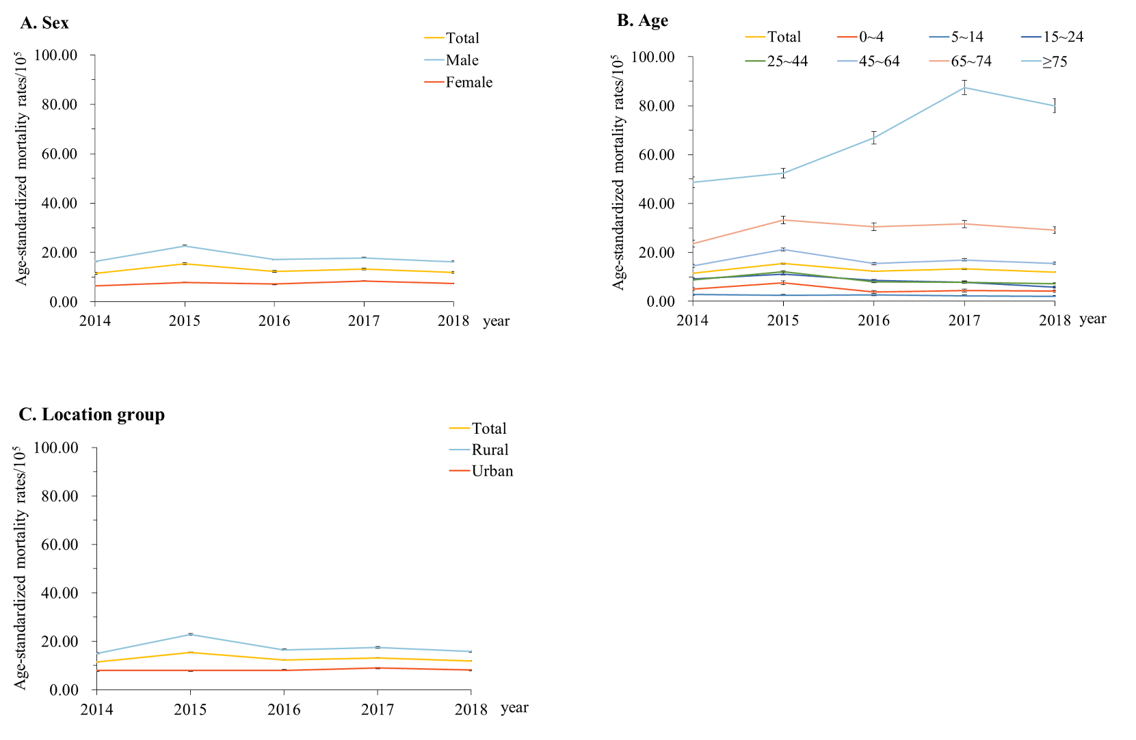
E-Figure 1. Mortality rates from traumatic brain injury when stratified by location (urban/rural), sex, and age group in Guangdong, China, 2014-2018. (A) Stratification by sex; (B) stratification by age; (C) stratification by location group. Mortality rates in (A) and (C) were age-standardized based on the population of China in 2010.
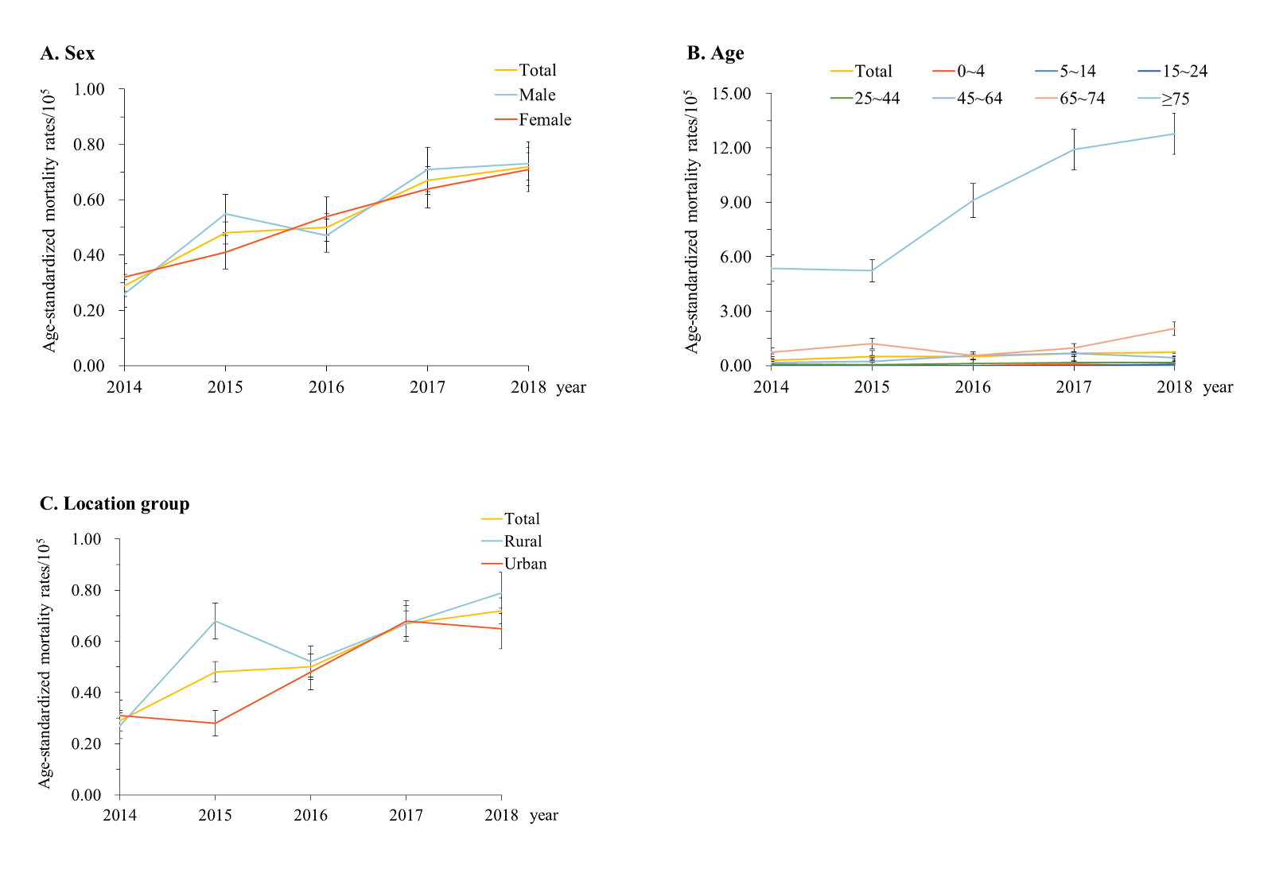
E-Figure 2. Mortality rates from spinal cord injury when stratified by sex, age and location (urban/rural) group in Guangdong China, 2014-2018. (A) Stratification by sex; (B) stratification by age; (C) stratification by location group. Mortality rates in (A) and (C) were age-standardized based on the population of China in 2010.
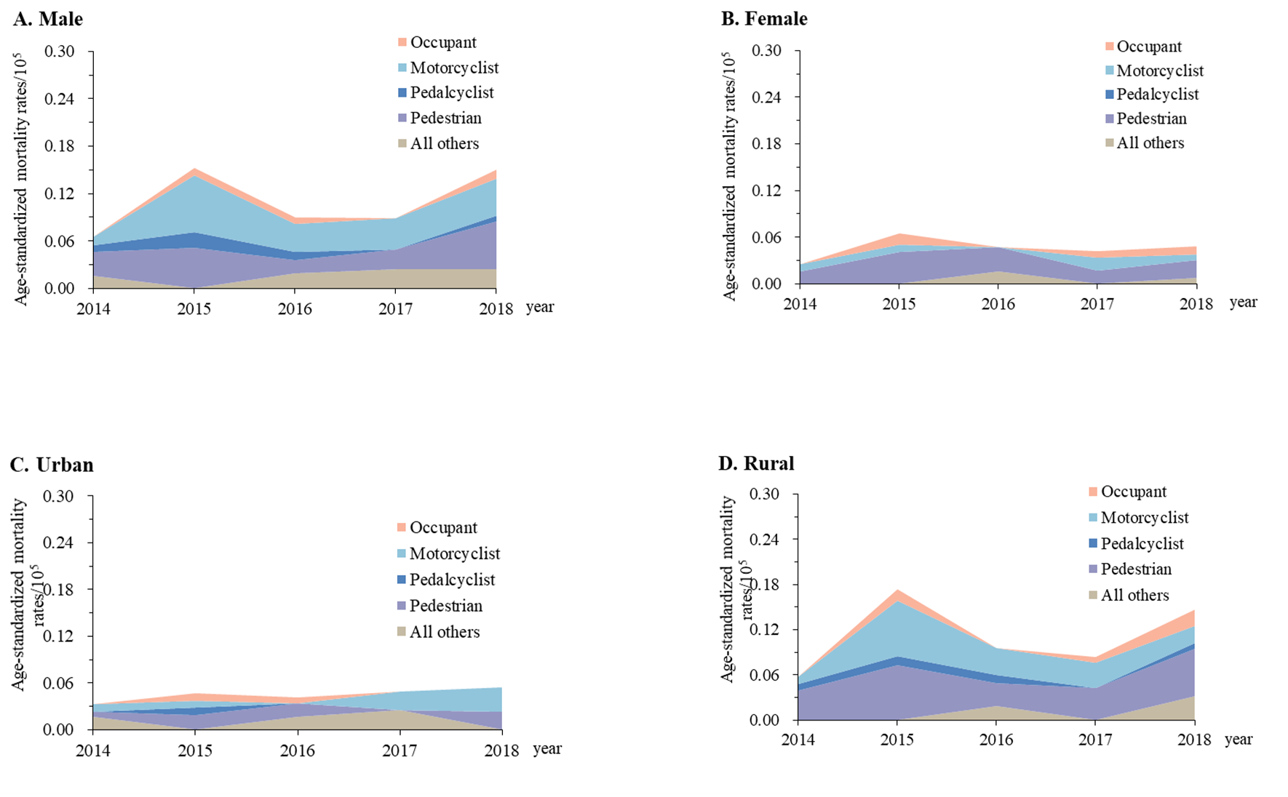
E-Figure 3. Mortality rates from spinal cord injury due to motor vehicle crashes when stratified by urban/rural location, sex, and road user category (Guangdong, China, 2014–2018). (A) Male; (B) female; (C) Urban areas; (D) rural areas. Mortality rates were age-standardized based on the population of China in 2010

