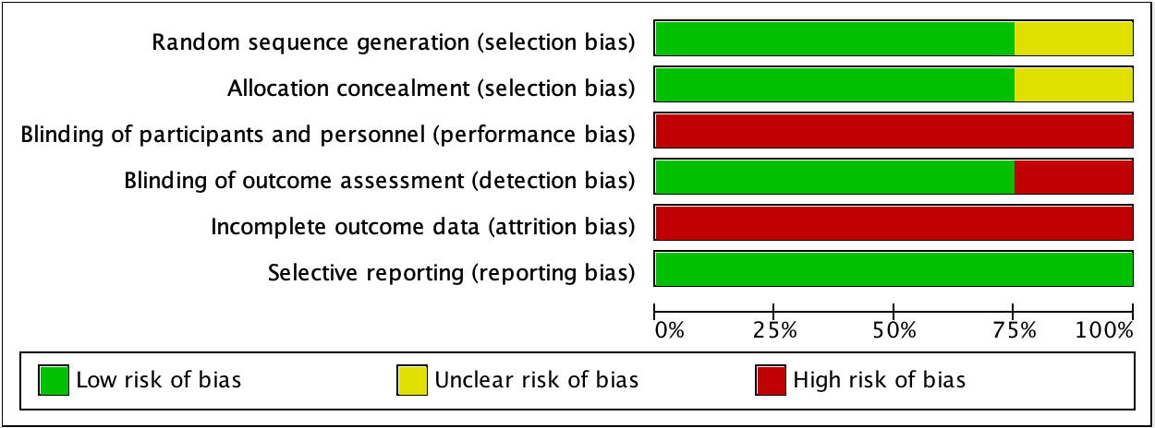
Figure S1. Risk of bias graph for RCTs.

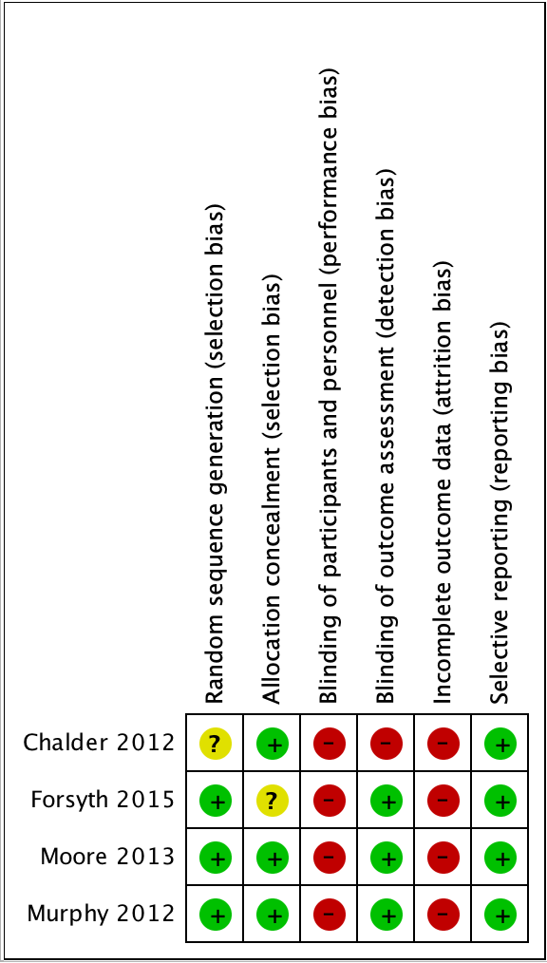
Figure S2. Risk of bias summary for RCTs.

Table S2. Quality appraisal checklist for case series studies
Criteria | Harrison 2005 | Crone 2008 | Tobi  2017 | Avery 2020 | Morgan 2020
Clear study objective | Yes | Yes | Yes | Yes | Yes
Conducted prospectively | No | No | No | No | No
Cases collected from multiple centres | Yes | Yes | Yes | Yes | Yes
Patients recruited consecutively | Unclear | Unclear | Unclear | Unclear | Unclear
Description of patient characteristics | Yes | Partial | Yes | Yes | Yes
Clear eligibility criteria | Partial | No | Partial | Yes | Yes
Similar disease severity at study entry | Unclear | Unclear | Unclear | Unclear | Unclear
Clearly described intervention | Yes | Partial | Partial | Yes | Yes
Pre-established outcome measures | Yes | Yes | Yes | Yes | Yes
Appropriate methods for measuring outcome | Yes | Yes | Yes | Yes | Yes
Appropriate length of follow up | Yes | Yes | Yes | Yes | Yes
Loss to follow up reported | Yes | Yes | Yes | Yes | Yes
Results support study conclusions | Yes | Yes | Yes | Yes | Yes
Competing interests and support sources reported | No | No | Partial | Partial | Yes

