Additional file 1

Supplementary Materials

Table A1 The meaning and value of covariates

Table A2 Demographic characteristics of scarlet fever in Sichuan Province, 2016–2019

Figure A1 Time series of scarlet fever counts in 21 cities (/prefectures) of Sichuan province from 2016 to 2019

Figure A2 The fitted values for 21 cities (/prefectures) in Sichuan Province during 2016–2019

Figure A3 The estimated multiplicative effect of seasonality on the endemic mean

Table A3 Model selection and comparison

Table A4 Model without spatial term

Table A5 The estimates of random effects

Figure A4 Spatial connectivity weights

Figure A5 The matrix of cities showing the connectivity weights

Table A1 The meaning and value of covariates
 | Meaning | Range of values
Population Density | Population density is a measurement of the number of people in an area. It is an average number. Population density is calculated by dividing the number of people by the area. Population density is usually shown as the number of people per 10,000 square kilometers. | 8-1157 (10,000 square kilometres)
School holidays | School holidays mainly refer to the winter and summer vacations in Sichuan province. | we set school holidays as a dummy variable, 0 denotes the school day, and 1 denotes the  summer and winter vacations.
GDP | Gross domestic product (GDP) is the total monetary or market value of all the finished goods and services produced within a region’s borders in a specific period. | 265.67-17012.65 (Trillion Yuan)
Number of health institutions | The number of health institutions per total population living in a designated area. | 1056-12121
Number of kindergartens | The number of kindergartens per total population living in a designated area. | 192-2630
Number of primary schools | The number of primary schools per total population living in a designated area. | 60-607
Passenger-kilometers of highways | Passenger-Kilometers of Highways refers to the sum of actual delivery by a variety of means of transport highway with the corresponding number of passengers, which could reflect the mobility in space. | 60531-902156 (10,000 passenger-km）

Table A2 Demographic characteristics of scarlet fever in Sichuan Province, 2016–2019
 |  |  | Year
 | Total |  | 2016 |  | 2017 |  | 2018 |  | 2019
 | cases | incidence | cases | incidence | cases | incidence | cases | incidence | cases | incidence
Gender
female | 2,968 | 0.892 | 657 | 0.795 | 805 | 0.970 | 754 | 0.904 | 752 | 0.898
male | 4,388 | 1.319 | 1,051 | 1.272 | 1,197 | 1.442 | 1,073 | 1.286 | 1,067 | 1.274
Age (year)
0-3 | 1,287 | 0.387 | 306 | 0.370 | 356 | 0.429 | 298 | 0.357 | 327 | 0.390
4-6 | 3,890 | 1.169 | 916 | 1.109 | 1,096 | 1.320 | 1,003 | 1.202 | 875 | 1.045
7-9 | 1,670 | 0.502 | 390 | 0.472 | 453 | 0.546 | 399 | 0.478 | 428 | 0.511
10-12 | 296 | 0.089 | 64 | 0.077 | 72 | 0.087 | 86 | 0.103 | 74 | 0.088
13-15 | 106 | 0.032 | 15 | 0.018 | 16 | 0.019 | 19 | 0.023 | 56 | 0.067
16-59 | 107 | 0.032 | 17 | 0.021 | 9 | 0.011 | 22 | 0.026 | 59 | 0.070
Source of cases
Other province | 57 | 0.017 | 11 | 0.013 | 16 | 0.019 | 11 | 0.013 | 19 | 0.023
Foreign country | 1 | 0.000 | 1 | 0.001 | 0 | 0.000 | 0 | 0.000 | 0 | 0.000
The same city | 7,160 | 2.151 | 1,675 | 2.027 | 1,933 | 2.328 | 1,728 | 2.072 | 1,770 | 2.113
Other cities | 138 | 0.041 | 21 | 0.025 | 53 | 0.064 | 34 | 0.041 | 30 | 0.036
Total | 7,356 | 2.210 | 1,708 | 2.067 | 2,002 | 2.411 | 1,827 | 2.190 | 1,819 | 2.172
Note: incidence is the average annual incidence rate (per 100,000 population)

Figure A1 Time series of scarlet fever counts in 21 cities (/prefectures) of Sichuan province from 2016 to 2019

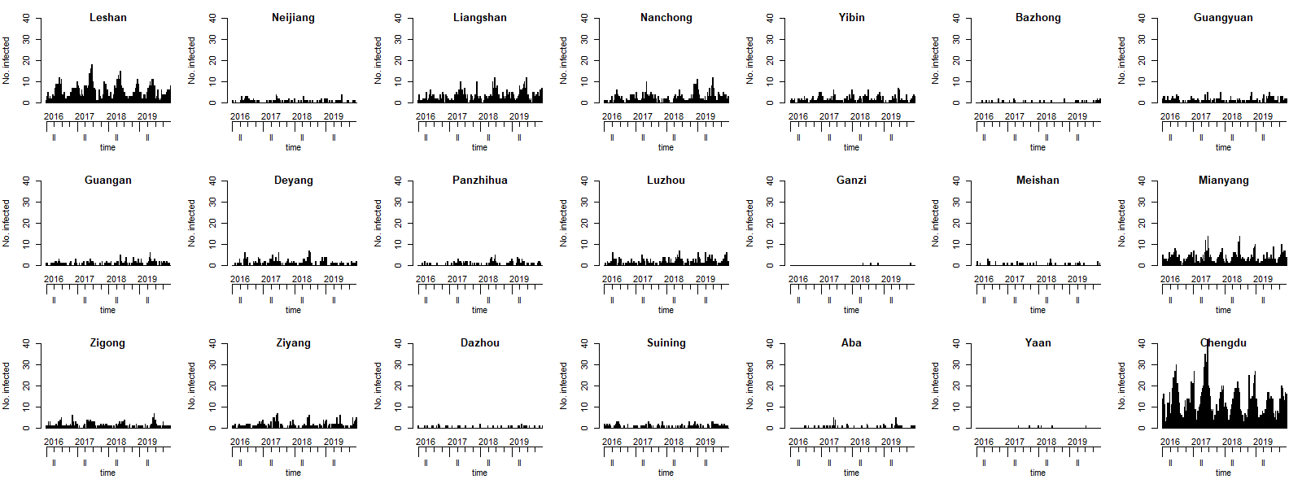

Figure A2 The fitted values for 21 cities (/prefectures) in Sichuan province during 2016-2019
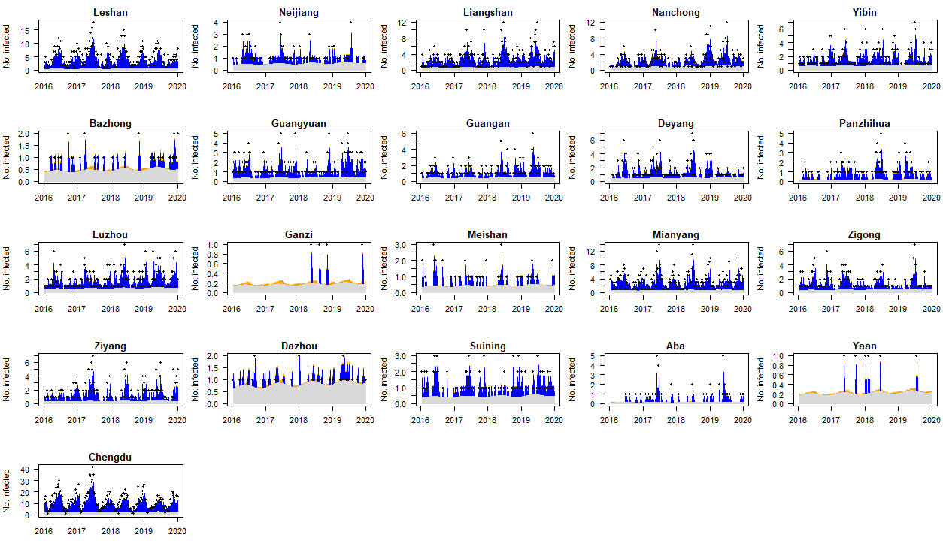

Figure A3. The estimated multiplicative effect of seasonality on the endemic mean
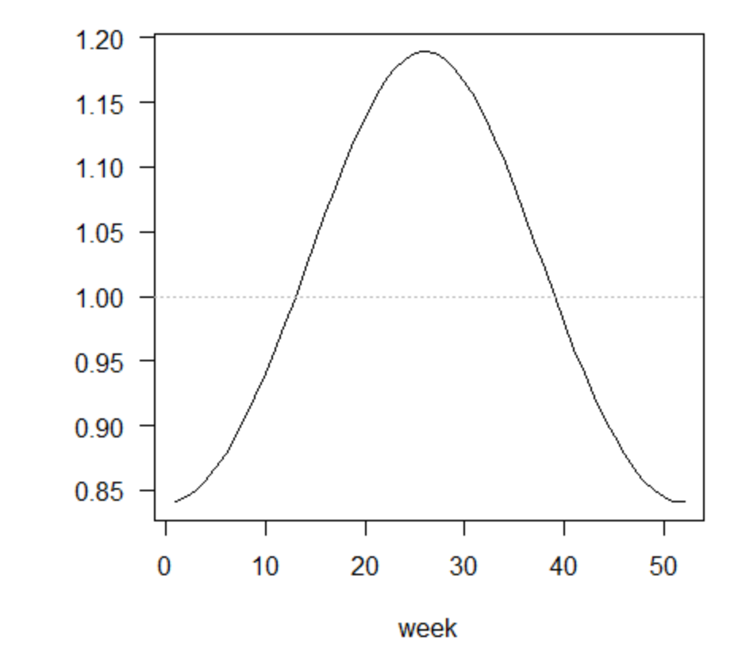

Table A3 Model selection and comparison
 |  | Model 1 |  |  | Model 2 |  |  | Model 3 |  |  | Model 4 |  |  | Model 5 |  | Model 6 | (with random effect)
Parameter | RR | 95%CI |  | RR | 95%CI |  | RR | 95%CI |  | RR | 95%CI |  | RR | 95%CI |  | RR | 95%CI |  | P value
 |  | lower | upper |  | lower | upper |  | lower | upper |  | lower | upper |  | lower | upper |  | lower | upper
Epidemic within city (autoregressive)
Intercept | 0.5383 | 0.3803 | 0.7620 | 0.7057 | 0.4821 | 1.0331 | 0.3376 | 0.1854 | 0.6149 | 0.4678 | 0.1621 | 1.3499 | 0.5022 | 0.1529 | 1.6489 | 0.1588 | 0.0034 | 7.4853 | 0.349
Density | 1.0444 | 0.9858 | 1.1065 | 0.9853 | 0.9238 | 1.0510 | 0.7475 | 0.6828 | 0.8184 | 0.7528 | 0.6871 | 0.8247 | 0.6673 | 0.579 | 0.7692 | 0.8162 | 0.5192 | 1.2831 | 0.379
School holidays |  |  |  | 0.6666 | 0.5608 | 0.7924 | 0.6429 | 0.5408 | 0.7643 | 0.6198 | 0.5098 | 0.7535 | 0.6325 | 0.5124 | 0.7809 | 0.4712 | 0.2776 | 0.7999 | 0.005
GDP |  |  |  |  |  |  | 1.3327 | 1.1965 | 1.4844 | 1.3483 | 1.1657 | 1.5595 | 1.1278 | 0.9627 | 1.3212 | 1.6331 | 0.9146 | 2.916 | 0.097
number of health institutions |  |  |  |  |  |  |  |  |  | 0.9484 | 0.7888 | 1.1403 | 0.7983 | 0.569 | 1.1201 | 0.8328 | 0.2562 | 2.7073 | 0.761
number of kindergartens |  |  |  |  |  |  |  |  |  |  |  |  | 2.1945 | 1.6516 | 2.916 | 1.0954 | 0.4324 | 2.7752 | 0.848
number of primary schools |  |  |  |  |  |  |  |  |  |  |  |  | 0.7254 | 0.5344 | 0.9848 | 0.7951 | 0.3146 | 2.0093 | 0.628
Epidemic among cities (spatiotemporal)
Intercept | 0.0016 | 0.0001 | 0.0181 | 0.0001 | 0.0001 | 0.6598 | 0.0002 | 0.0001 | 0.0003 | 0.0001 | 0.0001 | 0.0007 | 0.0049 | 7.00E-04 | 0.0342 | 0.0024 | 0.0001 | 2.5915 | 0.091
Density | 1.9458 | 1.3258 | 2.8557 | 2.7089 | 0.7216 | 10.1694 | 1.0114 | 0.9293 | 1.1007 | 0.9806 | 0.8398 | 1.1450 | 1.2406 | 1.0412 | 1.4781 | 1.1721 | 0.6524 | 2.1058 | 0.595
GDP |  |  |  |  |  |  | 2.8354 | 2.5248 | 3.1842 | 3.2734 | 2.7182 | 3.9420 | 2.7515 | 2.1115 | 3.5854 | 2.6898 | 1.1516 | 6.2822 | 0.022
Passengers |  |  |  |  |  |  |  |  |  |  |  |  | 0.6769 | 0.538 | 0.8516 | 0.7528 | 0.4971 | 1.14 | 0.18
Endemic
Intercept | 1.0018 | 1.0005 | 1.0031 | 1.0014 | 1.0002 | 1.0026 | 0.9979 | 0.9909 | 1.0048 | 0.9990 | 0.9969 | 1.0010 | 0.9986 | 0.9965 | 1.0006 | 0.9965 | 0.9929 | 1.0001 | 0.053
School holidays |  |  |  | 0.6693 | 0.5554 | 0.8065 | 313.2752 | 0.4519 | 217172.6761 | 0.6841 | 0.5098 | 0.9181 | 0.6129 | 0.4526 | 0.83 | 0.5299 | 0.3883 | 0.7233 | <0.001
number of kindergartens |  |  |  |  |  |  |  |  |  |  |  |  | 1.1684 | 0.9231 | 1.4789 | 2.144 | 0.6288 | 7.3111 | 0.223
number of primary schools |  |  |  |  |  |  |  |  |  |  |  |  | 2.9397 | 2.0369 | 4.2427 | 0.4996 | 0.178 | 1.4021 | 0.188
AIC | 11903 |  |  | 11837.21 |  |  | 11743.17 |  |  | 11670.93 |  |  | 11604.41 |  |  | -
logs | 1.543 |  |  | 1.526 |  |  | 1.534 |  |  | 1.51 |  |  | 1.516 |  |  | 1.424
rps | 0.809 |  |  | 0.782 |  |  | 0.77 |  |  | 0.753 |  |  | 0.741 |  |  | 0.653
Note: Sequential fixed model building from intercept-only model (model 1) to the final model (model 5) and the optimal model(model 6) introduced ramdom effects based on model 5; Statistically
significant explanatory factors are in bold

Table A4 Model without spatial term
 |  | Model 1 |  |  | Model 2 |  |  | Model 3 |  |  | Model 4 |  |  | Model 5 |  | Model 6 | (with random effect)
Parameter | RR | 95%CI |  | RR | 95%CI |  | RR | 95%CI |  | RR | 95%CI |  | RR | 95%CI |  | RR | 95%CI |  | P value
 |  | lower | upper |  | lower | upper |  | lower | upper |  | lower | upper |  | lower | upper |  | lower | upper
Epidemic within city (autoregressive)
Intercept | 0.6342 | 0.4417 | 0.9106 | 0.6515 | 0.4531 | 0.9368 | 0.2037 | 0.1341 | 0.3095 | 0.4518 | 0.1812 | 1.1265 | 0.9479 | 0.3091 | 2.9072 | 0.0711 | 0.003 | 1.7088
Density | 0.9935 | 0.9348 | 1.056 | 0.9968 | 0.9378 | 1.0595 | 0.7665 | 0.7061 | 0.8321 | 0.7576 | 0.6967 | 0.8237 | 0.7318 | 0.6424 | 0.8337 | 0.8682 | 0.6059 | 1.2439 | 0.441
School holidays |  |  |  | 0.6616 | 0.5557 | 0.7877 | 0.6535 | 0.5501 | 0.7765 | 0.6563 | 0.5521 | 0.7801 | 0.6453 | 0.5384 | 0.7734 | 0.5434 | 0.4026 | 0.7334 | <0.001
GDP |  |  |  |  |  |  | 1.4177 | 1.3127 | 1.5312 | 1.5472 | 1.3718 | 1.745 | 1.3585 | 1.174 | 1.5719 | 1.3284 | 0.8531 | 2.0687 | 0.209
number of health institutions |  |  |  |  |  |  |  |  |  | 0.846 | 0.712 | 1.0054 | 0.6035 | 0.4296 | 0.8478 | 1.0616 | 0.4405 | 2.5581 | 0.894
number of kindergartens |  |  |  |  |  |  |  |  |  |  |  |  | 1.4875 | 1.1582 | 1.9105 | 1.177 | 0.5786 | 2.3942 | 0.653
number of primary schools |  |  |  |  |  |  |  |  |  |  |  |  | 1.1165 | 0.8583 | 1.4525 | 0.7709 | 0.3649 | 1.6286 | 0.495
Endemic
Intercept | 1.0016 | 1.0005 | 1.0026 | 1.0013 | 1.0003 | 1.0023 | 1.0009 | 0.9999 | 1.0019 | 1.0009 | 0.9999 | 1.0019 | 1.0009 | 0.9999 | 1.0019 | 0.0105 | 2.00E-04 | 0.6902 | <0.001
School holidays |  |  |  | 0.6518 | 0.5544 | 0.7664 | 0.6387 | 0.5438 | 0.7501 | 0.6363 | 0.542 | 0.7469 | 0.6291 | 0.5375 | 0.7364 | 0.5854 | 0.5125 | 0.6687 | <0.001
number of kindergartens |  |  |  |  |  |  |  |  |  |  |  |  | 1.4127 | 1.2057 | 1.6553 | 0.7658 | 0.4141 | 1.416 | 0.395
number of primary schools |  |  |  |  |  |  |  |  |  |  |  |  | 0.8081 | 0.6488 | 1.0064 | 0.97 | 0.4772 | 1.9721 | 0.933
AIC | 11933.73 |  |  | 11846.7 |  |  | 11764.91 |  |  | 11763.3 |  |  | 11730.46 |  |  | -
logs | 1.528 |  |  | 1.514 |  |  | 1.503 |  |  | 1.507 |  |  | 1.508 |  |  | 1.448
rps | 0.8 |  |  | 0.774 |  |  | 0.76 |  |  | 0.763 |  |  | 0.756 |  |  | 0.678
Note: Sequential fixed model building from intercept-only model (model 1) to the final model (model 5) and the optimal model(model 6) introduced ramdom effects based on model 5;
Table A5 The estimates of random effects
Random effects | RR | 95%CI |  | P value
 |  | upper | lower
Epidemic within city (autoregressive)
Leshan | 1.1716 | 0.6735 | 2.038 | 0.575
Neijiang | 0.7222 | 0.3669 | 1.4214 | 0.346
Liangshan | 1.47 | 0.7416 | 2.914 | 0.27
Nanchong | 1.1315 | 0.5664 | 2.2605 | 0.726
Yibin | 0.9039 | 0.5068 | 1.6119 | 0.732
Bazhong | 0.9471 | 0.4685 | 1.9148 | 0.88
Guangyuan | 0.8737 | 0.4511 | 1.6925 | 0.689
Guang’an | 1.1956 | 0.6391 | 2.2369 | 0.576
Deyang | 0.9716 | 0.5067 | 1.8631 | 0.931
Panzhihua | 1.4847 | 0.742 | 2.9706 | 0.264
Luzhou | 0.9617 | 0.5301 | 1.7447 | 0.898
Ganzi | 0.9055 | 0.4228 | 1.9394 | 0.798
Meishan | 0.8418 | 0.4365 | 1.6234 | 0.607
Mianyang | 0.8122 | 0.4519 | 1.4596 | 0.487
Zigong | 0.6872 | 0.3657 | 1.2916 | 0.244
Ziyang | 1.2145 | 0.6215 | 2.3733 | 0.57
Dazhou | 0.7877 | 0.4144 | 1.4972 | 0.466
Suining | 1.1131 | 0.5827 | 2.1263 | 0.746
Aba | 0.9799 | 0.4759 | 2.0176 | 0.956
Ya’an | 0.87 | 0.4131 | 1.8323 | 0.714
Chengdu | 1.4828 | 0.7389 | 2.9756 | 0.268
Epidemic among cities (spatiotemporal)
Leshan | 3.9366 | 1.8292 | 8.4721 | <0.001
Neijiang | 0.5708 | 0.2014 | 1.6177 | 0.291
Liangshan | 3.1687 | 1.1534 | 8.7054 | 0.025
Nanchong | 2.8815 | 1.4418 | 5.7587 | 0.003
Yibin | 0.842 | 0.373 | 1.9009 | 0.679
Bazhong | 0.4154 | 0.1215 | 1.4205 | 0.161
Guangyuan | 1.9949 | 0.9107 | 4.3699 | 0.084
Guang’an | 1.3016 | 0.5486 | 3.0883 | 0.55
Deyang | 0.7272 | 0.3059 | 1.7285 | 0.471
Panzhihua | 0.7028 | 0.2362 | 2.0916 | 0.526
Luzhou | 1.9499 | 0.9359 | 4.0622 | 0.075
Ganzi | 0.2899 | 0.0583 | 1.441 | 0.13
Meishan | 0.3138 | 0.1224 | 0.8047 | 0.016
Mianyang | 3.2599 | 1.2948 | 8.2074 | 0.012
Zigong | 0.9483 | 0.3591 | 2.5041 | 0.915
Ziyang | 3.4968 | 1.2991 | 9.4122 | 0.013
Dazhou | 0.2117 | 0.0825 | 0.5435 | 0.001
Suining | 0.7615 | 0.2998 | 1.9341 | 0.567
Aba | 3.3242 | 0.7833 | 14.1078 | 0.103
Ya’an | 0.114 | 0.0354 | 0.3667 | <0.001
Chengdu | 0.8963 | 0.1414 | 5.6817 | 0.908
Endemic
Leshan | 7.0567 | 3.335 | 14.9316 | <0.001
Neijiang | 1.075 | 0.4607 | 2.5082 | 0.867
Liangshan | 8.2206 | 1.7757 | 38.0578 | 0.007
Nanchong | 0.3259 | 0.0794 | 1.3384 | 0.12
Yibin | 1.5341 | 0.6278 | 3.7492 | 0.348
Bazhong | 0.6912 | 0.2034 | 2.3488 | 0.554
Guangyuan | 3.4318 | 1.1217 | 10.4994 | 0.031
Guang’an | 0.4538 | 0.1183 | 1.7406 | 0.249
Deyang | 1.9802 | 0.6491 | 6.0412 | 0.23
Panzhihua | 1.6616 | 0.3666 | 7.5306 | 0.51
Luzhou | 1.062 | 0.3652 | 3.088 | 0.912
Ganzi | 0.2294 | 0.046 | 1.1453 | 0.073
Meishan | 0.4557 | 0.1402 | 1.4812 | 0.191
Mianyang | 2.2613 | 0.7521 | 6.7991 | 0.146
Zigong | 2.0477 | 0.748 | 5.6061 | 0.163
Ziyang | 0.3795 | 0.08 | 1.8 | 0.222
Dazhou | 0.1997 | 0.0667 | 0.5986 | 0.004
Suining | 0.8261 | 0.2757 | 2.4758 | 0.733
Aba | 0.597 | 0.0909 | 3.9199 | 0.591
Ya’an | 0.2164 | 0.0502 | 0.9336 | 0.04
Chengdu | 2.1773 | 0.4469 | 10.6068 | 0.335

Figure A4 Spatial connectivity weights
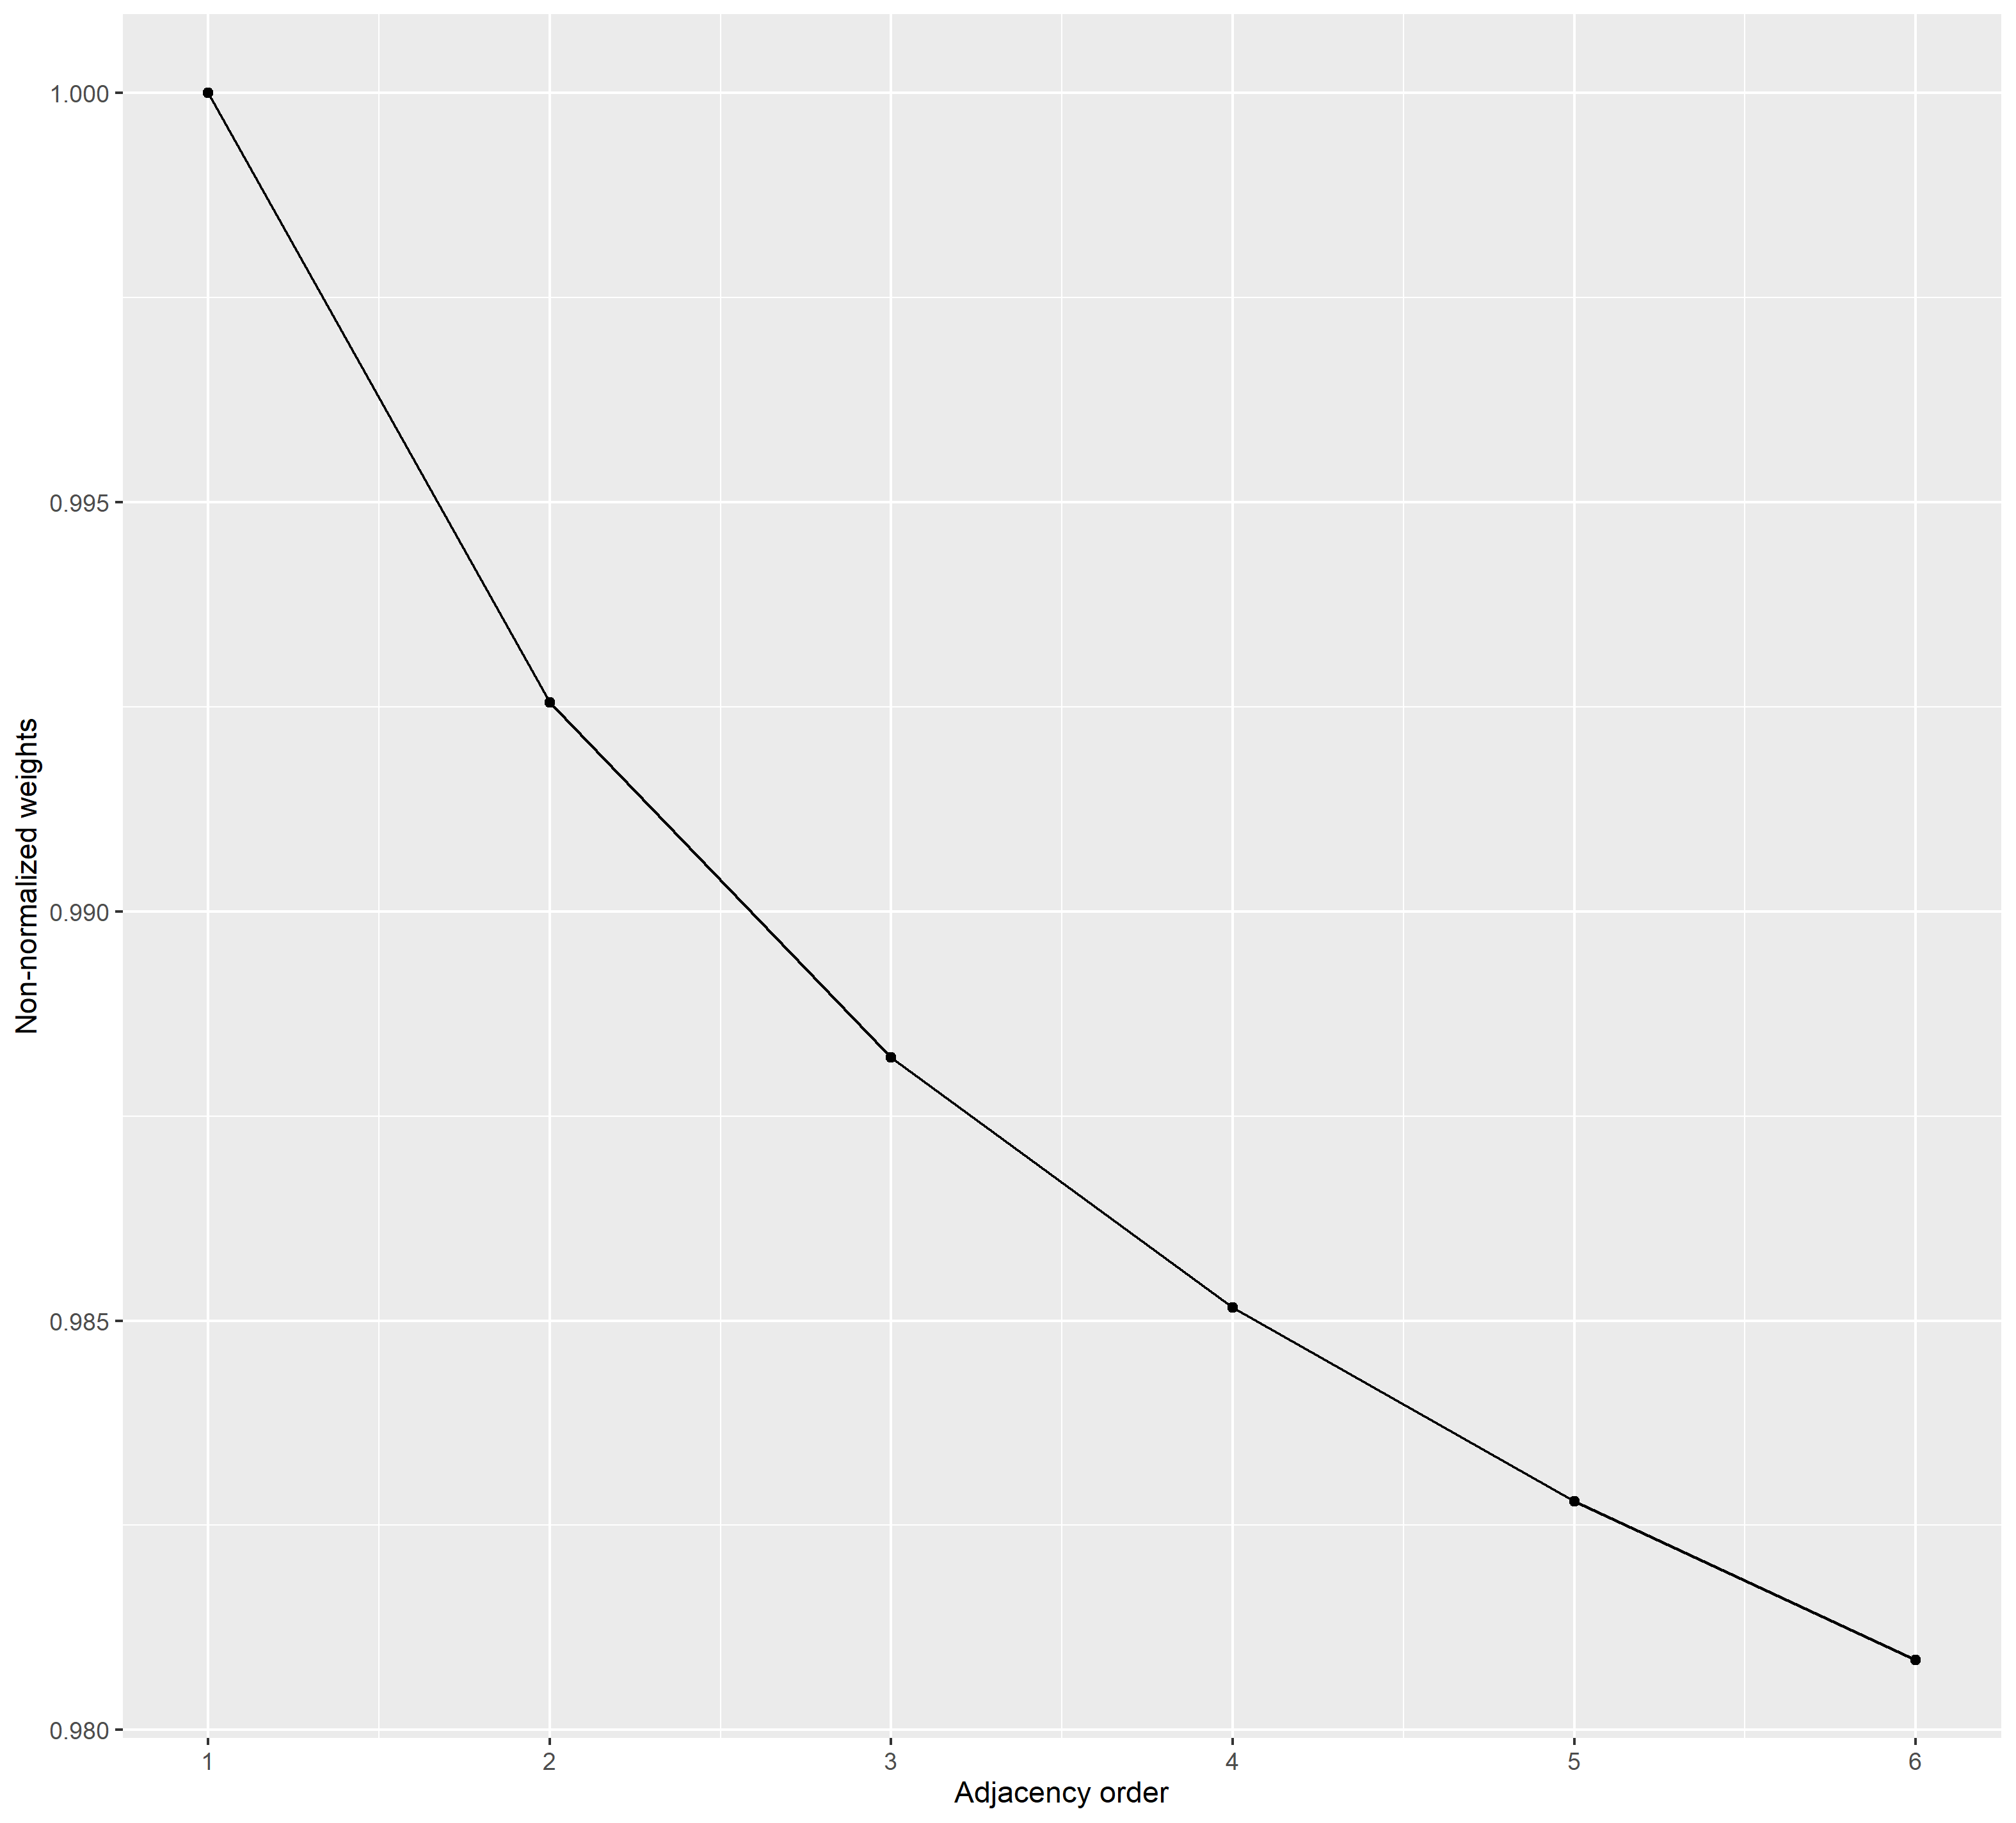

Figure A5 The matrix of cities showing the connectivity weights

