Modelling population responses to workplace minimum dietary standards introduced as workers return after social lockdowns

Additional File 2 Probability of matching group dietary choices

Individual agents were assigned a constant probability of matching their meal preference to their eating group. Agents drew a random number from a triangular distribution (minimum 0, peak 0.39, maximum 1) based on matching meal sizes (Vartanian et al, 2015).
Figure S3. The correlation between an agent’s probability of matching the group preference and an agent’s dietary index was null (Pearson’s rho -0.03, -0.08 to 0.02 assuming no adult isolation; 0.03, -0.02 to 0.08 with 100% adult isolation).
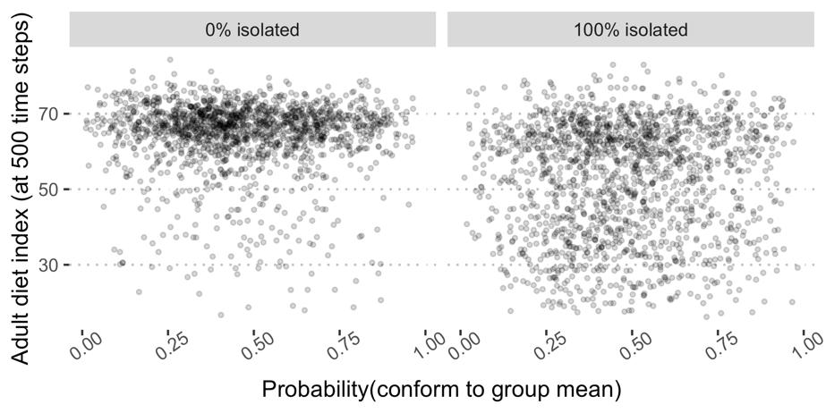

Figure S4. In sensitivity analysis, the triangular distribution was replaced with a beta distribution that was skewed either to individuals conform to the group diet or not.
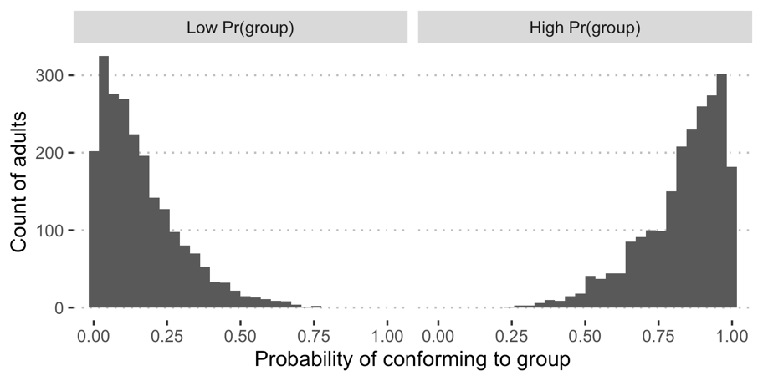
Assuming the same model structure with minimum standards of 60 in workplaces and schools, individual trajectories are illustrated below. In the low probability of group conformity (Figure S4: left; Figure S4: top row) the weight distribution was sampled from a beta distribution with shape parameters a=1, b=5; in the high conformity model (right above; bottom row below) the weights were sampled from a beta distribution with a=5, b=1. With extreme values, the difference between results is the clustering around the mean, which is tighter with greater conformity to modelling the group dietary preferences.

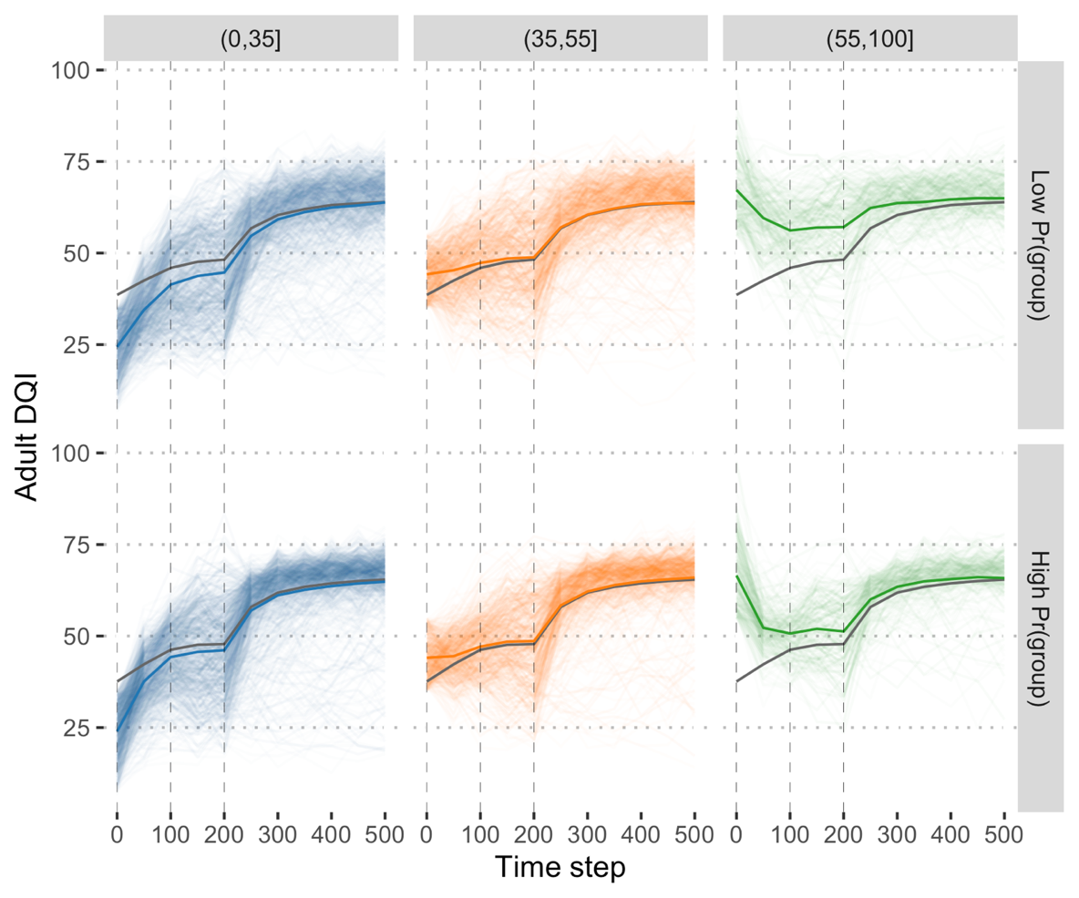
Figure S5. Adult DQI trajectories from sensitivity analysis using a beta distribution to describe the probability that individuals conform to the group diet or not.

