Female and male health adjusted life expectancy at birth (years), Somalia 1990 - 2030

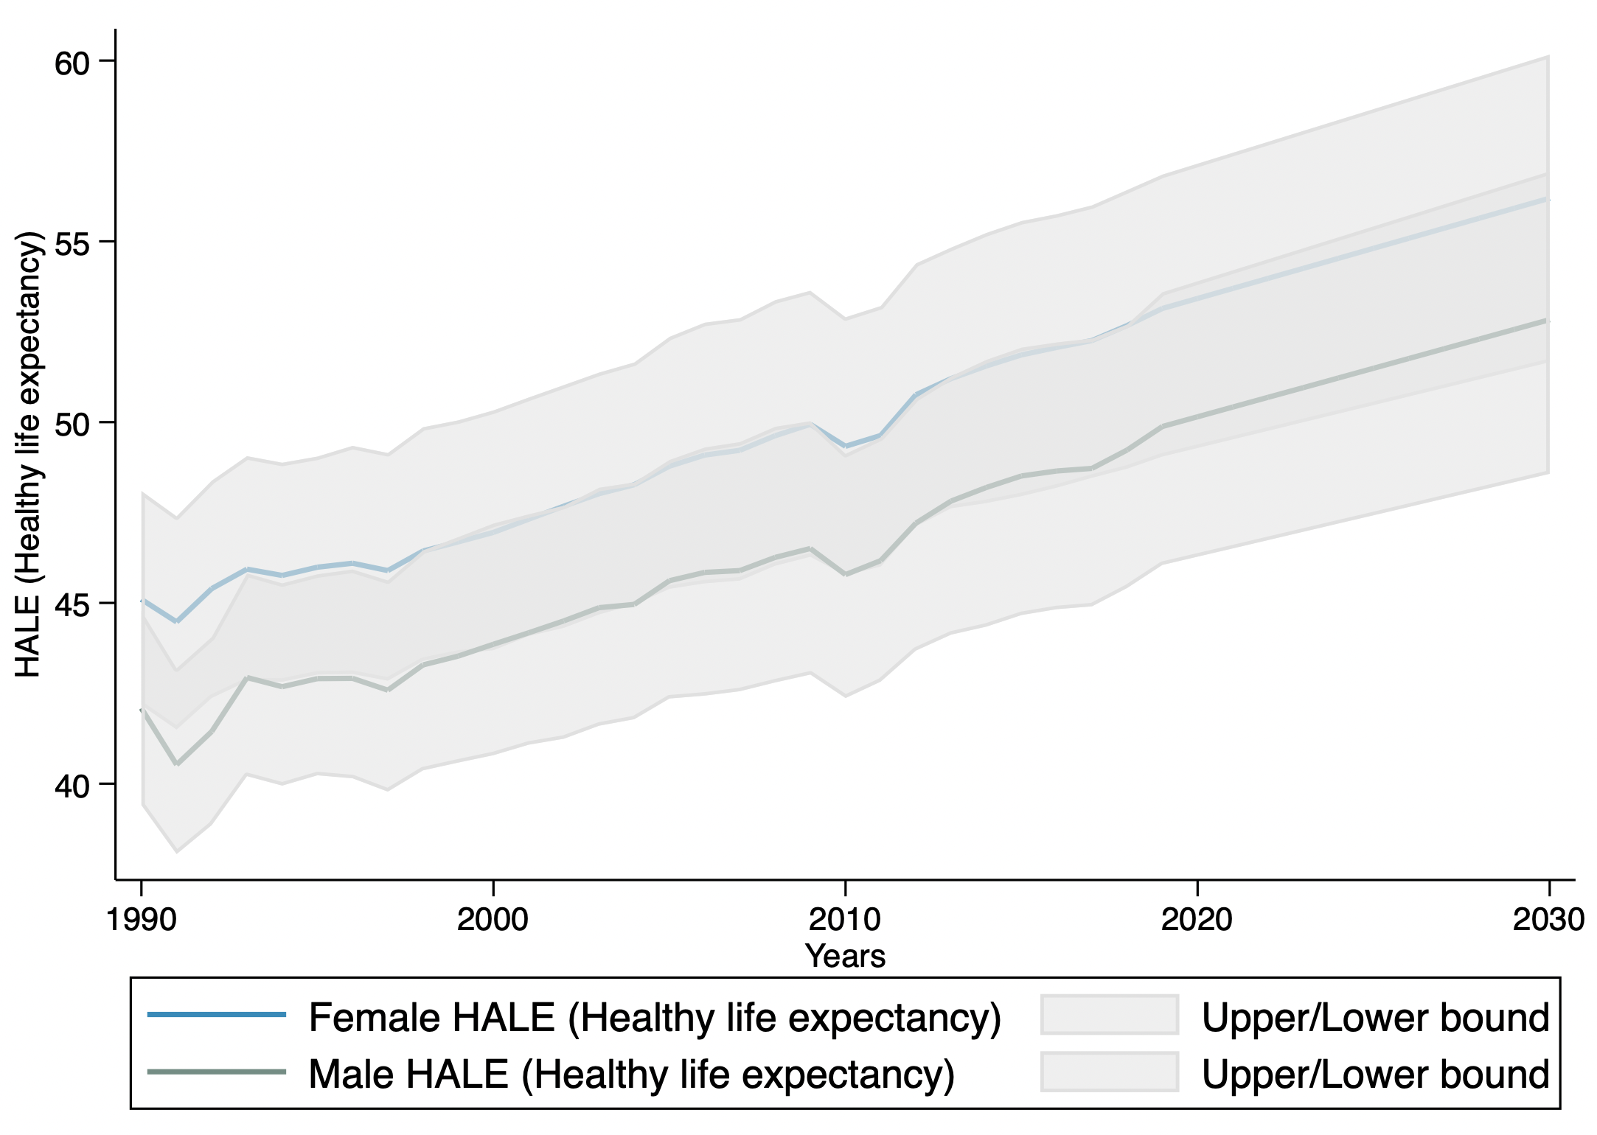
Note:
- Lower and Upper bounds refer to the 90 percent uncertainty intervals for the estimates.
- Observed values 1990 – 2019, estimated projections: 2020 – 2030

