Supplementary Materials
Supplementary table 1 Characteristics of included dose-response relationship studies
First Author | Year | Region | Gender | Sample size | Age, year | Date | Endpoint | PY/QY | NOS
 |  |  |  |  |  |  |  | interval*
Yi-xiong Lei | 1996 | Guangdong | male | 1,384 |  | 1986 | prevalence | 20 | 5
Moira Chan-Yeung | 2003 | Hong Kong | male | 662 | 55–57 | 1999–2001 | prevalence | 20 | 7
Zhiqiang Liu | 2015 | Fujian | male | 1,878 |  | 2006–2013 | prevalence | 20 | 6
Jinman Zhuang | 2021 | Fujian | male | 3,244 | 59 | 2006–2015 | prevalence | 20 | 7
Wuwilliams, A. H. | 1990 | Liaoning | female | 1,923 | 55 | 1985–1987 | prevalence | 15，5 | 6
X.-R. Wang | 2009 | Hong Kong | female | 601 | 65 | 2002–2004 | prevalence | 25 | 7
Yuk-Lan Chiu | 2010 | Hong Kong | female | 601 | 65 | 2002–2004 | prevalence | 25 | 6
Zi-Yi Jin | 2013 | Jiangsu | both | 5,967 | 63–64 | 2003–2010 | prevalence | 30 | 5
Jin-Kou Zhao | 2017 | Jiangsu | both | 10,890 | 64 | 2003–2010 | prevalence | 20 | 6
YU-TANG GAO | 1988 | Shanghai | male, female | 2,899 | 35–69 | 1984–1986 | prevalence | 5** | 5
He, Y.# | 2014 | Shaanxi | both | 1,494 | 51.5–87.8 | 1994–2011 | mortality | 35 | 9
Chang, L. C. # | 2014 | Taiwan | both | 1,677 | ≥65 | 2001–2010 | mortality | 5** | 9
Note: *PY: pack-year; **QY: quit-year; # cohort study

Supplementary table 2 Smoking definition of included dose-response relationship studies
Studies | Status | Definition
Yi-xiong Lei, 1996 | Ever | Not specified.
Moira Chan-Yeung, 2003 | Ever | Ever-smoker: one who had smoked at least one cigarette a day, pipe, water pipes, cigars, and/or hand rolled cigarettes, for 1 year or more.
Zhiqiang Liu, 2015 | Ever | Smoking was defined who had smoked more than 100 cigarettes in their life.
Jinman Zhuang, 2021 | Ever | Smoking was defined if participants reported to have smoked a total of at least 100 cigarettes in their lifetime.
Wuwilliams, A. H., 1990 | Ever | Not specified.
X.-R. Wang, 2009 | Ever | An ever smoker was defined as one who had ever smoked >20 packs of cigarettes in lifetime, more than one cigarette a day, or more than one cigar a week for 1 year.
Yuk-Lan Chiu, 2010 | Ever | Smoker was defined as one who had ever smoked more than 20 packs of cigarettes in lifetime, or more than one cigarette a day, or more than one cigar a week for 1 year.
Zi-Yi Jin, 2013 | Ever | Not specified.
Jin-Kou Zhao, 2017 | Ever | Ever smokers were defined as individuals who had smoked at least 100 cigarettes in their lifetimes.
He, Y., 2014 | Current | Current smokers were persons who were current smokers at either the 1976 baseline or the 1994 follow-up.
YU-TANG GAO, 1988 | Former | Not specified.
Chang, L. C.， 2014 | Former | Former smokers were those who had smoked more than 100 cigarettes in their life time but did not smoke in the past month.

Supplementary Figure
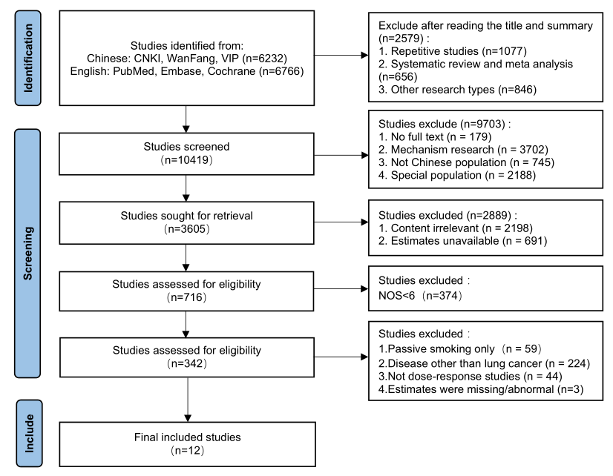
Figure S1 Flowchart of the literature screening process

