Pregnancy Intentions of Youth in the Era of Climate Change: A Qualitative Auto-Photography Study
Supplementary File I- Additional Photographs

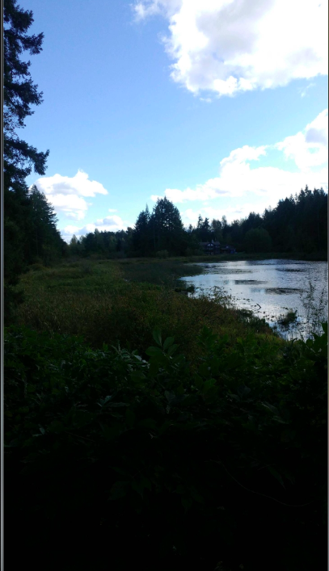
Supplementary figure 1, Clear skies in Nanaimo, Participant 1

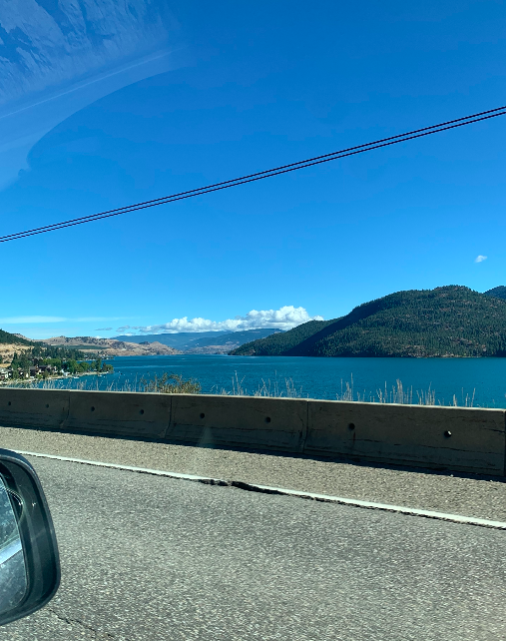
Supplementary figure 2, Fresh water lake in the Okanagan, Participant 1

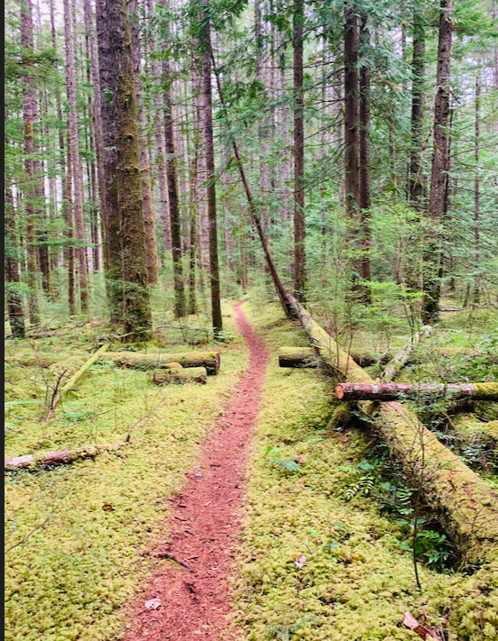
Supplementary figure 3, Lush and green on Quadra Island, Participant 1

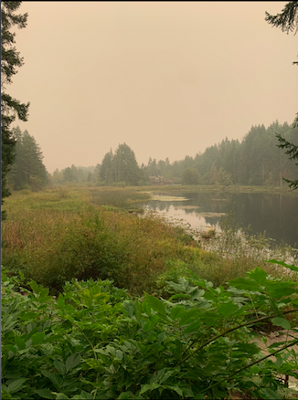
Supplementary figure 4, Smoke in Nanaimo, Participant 1

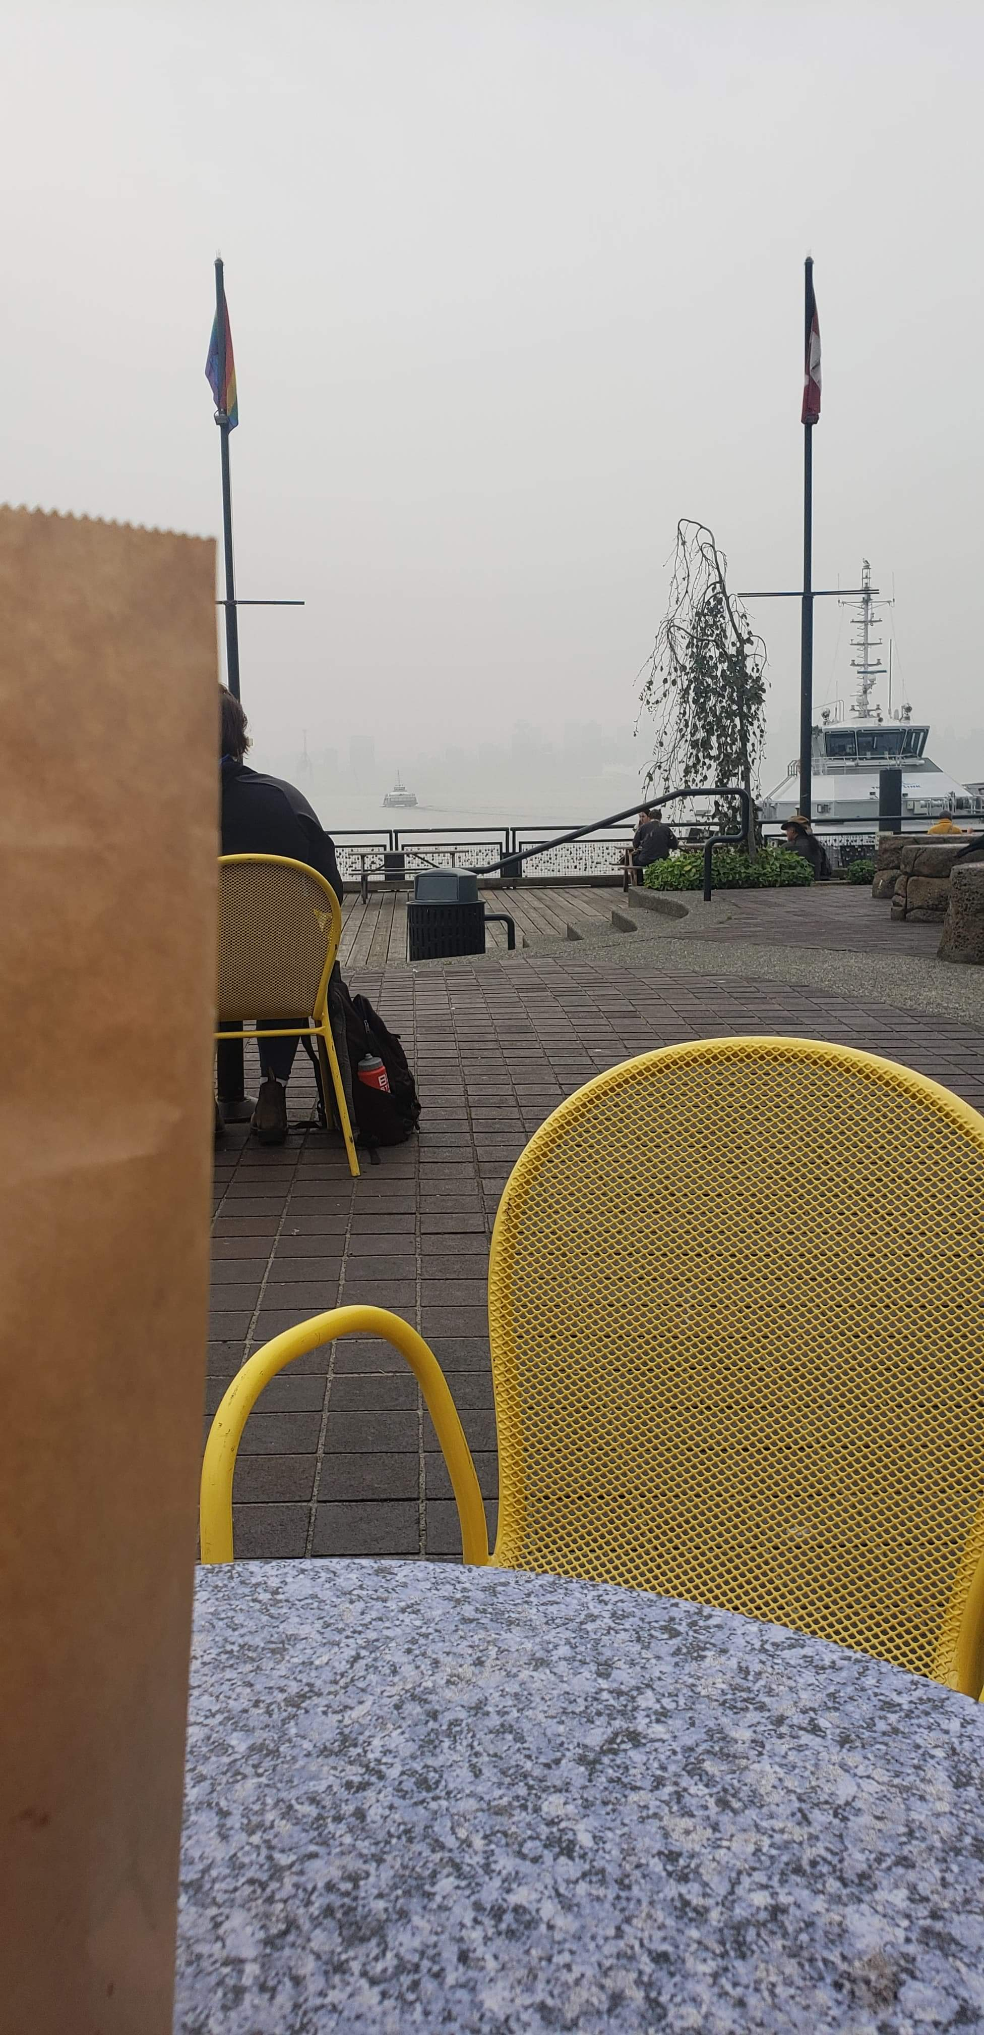
Supplementary figure 5, Wildfire Smoke, Participant 2

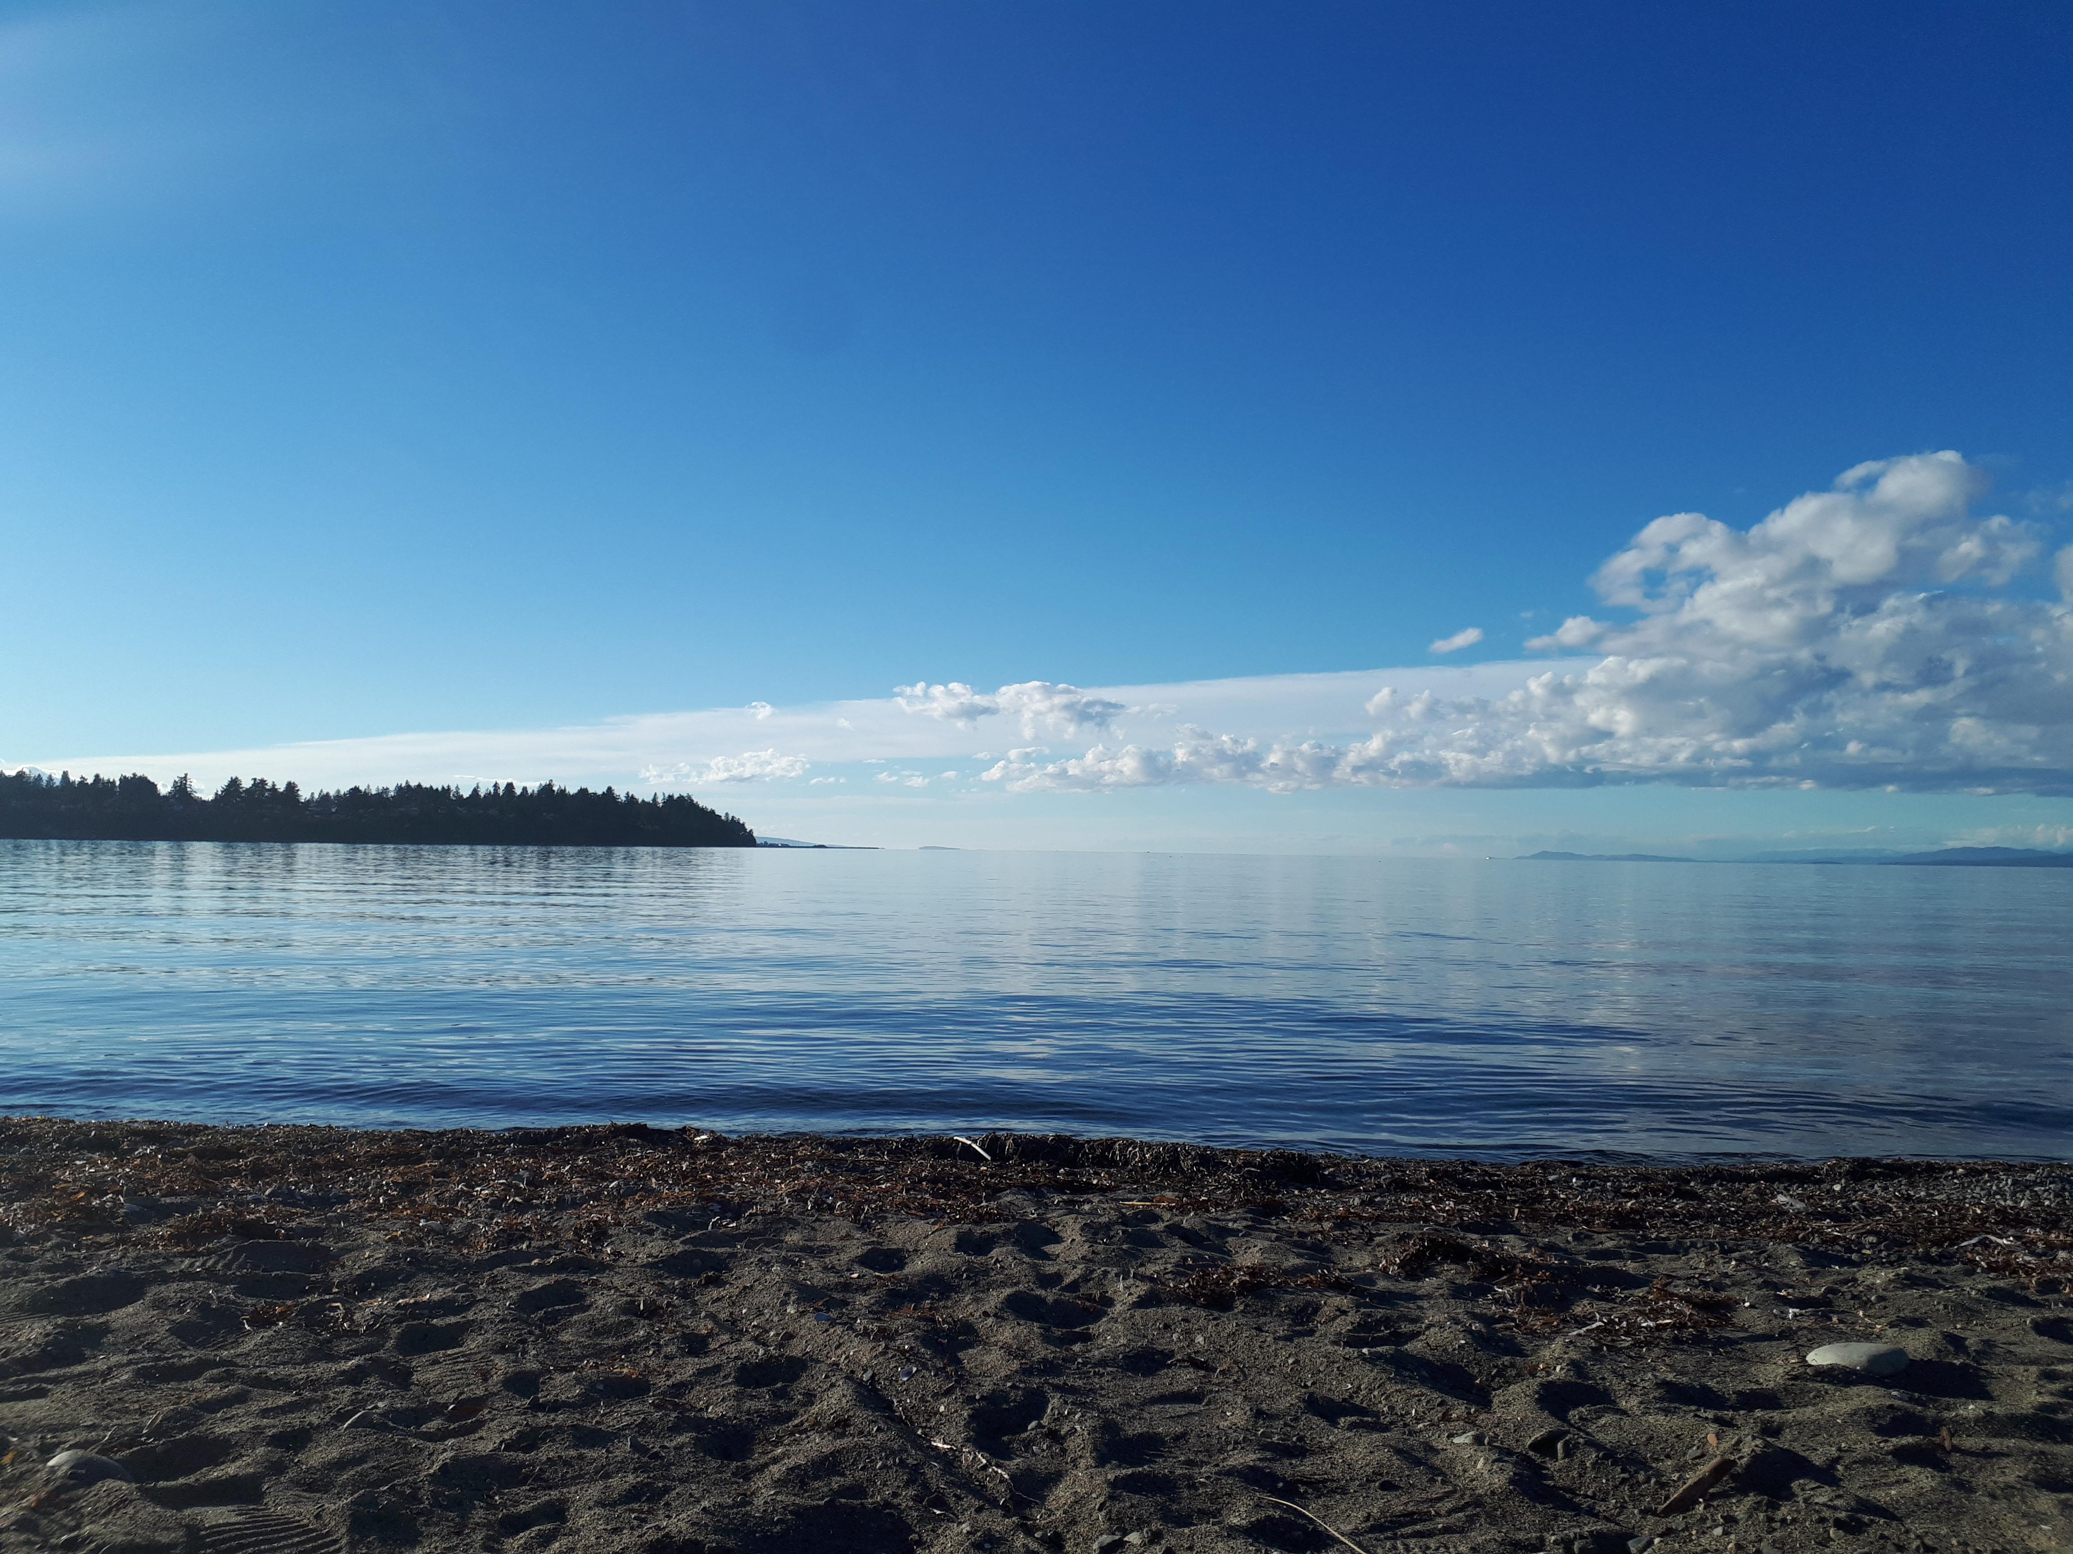
Supplementary figure 6, High Tide, Participant 2

Supplementary figure 7, Industrialization, Participant 2

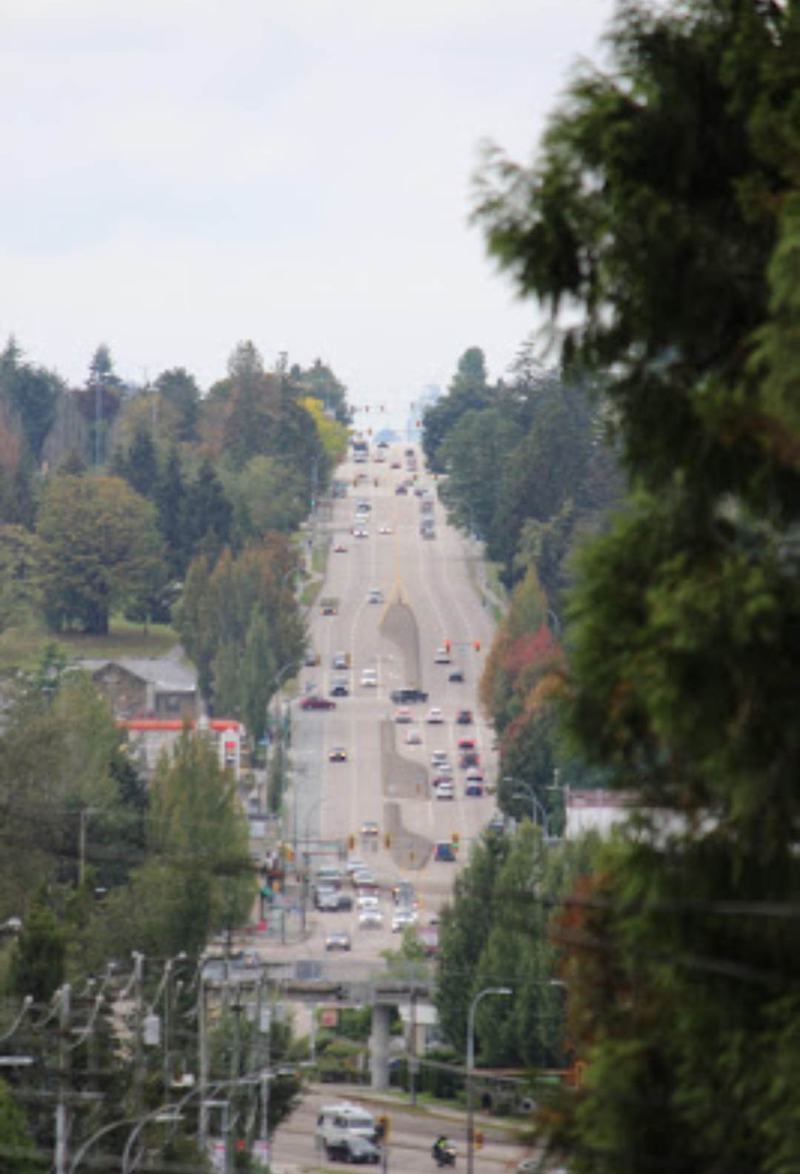
Supplementary figure 8, Busy Streets, Participant 2

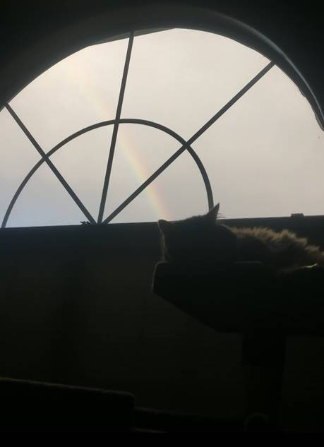
Supplementary figure 9, Foggy Future, Participant 3

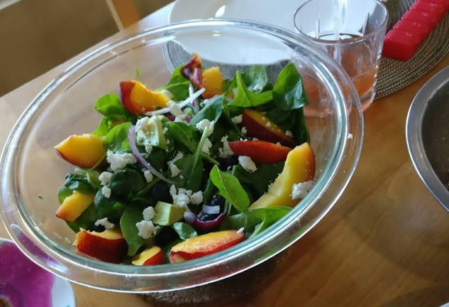
Supplementary figure 10, We are able to teach environmentally conscious dietary choices, such as reduce consumption of meat, Participant 3

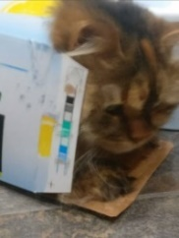
Supplementary figure 11, Cat promoting recycling, Participant 3

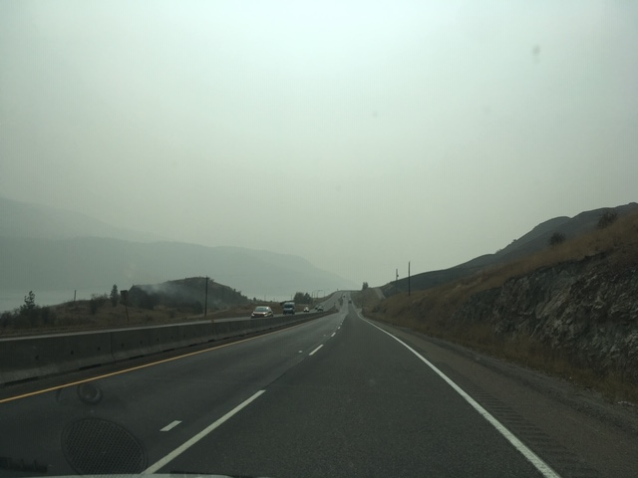 Supplementary figure 12, What’s up ahead? Participant 4

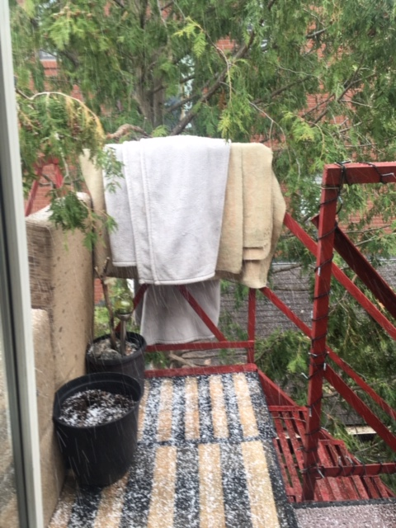
Supplementary figure 13, There is no God, Participant 4

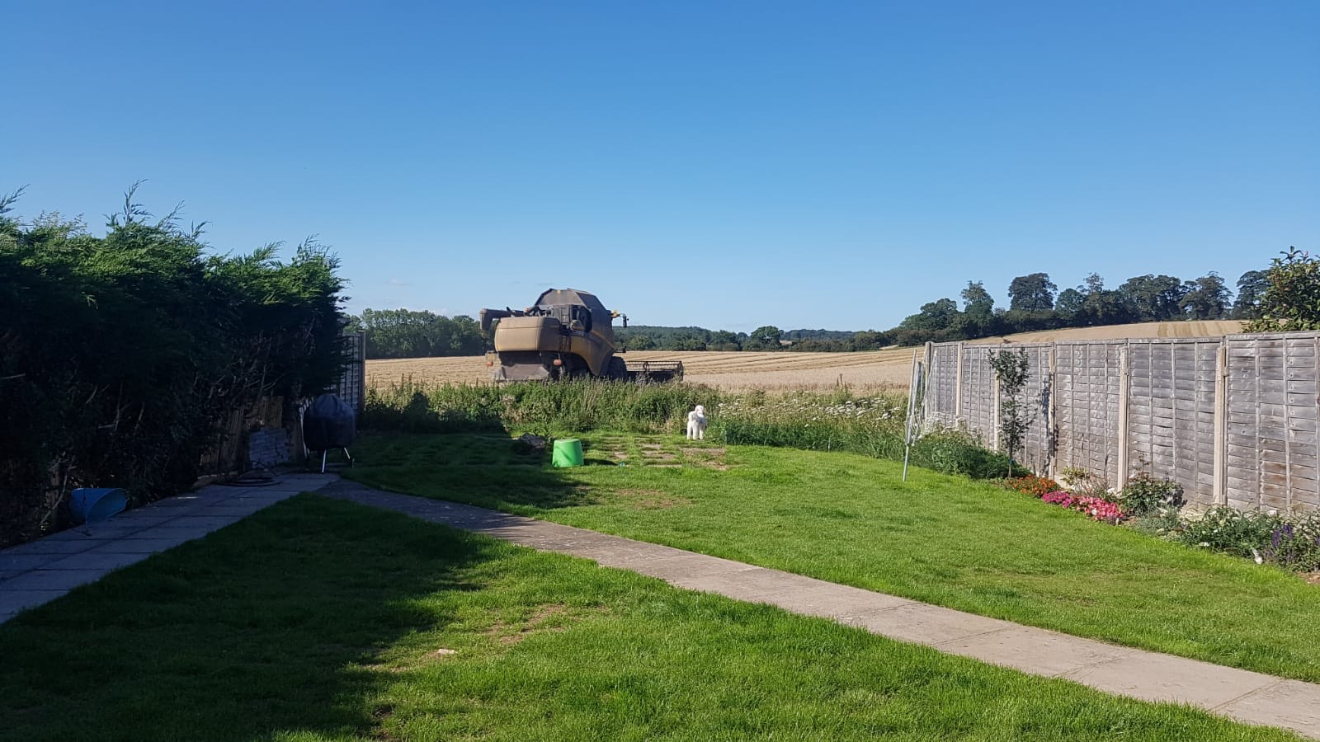 Supplementary figure 14, Ignorance is Bliss, Participant 5

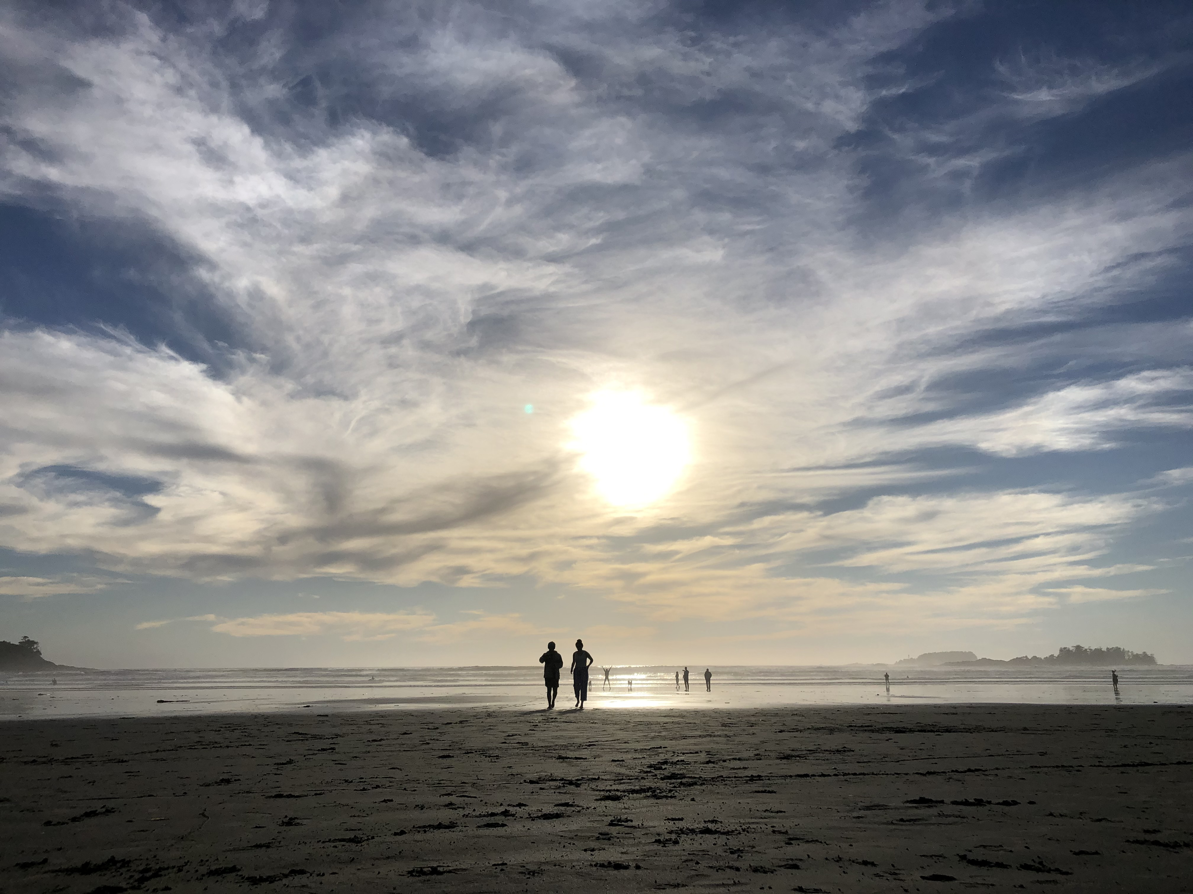
Supplementary figure 15, Taking in the Natural Beauty, Participant 5

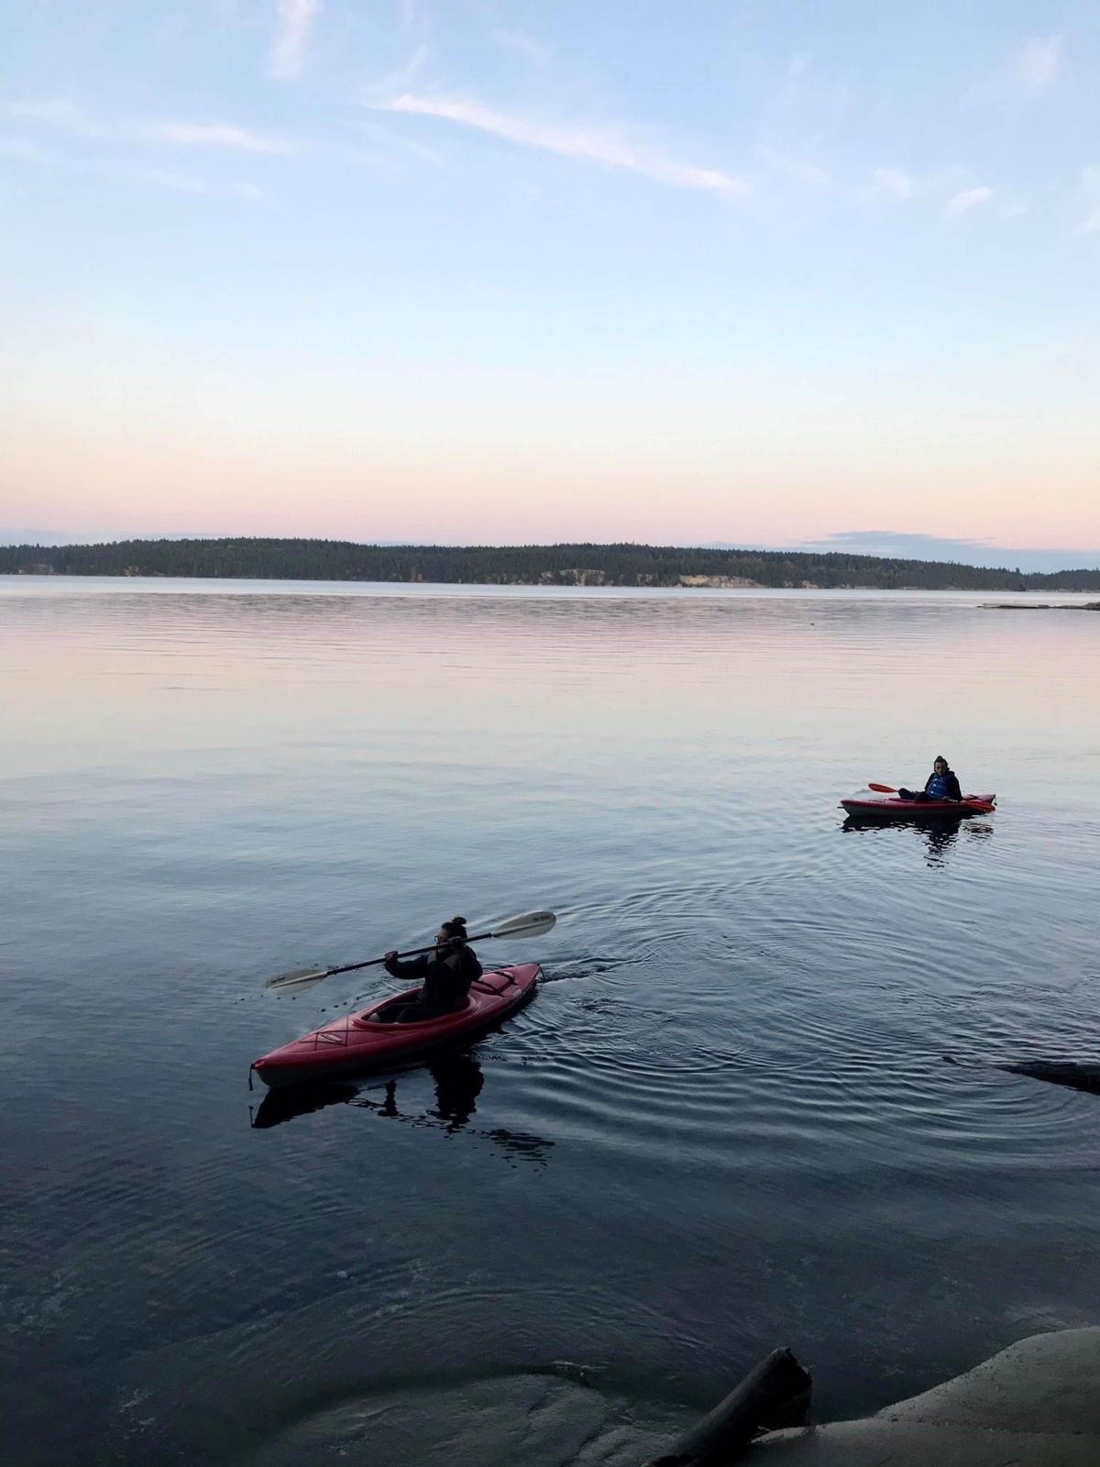
Supplementary figure 16, Nature’s Serenity, Participant 5
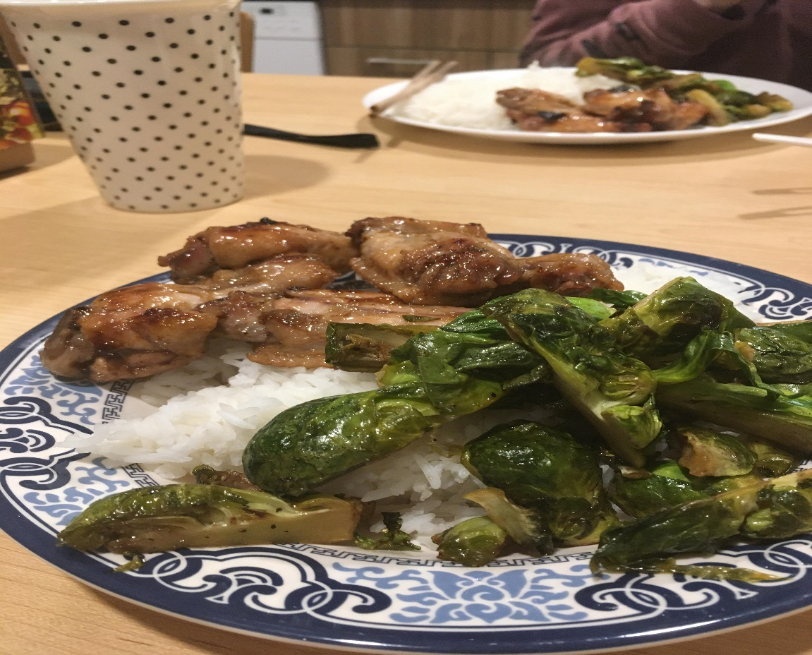
Supplementary figure 17, Eating with Family, Participant 6

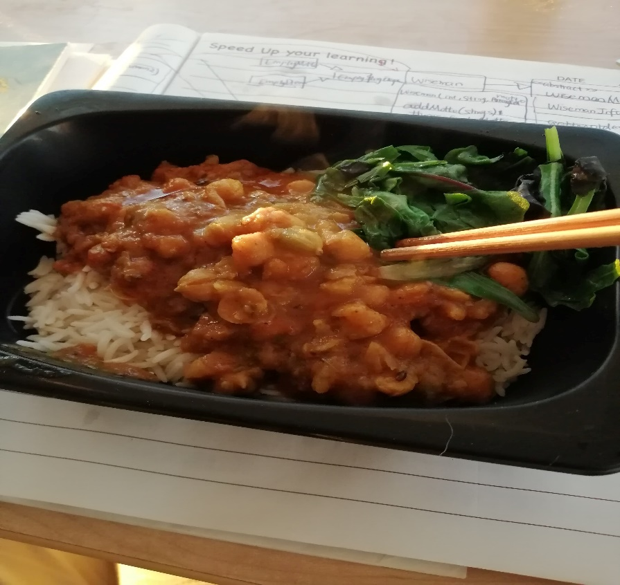
Supplementary figure 18, Eating alone fast food (not environmental friendly), Participant 6

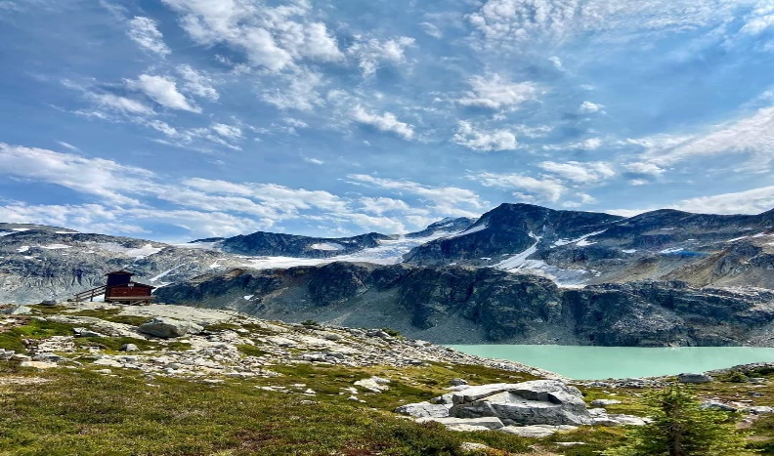
Supplementary figure 19, Climb with my family (appreciation to the nature), Participant 6

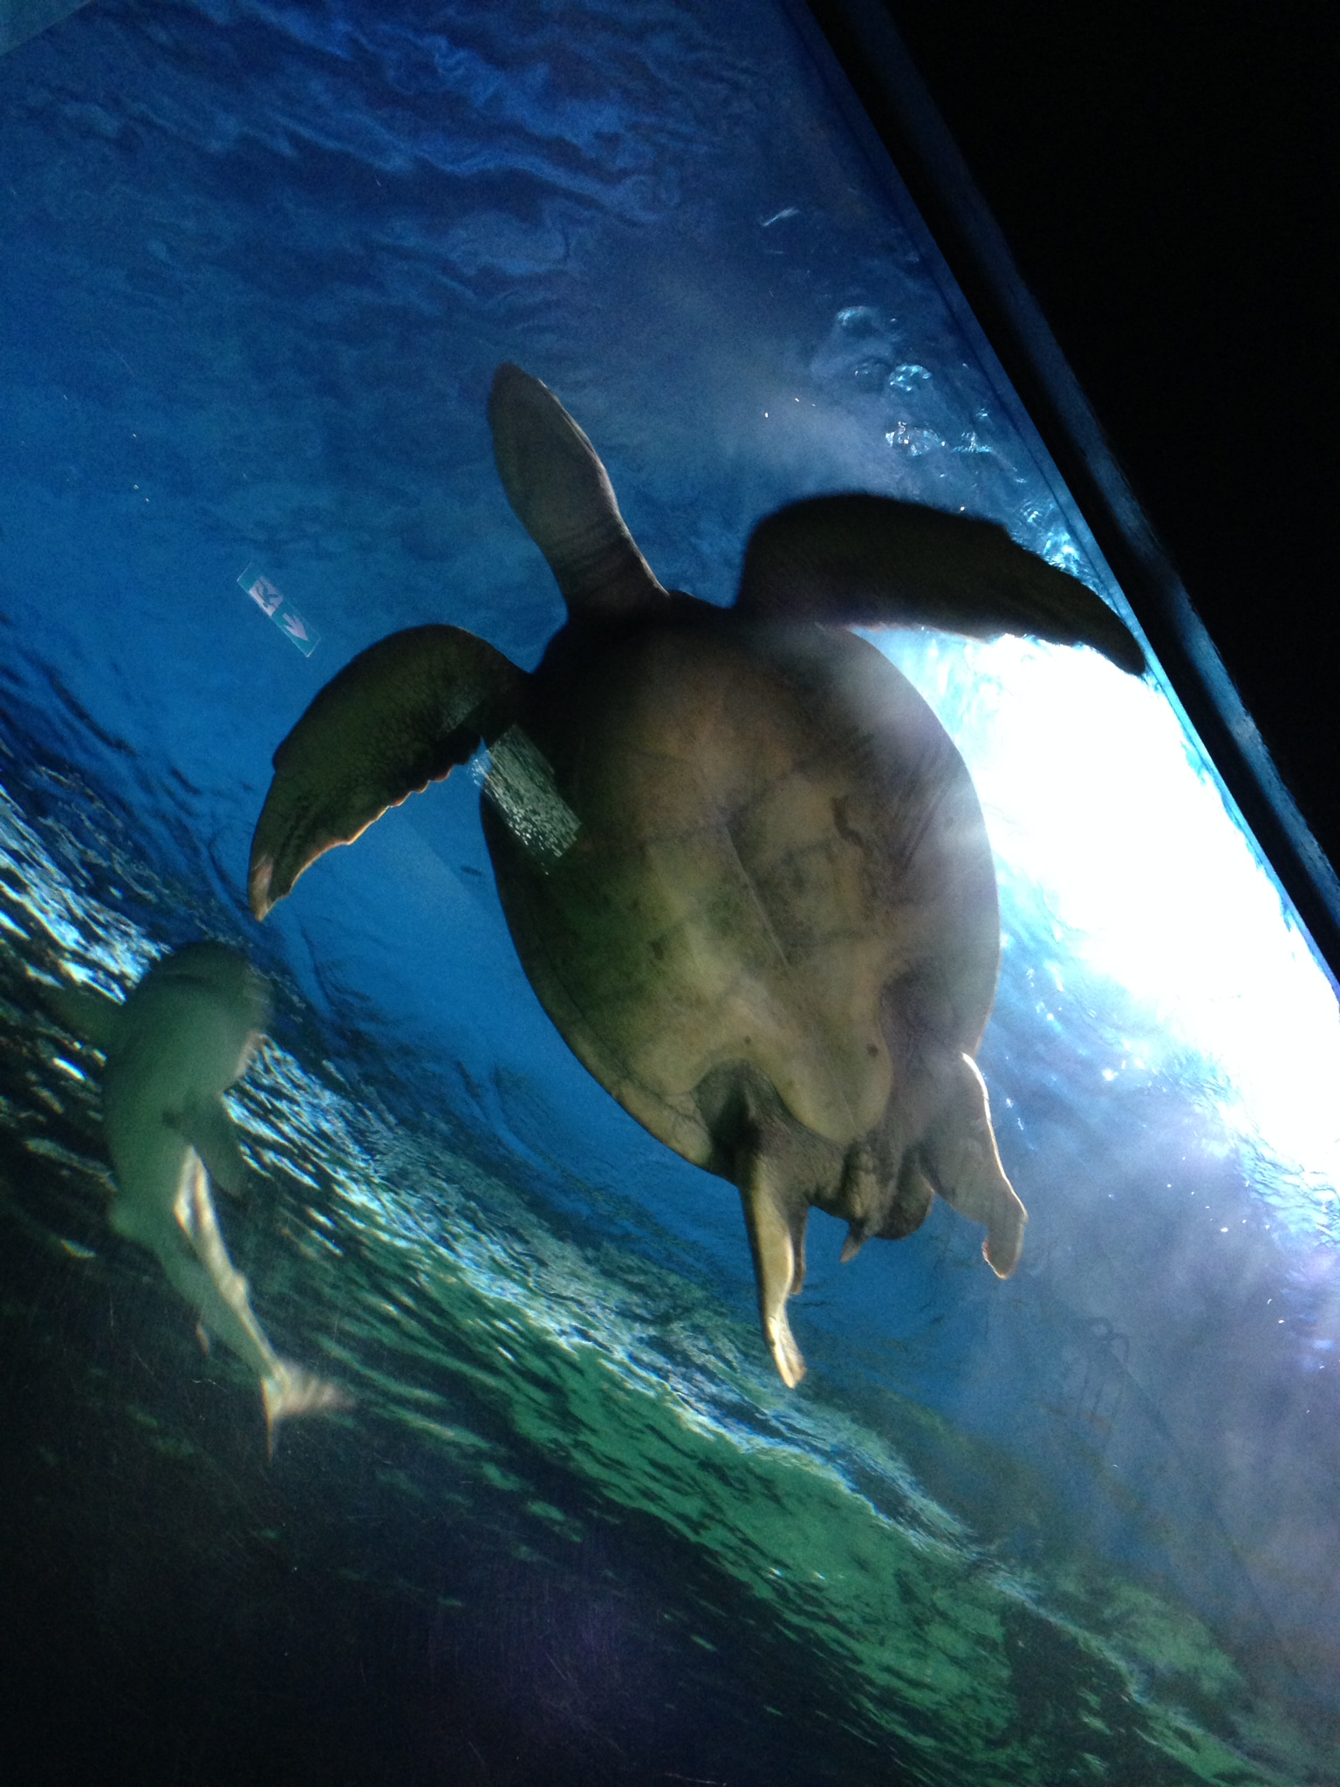
Supplementary figure 20, Enclosed Beauty, Participant 7

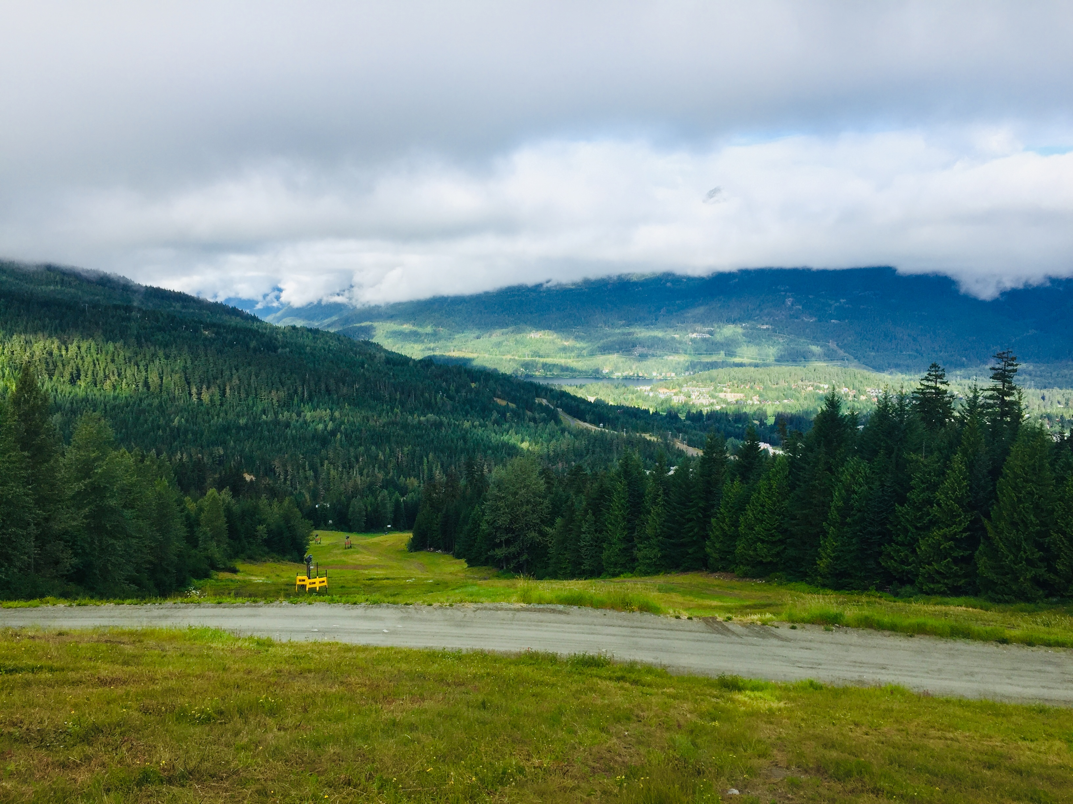
Supplementary figure 21, No Title, Participant 7

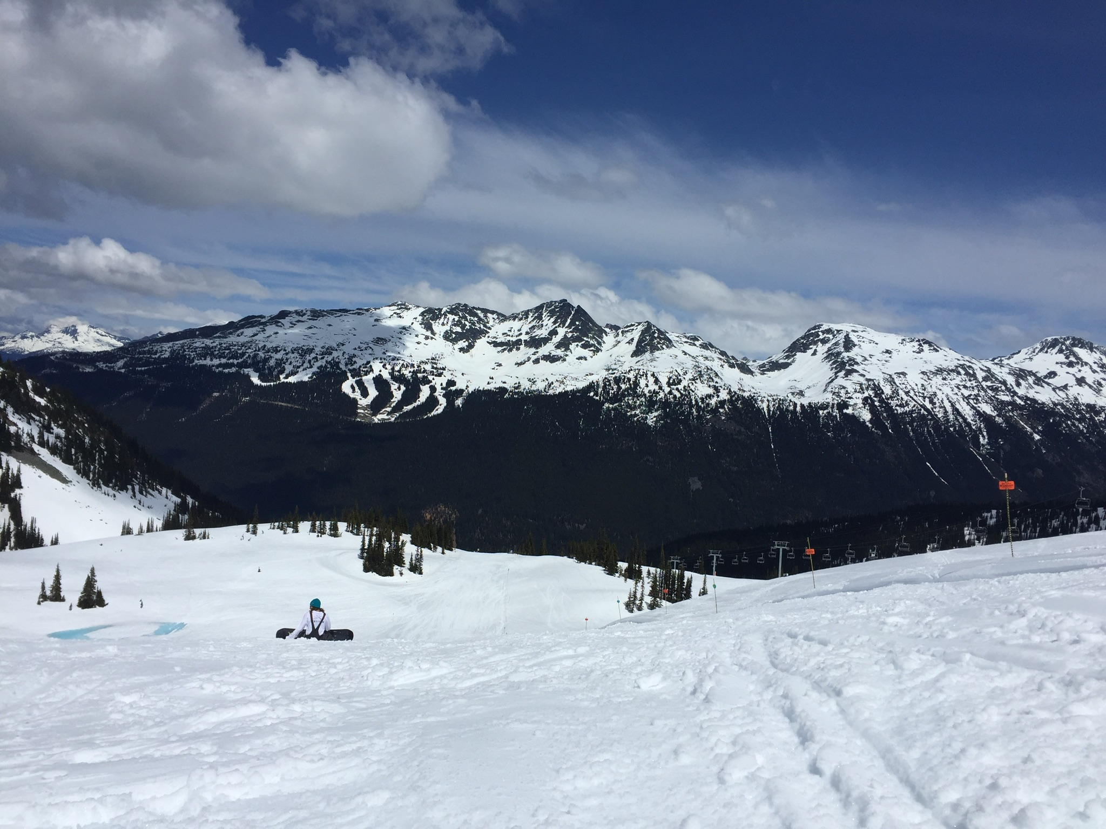
Supplementary figure 22, No Title, Participant 7

