Instructions for how often the exercises should be performed and how many repetitions
Week 1 and 2: Exercise 1 and 2: Three times a day with 3 repetitions each.
Week 3 to 8: All exercises (1, 2, 3, 4): Once every day with 3 repetitions each.
See video of the program at: http://youtu.be/6nRYdqYniUI

Diary
Name:………………………………..
born: ………………………………..

Day | Exercise 1 |  |  | Exercise 2
1
2
3
4
5
6
7
8
9
10
11
12
13
14
Day | Ex. 1 | Ex. 2 | Ex. 3 | Ex. 4
28
29
30
31
32
33
34
35
36
37
38
39
40
41
42
43
44
45
46
47
48
49
50
51
52
53
54
55
56

Day | Ex. 1 | Ex. 2 | Ex. 3 | Ex. 4
15
16
17
18
19
20
21
22
23
24
25
26
27

SHOULDER EXERCISES
Home-based exercises for the shoulder

KALK study 2015
Sandvika · Oslo · Stavern · Stord · Bergen · Linköping

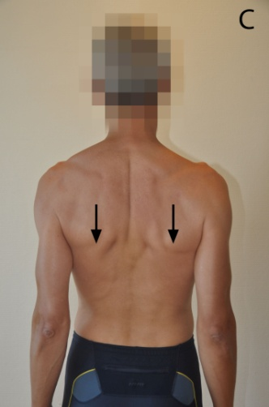
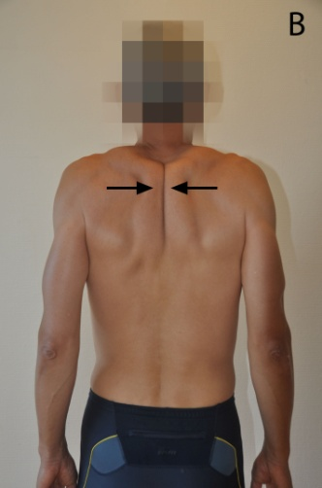
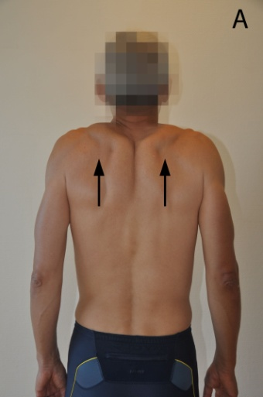
Exercise 1
Starting position: Stand straight in front of a mirror. Arms hanging down by your side
Exercise: First shrug your shoulders (A), then squeeze your shoulder blades back and together (B), then pull them downwards as if putting them in your back pocket (C). Relax.
Important: Keep your arms relaxed during this exercise.

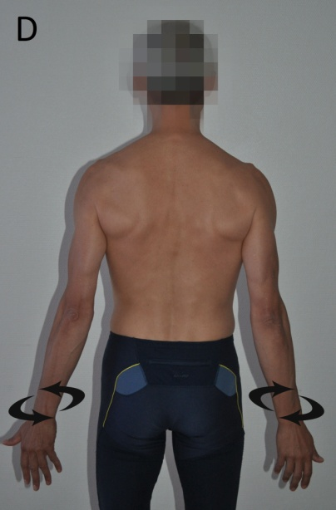
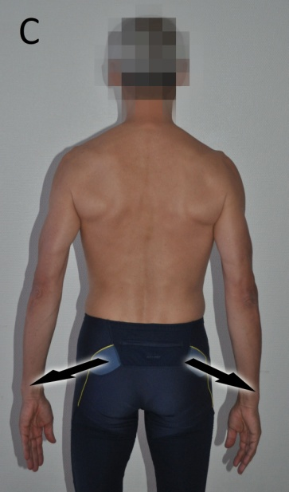
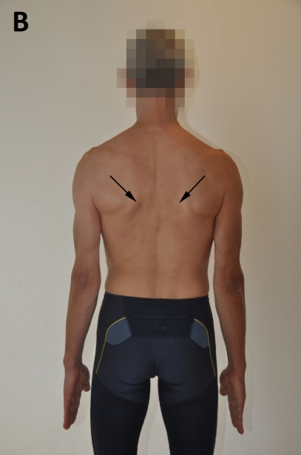
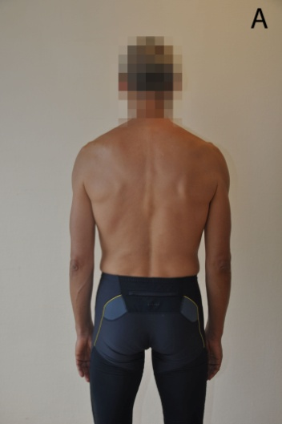
Exercise 2

Starting position: Stand straight in front of a mirror. Arms hanging down by your side (A). Squeeze your shoulder blades gently together and downwards (B). Exercise: Move both arms slightly backwards (C). Maintaining this position rotate your arms slowly inwards and outwards, 3 times (D). Relax.
Important: Maintain shoulder blades in correct position throughout the exercise.

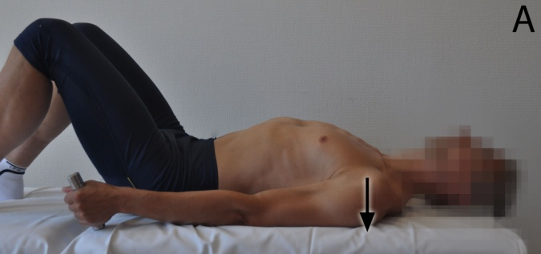
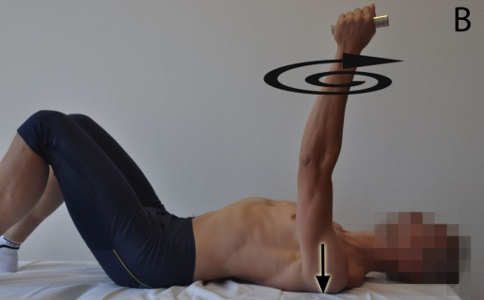
Exercise 3

Starting position: Lie on your back with knees bent, hold a light weight in your hand (A). Raise your arm towards the ceiling being careful not to lift your shoulder blade from the bed/floor.
Exercise: Move your arm round in small circles, 3 times in both directions (B).
Important: Shoulder blade should remain in contact with the bed/floor during the entire exercise.

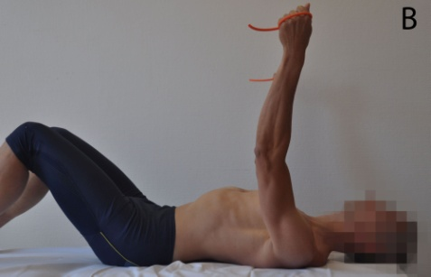
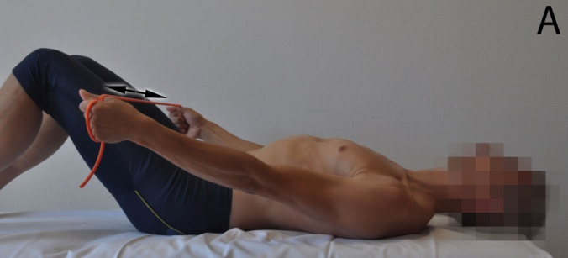
Exercise 4

Starting position: Lie on your back with knees bent and hold an elastic rope between your hands. Point thumbs up and arms are straight (A).
Exercise: Increase the tension in the rope by pulling arms slightly apart, then slowly raise your arms up as far as you can and lower them down again, 3 times (B, C).
Important: Maintain contact between shoulder blades and bed/floor during the exercise. Stop the exercise if you feel any pain.

