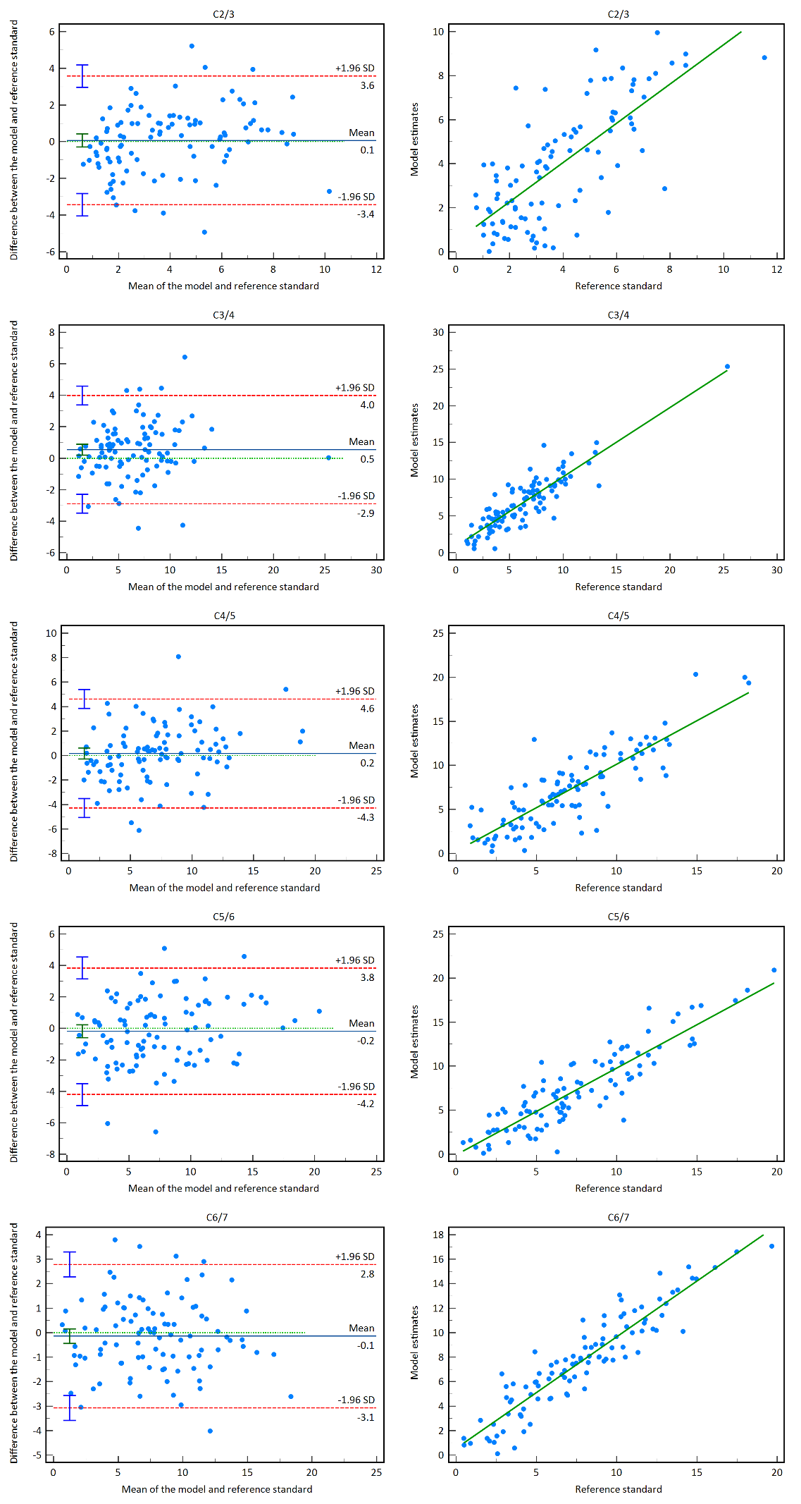
Additional file 2 Bland–Altman plots (left) and correlation scatter diagrams (right) showing the differences and correlations between the model and reference standards on F/N motion.

