Additional Figure S1. ROC curves of prognostic factors for RFS

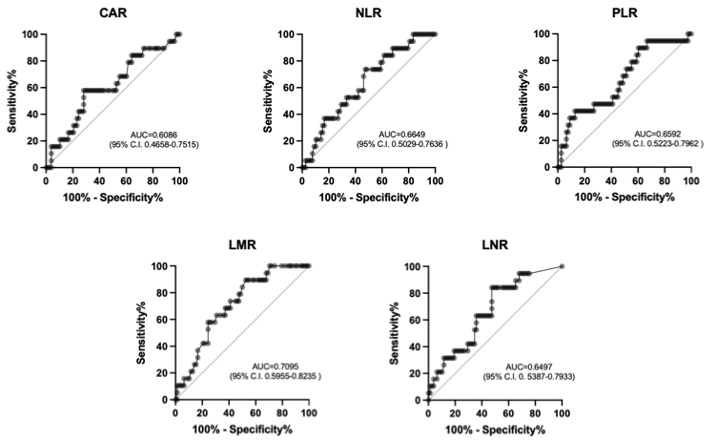

Additional Figure S2. ROC curves of prognostic factors for OS
