Self-assessment questionnaire

Date of salivary sample collection
Time of salivary sample collection

Your name

Your date of birth

Tanner self-assessment  Please look at these pictures and tick the one that best describes you | 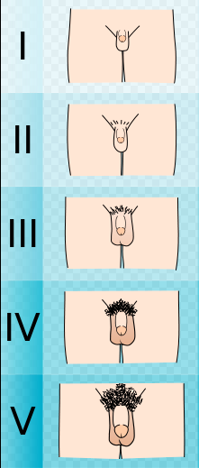 | ☐  ☐  ☐  ☐  ☐
Current testosterone treatment? | YES ☐ NO ☐
Previous testosterone treatment? | YES ☐ NO ☐
If Yes, when was the last dose of testosterone given? | Approximate date :
What form of testosterone? | Injection ☐ Tablet ☐ Gel ☐ Patch ☐
Do you take either prednisolone or deflazacort? | YES ☐ NO ☐
If yes, what dose?

