Oral Health Questionnaire
Name: Age: Gender:
School Name:

Hello my friends… Can you help me answering the following questions?
Select one answer to each of the following questions:
- How many are the baby teeth?
- 10 teeth
- 15 teeth
- 20 teeth
- 32 teeth

- How many are the adult teeth?
- 10 teeth
- 15 teeth
- 20 teeth
- 32 teeth

- What is tooth decay?
- Little hole caused by germs
- Staining of the teeth
- Inflammation of the gum
- I do not know

- How often do you brush your teeth?
- I do not brush my teeth
- Once a day
- Twice a day
- After every meal

- What do you use for cleaning your teeth?
- Brush
- Brush + Toothpaste + Dental floss
- Mouthwash
- Toothpicks

- How long does it take to brush your teeth?
- Less than one minute
- One minute
- Two minutes
- More than two minutes

- When should you get a new toothbrush?
- Every year
- Every 3-4 year
- I do not change my brush
- I do not know

- How often do you eat sweets and soft drinks?
- I do not eat sweets and soft drinks
- Less than three times a day
- Three times a day
- More than three times a day

- If you eat sweets, when do you usually have them?
- With the main meals ( Breakfast- Lunch- Dinner)
- Between the main meals
- Before going to bed
- There is no specific time

- What does eating too many sweets lead to?
- Sweets never affect the teeth
- Sweets prevent tooth decay
- Eating too much sweets can lead to tooth decay
- I do not know

- How often do you visit your dentist?
- Regularly twice a year
- Occasionally
- When I have dental pain
- I never visit a dentist

- What does plaque mean?
- Hard debris on the teeth
- Staining of the teeth
- Soft debris on the teeth
- I do not know

- What does dental plaque lead to?
- Your teeth become more shiny
- Tooth decay and inflammation of the gum
- Staining of the teeth
- I do not know

- What is fluoride?
- Fluoride strengthens the teeth
- Fluoride harms the teeth
- Fluoride prevents tooth decay
- I do not know

Now, my friends, let’s put the following drinks in the proper container
Milk – Sweetened drinks – Lemon juice – Water – Orange juice – Soft drinks
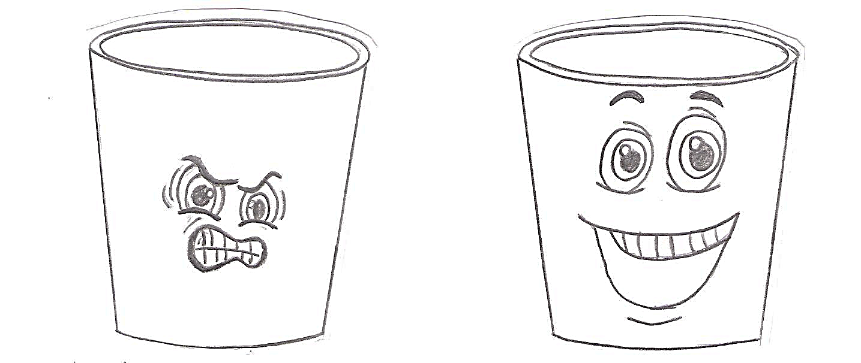
Harmful drinks for my teeth Good drinks for my teeth
My friends, let’s put the following foods in the proper container
Carrot – Banana – Biscuit – Chips – Cheese – Cookies – Chocolate – Apple – Ice cream – Candy – Cucumber
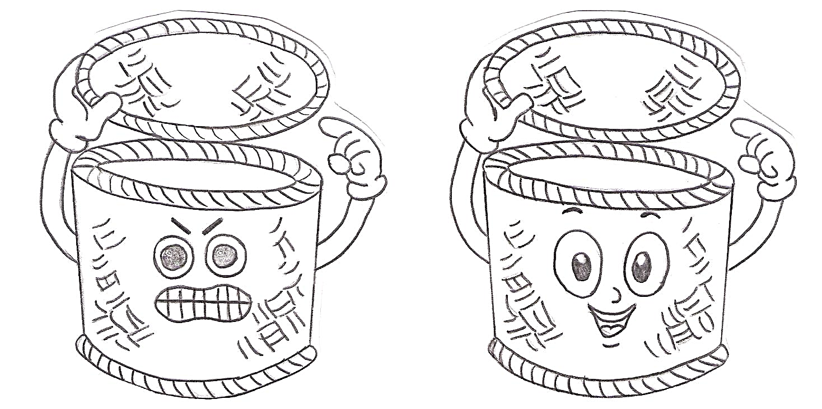
Harmful foods for my teeth Good foods for my teeth

