Map of Nigeria highlighting Enugu State in red
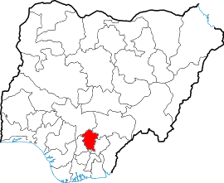

Map of Enugu State showing Local Government Areas
