MATERIALS AND METHODS
Search strategies
Highly sensitive electronic search was conducted from four databases, including the PubMed, Scopus, and Embase (update to January 28, 2023) with no language restriction.
The search strategy on PubMed
( ( "uric acid" [Title/Abstract] OR urate [Title/Abstract] OR purine [Title/Abstract] OR hyperuricemia [Title/Abstract] OR gout [Title/Abstract] ) OR (antioxidant [Title/Abstract] AND ( "uric acid" OR urate OR purine OR hyperuricemia OR gout) ) ) AND ( "Periodontal Diseases" [MeSH Terms] OR periodontitis NOT "apical periodontitis" ) AND ( blood [Title/Abstract] OR serum [Title/Abstract] OR plasma [Title/Abstract] OR circulation [Title/Abstract] OR GCF [Title/Abstract] OR "gingival crevicular fluid" [Title/Abstract] OR saliva [Title/Abstract] )
The search strategy on SCOPUS
( TITLE-ABS-KEY ( blood OR serum OR plasma OR circulation OR gcf OR "gingival crevicular fluid" OR saliva ) AND DOCTYPE ( ar ) ) AND ( ( ( ALL ( "uric acid" OR urate OR purine OR hyperuricemia OR gout ) AND TITLE-ABS-KEY ( antioxidant ) ) AND DOCTYPE ( ar ) ) OR ( TITLE-ABS-KEY ( "uric acid" OR urate OR purine OR hyperuricemia OR gout ) AND DOCTYPE ( ar ) ) ) AND ( ( TITLE-ABS-KEY ( "periodontal disease" ) OR TITLE-ABS-KEY ( periodontitis ) AND NOT TITLE-ABS-KEY ( "apical periodontitis" ) ) AND DOCTYPE ( ar ) )
The search strategy on EMBASE
( 'uric acid':ti,ab,kw OR urate:ti,ab,kw OR purine:ti,ab,kw OR hyperuricemia:ti,ab,kw OR gout:ti,ab,kw ) OR ( ( 'uric acid' OR urate OR purine OR hyperuricemia OR gout ) AND antioxidant:ti,ab,kw ) AND ( ( 'periodontal disease':ti,ab,kw OR periodontitis:ti,ab,kw ) NOT 'apical periodontitis':ti,ab,kw ) AND ( blood:ti,ab,kw OR serum:ti,ab,kw OR plasma:ti,ab,kw OR circulation:ti,ab,kw OR gcf:ti,ab,kw OR 'gingival crevicular fluid':ti,ab,kw OR saliva:ti,ab,kw )
The search strategy on Web of Science
( "uric acid" OR urate OR purine OR hyperuricemia OR gout ) AND ( "periodontal disease" OR periodontitis NOT "apical periodontitis" ) AND ( blood OR serum OR plasma OR circulation OR gcf OR "gingival crevicular fluid" OR saliva )

TABLES
Table S1. The characteristics of excluded studies.
Study | Year | Type of study | Reasons for exclusion
Almerich-Silla, J M. et al. | 2015 | Cross-sectional study | Not involving uric acid
Al-Rawi, N H. et al. | 2017 | Case-control study | Participants with unclear/barred systemic condition
Arora, N. et al. | 2013 | Randomized controlled trials study | Lack of periodontal health controls
Babaei, H. et al. | 2018 | Randomized controlled trials study | Lack of periodontal health controls
Barnes, V M. et al. | 2014 | Cross-sectional study | Not involving uric acid
Barnes, V M. et al. | 2009 | Case-control study | Lack of periodontal health controls
Batista, E L. et al. | 2010 | Interventional study | Lack of periodontal health controls
Botelho, J. et al. | 2020 | Retrospective cohort study | Participants with unclear/barred systemic condition
Byun, S H. et al. | 2020 | Cross-sectional study | Lack of periodontal health controls
Cao, Y. et al. | 2016 | Cross-sectional study | Participants with unclear/barred systemic condition
Chapple, I L C. et al. | 2007 | Prospective cohort study | Lack of periodontal health controls
Chapple, I L C. et al. | 1997 | Cross-sectional study | Lack of periodontal health controls
Chen, H W. et al. | 2018 | Cross-sectional study | Not involving uric acid
Choromańska, M. et al. | 2017 | Case-control study | Participants with unclear/barred systemic condition
Fons-Badal, C. et al. | 2019 | Randomized controlled trials study | Lack of periodontal health controls
Fornasaro, S. et al. | 2021 | Case-control study | Not involving uric acid
Front, E. et al. | 2013 | Interventional study | Lack of periodontal health controls
Garg, N. et al. | 2006 | Case-control study | Lack of periodontal health controls
Greabu, M. et al. | 2006 | Interventional study | Lack of periodontal health controls
Gümüş, P. et al. | 2009 | Case-control study | Lack of periodontal health controls
Gumus, P. et al. | 2015 | Case-control study | Not involving uric acid
Khodaii, Z. et al. | 2019 | Case-control study | Full text unavailable
Konopka, T. et al. | 2007 | Case-control study | Not involving uric acid
Lee, C. et al. | 2018 | Prospective cohort study | Lack of periodontal health controls
Mashayekhi, F. et al. | 2005 | Case-control study | Not involving uric acid
Miricescu, D. et al. | 2011 | Case-control study | Duplicate publication
Moore, S. et al. | 1994 | Case-control study | Participants with unclear/barred systemic condition
Mourāo, L C. et al. | 2014 | Randomized controlled trials study | Lack of periodontal health controls
Munther, S | 2019 | Cross-sectional study | Lack of periodontal health controls
Nguyen, T T. et al. | 2017 | Case-control study | Not involving uric acid
Novaković, N. et al. | 2013 | Interventional study | Duplicate publication
Olszewska-Czyz, I. et al. | 2022 | Cross-sectional study | Lack of periodontal health controls
Pulido-Moran, M. et al. | 2017 | Cross-sectional study | Participants with unclear/barred systemic condition
Rai, B. et al. | 2011 | Interventional study | Lack of periodontal health controls
Sculley, D V. et al. | 2003 | Prospective cohort study | Participants with unclear/barred systemic condition
Seydanur et al. | 2019 | Randomized controlled trials study | Lack of periodontal health controls
Sezer, U. et al. | 2016 | Case-control study | Not involving uric acid
Shetty, M S. et al. | 2018 | Case-control study | Participants with unclear/barred systemic condition
Shetty, M. et al. | 2012 | Case-control study | Full text unavailable
Sincar, C D. et al. | 2017 | Case-control study | Lack of periodontal health controls
Su, H. et al. | 2009 | Cross-sectional study | Not involving uric acid
Summers, C J. et al. | 1968 | Cross-sectional study | Lack of periodontal health controls
Tamaki, N. et al. | 2015 | Cross-sectional study | Not involving uric acid
Tartaglia, G M. et al. | 2017 | Cross-sectional study | Lack of periodontal health controls
Hu, S A. et al. | 2022 | Cross-sectional study | Lack of periodontal health controls
Chabuk, M I. et al. | 2021 | Case-control study | Lack of periodontal health controls
Tu, Y K. et al. | 2013 | Prospective cohort study | Participants with unclear/barred systemic condition
Vernerov, A. et al. | 2021 | Case-control study | Lack of periodontal health controls
Yoshino, F. et al. | 2012 | Cross-sectional study | Not involving uric acid
Ziebolz, D. et al. | 2007 | Cross-sectional study | Participants with unclear/barred systemic condition
Zipkin, I. et al. | 1964 | Case-control study | Participants with unclear/barred systemic condition
Chen, S., et al., | 2023 | Case-control study | Not involving uric acid
Toczewska, J., et al., | 2022 | Case-control study | Not involving uric acid

Table S2. Quality assessment of the included case-control studies with Newcastle-Ottawa Scale.
Studies | Selection |  |  |  |  | Comparability |  | Exposure |  |  | Final Score
 | Is the case definition adequate? |  | Representativeness of the cases? | Selection of controls | Definition of controls | Comparability of cases and controls on the basis of the design or analysis |  | Ascertainment of exposure | Same method of ascertainment for cases and controls | Non-response rate
 |  |  |  |  |  | Main factor† | Additional factor‡
Gharbi et al., 2019 |  | 1 | 1 | 0 | 1 | 1 | 1 | 1 | 1 | 1 | 8
Sakanaka et al., 2017 |  | 1 | 1 | 0 | 1 | 0 | 0 | 1 | 1 | 1 | 6
Banu et al., 2015 |  | 1 | 1 | 0 | 1 | 1 | 1 | 1 | 1 | 1 | 8
Diab-Ladki et al., 2003 |  | 0 | 0 | 0 | 1 | 0 | 0 | 0 | 0 | 1 | 2
Mourão et al., 2015 |  | 0 | 1 | 0 | 1 | 1 | 1 | 1 | 1 | 1 | 7
Mathur et al., 2013 |  | 0 | 1 | 0 | 1 | 0 | 0 | 0 | 1 | 1 | 4
Brotto et al., 2011 |  | 0 | 1 | 1 | 1 | 1 | 0 | 1 | 1 | 0 | 6
Fatima G et al., 2016 |  | 0 | 1 | 1 | 1 | 1 | 0 | 1 | 1 | 1 | 7
Senouci et al., 2021 |  | 1 | 1 | 1 | 0 | 1 | 1 | 0 | 1 | 1 | 8
Novakovic et al., 2014 |  | 1 | 1 | 0 | 1 | 1 | 1 | 1 | 1 | 1 | 8
Priya, K.L., et al., 2022 |  | 1 | 0 | 1 | 1 | 0 | 0 | 1 | 1 | 1 | 6
†, Gender was selected as the main factor; ‡, Age was considered as an additional factor.

Table S3. Agency for Healthcare Research and Quality for risk of bias assessment of the cross-sectional studies.
 | Narendra et al., 2018 | Miricescu et al., 2014 | Sreeram et al., 2015 | Sharma et al., 2018 | Tsai et al., 2021 | Merle, C.L., et al., 2022
Define the source of information | Yes | Yes | Yes | Yes | Yes | Yes
List inclusion and exclusion criteria for exposed and unexposed subjects (cases and controls) or refer to previous publications | Yes | No | Yes | Yes | Yes | Yes
Indicate time period used for identifying patients | No | No | Yes | No | Yes | Yes
Indicate whether or not subjects were consecutive if not population-based | No | Yes | Yes | Yes | No | Yes
Indicate if evaluators of subjective components of study were masked to other aspects of the status of the participants | Yes | Yes | Yes | Yes | Yes | Yes
Describe any assessments undertaken for quality assurance purposes | No | No | No | No | No | No
Explain any patient exclusions from analysis | Yes | No | Yes | Yes | Yes | Yes
Describe how confouding was assessed and/or controlled | Yes | No | No | Yes | Yes | Yes
If applicable, explain how missing data were handled in the analysis | No | No | No | No | No | Yes
Summarize patient response rates and completeness of data collection | Yes | Yes | Yes | Yes | Yes | Yes
Clarify what follow-up, if any, was expected and the percentage of patients for which incomplete data of follow-up was obtained | No | No | No | No | No | No
Total score | 6 | 4 | 7 | 7 | 7 | 9

FIGURES
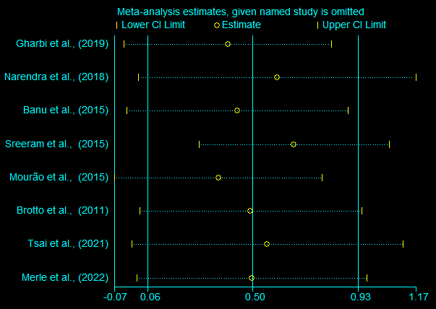
Figure S1. Sensitivity analysis of the relationship between periodontitis and controls of UA levels in blood.
In these studies, no clearly heterogeneous origin could be found.
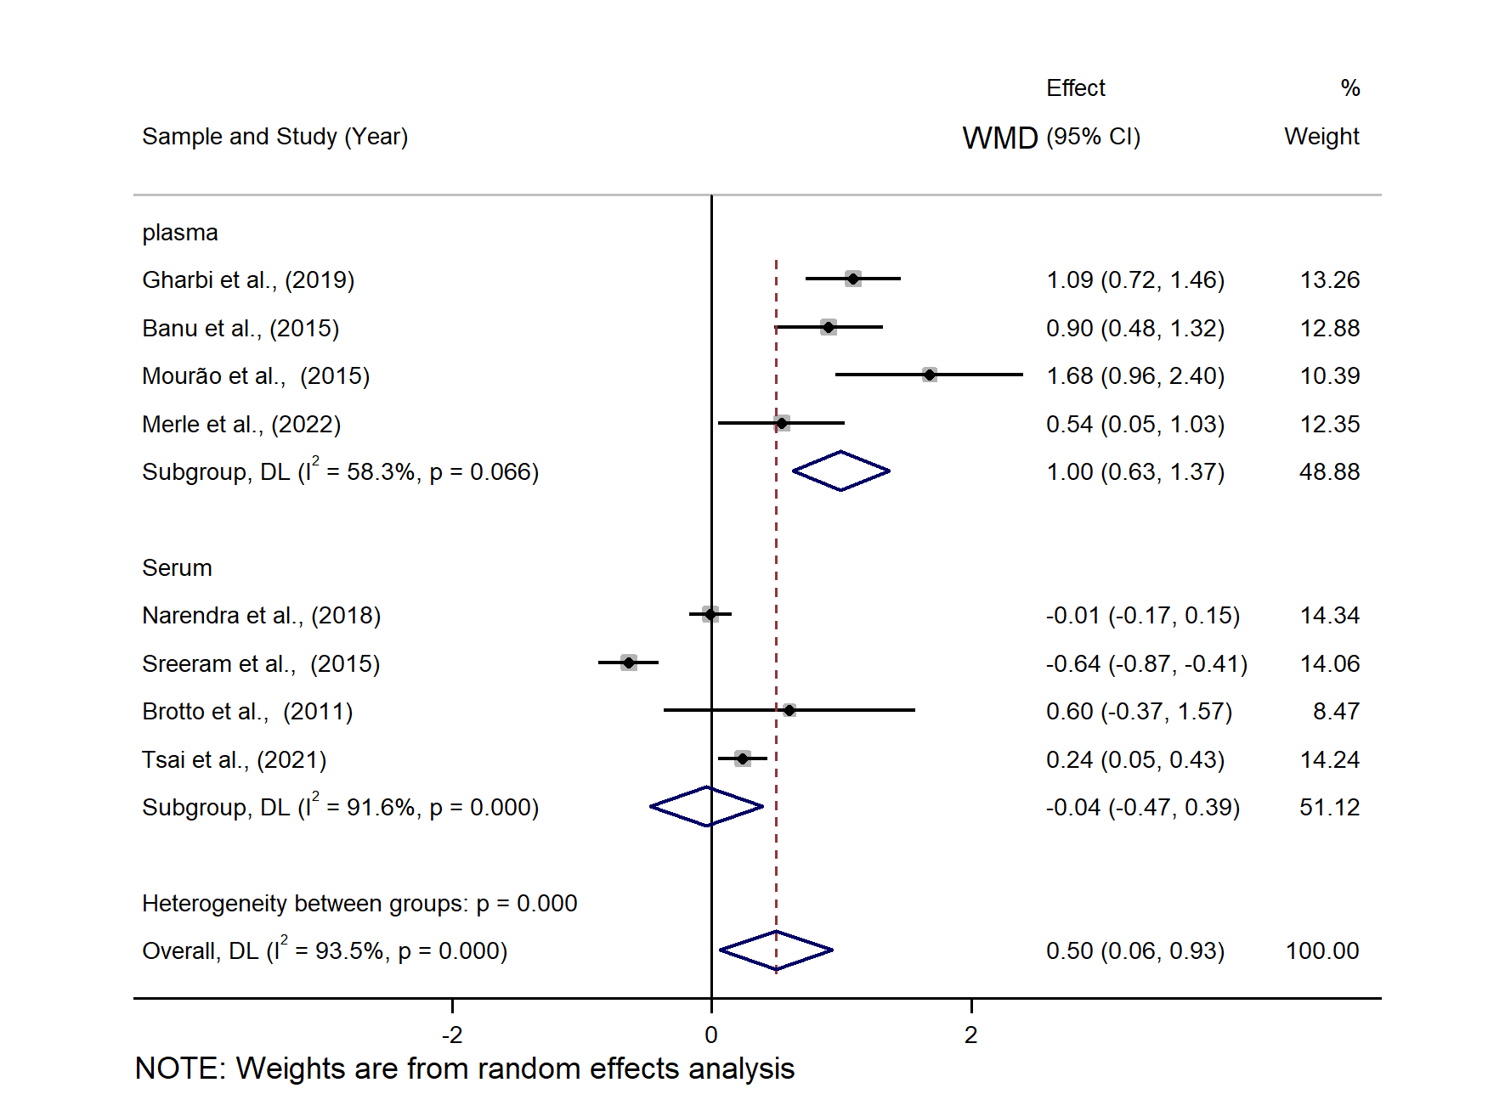
Figure S2. Forest plot comparing UA levels of periodontitis vs. control in plasma/serum subgroups.
CI, confidence interval; WMD, weighted mean difference.
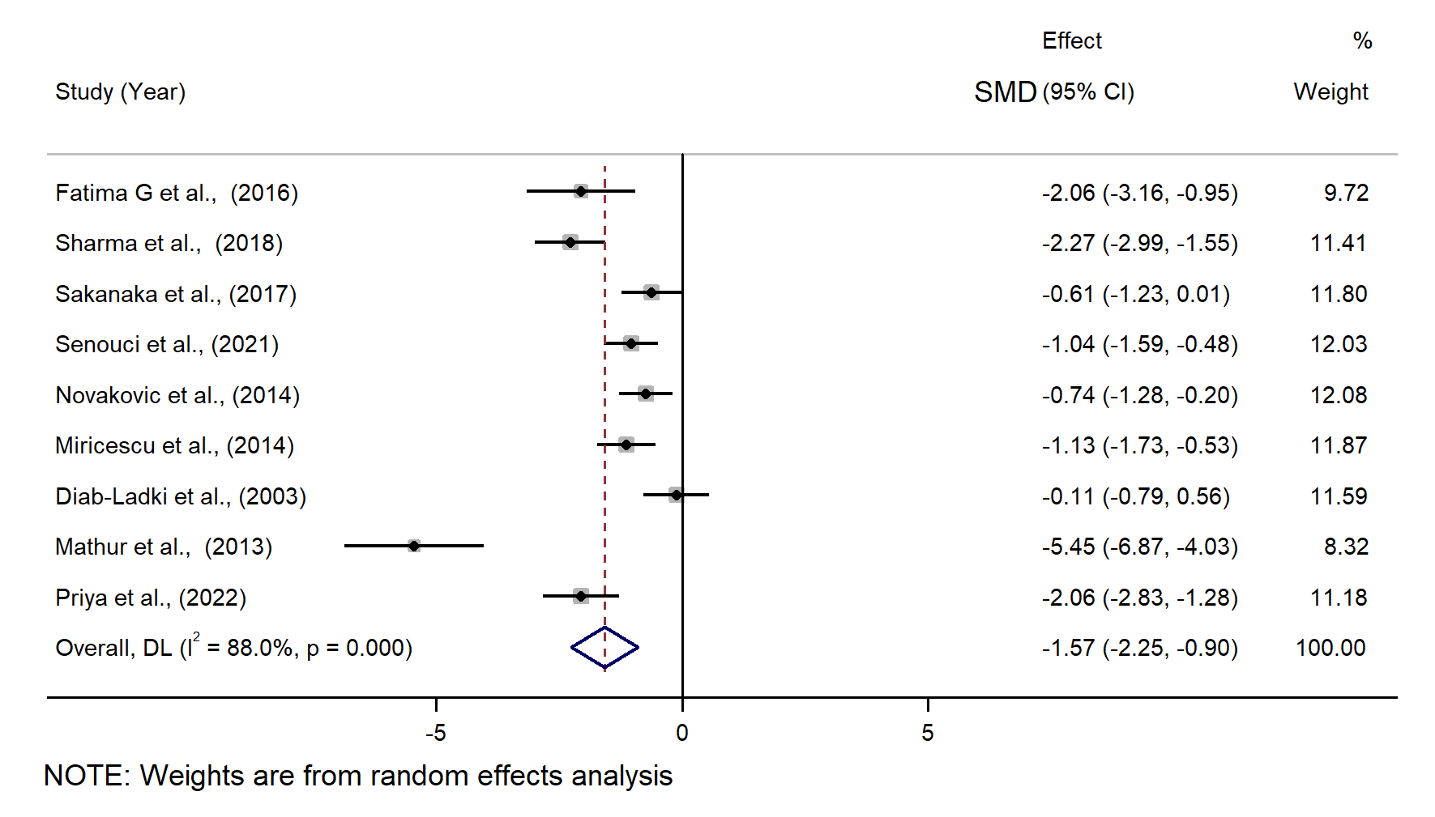
Figure S3. Forest plot comparing the salivary UA levels of periodontitis vs control before sensitivity analysis.
There was a high heterogeneity among the studies (I² = 88.6%, P < 0.001). Therefore, sensitivity analysis should be performed to find sources of heterogeneity. SMD, standardized mean difference.

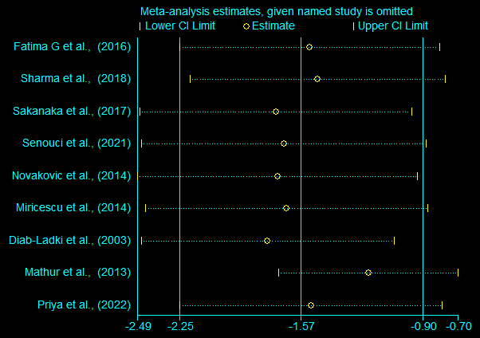
Figure S4. Sensitivity analysis of the relationship between periodontitis and controls of UA levels in saliva.
A sensitivity analysis was performed to explore potential sources of heterogeneity. Statistical heterogeneity was decreased obviously, indicating that they were likely the source of heterogeneity.

