**Supplementary figure**

The original images of the blots of the indicated proteins, visualized by enhanced chmiluminescent (ECL) substrate on X-ray film (The films were cut prior to developing the bands images).

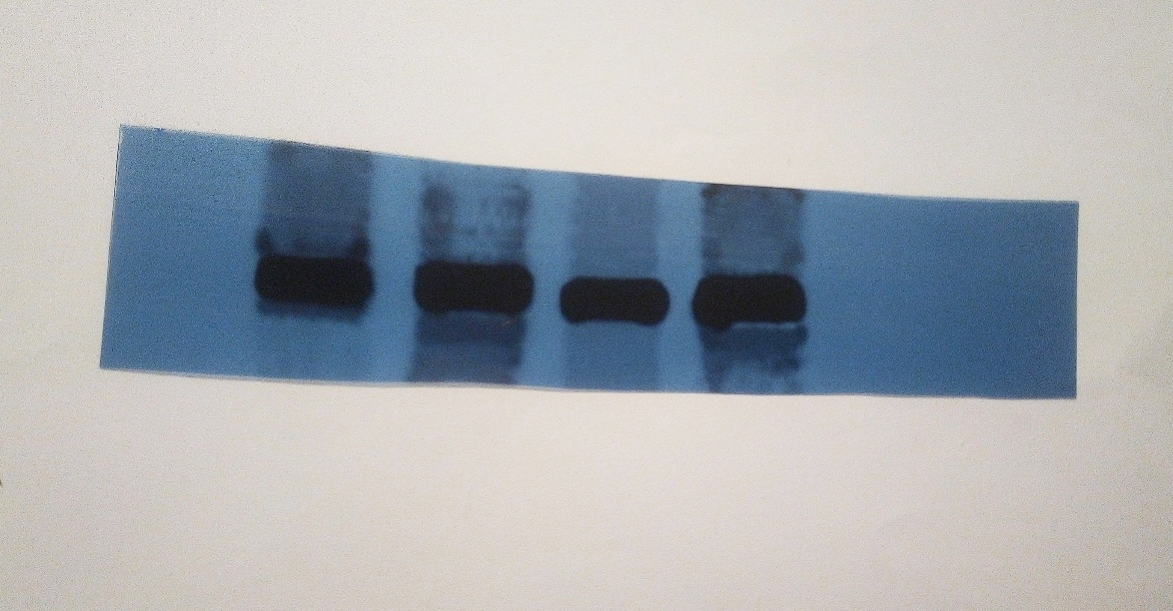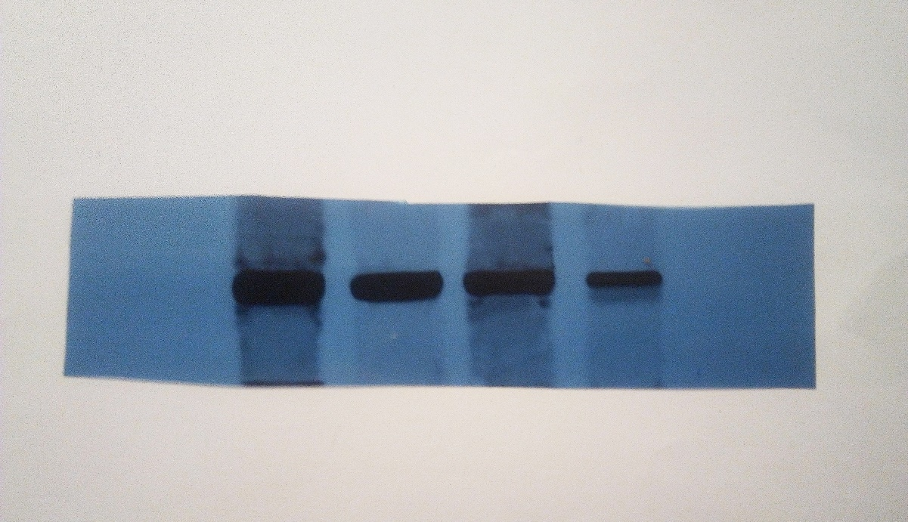

**JAK-2**

**p-JAK-2**

**130 kDa**

**130 kDa**

**p-STAT3**

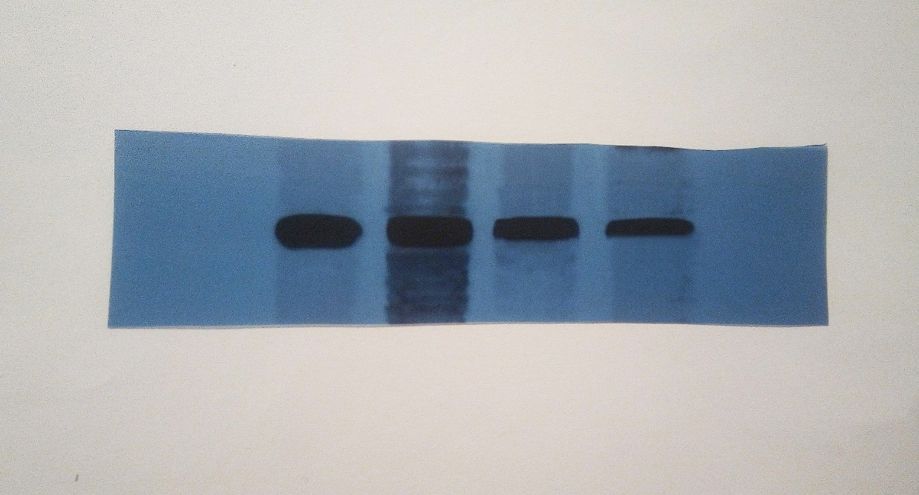

**100 kDa**

**70 kDa**

**STAT3**

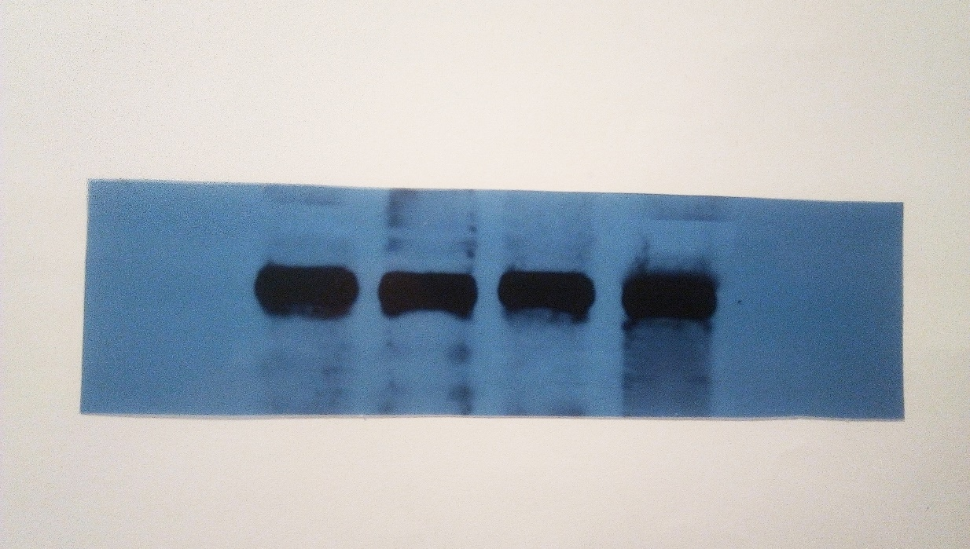

**70 kDa**

**100 kDa**

**b-Actin**

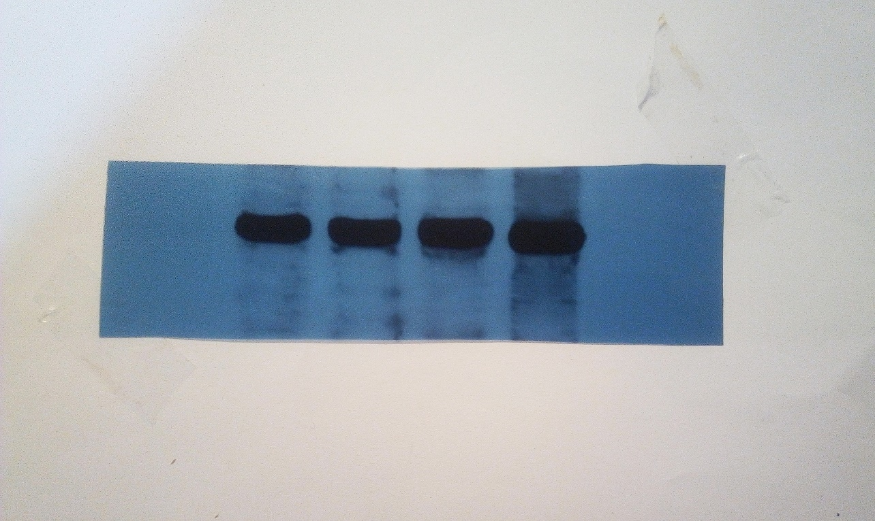

**40 kDa**

**55 kDa**