Potent hepatoprotective activity of common rattan (Calamus rotang L.) leaf extract and its molecular mechanism

Walaa S. Anwar¹, Fatma M. Abdel-maksoud², Ahmed M. Sayed³, Iman A. M. Abdel-Rahman⁴, Makboul A. Makboul¹, Ahmed M. Zaher^{1*}

¹ Department of Pharmacognosy, Faculty of Pharmacy, Assiut University, 71515
Assiut, Egypt.
² Department of Anatomy, Faculty of Vet. Medicine, Assiut University, Assiut, Egypt.
³ Biochemistry Laboratory, Chemistry Department, Faculty of Science, Assiut University, Assiut, Egypt.
⁴ Department of Pharmacognosy, Faculty of Pharmacy, South Valley University, Qena, Egypt.

Fig.S1: A) Phenolics and flavonoids contents of C. rotang L. ethyl acetate extract determined by Folin-Ciocalteu and Aluminum chloride colorimetric methods.
B) DPPH scavenged (%) activity (SA%) of C. rotang L. (CR) and ascorbic acid (AS). (SA% = (A₀ - A_{s}/A₀) × 100) (A₀ = Absorbance of DPPH solution in ethanol, A_{s} = Absorbance of CR extract or ascorbic acid and DPPH solution).

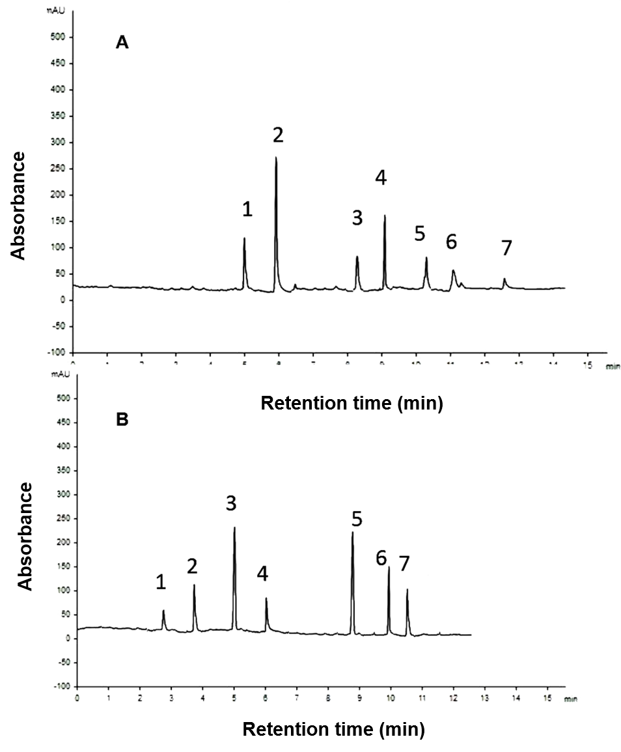

Fig.S2: A) HPLC chromatogram of detected phenolics of C. rotang L. ethyl acetate. Seven phenolics were identified using authentic samples by matching the retention time (min).
B) HPLC chromatogram of detected flavonoids of C. rotang L. ethyl acetate extract. Seven flavonoids were identified using authentic samples by matching the retention time (min).

Fig S3: Standard curve of gallic acid used in Folin-Ciocalteu assay for detection of phenolic contents.

Fig. S4.: Standard curve of quercetin used in Aluminum chloride assay for detection of flavonoids content.

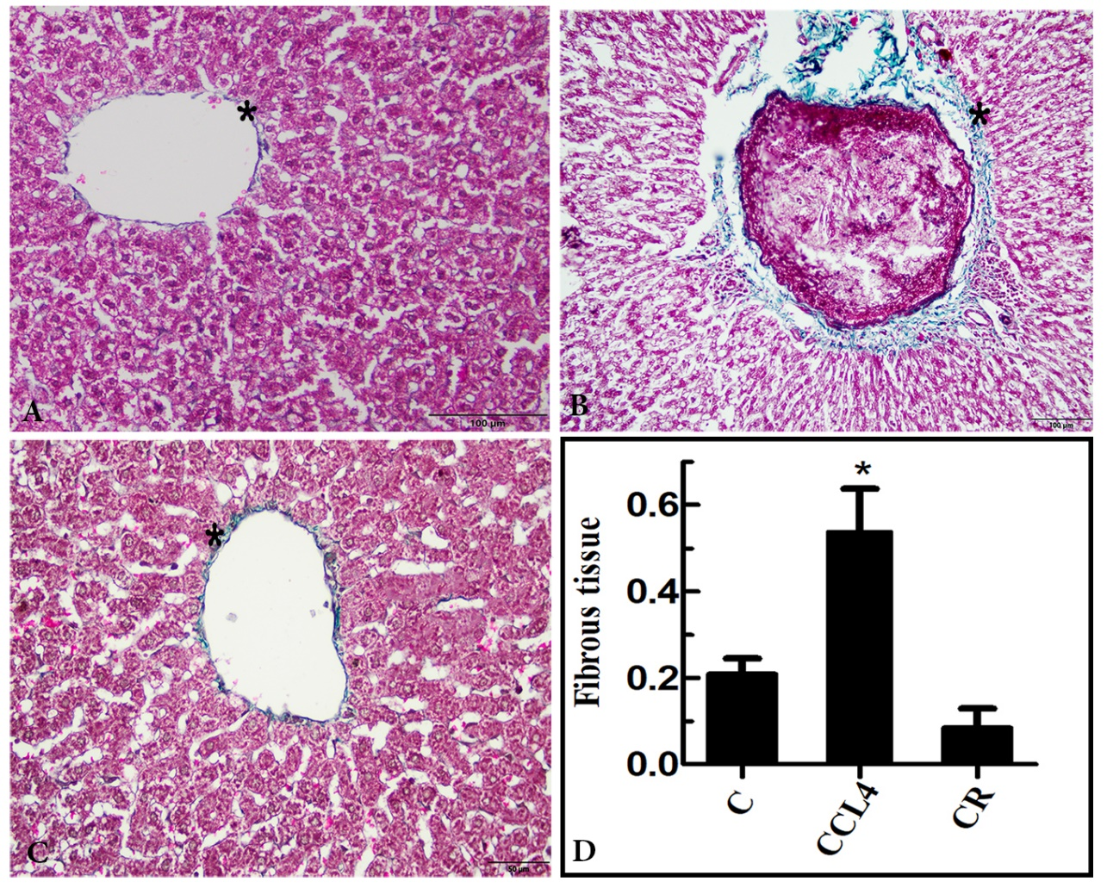
Fig. S5: Photomicrograph of a liver sections stained with Crossman’s trichrome. A: The mild green staining for collagen around the central vein (C) and portal tract (P) in normal group, B: the strong staining for collagen fibers in CCL₄ group. C: The deposition of collagen in CR extract group was lesser. D: Quantification of Crossman’s trichrome staining using Image-J software. The CR extract treated group is compared to control and CCL₄ groups using Tukey test (n = 3). *P ≤ 0.05.

Table S1: Molecular docking of identified metabolites as potential inhibitors of pro-apoptotic Bcl2: Bim (BH3) protein
Compounds | Lowest energy of docking (kcal/mol)
Myricetin | -6.10±0.41
Quercetin | -6.23±0.30
Apigenin | -6.35±0.33
Kaempferol | -6.05±0.34
Naringin | -6.88±0.06
Rutin | -6.70±0.19
7-hydroxy flavone | -6.42±0.31
Ellagic acid | -6.57±0.26
Syringic acid | -4.48±0.09
Gallic acid | -4.82±0.19
Caffeic acid | -4.98±0.24
Ferulic acid | -4.75±0.15
P-coumaric acid | -4.58±0.16
Pyrogallol | -4.47±0.13

