Figure S3. Receiver-operating characteristic (ROC) curve and calibration plot of the machine learning acute kidney injury risk model, in validation dataset

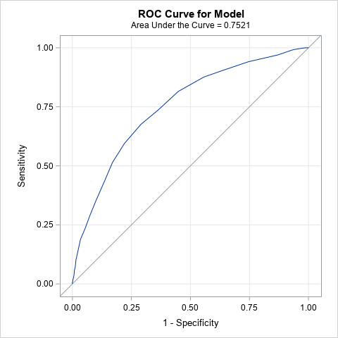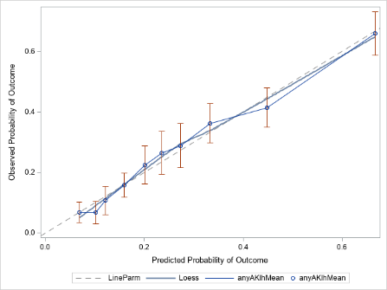
Decile-decile calibration plots of the predicted probability (deciles) versus the observed probability of AKI.

