Appendix
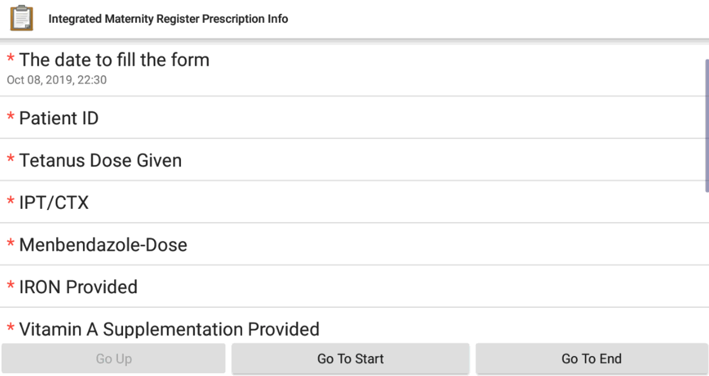
Supplementary Fig. 1 Example mobile device form

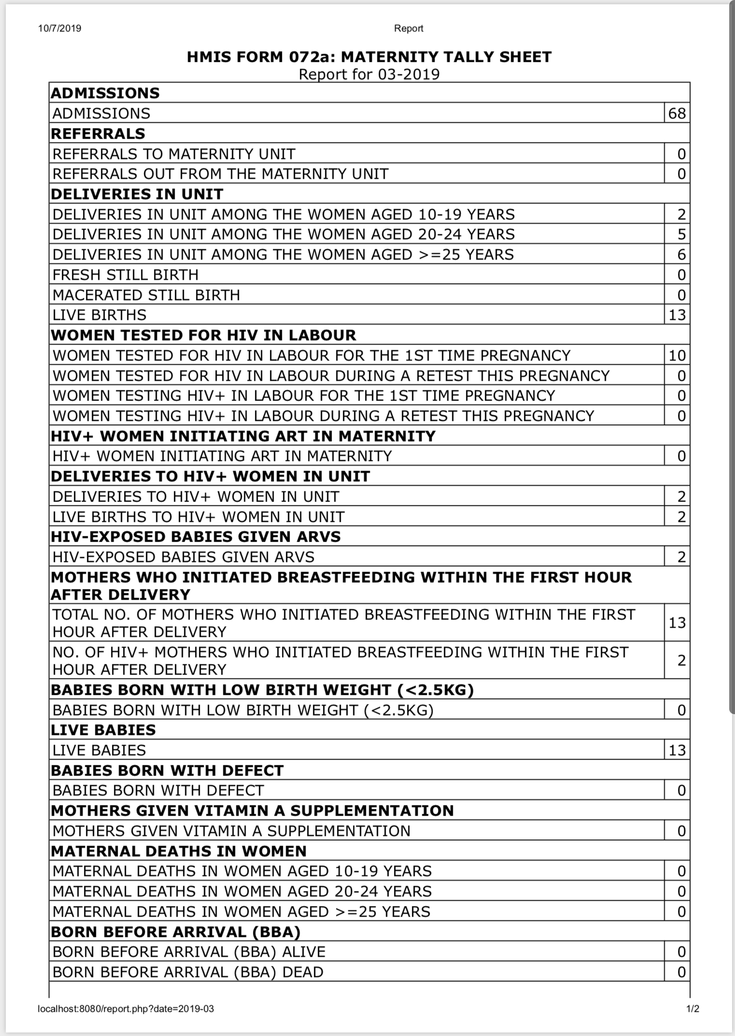
Supplementary Fig. 2 Generated HMIS printable form

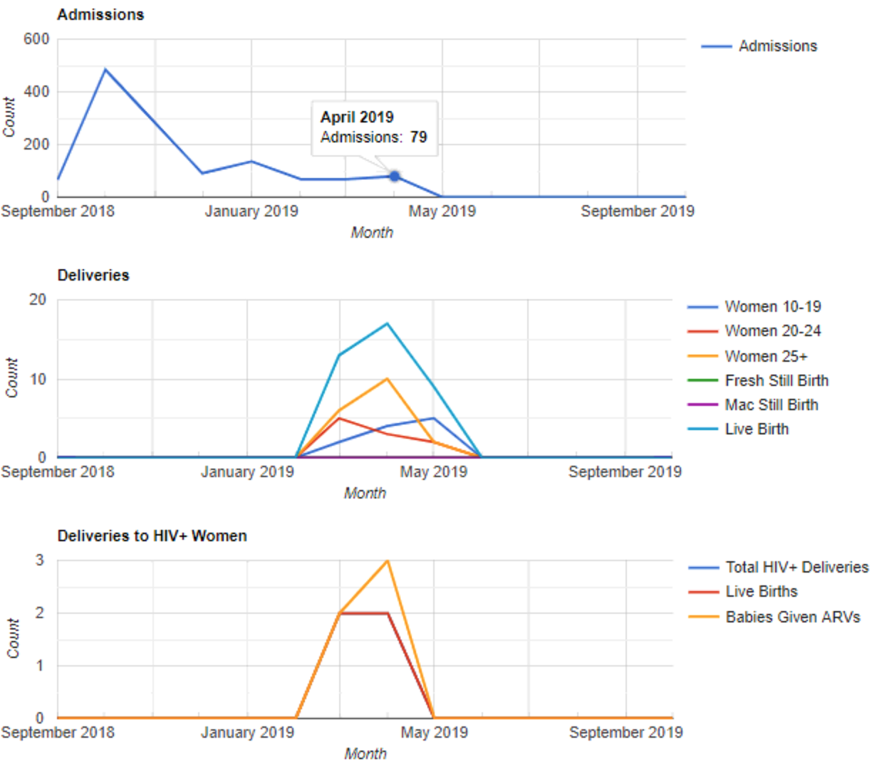

Supplementary Fig. 3 Generated plots

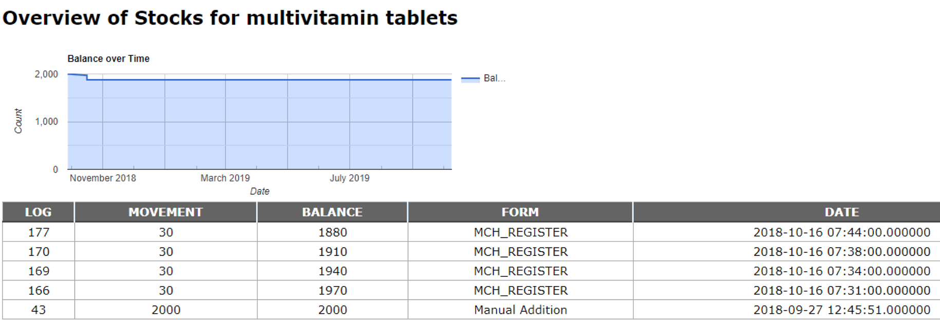
Supplementary Fig. 4 Full history of transactions of each commodity

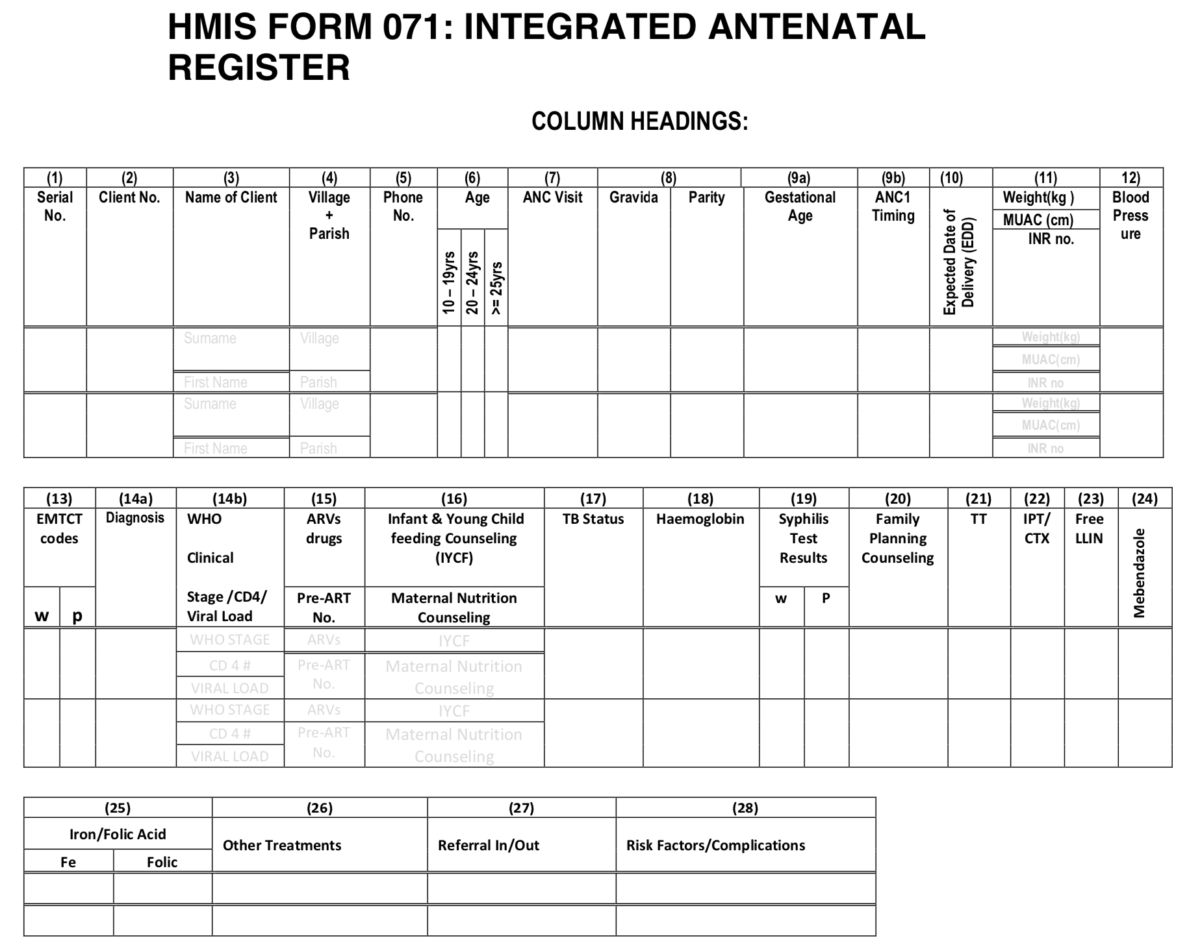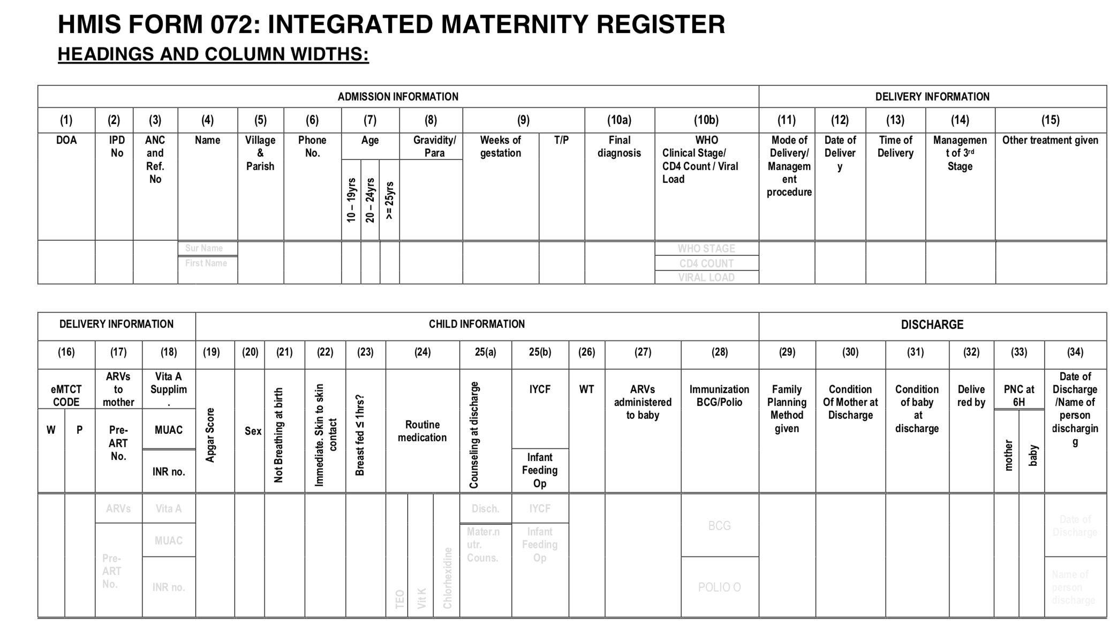
Supplementary Fig. 5. HMIS Forms: Integrated Antenatal Register and Integrated Maternity Register

