Appendix A: Electronic Health Records Tools Screen Shots
Figure 1: History of Present Illness template for physical activity

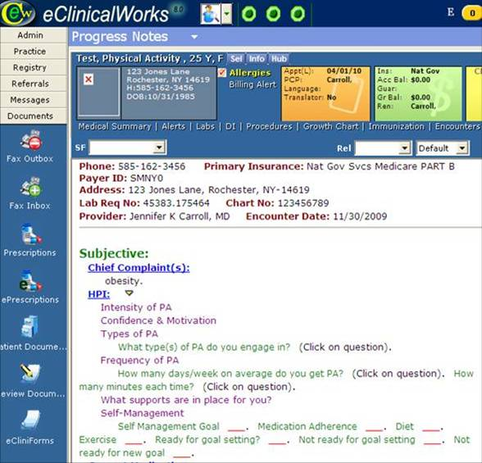
Figure 2: Social History box

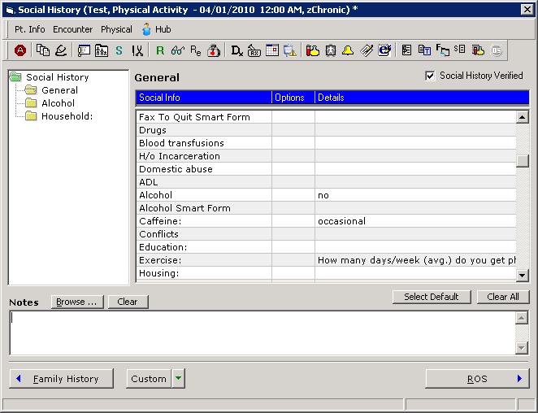

Figure 3: Preventive Medicine Link for physical activity prescription

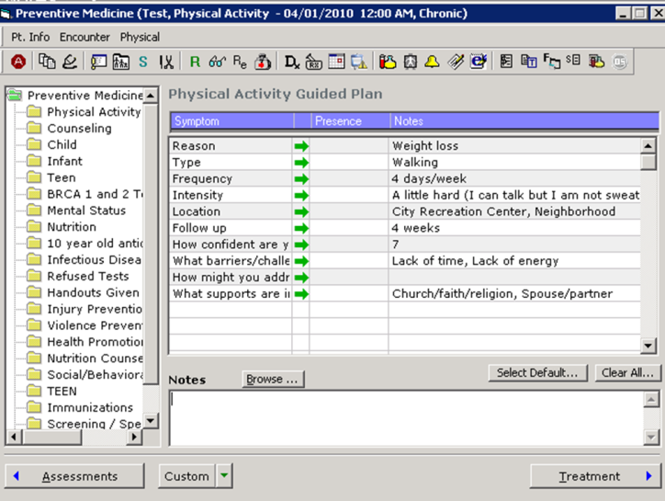

Figure 4: Order Sets Page

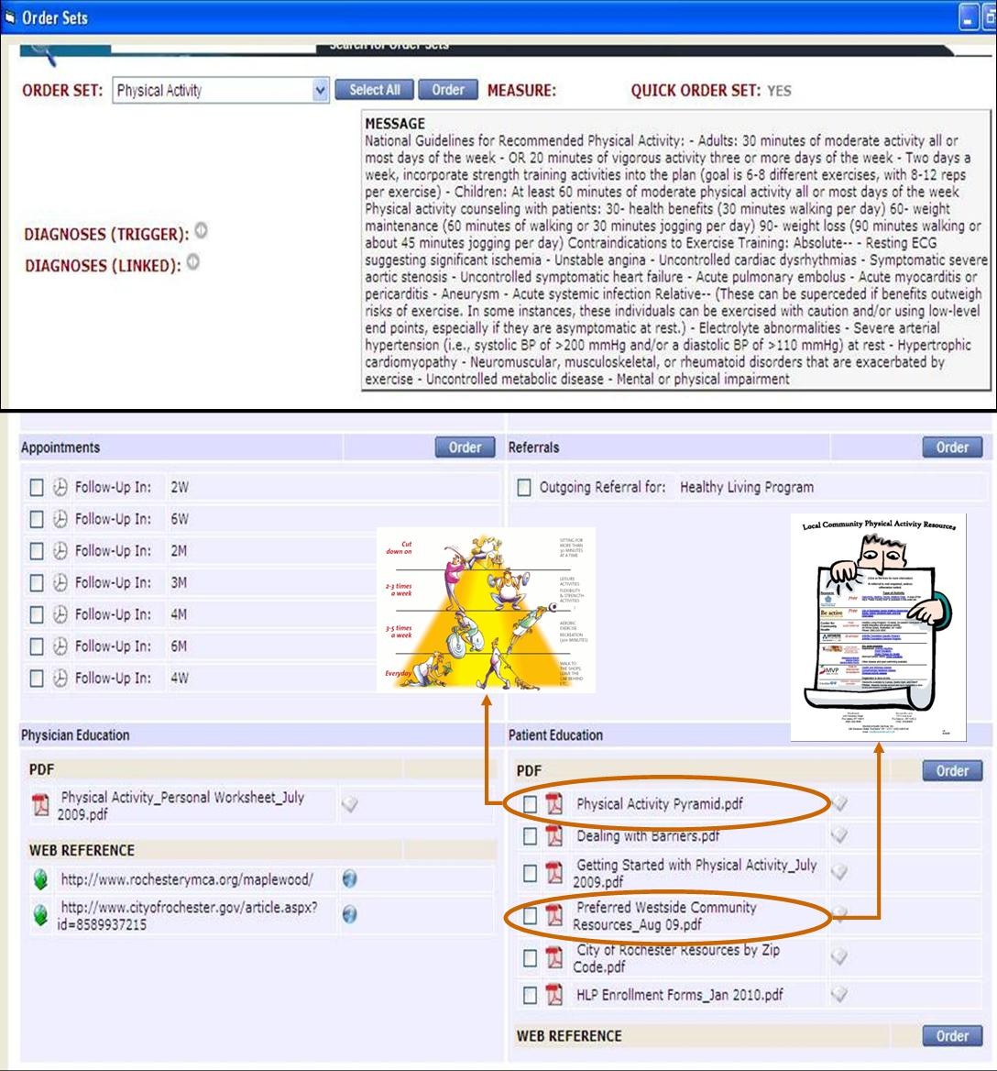

Figure 5: Clinician Referrals Tab (link) to community program

