**Appendix 6: Funnel plots used to check publication bias**

**Outcome 1: Hospitalisation**

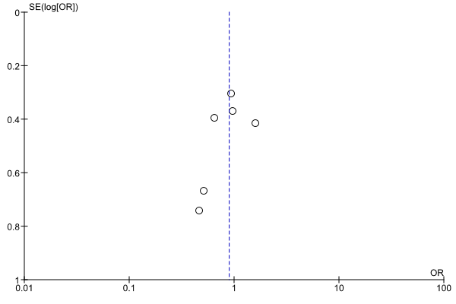

**Outcome 2: Institutionalisation**

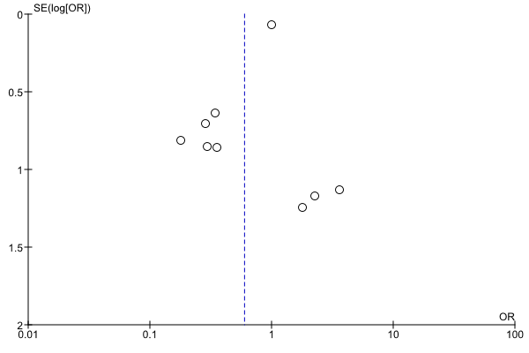

**Outcome 3: Mortality**

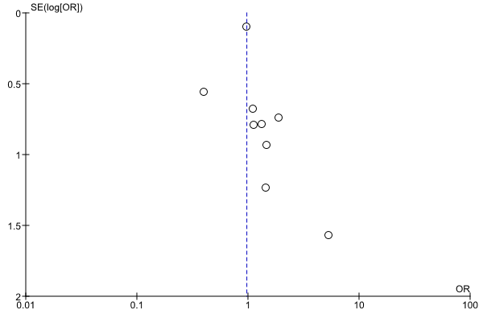

**Outcome 4: Patient quality of life**

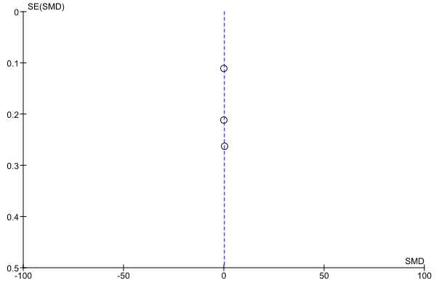

**Outcome 5: Patient cognition**

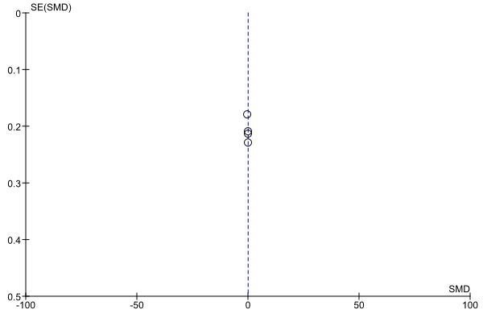

**Outcome 6: Patient function**

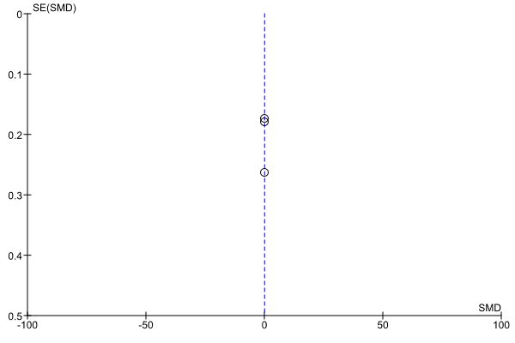

**Outcome 7: Caregiver burden**

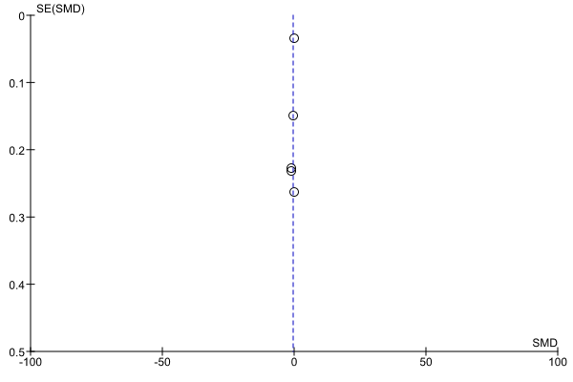

**Outcome 8: Caregiver mood**

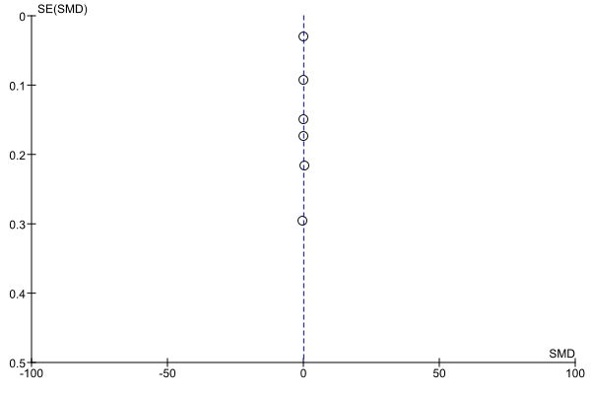

**Outcome 9: Caregiver quality of life**

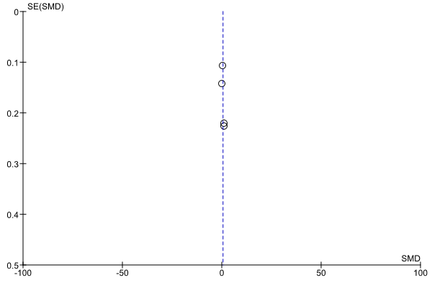

**Outcome 10: Social support**

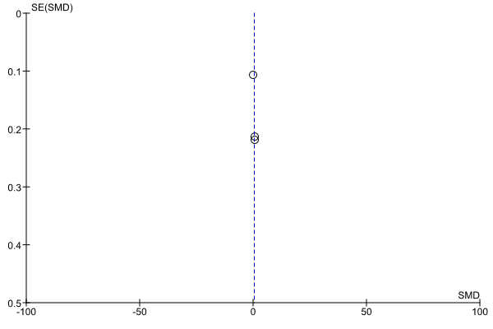

**Outcome 11: Patient behaviour**

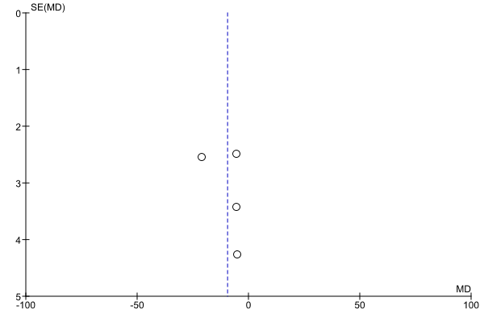

**Outcome 12: Patient depression**

