Fig.S1 Decision tree basic model structure

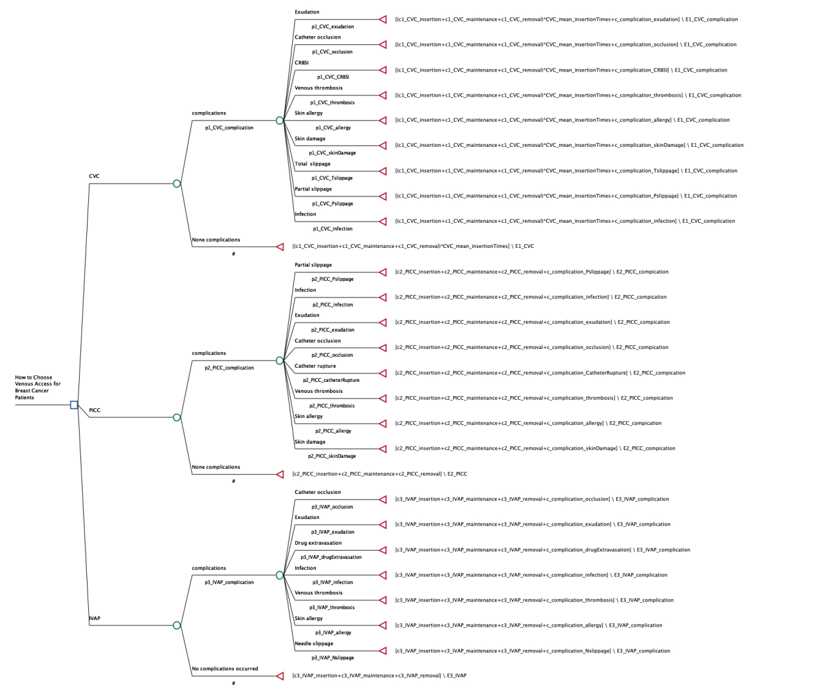

Fig.S2 Survival curves for three vascular accesses

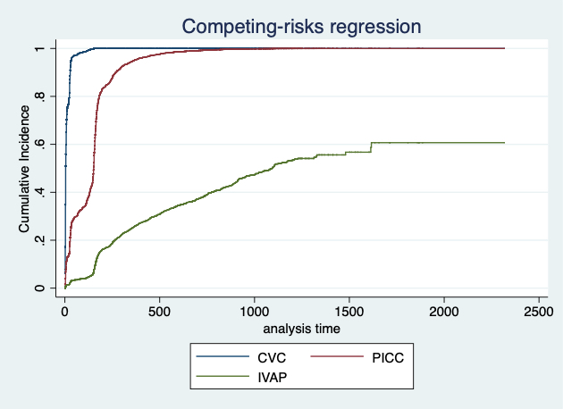

Fig.S3 Cost-effectiveness analysis for CVC、PICC and IVAP

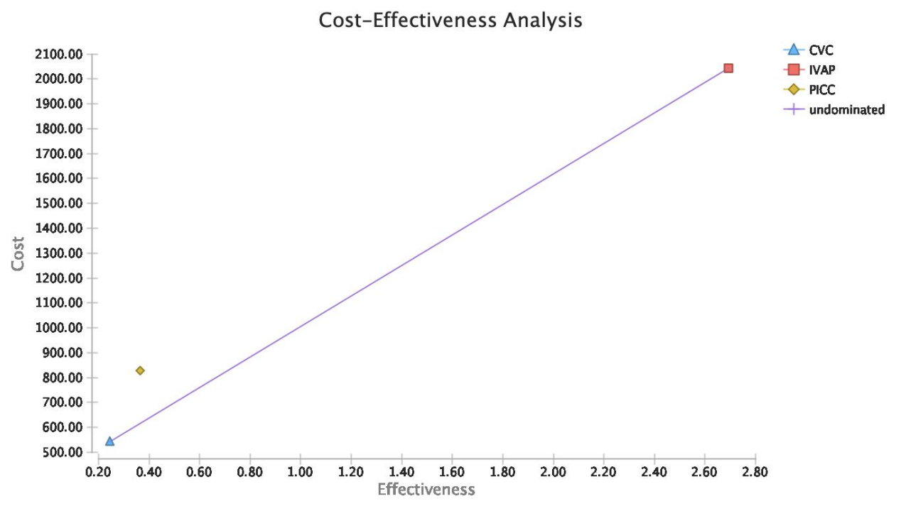

Fig.S4 Scatterplot of probability sensitivity analysis

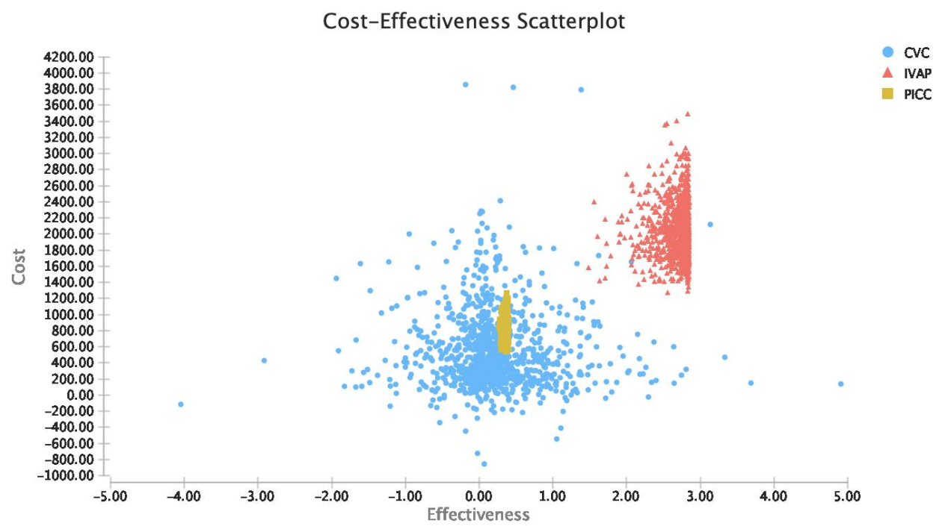

Fig.S5 Histogram of probability sensitivity analysis

