Table S1 Pulmonary medication use at baseline (treated set)
Pulmonary medication class, n (%) | Study
 | 1222.37  (n = 151) | 1222.38  (n = 157)
LAMA monotherapy | 30 (19.9) | 30 (19.1)
LABA monotherapy | 8 (5.3) | 3 (1.9)
LABA/ICS and no LAMA | 11 (7.3) | 23 (14.6)
LAMA/ICS and no LABA | 1 (0.7) | 1 (0.6)
LAMA/LABA and no ICS | 15 (9.9) | 4 (2.5)
LAMA/LABA/ICS triple therapy | 39 (25.8) | 23 (14.6)
LAMA: long-acting muscarinic antagonist; LABA: long-acting β₂-agonist; ICS: inhaled corticosteroid

Table S2 Arithmetic mean, geometric mean and median endurance times after 6 weeks (full analysis set)
 | Study 1222.37 |  |  | Study 1222.38
 | Adjusted arithmetic mean, s (SE)ª | Adjusted geometric mean, s (SE)^{b} | Median, s | Adjusted arithmetic mean, s (SE)ª | Adjusted geometric mean, s (SE)^{b} | Median, s
Placebo | 448.1 (16.7) | 369.8 (11.9) | 394 | 405.2 (17.0) | 354.3 (12.1) | 346
Olodaterol 5 µg | 492.0 (16.5) | 421.6 (13.5) | 427 | 469.6 (17.2) | 396.3 (13.7) | 397
Olodaterol 10 µg | 494.2 (16.7) | 420.7 (13.6) | 445 | 444.9 (17.2) | 391.5 (13.6) | 380
ªCalculated based on a mixed effects repeated measures model on original scale; ^{b}calculated based on back-transformation of mean estimated with a mixed effects repeated measures model on log₁₀-transformed data
SE: standard error

Table S3 Geometric mean (SE) endurance time after 6 weeks by GOLD (full analysis set)
Study | GOLD 2 |  |  | GOLD 3/4
 | Patients, n | Adjusted geometric mean (SE) endurance time, s | Improvement compared to placebo, % | Patients, n | Adjusted geometric mean (SE) endurance time, s | Improvement compared to placebo, %
1222.37  Placebo  Olodaterol 5 µg  Olodaterol 10 µg | 91  94  93 | 410.5 (24.3)  455.9 (26.8)  462.3 (27.3) | 11.1  12.6 | 45  46  43 | 288.7 (24.3)  348.2 (29.1)  335.2 (28.5) | 20.6  16.1
1222.38  Placebo  Olodaterol 5 µg  Olodaterol 10 µg | 105  103  102 | 372.7 (18.7)  412.2 (20.8)  412.3 (20.9) | 10.6  10.6 | 40  37  37 | 305.5 (24.7)  350.0 (29.0)  338.2 (28.0) | 14.6  10.7
GOLD: Global initiative for chronic Obstructive Lung Disease; SE: standard error

Table S4 Peak expiratory flow outcomes at 6 weeks (full analysis set)
Treatment | Planned time, min | Adjusted mean (SE) difference from placebo after 6 weeks, L/s
Study 1222.37  Olodaterol 5 µg  Olodaterol 10 µg  Olodaterol 5 µg  Olodaterol 10 µg | -0.30 (pre-dose/trough)  60 (post-dose) | 0.32 (0.06)ª  0.30 (0.06)ª  0.59 (0.06)ª  0.62 (0.06)ª
Study 1222.38  Olodaterol 5 µg  Olodaterol 10 µg  Olodaterol 5 µg  Olodaterol 10 µg | -0.30 (pre-dose/trough)  60 (post-dose) | 0.28 (0.06)^{c}  0.29 (0.06)^{d}  0.58 (0.07)^{c}  0.55 (0.07)^{d}
ªn = 137; ^{b}n = 136; ^{c}n = 143; ^{d}n = 139
p < 0.0001 for all
SE: standard error

Fig. S1 Hierarchical testing order: each test was considered confirmatory only if all of the previous tests were positive
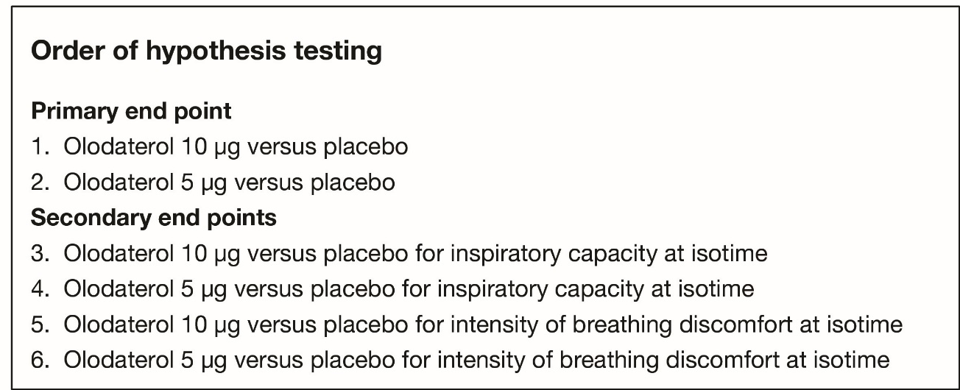

Fig. S2 Participant flow in (a) Study 1222.37 and (b) Study 1222.38
QD: once daily
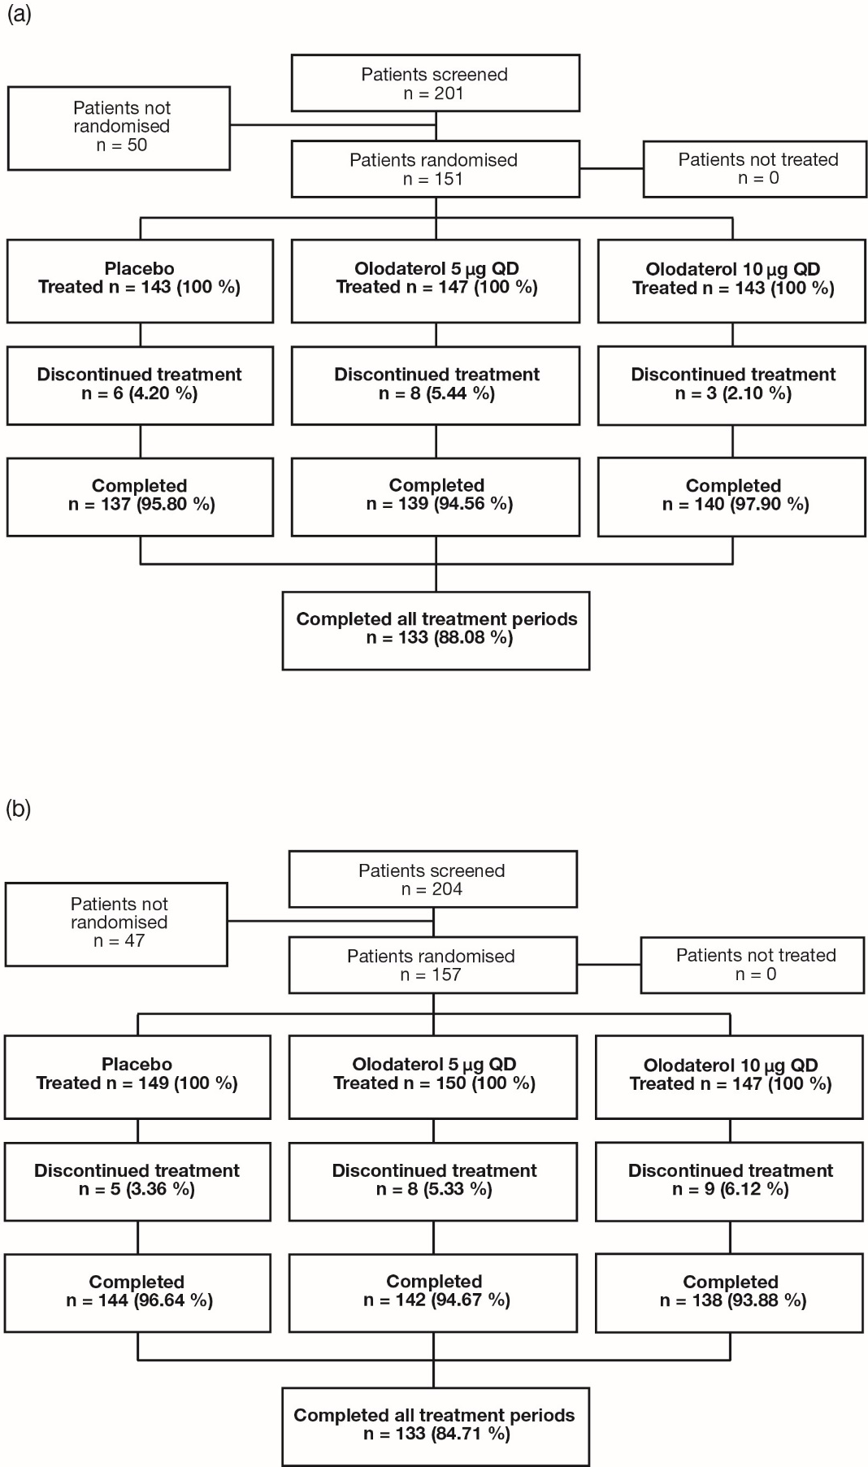

Fig. S3. Exercise endurance time after 6 weeks for (a) Study 1222.37 and (c) Study 1222.38. Log₁₀-transformation of exercise endurance time after 6 weeks for (b) Study 1222.37 and (d) Study 1222.38 (full analysis set)
