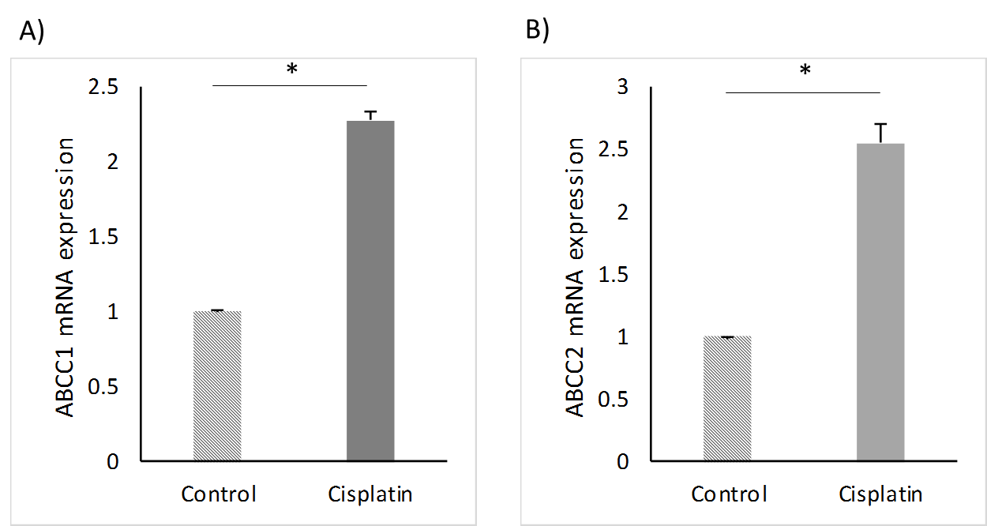
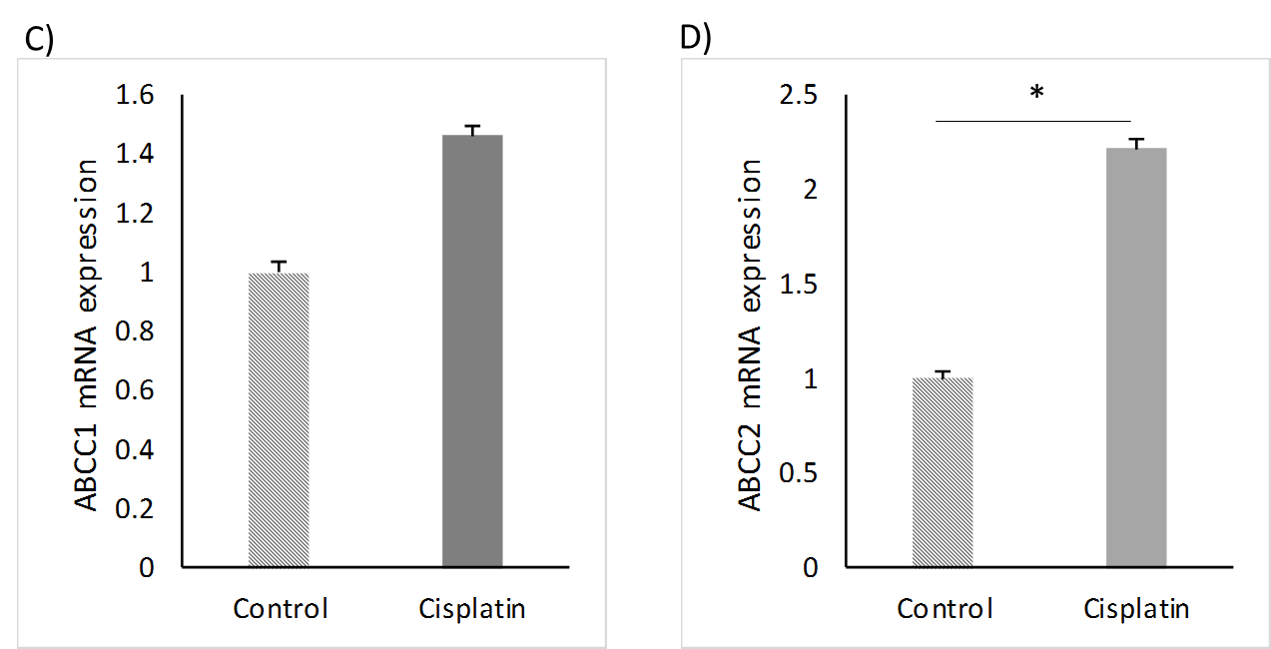
Supplementary Figure 3. Effects of cisplatin in 3D lung tissue tumor cell line aggregates. Relative mRNA expression of ABCC1 and ABCC2 drug transporters of cisplatin treatment of 3D co-culture aggregates of adenocarcinoma cell line A549-NHLF (A) and B)); 3D co-culture aggregates of squamous cell line H520-NHLF (C) and D)). Data are presented as mean±SEM, n=3.

