Online supplement:
Table 1. Physical and baseline functional characteristics of bovine tracheal strips.
Control muscles Test muscles
EFS studies‡
Weight, mg | Fresh | 13.9 ± 9.3 | 12.8 ± 3.9
 | 24-h stored | 14.4 ± 9.0 | 11.4 ± 5.4
Resting Force, g | Fresh | 0.5 ± 0.4 | 0.6 ± 0.1
 | 24-h stored | 0.5 ± 0.4 | 0.7 ± 0.3
Active force @64 Hz, g | Fresh | 21.8 ± 4.0 | 18.0 ± 0.2
 | 24-h stored | 21.3 ± 8.6 | 17.7 ± 6.3
Exogenous ACh studies#
Weight, mg * | Fresh | 10.6 ± 3.0 | 10.6 ± 0.7
 | 24-h stored | 6.9 ± 2.3 | 7.0 ± 1.4
Resting Force, g * | Fresh | 0.3 ± 0.1 | 0.6 ± 0.1
 | 24-h stored | 0.7 ± 0.2 | 0.8 ± 0.2
Active force @10⁻⁴M, g | Fresh | 23.7 ± 1.1 | 21.8 ± 2.0
 | 24-h stored | 20.6 ± 1.8 | 21.0 ± 2.5
ACh release studies¶
Weight, mg ** | Fresh | 27.5 ± 7.0 | 27.3 ± 7.3
 | 24-h stored | 20.7 ± 5.4 | 20.3 ± 5.8
 | 48-h stored | 18.7 ± 4.1 | 21.5 ± 4.9
Resting Force, g | Fresh | 0.8 ± 0.4 | 0.9 ± 0.5
 | 24-h stored | 0.7 ± 0.4 | 0.7 ± 0.4
 | 48-h stored | 0.5 ± 0.3 | 0.7 ± 0.4
Active force @4 Hz, g | Fresh | 20.9 ± 7.4 | 20.9 ± 7.8
 | 24-h stored | 19.7 ± 6.2 | 18.2 ± 5.2
 | 48-h stored | 15.7 ± 3.8 | 16.7 ± 3.3
ACh release @4 Hz, disintegrations | Fresh | 1242 ± 542 | 1197 ± 563
 | 24-h stored | 1586 ±1059 | 1658 ± 1456
 | 48-h stored | 1352 ± 563 | 1604 ± 889

Data are mean ± SD; ‡, n=24 (fresh and stored); #, n=24 (fresh), 32 (stored); ¶, n= 32 (fresh), 26 (24-h stored), 16 (48-h stored). *, p<0.017 and **, p=0.004 stored vs. fresh; p>0.194 for all other comparisons fresh vs. stored; p>0.153 for all comparisons between control and test muscles; interaction between fresh/stored vs. control/test p>0.081 for all comparisons (ANOVA).
Figure 1:

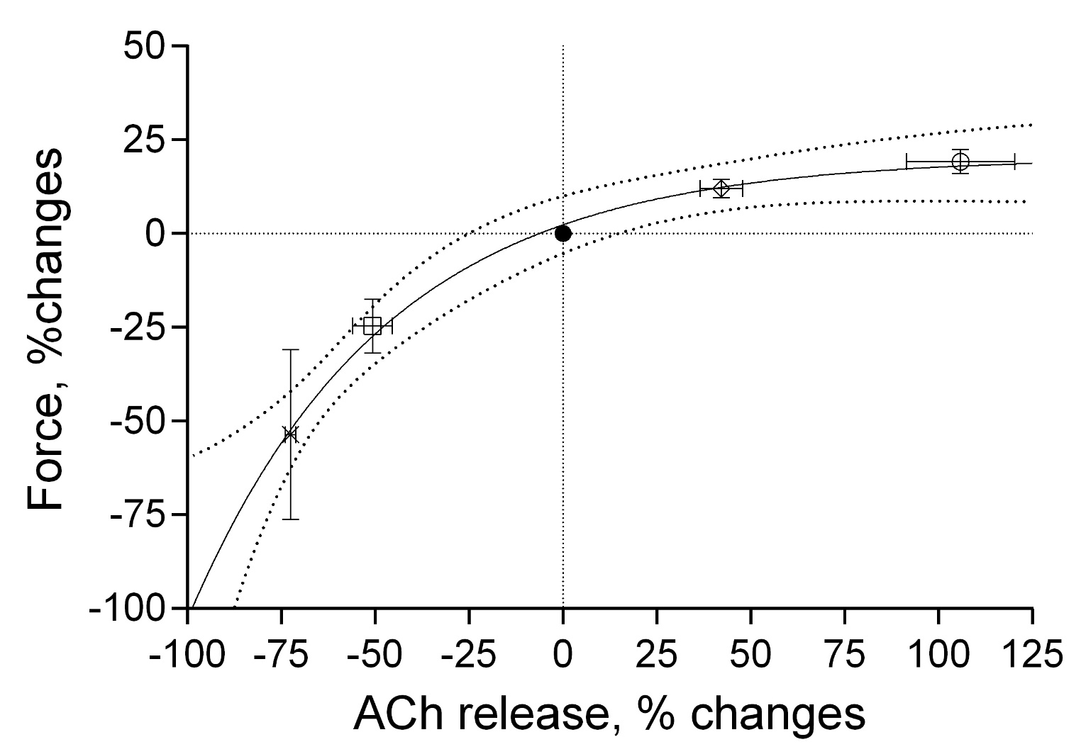
Figure 1. Relationships between ACh-release and isometric force at ES frequencies of 1 (x), 2 (□), 4 (●), 8 (◊), and 16 (○) Hz in 4 separate experiments. Data are mean and SD of percent changes from 4 Hz; continuous thick line is the regression model o$f the form y=\left(plateau-y_{0}\right)•\left[1-e^{\left(-k•x\right)}\right]$, interrupted lines are the 95% CI; r²=0.887.

