ADDITIONAL FILE 2

Characterization of cystic fibrosis airway epithelial cell cultures at the air-liquid interface obtained by non-invasive nasal cytology brush sampling
Aline Schögler, Fabian Blank, Melanie Brügger, Seraina Beyeler, Stefan A. Tschanz, Nicolas Regamey, Carmen Casaulta, Thomas Geiser, and Marco P. Alves

A | B
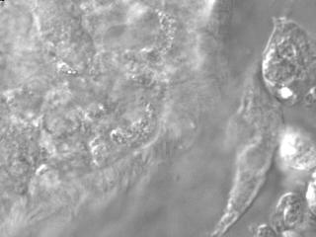 | 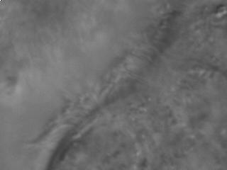
Recording of ciliary beat by differentiated cystic fibrosis cell cultures grown at the air-liquid interface. Representative movies of ciliary beating and mucociliary transport of cell debris of well-differentiated cystic fibrosis nasal epithelial cell cultures (A, B). Image series of beating cilia were taken serially at 300 frames per second at a 40X magnification (as described in the main manucsript) and played at 50 frames per second.

