Long-acting bronchodilators improve exercise capacity in COPD patients: a systematic review and meta-analysis

Fabiano Di Marco¹, Giovanni Sotgiu², Pierachille Santus³, Denis E. O’Donnell⁴, Kai-Michael Beeh⁵, Simone Dore², Maria Adelaide Roggi⁶, Lisa Giuliani¹, Francesco Blasi⁷, and Stefano Centanni¹

Additional file

Figure S1. Funnel plots for ET, isotime IC and isotime dyspnea (all studies).

Endurance time
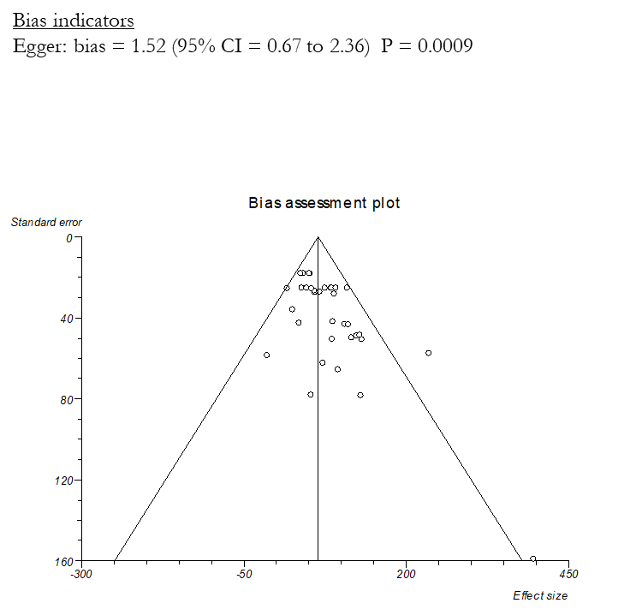

Isotime inspiratory capacity
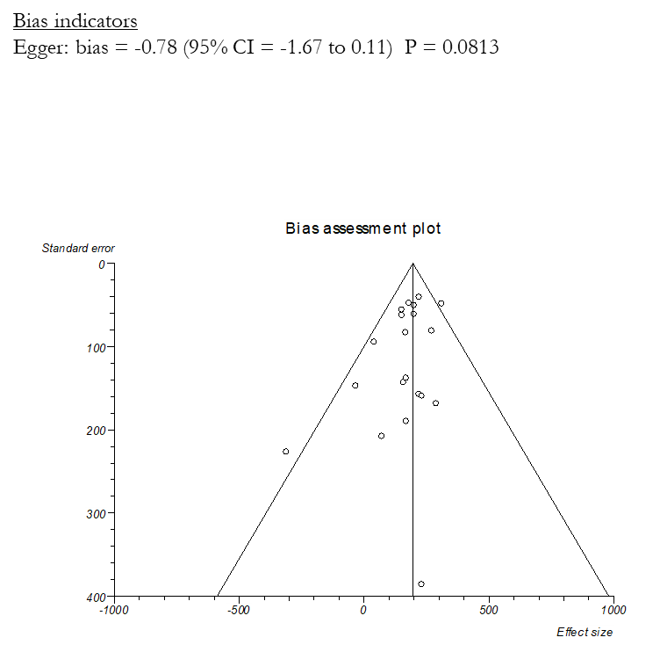

Isotime dyspnea BORG

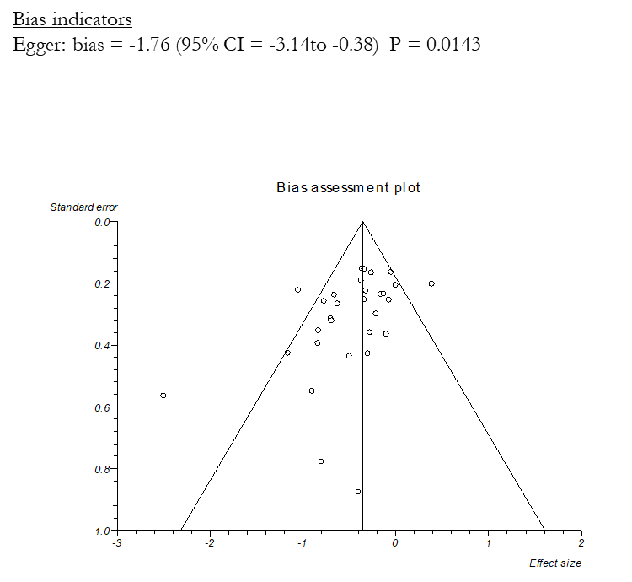

Figure S2 A. Forest and Funnel plots of ET, isotime IC and isotime dyspnea in the 11 studies which included only COPD patients with functional residual capacity (FRC) > 120%.

Endurance time

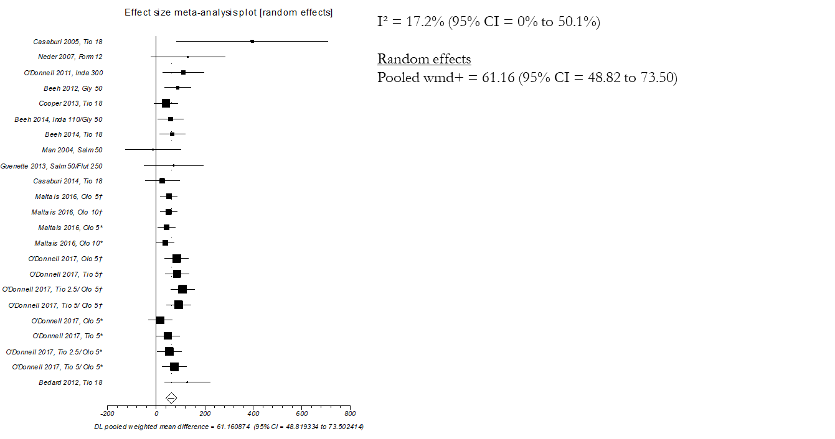

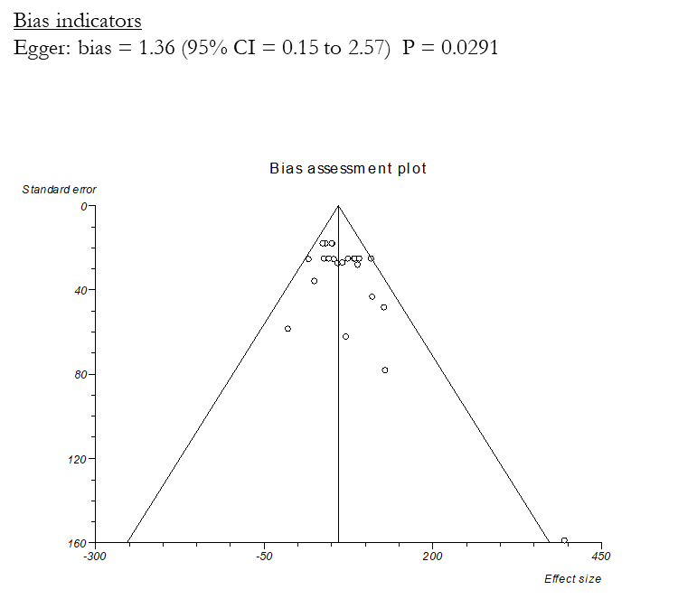

Isotime inspiratory capacity

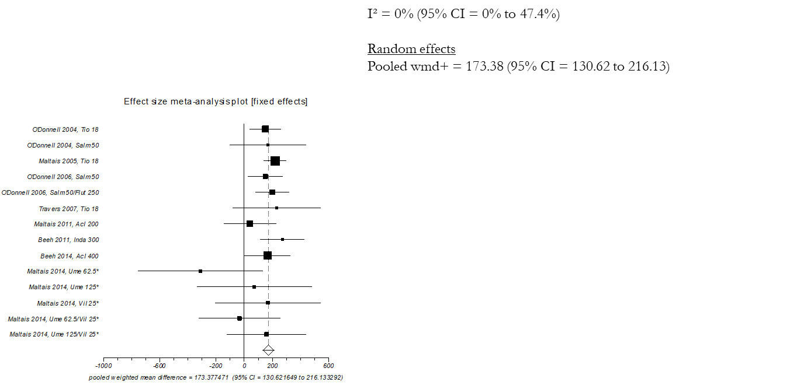

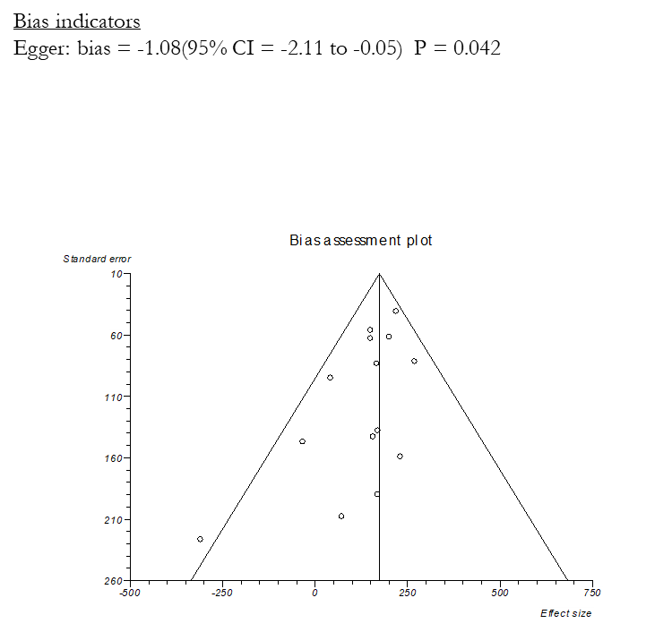

Isotime dyspnea BORG

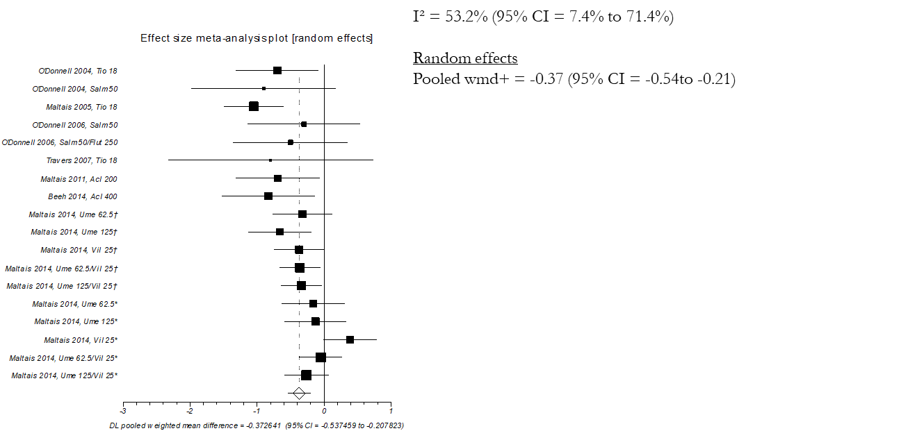

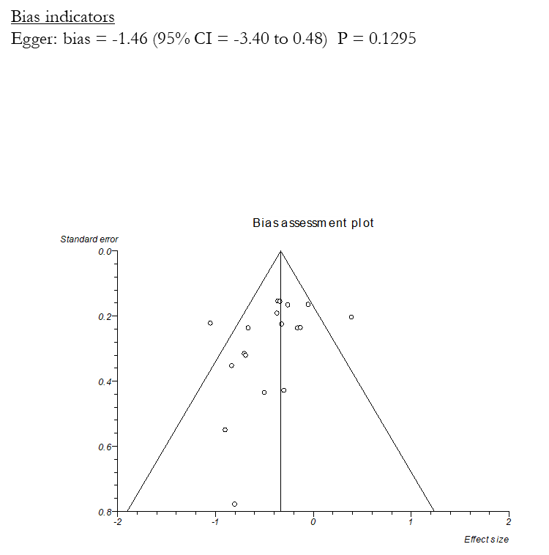

Figure S2 B. Forest and Funnel plots of ET, isotime IC and isotime dyspnea in the studies which did not require an increase of functional residual capacity (FRC) as inclusion criterion.

Endurance time

Isotime inspiratory capacity

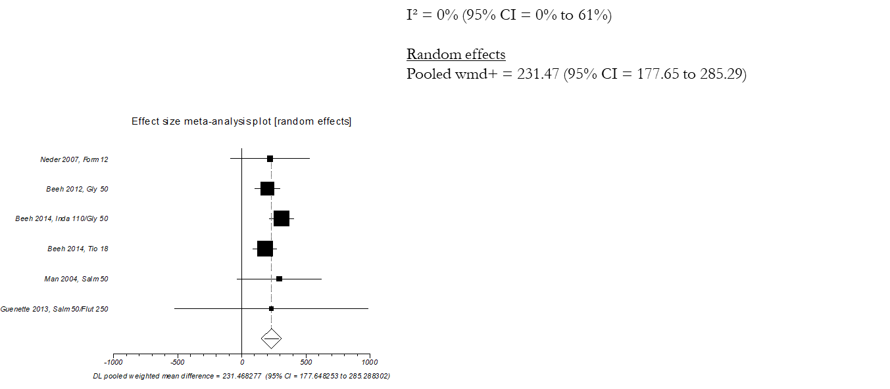

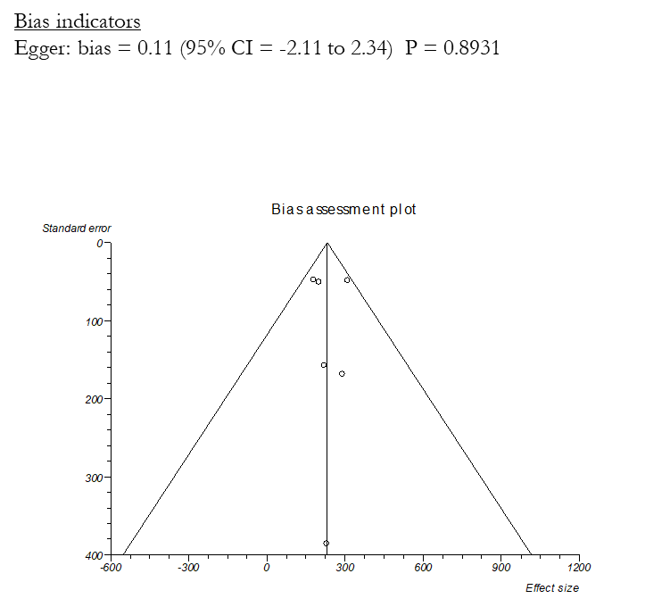

Isotime dyspnea BORG

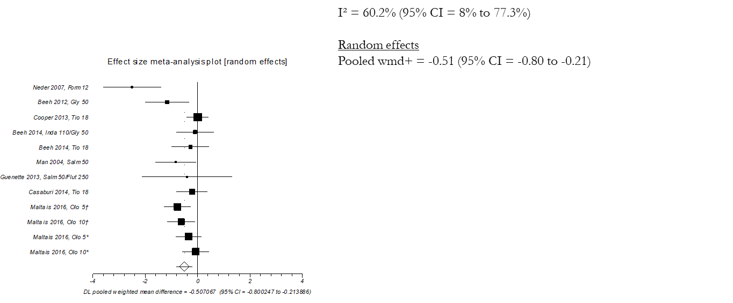

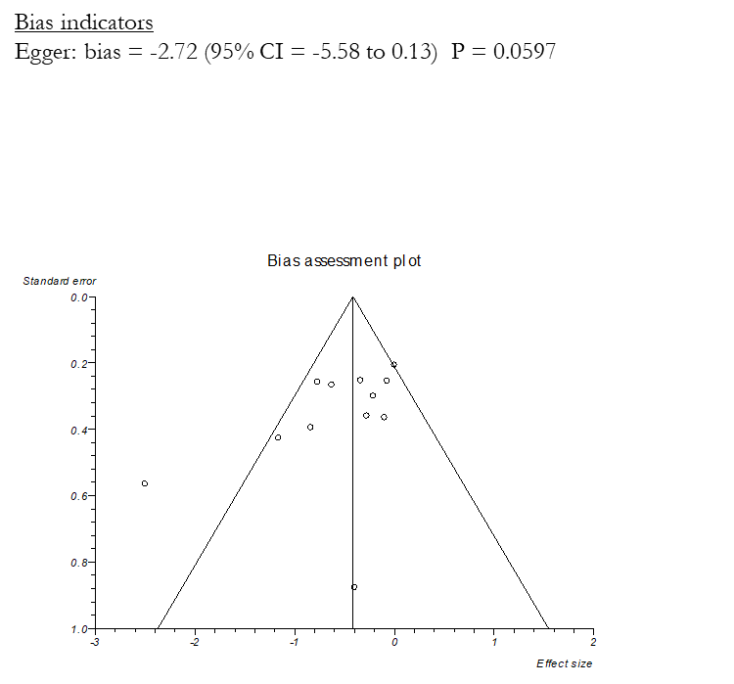

Figure S3. Forest and Funnel plots of ET of the 5 studies (A) which used walking and 17 studies (B) which used cycling as exercise methodology to assess the efficacy of long-acting bronchodilators.

A)
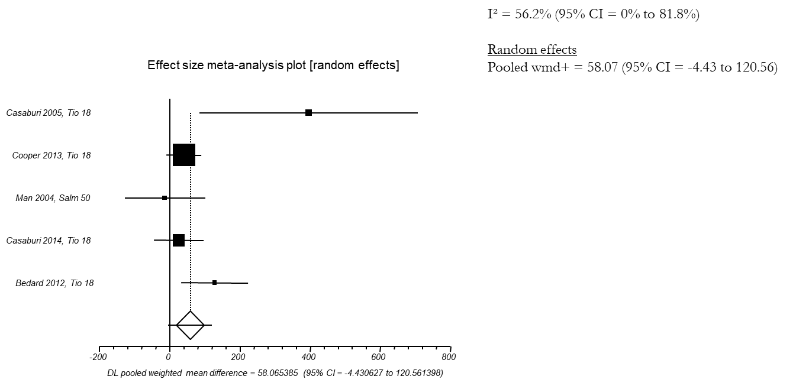

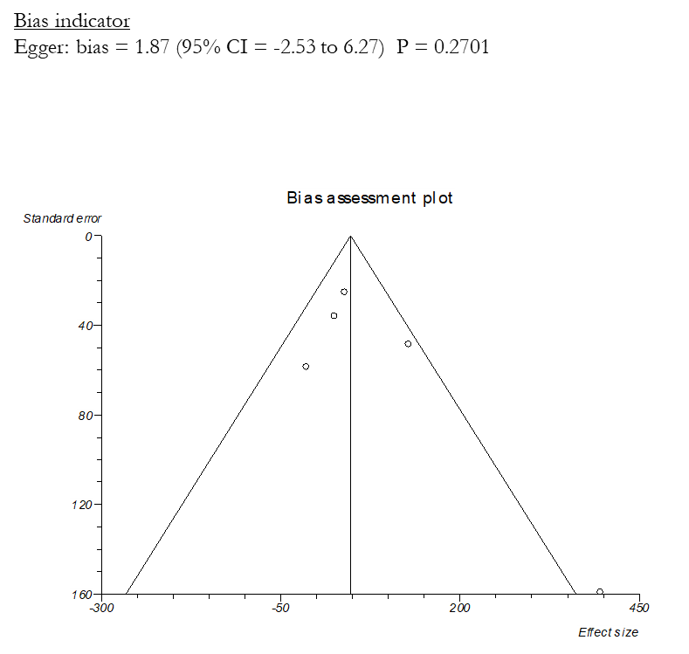

B)

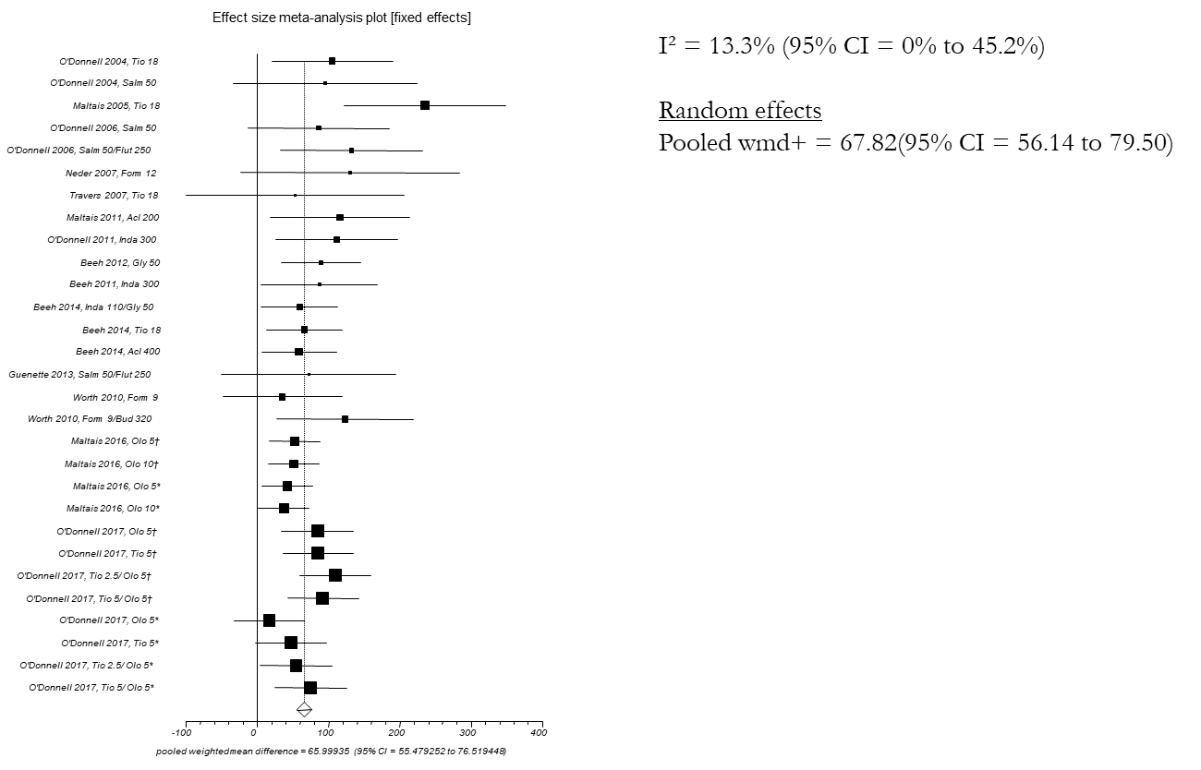

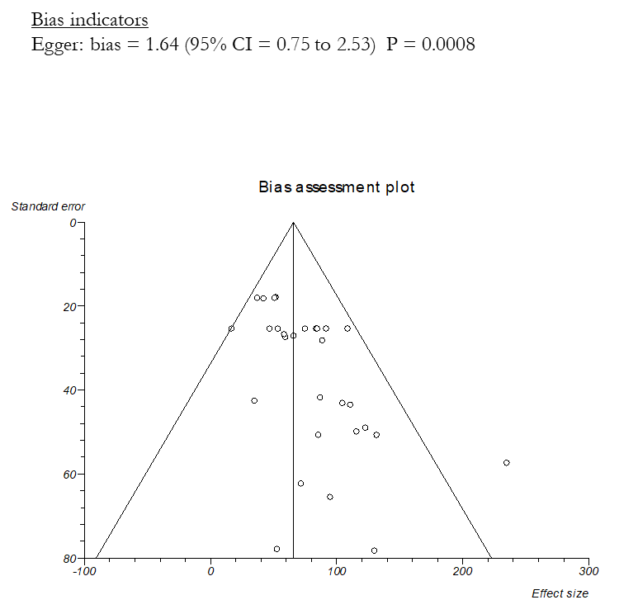

Table S1. Cochrane collaboration tool for assessing risk of bias.
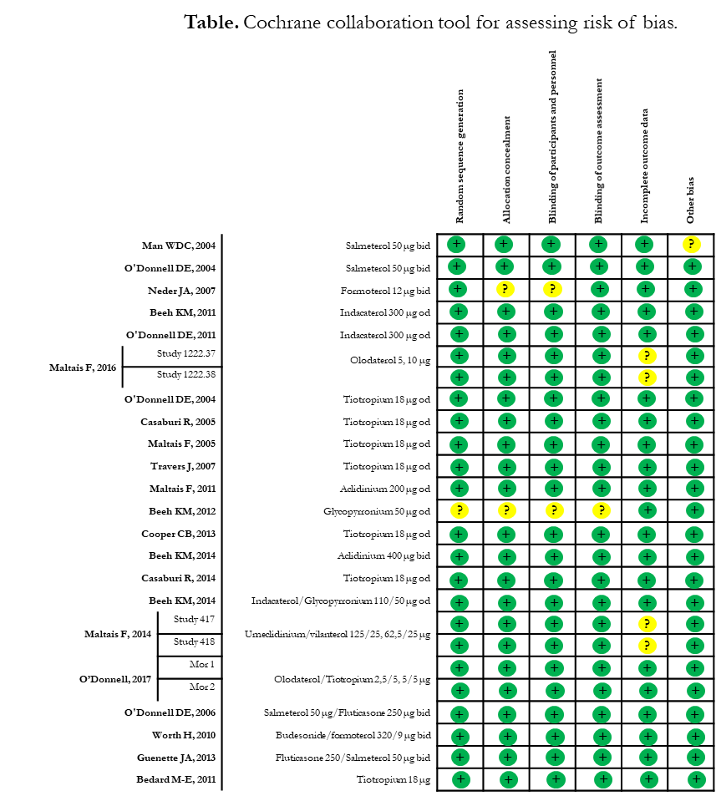

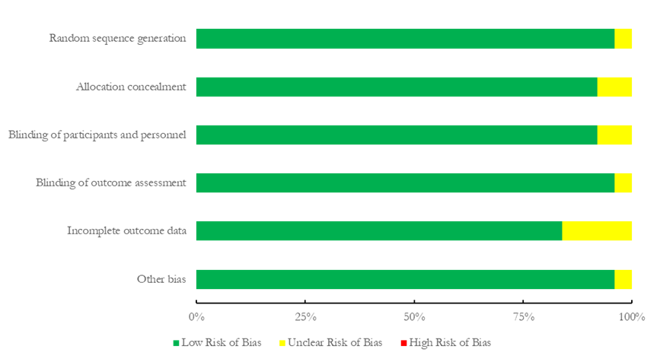

Table S2. List of and reason why studies on long-acting bronchodilators have been excluded from the analysis.
Study | Reason for exclusion
Canto ND, et al. Addition of tiotropium to formoterol improves inspiratory muscle strength after exercise in COPD. Respir Med 2012; 106: 1404–1412. | No placebo arm
Tzani P, et al.Effects of beclomethasone/formoterol fixed combination on lung hyperinflation and dyspnea in COPD patients. Int J Chron Obstruct Pulmon Dis. 2011;6:503-9. | No placebo arm
Berton DC, et al. Effects of tiotropium and formoterol on dynamic hyperinflation and exercise endurance in COPD. Respir Med. 2010 Sep;104(9):1288-96. | No placebo arm
Magnussen H, et al. Effect of combination treatment on lung volumes and exercise endurance time in COPD. Respir Med. 2012 Oct;106(10):1413-20. | No placebo arm
Yoshimura K, et al. Effects of tiotropium on sympathetic activation during exercise in stable chronic obstructive pulmonary disease patients. Int J Chron Obstruct Pulmon Dis 2012; 7: 109–117. | No placebo arm
Brouillard C, et al. Endurance shuttle walking test: responsiveness to salmeterol in COPD. Eur Respir J. 2008 Mar;31(3):579-84. | Duration < 1 week
van der Vaart H, et al. Bronchodilation improves endurance but not muscular efficiency in chronic obstructive pulmonary disease. Int J Chron Obstruct Pulmon Dis. 2011;6:229-35. | Data expressed only as difference vs. placebo and not high intensity protocol
Watz H, et al. ACTIVATE: the effect of aclidinium/formoterol on hyperinflation, exercise capacity, and physical activity in patients with COPD. Int J Chron Obstruct Pulmon Dis. 2017 Aug 24;12:2545-2558. | Data expressed only as difference vs. placebo
Zhang X, et al. Advantages of endurance treadmill walking compared with cycling to assess bronchodilator therapy. Chest. 2010 Jun;137(6):1354-61. | Data expressed only as difference vs. placebo

