**Table S1.** Radiological findings at exacerbation.

|  |  |  |  |
| --- | --- | --- | --- |
|  | All exacerbations (n=343) | Exacerbations without infiltrate (n=274) | Exacerbations with infiltrate (n=69) |
| Pleural effusion | 7 (2) | 5 (1.8) | 2 (2.9) |
| Cardiomegaly | 16 (4.7)* | 12 (4.4) | 5 (5.8) |
| Mass/nodule | 1 (0.3) | 1 (0.4) | 0 (0.0) |
| Pulmonary oedema | 1 (0.3) | 1 (0.4) | 0 (0.0) |

*7 CXRs at exacerbation with reported cardiomegaly are from one individual subject.

Data presented as n, (%)

**Table S2.** Exacerbation treatment stratified by the presence or absence of radiographic pneumonic infiltrate.

|  |  |  |
| --- | --- | --- |
|  | Exacerbations without infiltrate  (n=274) | Exacerbations with infiltrate  (n=69) |
| No treatment | 25 (9.1) | 5 (7.2) |
| Antibiotic only | 22 (8.0) | 11 (15.9) |
| OCS only | 62 (22.6) | 10 (14.5) |
| Antibiotics and OCS | 161 (58.8) | 43 (62.3) |
| Data unavailable | 4 (1.5) | 0 (0.0) |

Data presented as n, (%).

**Table S3.** Bacterial identification by culture and PCR in all exacerbation sputum samples and those exacerbation sputum samples with fewer than 30% squamous cells (considered high quality).

|  |  |  |  |  |  |  |
| --- | --- | --- | --- | --- | --- | --- |
|  | All exacerbations with valid sputum | | | Only exacerbations with high quality sputum | | |
| Infiltrate | No infiltrate | P-value | Infiltrate | No infiltrate | P-value |
| Culture | n=308 | | | n=209 | | |
| Any bacteria | 44 (69.8%) | 140 (57.1%) | 0.067 | 31 (70.5%) | 97 (58.8%) | 0.158 |
| *Haemophilus influenzae* | 33 (52.4%) | 93 (38.0%) | 0.038 | 25 (56.8%) | 67 (40.6%) | 0.054 |
| PCR | n=295 | | | n=204 | | |
| Any bacteria | 47 (77.0%) | 153 (65.4%) | 0.082 | 34 (77.3%) | 106 (66.3%) | 0.163 |
| *Haemophilus influenzae* | 38 (62.3%) | 122 (52.4%) | 0.165 | 26 (59.1%) | 85 (53.1%) | 0.482 |

Data represented as n (%). P-values from Chi-square test unless otherwise stated.

**Table S4.** Bacterial and viral identification at exacerbation by culture (bacteria) and PCR (bacteria/virus).

|  |  |  |  |  |  |
| --- | --- | --- | --- | --- | --- |
|  | Exacerbations with infiltrate | | Exacerbations without infiltrate | |  |
|  | n♯ |  | n♯ |  | P-Value |
| By culture | | | | | |
| Any bacteria | 63 | 44 (69.8) | 245 | 140 (57.1) | 0.067 |
| *Haemophilus influenzae* | 63 | 33 (52.4) | 245 | 93 (38.0) | 0.038 |
| *Streptococcus pneumoniae* | 63 | 7 (11.1) | 245 | 40 (16.3) | 0.305 |
| By PCR | | | | | |
| Any bacteria | 61 | 47 (77.0) | 233 | 153 (65.4) | 0.092 |
| *Haemophilus influenzae* | 61 | 38 (62.3) | 233 | 122 (52.4) | 0.165 |
| *Streptococcus pneumoniae* | 61 | 7 (11.5) | 233 | 19 (8.2) | 0.416 |
| Rhinovirus | 60 | 14 (23.3) | 234 | 56 (23.9) | 0.923 |
| Any virus | 60 | 25 (41.7) | 234 | 101 (43.2) | 0.835 |

Data represented as n (%). P-values from Chi-square test unless otherwise stated.

♯ indicates the number of subjects with available data/samples.

Any bacteria includes: *Haemophilus influenzae*, *Moraxella catarrhalis*, *Streptococcus pneumoniae*, *Pseudomonas aeruginosa*, and *Staphylococcus aureus*.

Any virus includes: influenza A, influenza B, respiratory syncytial virus, human metapneumovirus, parainfluenza virus 1–4, coronavirus (OC43, 229E, NL63, HKU1), rhinovirus/enterovirus, adenovirus, and bocavirus.

**Table S5.** Levels of serum inflammatory markers at paired stable, and exacerbation visits.

|  |  |  |  |  |  |  |  |  |  |  |
| --- | --- | --- | --- | --- | --- | --- | --- | --- | --- | --- |
| Serum marker | Exacerbation with infiltrate | | | | Exacerbation without infiltrate | | | | P-value | P-value |
| n♯ | Pre- AE stable visit | AE | P-value* | n♯ | Pre- AE stable visit | AE | P- value* | Stable- stable  ** | AE-AE  ** |
| CRP (mg/L) | 29 | 5.0 (11.0) | 19 (58.0) | <0.001 | 153 | 4.0 (6.0) | 7.0 (13.5) | <0.001 | 0.254 | <0.001 |
| Fibrinogen (g/L) | 29 | 4.8 (1.8) | 5.8 (2.3) | <0.001 | 137 | 4.6 (1.1) | 5.0 (1.5) | <0.001 | 0.868 | 0.005 |
| Blood WCC (cellsx109L) | 31 | 7.8 (2.8) | 10.2 (4.5) | <0.001 | 150 | 7.6 (2.6) | 8.0 (3.5) | 0.010 | 0.518 | <0.001 |
| Blood neutrophils (cellsx109L) | 31 | 5.1 (2.7) | 7.7 (4.4) | <0.001 | 150 | 4.8 (2.0) | 5.3 (3.2) | <0.001 | 0.414 | <0.001 |
| Procalcitonin (μg/L) | 32 | 0.0633 (0.0400) | 0.0798 (0.0400) | <0.001 | 151 | 0.0662 (0.0300) | 0.0723 (0.0400) | <0.001 | 0.187 | 0.220 |

AE: Acute exacerbation.

Data presented as median (IQR). * P-value from Wilcoxon signed rank test. ** P-values from Mann Whitney U test.

♯ indicates the number of subjects with available data/samples.

Blood was sampled at both stable visits and at exacerbation (within 72 hours of symptom onset) and results compared.

**Table S6.** Changes in levels of serum inflammatory markers between stable (pre-exacerbation) and exacerbation samples.

|  |  |  |  |  |  |
| --- | --- | --- | --- | --- | --- |
| Serum marker | Exacerbation with infiltrate | | Exacerbation without infiltrate | | P-value |
| n♯ |  | n♯ |  |
| Blood WCC (cellsx109L) | 31 | 1.6 (3.8) | 150 | 0.4 (2.1) | 0.001 |
| Blood neutrophils (cellsx109L) | 31 | 1.7 (3.7) | 150 | 0.5 (1.9) | 0.003 |
| CRP (mg/L) | 29 | 10.0 (59) | 153 | 2.0 (9.0) | 0.002 |
| Fibrinogen (g/L) | 29 | 0.9 (2.3) | 137 | 0.2 (1.2) | 0.009 |
| Procalcitonin (μg/L) | 32 | 0.019 (0.030) | 151 | 0.005 (0.030) | 0.002 |

Data presented as median (IQR). P-value from Mann Whitney U test.

♯ indicates the number of subjects with available data/samples.

Blood was sampled at both stable visits and at exacerbation (within 72 hours of symptom onset) and the median changes compared.

**Table S7.** Levels of serum inflammatory markers at paired stable, and exacerbation visits. The occurrence of the first infiltrate-associated exacerbation with available data was prioritised, or the first non-infiltrative exacerbation if not (subjects are therefore only represented once).

|  |  |  |  |  |  |  |  |  |  |  |
| --- | --- | --- | --- | --- | --- | --- | --- | --- | --- | --- |
| Serum Marker | Exacerbations with infiltrate | | | | Exacerbations without infiltrate | | | | P-value | |
| n♯ | Stable | AE | P-value* | n♯ | Stable | AE | P-value* | Stable-Stable** | AE-AE** |
| Blood WCC (cellsx109L) | 27 | 7.6 (1.9) | 9.2 (5.5) | <0.001 | 73 | 7.5 (2.4) | 7.9 (3.0) | 0.031 | 0.810 | 0.001 |
| Blood neutrophils (cellsx109L) | 27 | 4.5 (2.3) | 6.8 (4.7) | <0.001 | 73 | 4.7 (1.8) | 5.2 (2.5) | 0.026 | 0.652 | 0.002 |
| CRP (mg/L) | 25 | 5.0 (10.5) | 19.0 (56.5) | 0.001 | 76 | 4.0 (6.0) | 8.0 (13.0) | <0.001 | 0.202 | 0.001 |
| Fibrinogen (g/L) | 25 | 4.8 (1.7) | 5.8 (2.2) | 0.001 | 64 | 4.8 (1.0) | 5.3 (1.5) | <0.001 | 0.798 | 0.019 |
| Procalcitonin (μg/L) | 28 | 0.0651 (0.0400) | 0.0759 (0.0400) | 0.001 | 74 | 0.0652 (0.0300) | 0.0686 (0.0400) | 0.172 | 0.409 | 0.117 |

Stable = visit prior to exacerbation in which patient deemed to be at stable-state; AE = acute exacerbation visit.

Data presented as median (IQR). *P-value from Wilcoxon ranked sign test. **P-value from Mann Whitney U test.

♯ indicates the number of subjects with available data/samples.

Blood was sampled at both stable visits and at exacerbation (within 72 hours of symptom onset) and results compared.

**Table S8.** Lung function changes between nearest stable-state and exacerbation visits, stratified by presence/absence of pneumonic infiltrate.

|  |  |  |  |
| --- | --- | --- | --- |
|  | Exacerbations with infiltrate  (n=36) | Exacerbations without infiltrate  (n=203) | P-value |
| FEV1 (ml) | -125 (0.18) | -40 (0.17) | 0.010 |
| FVC (ml) | -180 (0.49) | -70 (0.39) | 0.091 |

FVC=forced vital capacity; FEV1=forced expiratory volume in 1 second.

Data presented as median (IQR). P-value from Mann Whitney U test.



**Figure S1.** The proportion of bacterial positive sputum samples at exacerbation, by both culture and PCR. ‘Any bacteria’ comprise *Haemophilus influenzae*, *Streptococcus pneumoniae*, *Moraxella catarrhalis*, *Pseudomonas aeruginosa* and *Staphylococcus aureus*.

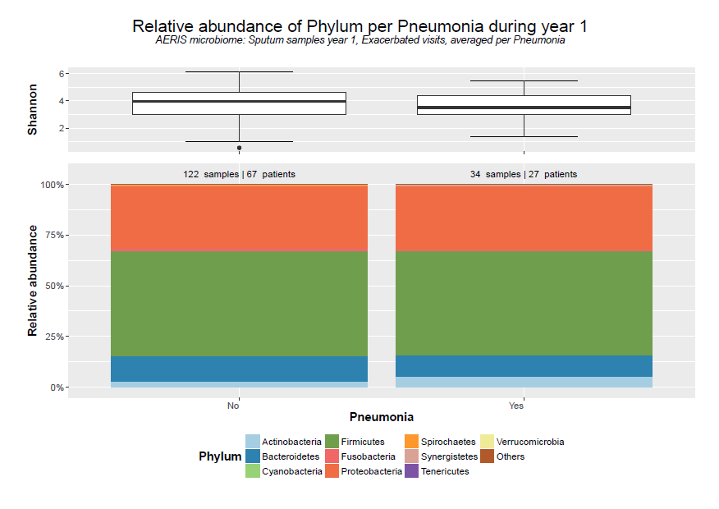

**Figure S2.** The lung microbiome of exacerbations, stratified by the presence or absence of pneumonic infiltrate. (A) The Shannon diversity index did not show any significant difference between radiological groups (p=0.45). (B) The relative phylum abundances showed no significant differences between groups (p=0.35).

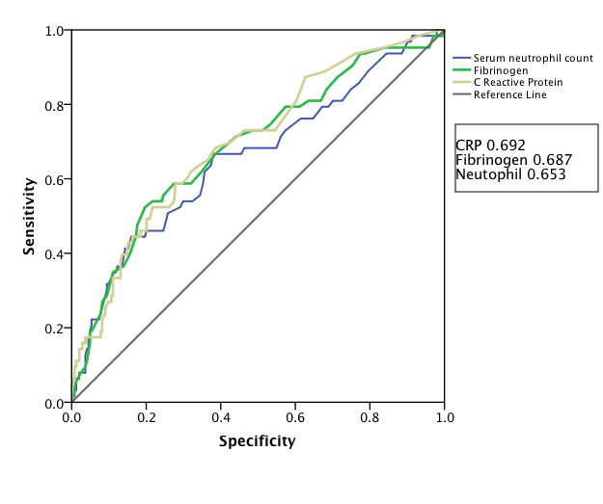

**Figure S3.** Area under the receiver operator curve analysis for CRP, fibrinogen and neutrophil count.