Additional file 3
Definition of the Central Sleep Apnea Group, the Obstructive Sleep Apnea group, and the Treatment Emergent Central Sleep Apnea Group.

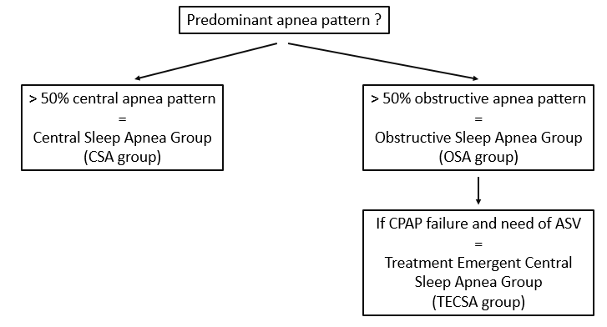

Diagnostic methods (polygraphy (PG) or polysomnography (PSG) ), and the scoring of respiratory events were not standardised (excepted for central or obstructive apnea patterns) because of the change overtime in recommendations for the scoring of respiratory events (initial PG or PSG diagnoses span 2002 to 2016).

