Additional file 5.
Date of the last cardiological consultation depending on the year of ASV initiation (p=0.19 )

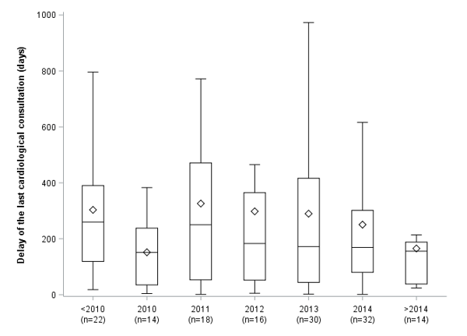

Bold line is median, square is mean, box is first quartile to the third quartile (IQR). Whiskers are minimum and maximum (or Q1- 1.5 IQR and Q3+ 1.5 IQR respectively ; values above 1.5*IQR from the box are considered to be outliers and not represented)

