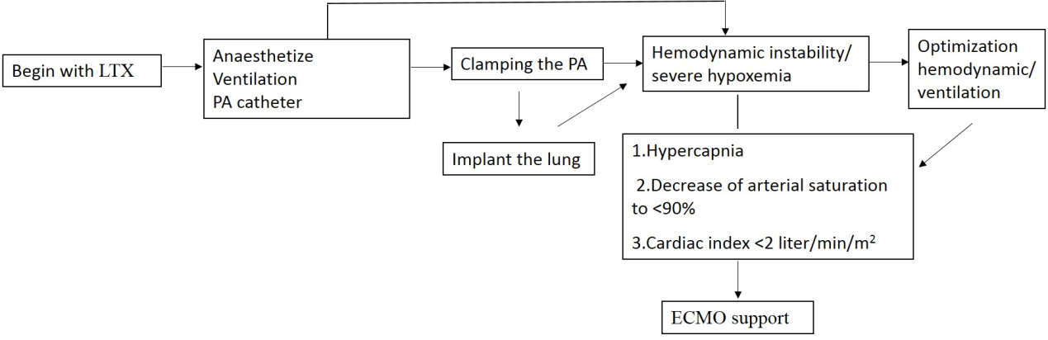
Figure 4. Process reports intraoperative ECMO support in LTX patients. PA (pulmonary artery); LTX (lung transplantation).

