Months | Number of hospitalizations, monthly  (mean ± SD) | Monthly hospitalization rate, per 100,000 population  (mean ± SD) | In-hospital mortality, % (mean ± SD)
Jan | 2,437 ± 312 | 0.79 ± 0.11 | 7.81 ± 1.49
Feb | 2,456 ± 313 | 0.79 ± 0.11 | 8.23 ± 1.39
Mar | 2,458 ± 315 | 0.79 ± 0.11 | 7.87 ± 1.04
Apr | 2,482 ± 337 | 0.80 ± 0.12 | 7.56 ± 0.73
May | 2,353 ± 293 | 0.76 ± 0.10 | 7.37 ± 0.93
Jun | 2,202 ± 321 | 0.71 ± 0.11 | 7.25 ± 1.09
Jul | 2,151 ± 304 | 0.69 ± 0.10 | 6.92 ± 1.45
Aug | 2,149 ± 227 | 0.69 ± 0.08 | 7.23 ± 0.90
Sep | 2,154 ± 245 | 0.69 ± 0.09 | 6.85 ± 1.20
Oct | 2,197 ± 368 | 0.71 ± 0.13 | 8.12 ± 1.33
Nov | 2,131 ± 363 | 0.68 ± 0.13 | 7.72 ± 1.17
Dec | 2,207 ± 296 | 0.71 ± 0.10 | 8.45 ± 1.56

1/ Table 1: ILD hospitalization rates and in-hospital mortality by month

2/ Subgroup analysis of only idiopathic pulmonary fibrosis

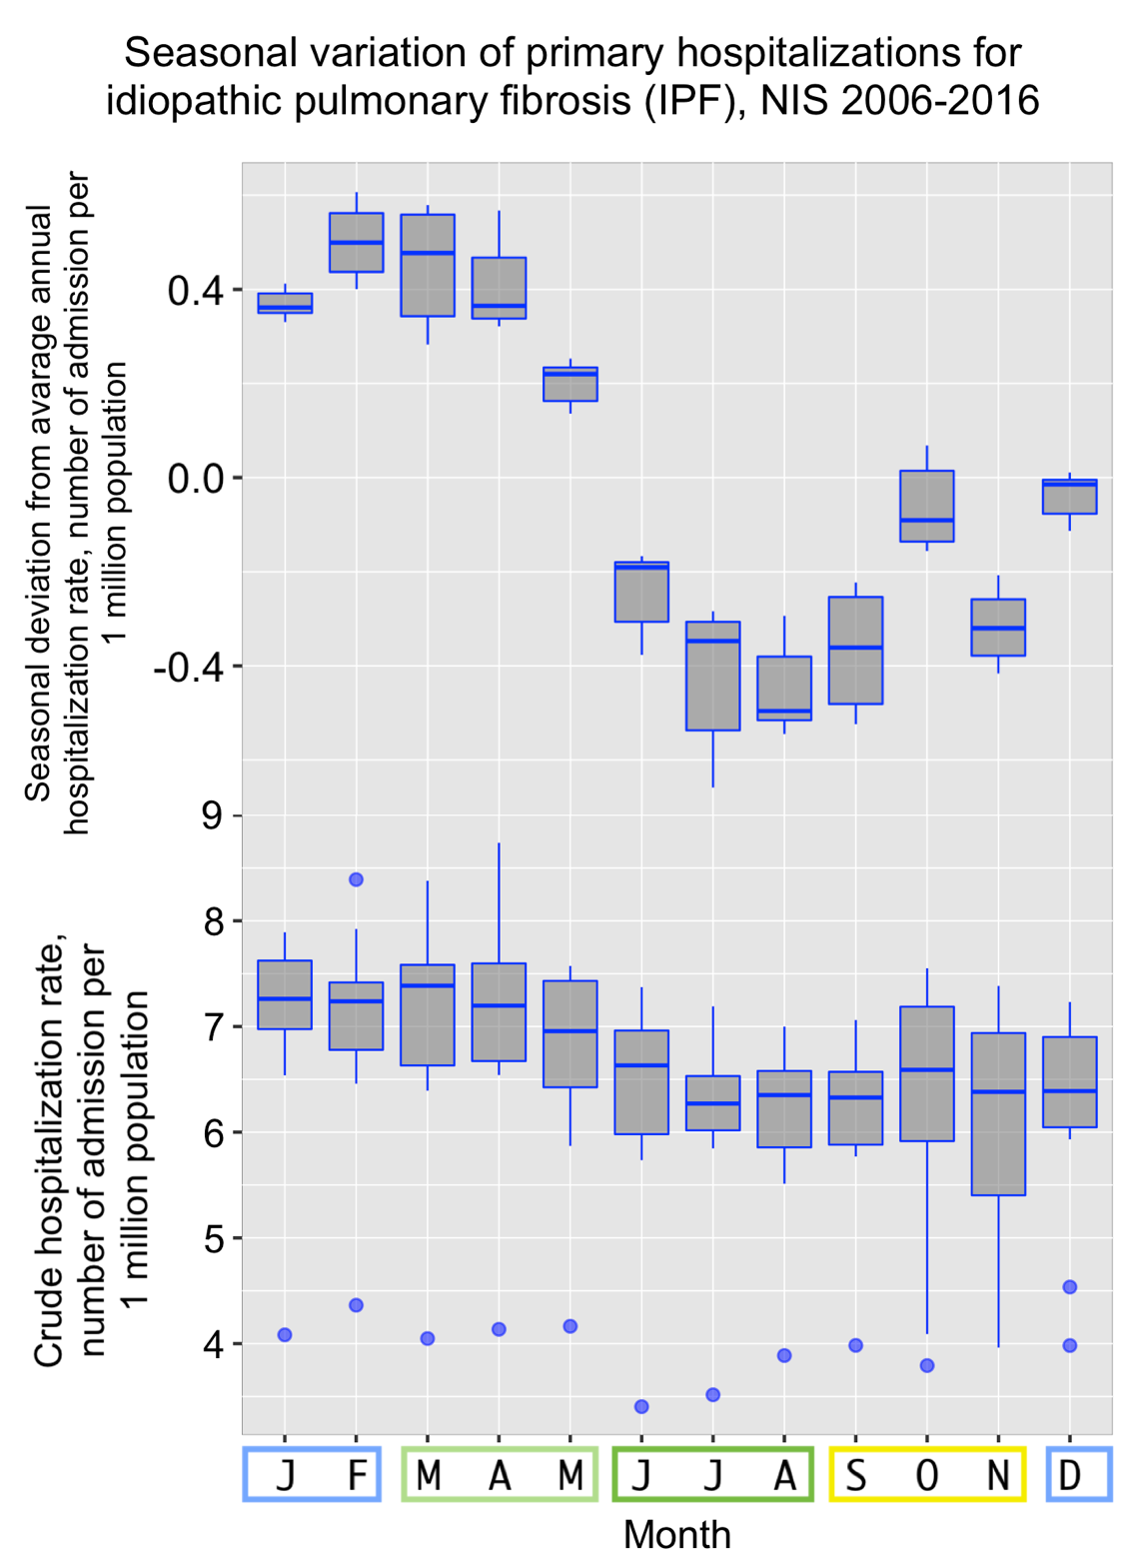

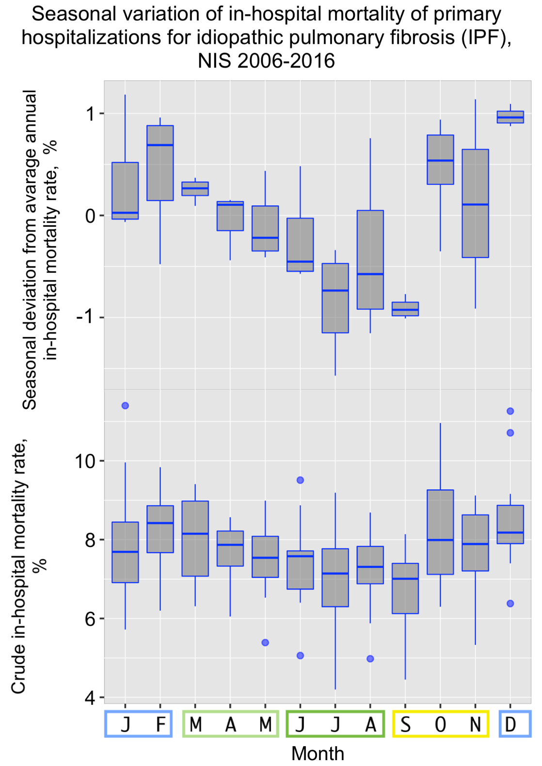

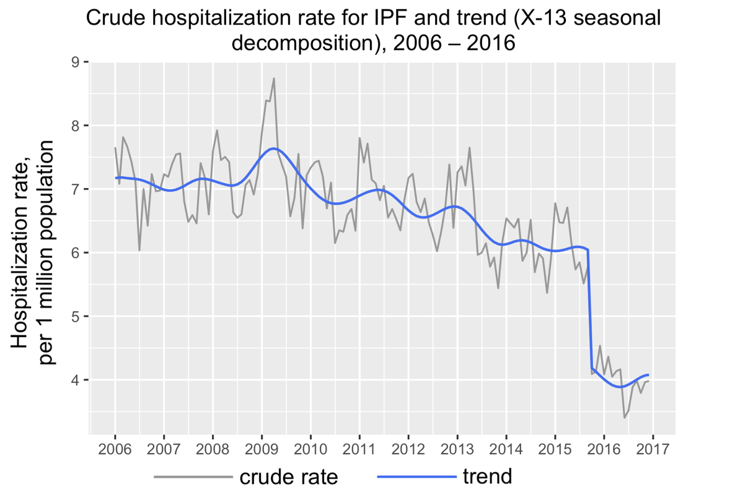

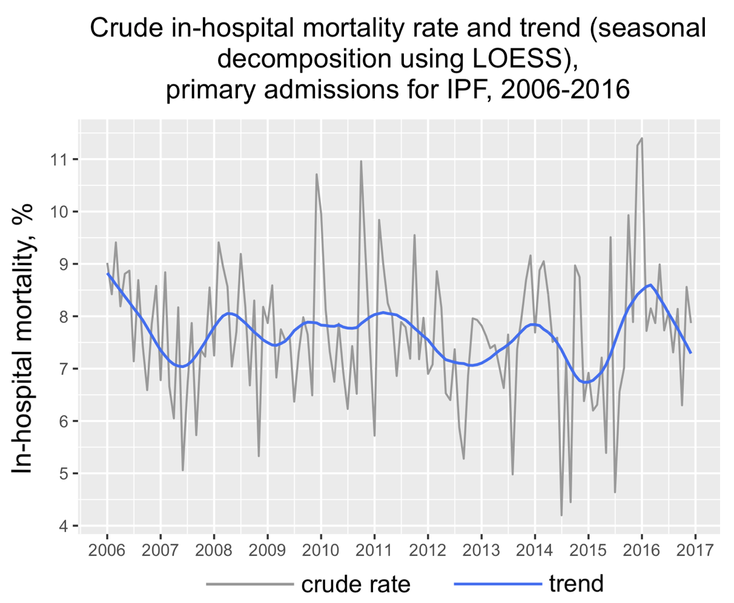

2/ Subgroup analysis of only pneumonia
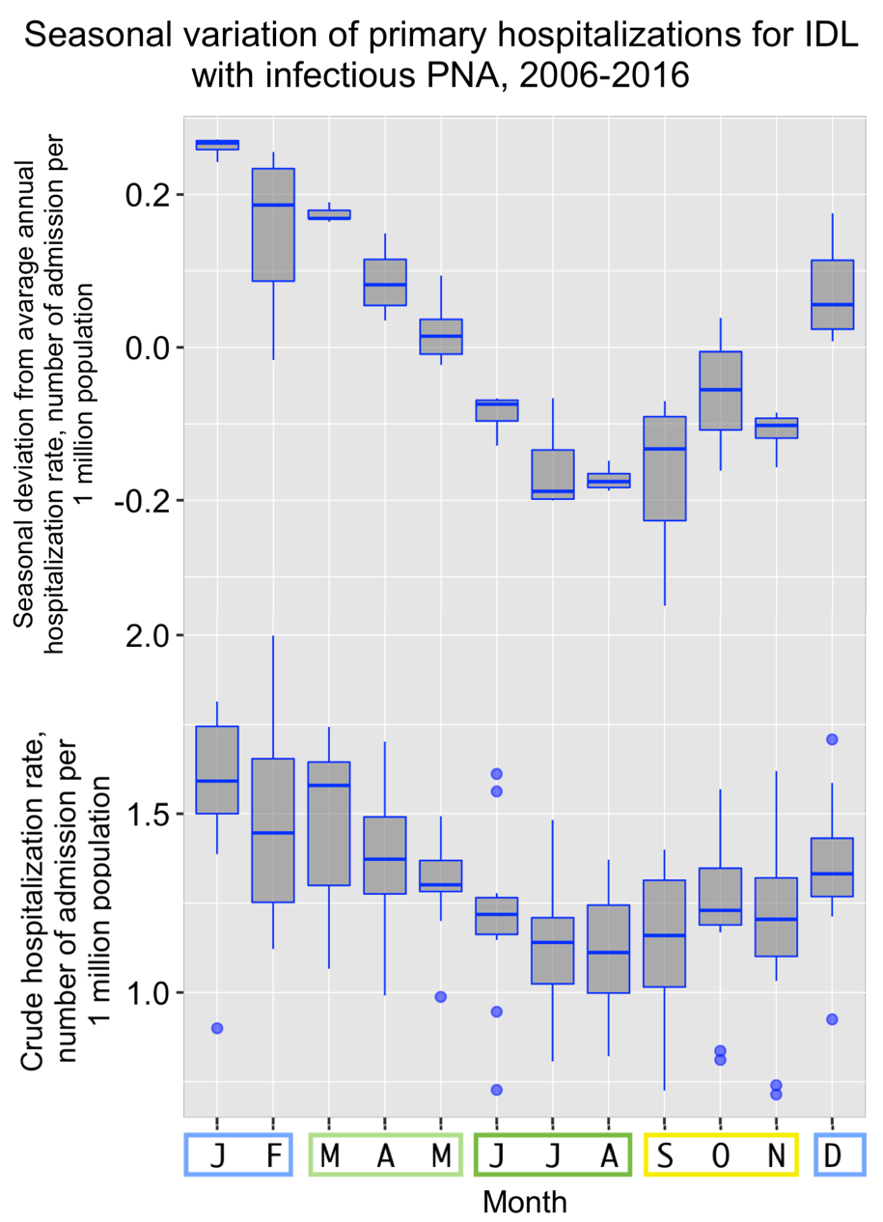
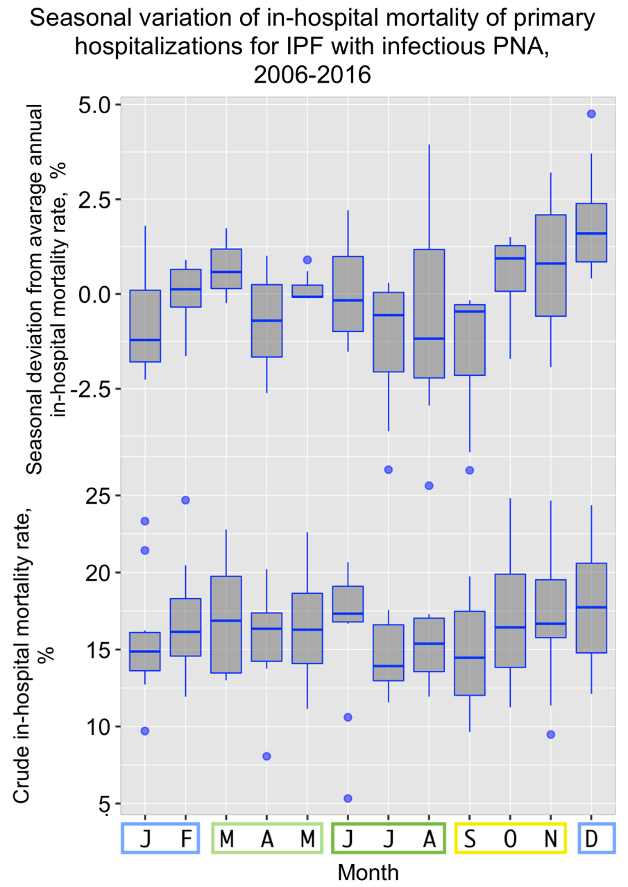
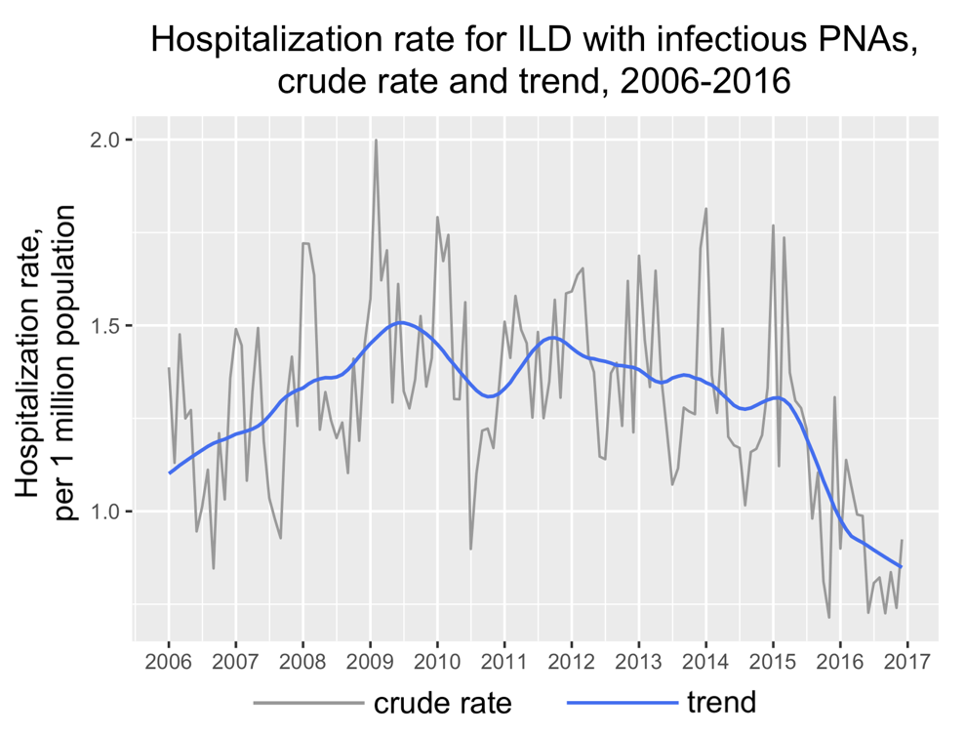
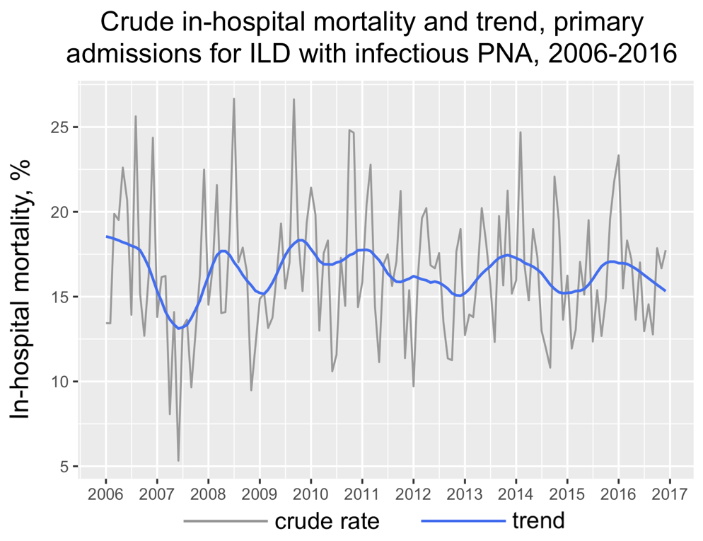

3/ Subgroup analysis of admissions due to acute respiratory failure
