Additional files to accompany manuscript “Empagliflozin monotherapy in drug-naïve patients with type 2 diabetes: a double-blind extension of a Phase III randomized controlled trial” by M Roden et al

Additional file 3 Change from baseline in diastolic blood pressure over time.
A
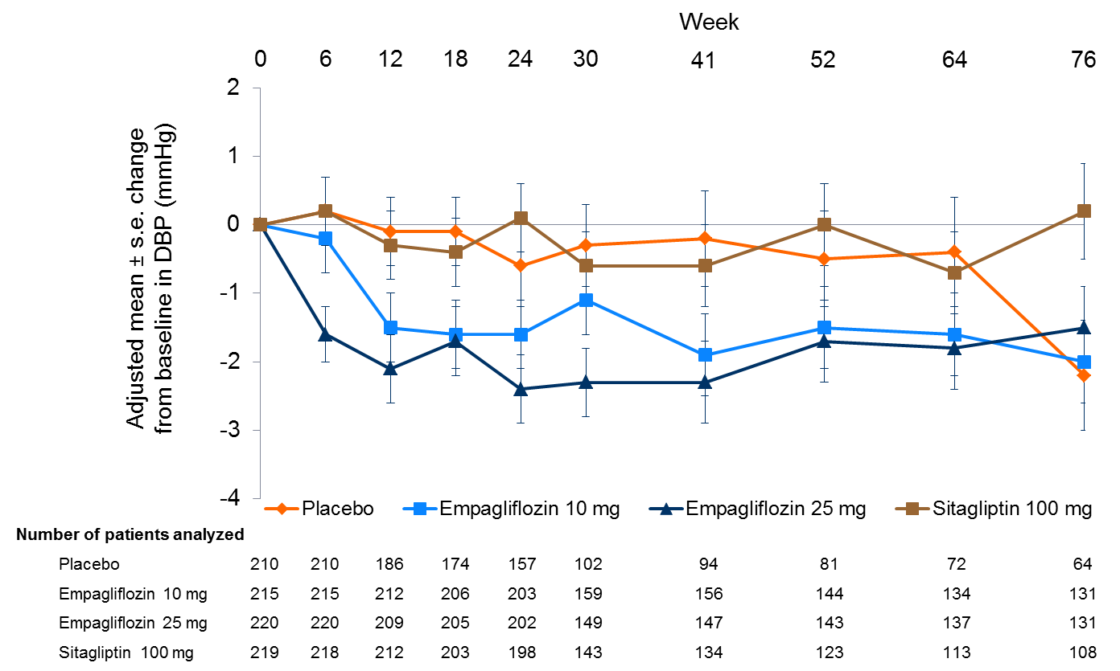

Mixed model repeated measures in the full analysis set, observed cases.
s.e.: standard error; DBP: diastolic blood pressure.

