Supplementary Figures
5.5 mmol/L glucose
11 mmol/L glucose
22 mmol/L glucose
Glucose consumption
(pmol per cell)
0
8
24
0
2
4
6
Time (h)

Figure S1. Basal consumption of glucose by human aortic smooth muscle cells cultured for 8 and 24 h in medium initially containing 5.5, 11, or 22 mmol/L glucose. Results are the mean ± standard error of 13-25 separate experiments.

5,5 mmol/L glucose
22 mmol/L glucose
5,5 mmol/L glucose+IL1β
22 mmol/L glucose+IL1β

Figure S2. Immunofluorescence for GLUT1 transporters (green) in cells exposed for 18 h to IL1β (10 ng/mL) in medium containing 5.5 or 22 mmol/L glucose. Nuclei were counterstained with DAPI (blue).

Figure S3. (A) Representative gel and quantification of GLUT1 mRNA levels determined by PCR in control (C) cells, cells transfected with cDNA for GLUT1 (GLUT1+) and cells infected with an empty vector (EV). Results are expressed as mean±SEM of 3 separate experiments expressed as percentage of the level in control (c) cells. *P<0.05 vs C. †P<0.05 vs EV. (B) Cytochalasin B-sensitive uptake of ³H-deoxyglucose in control, GLUT1+ and EV-transfected cells. Results are mean ± standard error of 14 separate experiments expressed as percentage of the control radioactivity uptake (87.7±14.2 dpm/µg protein). *P<0.05 vs C. †P<0.05 vs EV.

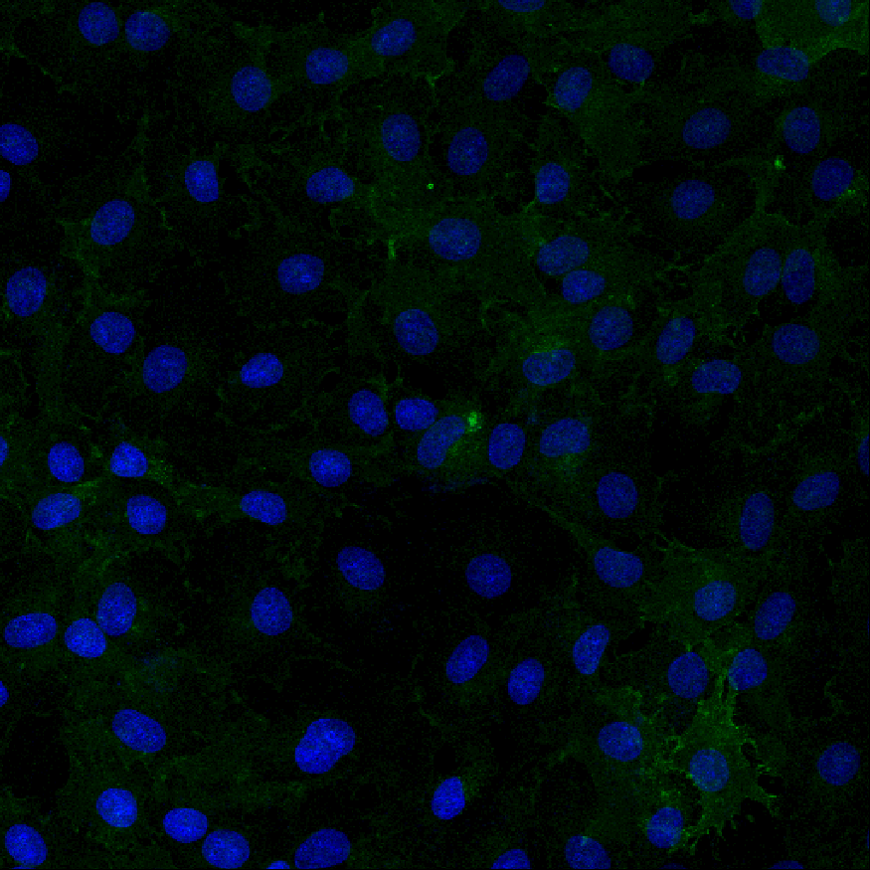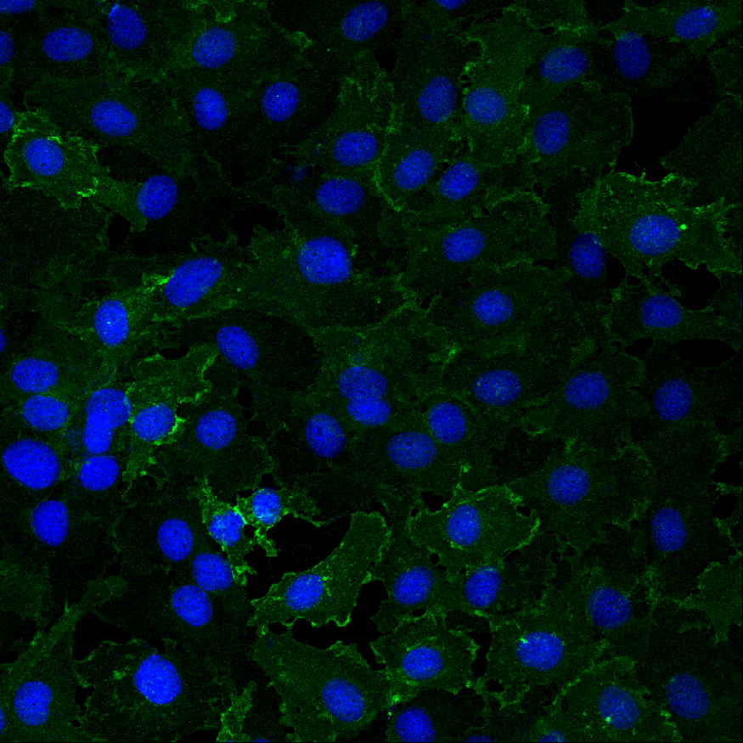
Control
+azide

Figure S4. Immunofluorescence for GLUT1 transporters (green) in cells exposed for 18 hr to sodium azide (0.5 mmol/L) in medium containing 5.5 mmol/L glucose. Nuclei were counterstained with DAPI (blue).

Figure S5. (A) Effect of apocynin (10 µmol/L) on the impairment of the ACh-induced vasodilatations induced by 2.5 ng/ml IL1β in rat vascular mesenteric segments incubated in 5.5 mmol/L glucose. Data are expressed (means ± SE) as the percentage of the previous contraction induced with NA, which averaged 10.78±0.70, 9.61±0.72, 10.39±1.22, and 9.44±1.15 mNewtons, respectively. The number of segments used for every curve, which were obtained from 5 animals, are in parenthesis. *P<0.05 vs control. (B) Effect of apocynin on the endothelium impairment induced by IL1β in rat vascular mesenteric segments incubated in 22 mmol/L glucose. Data are expressed (means ± SE) as the percentage of the previous contraction induced with NA, which averaged 9.87±0.56, 9.88±0.70, 9.16±0.48, and 10.38±1.13 mNewtons, respectively. The number of segments used for every curve, which were obtained from 5 animals are in parenthesis. *P<0.05 vs control. †P<0.05 vs IL1β.

