Appendix 1. Other cardiac measures of function and structure

- Peak Systolic Strain
- Left Ventricular Ejection Fraction
- Stroke volume
- LV end-diastolic volume
- LV end-systolic volume
- LV end-diastolic mass
- Left Ventricular End Diastolic Mass/volume ratio
- Pre-and post contrast T1 mapping to calculate volume of distribution, a marker of diffuse cardiac fibrosis
- Myocardial Perfusion Reserve ( a measure of microvascular function)

Appendix 2 – Secondary outcome measures

- HbA1c
- Lipid profile including total-, LDL- and HDL-cholesterol and triglycerides
- Liver Function Tests
- Renal Function Tests
- Thyroid function tests
- Complete Blood Count (Hematocrit)
- Vitamin D
- Endothelial function (EPCs & SDF-1α)
- Measures of inflammation (hs-CRP)
- Anthropometirc measures – body weight, height, BMI, blood pressure
- Cardiorespiratory fitness (V02 max)
- Level of physical activity (accelerometer/inclinometer)
- 7-point glucose profile
- Treatment satisfaction & quality of life
- Thoracic and abdominal subcutaneous and visceral fat assessment

Appendix 3 – Participant flow chart

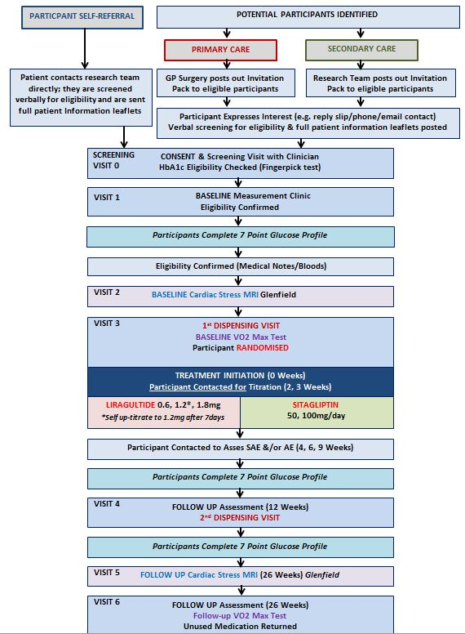

Appendix 4 – Examination and measures

Visit | Consent /Screening (Visit 0) | Baseline (Visit 1) | Baseline (Visit 2) | Baseline (Visit 3) | Follow Up Contact | Follow Up Contact | Pre-Visit 4 Self Reporting | 1st Follow Up, 2nd Dispensing (Visit 4 ) | Pre-Visit 6 Self Reporting | Follow Up MRI (Visit 5) | 2nd Follow Up (Visit 6)
Time-point | n/a | n/a | n/a | Week 0 | Weeks 1,2,3 | Weeks 4,6,9 | 11 weeks* | 12 weeks | 25 weeks* | 26 weeks  (< or > v6) | 26 weeks  (< or > v5)
Visit Window | n/a | n/a | n/a | n/a | +/- 7 days | +/- 7 days | +/- 7 days | +/- 14 days | +/- 7 days | +/- 14 days | +/- 14 days
HbA1C Finger prick Test | √
Cardiac MRI |  |  | √ |  |  |  |  |  |  | √
Standard Biochemical variables |  | √ |  |  |  |  |  | √ |  |  | √
Other Biochemical measures i.e. chronic low-grade inflammation |  | √ |  |  |  |  |  | √ |  |  | √
Anthropometric variables |  | √ |  |  |  |  |  | √ |  |  | √
Blood Pressure |  | √ |  |  |  |  |  | √ |  |  | √
Smoking, Medical & Family History |  | √
Pregnancy Test |  | √ |  | √ |  |  |  | √ |  |  | √
Endothelial function |  | √ |  |  |  |  |  |  |  |  | √
Vitamin D |  | √ |  |  |  |  |  |  |  |  | √
Cardio-respiratory fitness (graded VO2 max test) |  |  |  | √ (+2 weeks) |  |  |  |  |  |  | √

Visit | Consent /Screening (Visit 0) | Baseline (Visit 1) | Baseline (Visit 2) | Baseline (Visit 3) | (Follow Up Contact | (Follow Up Contact | Pre-Visit 4 Self Reporting | 1st Follow Up, 2nd Dispensing (Visit 4 ) | Pre-Visit 6 Self Reporting | Follow Up MRI (Visit 5) | 2nd Follow Up (Visit 6)
Time-point | Any | n/a | n/a | Week 0 | Weeks 1,2,3 | Weeks 4,6,9 | 11 weeks* | 12 weeks | 25 weeks* | 26 weeks  (< or > v6) | 26 weeks (< or > v5)
Visit Window | n/a | n/a | n/a | n/a | +/- 7 days | +/- 7 days | +/- 7 days | +/- 14 days | +/- 7 days | +/- 14days | +/- 14 days
Physical Activity and Sitting Time** |  | √ |  |  |  |  |  | √ |  |  | √
Quality of life and depression |  | √ |  |  |  |  |  | √ |  |  | √
Treatment satisfaction |  | √ |  |  |  |  |  | √ |  |  | √
7-point G profile* |  |  | √ |  |  |  | √ |  | √
Hypoglycaemia Diary*** |  |  |  |  |  |  |  | √ |  |  | √
Adverse events |  | √ |  |  | √ | √ |  | √ |  |  | √

Key: (*) The 7-point glucose profile is self-reported by the participant at (-)2 weeks, 11 weeks and 25 weeks prior to the visits 3, 4 and 6 in which the data is collected.
(**) An accelerometer and inclinometer are setup for 7 days at visit 1 to be returned in the post or at visit 3 and then setup at visits 4 and 6 and returned in the post.
(***) The hypoglycaemia diary is self-reported by the patient throughout the 26 weeks of drug treatment and a copy of this taken at visit 4 and visit 6.

